

CSE471 : System Analysis and Design
Lab Assignment on API Postman Collection

Project Title : MedFind BD
Group Number : 02
Backend Framework : Node.js + Express.js (MongoDB Atlas, Mongoose)

Submitted by : Abdullah Al Muqit
Student ID : 22201783
Section: 03

Date : 05 November 2026
APIs of Feature - 01: Medicine Search & Filter
Server: Member 3 backend, started with "npm run start:member3" on port 1783 (last four digits of student ID 22201783). Base URL: http://127.0.0.1:1783. Database: MongoDB (Mongoose ODM), connected at server start.
Method | Endpoint - API
1. GET | /api/search/suggestions - Partial-match suggestions
2. GET | /api/search/medicines - Search medicines by brand or generic name
3. GET | /api/search/medicines - Search with filters
4. GET | /api/search/filters - Filter options with counts
5. GET | /api/search/popular - Popular searches
6. GET | /api/search/medicines - No results found

API 1: Partial-match suggestions
Purpose | Suggestions while typing: matching generic names (with brand counts) and brand names with manufacturer, form and strength.
Endpoint URL | http://127.0.0.1:1783/api/search/suggestions
HTTP Method | GET
Headers | None
Authentication | Public (no login required)
Body / Parameters | Query parameters:  q = para  limit = 8
Status code | Expected 200 OK; returned 200 OK in the Postman test below

Example request (cURL):
curl -X GET "http://127.0.0.1:1783/api/search/suggestions?q=para&limit=8"

Example response (200 OK, recorded from the Postman collection run):
{
"success": true,
"message": "Suggestions",
"data": {
"query": "para",
"suggestions": [
{
"type": "Generic",
"name": "Paracetamol",
"subtitle": "7 brands"
},
{
"type": "Generic",
"name": "Paracetamol + Caffeine",
"subtitle": "2 brands"
}
]
}
}

Code snippet (route -> controller -> service):
// src/routes/search.routes.js
router.get('/search/suggestions', validate(v.suggestionsQuery, 'query'), ctrl.suggestions);

// src/controllers/search.controller.js
async function suggestions(req, res) {
const { q, limit } = req.validatedQuery;
ok(res, await service.suggestions(q, limit), 'Suggestions');
}

// src/services/search.service.js
/** Partial-match suggestions while typing: matching generic names (with brand counts) and brand names. */
async function suggestions(q, limit = 8) {
const rx = new RegExp(escapeRegex(q.trim()), 'i');
const prefix = new RegExp(`^${escapeRegex(q.trim())}`, 'i');

const [generics, brands] = await Promise.all([
MasterMedicine.aggregate([
{ $match: { isActive: true, genericName: rx } },
{ $group: { _id: '$genericName', brands: { $addToSet: '$brandName' } } },
{ $project: { _id: 0, name: '$_id', brandCount: { $size: '$brands' } } },
{ $sort: { brandCount: -1, name: 1 } },
{ $limit: 4 },
]),
MasterMedicine.find({ isActive: true, brandName: rx }).limit(30),
]);

// brands that start with the query come first
const sortedBrands = brands.sort((a, b) => Number(prefix.test(b.brandName)) - Number(prefix.test(a.brandName)) || a.brandName.localeCompare(b.brandName));
const items = [
...generics.map((g) => ({ type: 'Generic', name: g.name, subtitle: `${g.brandCount} brand${g.brandCount === 1 ? '' : 's'}` })),
...sortedBrands.map((m) => ({ type: 'Brand', id: m._id, name: m.brandName, subtitle: `${m.manufacturer} · ${m.dosageForm} ${m.strength}`, genericName: m.genericName })),
].slice(0, limit);

return { query: q, suggestions: items };
}

Postman screenshot:
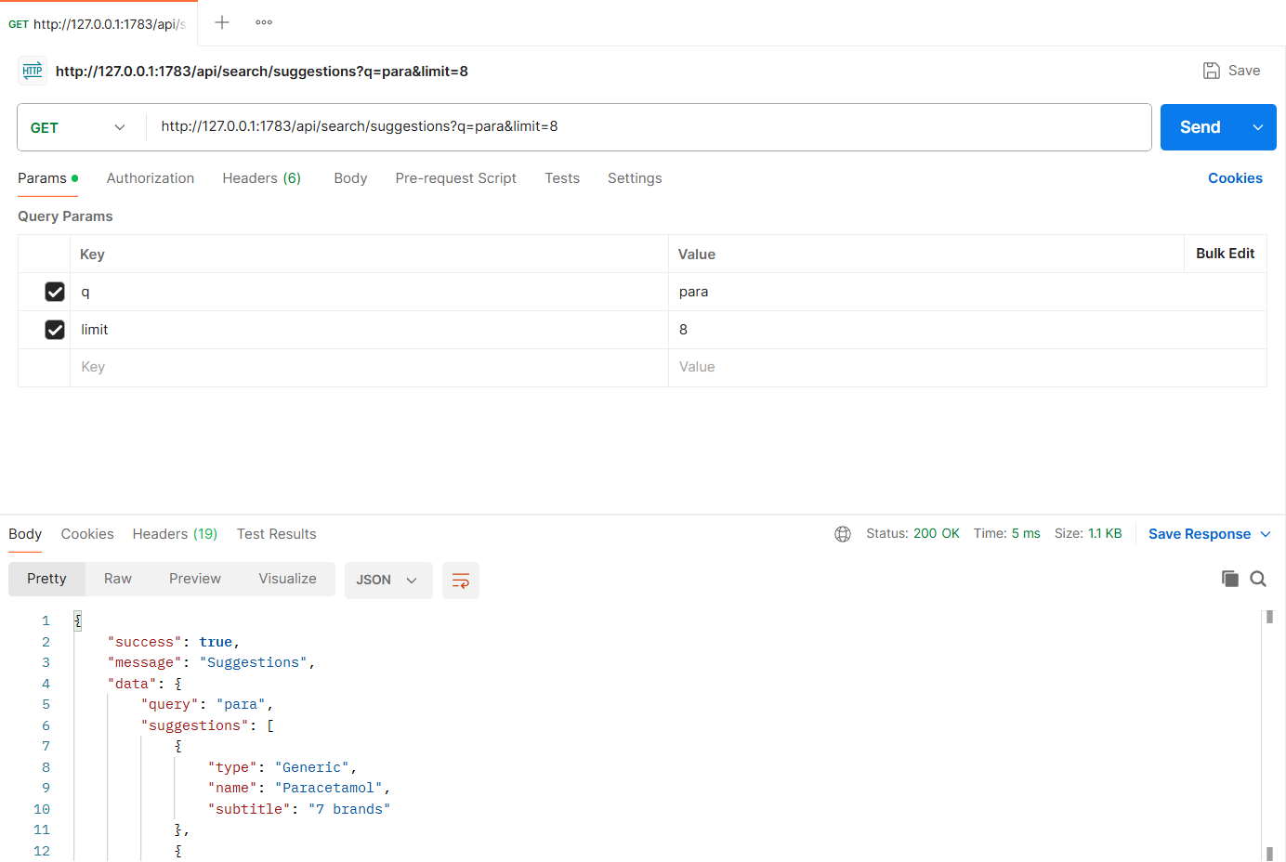
Figure: M3-F1-01 - GET /api/search/suggestions tested in Postman (status 200)
API 2: Search medicines by brand or generic name
Purpose | Search results with per-unit price range and how many verified pharmacies list each medicine; paginated and sortable.
Endpoint URL | http://127.0.0.1:1783/api/search/medicines
HTTP Method | GET
Headers | None
Authentication | Public (no login required)
Body / Parameters | Query parameters:  q = paracetamol  page = 1  limit = 10
Status code | Expected 200 OK; returned 200 OK in the Postman test below

Example request (cURL):
curl -X GET "http://127.0.0.1:1783/api/search/medicines?q=paracetamol&page=1&limit=10"

Example response (200 OK, recorded from the Postman collection run):
{
"success": true,
"message": "Search results",
"data": {
"query": "paracetamol",
"appliedFilters": {
"inStock": false
},
"total": 9,
"results": [
{
"id": "3bec8373567f1e169fbef9cb",
"brandName": "Napa",
"genericName": "Paracetamol",
"manufacturer": "Beximco Pharmaceuticals",
"dosageForm": "Tablet",
"strength": "500 mg",
"unit": "pc",
"requiresPrescription": false,
"priceRange": {
"min": 1,
"max": 1.5
},
"pharmacyCount": 5,
"inStockPharmacyCount": 5
},
{
"id": "be56a4bd6dcd067d5a7dcfd1",
... (truncated - full response in the Postman screenshot / collection run)

Code snippet (route -> controller -> service):
// src/routes/search.routes.js
router.get('/search/medicines', validate(v.searchQuery, 'query'), ctrl.searchMedicines);

// src/controllers/search.controller.js
async function searchMedicines(req, res) {
const q = req.validatedQuery;
ok(res, await service.searchMedicines({ ...q, ...getPagination(q, { limit: 10 }) }), 'Search results');
}

// src/services/search.service.js
/**
* Search results with filters. Each result shows the per-unit price range and how many verified pharmacies list it.
* Filters: dosageForm, strength, manufacturer (comma separated = OR), minPrice/maxPrice (pharmacy price), inStock.
*/
async function searchMedicines({ q, dosageForm, strength, manufacturer, minPrice, maxPrice, inStock, sort, page, limit, skip }) {
const pharmacyIds = await publicPharmacyIds();
const match = { isActive: true, ...textMatch(q) };
if (dosageForm && dosageForm.length) match.dosageForm = { $in: dosageForm };
if (strength && strength.length) match.strength = { $in: strength };
if (manufacturer && manufacturer.length) match.manufacturer = { $in: manufacturer };

const listingMatch = [{ $eq: ['$medicine', '$$mid'] }, { $eq: ['$isActive', true] }, { $in: ['$pharmacy', pharmacyIds] }];
if (minPrice !== undefined) listingMatch.push({ $gte: ['$price', minPrice] });
if (maxPrice !== undefined) listingMatch.push({ $lte: ['$price', maxPrice] });
if (inStock) listingMatch.push({ $gt: ['$stockQuantity', 0] });
const needsListing = inStock || minPrice !== undefined || maxPrice !== undefined;

const sortStage = {
relevance: { startsWithQuery: -1, pharmacyCount: -1, brandName: 1 },
name: { brandName: 1, strength: 1 },
price_asc: { hasListing: -1, minPrice: 1, brandName: 1 },
price_desc: { maxPrice: -1, brandName: 1 },
pharmacies: { pharmacyCount: -1, brandName: 1 },
}[sort || 'relevance'];

const pipeline = [
{ $match: match },
{
$lookup: {
from: CatalogItem.collection.name,
let: { mid: '$_id' },
pipeline: [{ $match: { $expr: { $and: listingMatch } } }, { $project: { price: 1, stockQuantity: 1 } }],
as: 'listings',
},
},
...(needsListing ? [{ $match: { 'listings.0': { $exists: true } } }] : []),
{
$addFields: {
pharmacyCount: { $size: '$listings' },
inStockPharmacyCount: { $size: { $filter: { input: '$listings', cond: { $gt: ['$$this.stockQuantity', 0] } } } },
minPrice: { $min: '$listings.price' },
maxPrice: { $max: '$listings.price' },
hasListing: { $gt: [{ $size: '$listings' }, 0] },
startsWithQuery: q ? { $regexMatch: { input: '$brandName', regex: `^${escapeRegex(q.trim())}`, options: 'i' } } : true,
},
},
{ $sort: sortStage },
{
$facet: {
total: [{ $count: 'n' }],
results: [
{ $skip: skip },
{ $limit: limit },
{ $project: { listings: 0, startsWithQuery: 0, hasListing: 0, __v: 0, createdAt: 0, updatedAt: 0, isActive: 0 } },
],
},
},
];

const [out] = await MasterMedicine.aggregate(pipeline);
const total = out.total[0] ? out.total[0].n : 0;

if (q && page === 1) await logSearch(q);

return {
query: q || '',
appliedFilters: { dosageForm, strength, manufacturer, minPrice, maxPrice, inStock: Boolean(inStock) },
total,
results: out.results.map((m) => ({
id: m._id,
brandName: m.brandName,
genericName: m.genericName,
manufacturer: m.manufacturer,
dosageForm: m.dosageForm,
strength: m.strength,
unit: m.unit,
requiresPrescription: m.requiresPrescription,
priceRange: m.pharmacyCount ? { min: m.minPrice, max: m.maxPrice } : null,
pharmacyCount: m.pharmacyCount,
inStockPharmacyCount: m.inStockPharmacyCount,
})),
pagination: pageMeta(page, limit, total),
message: total === 0 ? `No medicines found for "${q || ''}". Check the spelling or try a generic name. You can also clear some filters.` : undefined,
disclaimer: DISCLAIMER,
};
}

Postman screenshot:
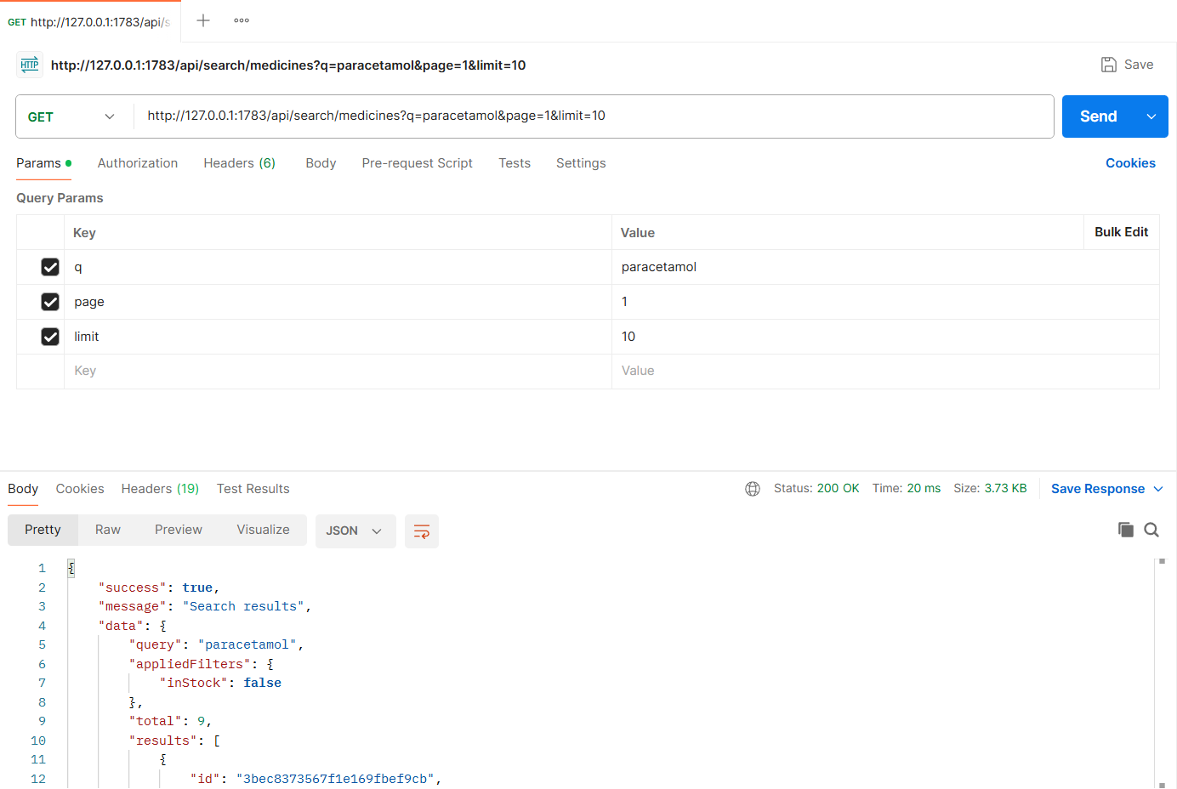
Figure: M3-F1-02 - GET /api/search/medicines tested in Postman (status 200)
API 3: Search with filters
Purpose | Filter by dosage form, strength, manufacturer, price range and "in stock only"; sort by lowest price.
Endpoint URL | http://127.0.0.1:1783/api/search/medicines
HTTP Method | GET
Headers | None
Authentication | Public (no login required)
Body / Parameters | Query parameters:  q = paracetamol  dosageForm = Tablet  strength = 500 mg  manufacturer = Beximco Pharmaceuticals,Square Pharmaceuticals  minPrice = 1  maxPrice = 5  inStock = true  sort = price_asc
Status code | Expected 200 OK; returned 200 OK in the Postman test below

Example request (cURL):
curl -X GET "http://127.0.0.1:1783/api/search/medicines?q=paracetamol&dosageForm=Tablet&strength=500 mg&manufacturer=Beximco Pharmaceuticals,Square Pharmaceuticals&minPrice=1&maxPrice=5&inStock=true&sort=price_asc"

Example response (200 OK, recorded from the Postman collection run):
{
"success": true,
"message": "Search results",
"data": {
"query": "paracetamol",
"appliedFilters": {
"dosageForm": [
"Tablet"
],
"strength": [
"500 mg"
],
"manufacturer": [
"Beximco Pharmaceuticals",
"Square Pharmaceuticals"
],
"minPrice": 1,
"maxPrice": 5,
"inStock": true
},
"total": 2,
"results": [
{
"id": "3bec8373567f1e169fbef9cb",
"brandName": "Napa",
"genericName": "Paracetamol",
"manufacturer": "Beximco Pharmaceuticals",
"dosageForm": "Tablet",
... (truncated - full response in the Postman screenshot / collection run)

Code snippet (route -> controller -> service):
// src/routes/search.routes.js
router.get('/search/medicines', validate(v.searchQuery, 'query'), ctrl.searchMedicines);

// src/controllers/search.controller.js
async function searchMedicines(req, res) {
const q = req.validatedQuery;
ok(res, await service.searchMedicines({ ...q, ...getPagination(q, { limit: 10 }) }), 'Search results');
}

Postman screenshot:
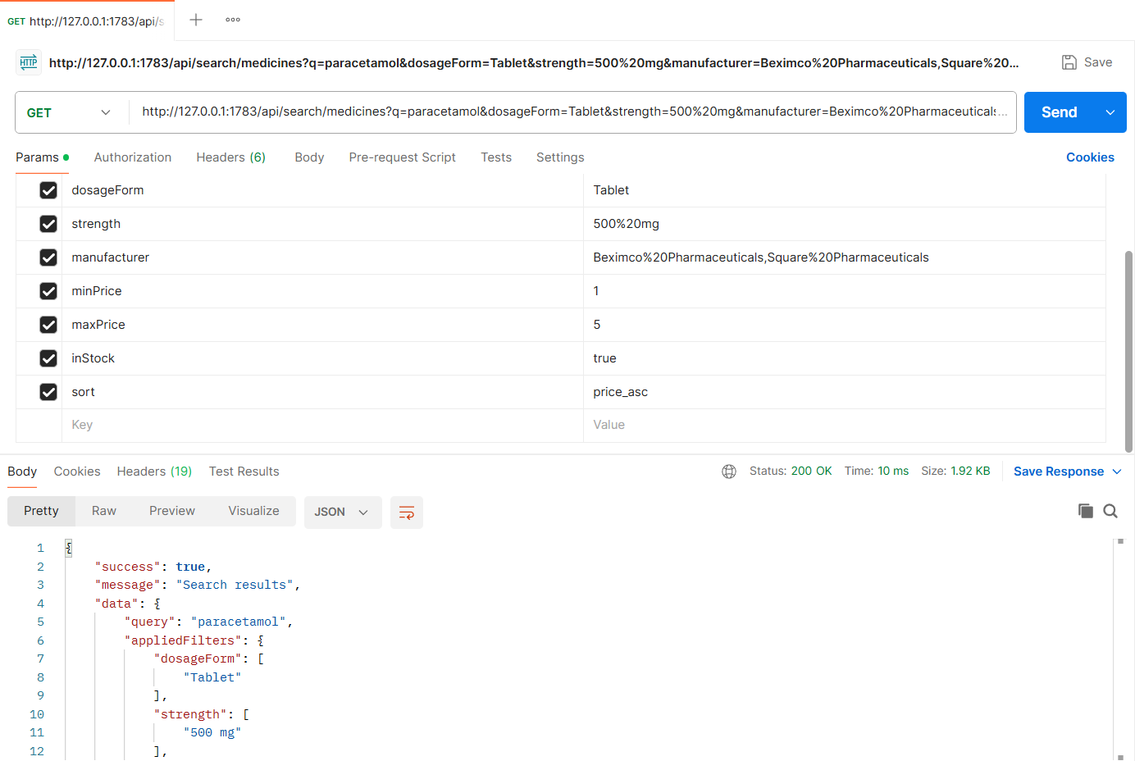
Figure: M3-F1-03 - GET /api/search/medicines tested in Postman (status 200)
API 4: Filter options with counts
Purpose | Values and counts for the filter sidebar (dosage forms, strengths, manufacturers) and the price range for the current query.
Endpoint URL | http://127.0.0.1:1783/api/search/filters
HTTP Method | GET
Headers | None
Authentication | Public (no login required)
Body / Parameters | Query parameters:  q = paracetamol
Status code | Expected 200 OK; returned 200 OK in the Postman test below

Example request (cURL):
curl -X GET "http://127.0.0.1:1783/api/search/filters?q=paracetamol"

Example response (200 OK, recorded from the Postman collection run):
{
"success": true,
"message": "Filter options",
"data": {
"query": "paracetamol",
"dosageForms": [
{
"value": "Tablet",
"count": 7
},
{
"value": "Syrup",
"count": 2
}
],
"strengths": [
{
"value": "120 mg/5 ml",
"count": 2
},
{
"value": "250 mg",
"count": 1
},
{
"value": "500 mg",
"count": 3
},
... (truncated - full response in the Postman screenshot / collection run)

Code snippet (route -> controller -> service):
// src/routes/search.routes.js
router.get('/search/filters', validate(v.filtersQuery, 'query'), ctrl.filterOptions);

// src/controllers/search.controller.js
async function filterOptions(req, res) {
ok(res, await service.filterOptions(req.validatedQuery.q), 'Filter options');
}

// src/services/search.service.js
/** Filter options with counts for the current query (left sidebar of the results page). */
async function filterOptions(q) {
const pharmacyIds = await publicPharmacyIds();
const match = { isActive: true, ...textMatch(q) };
const [facets] = await MasterMedicine.aggregate([
{ $match: match },
{
$facet: {
dosageForms: [{ $group: { _id: '$dosageForm', count: { $sum: 1 } } }, { $sort: { count: -1 } }],
strengths: [{ $group: { _id: '$strength', count: { $sum: 1 } } }, { $sort: { _id: 1 } }],
manufacturers: [{ $group: { _id: '$manufacturer', count: { $sum: 1 } } }, { $sort: { count: -1 } }],
ids: [{ $project: { _id: 1 } }],
},
},
]);
const ids = facets.ids.map((d) => d._id);
const [price] = await CatalogItem.aggregate([
{ $match: { medicine: { $in: ids }, isActive: true, pharmacy: { $in: pharmacyIds } } },
{ $group: { _id: null, min: { $min: '$price' }, max: { $max: '$price' } } },
]);
const toList = (arr) => arr.map((f) => ({ value: f._id, count: f.count }));
return {
query: q || '',
dosageForms: toList(facets.dosageForms),
strengths: toList(facets.strengths),
manufacturers: toList(facets.manufacturers),
priceRange: price ? { min: price.min, max: price.max } : null,
};
}

Postman screenshot:
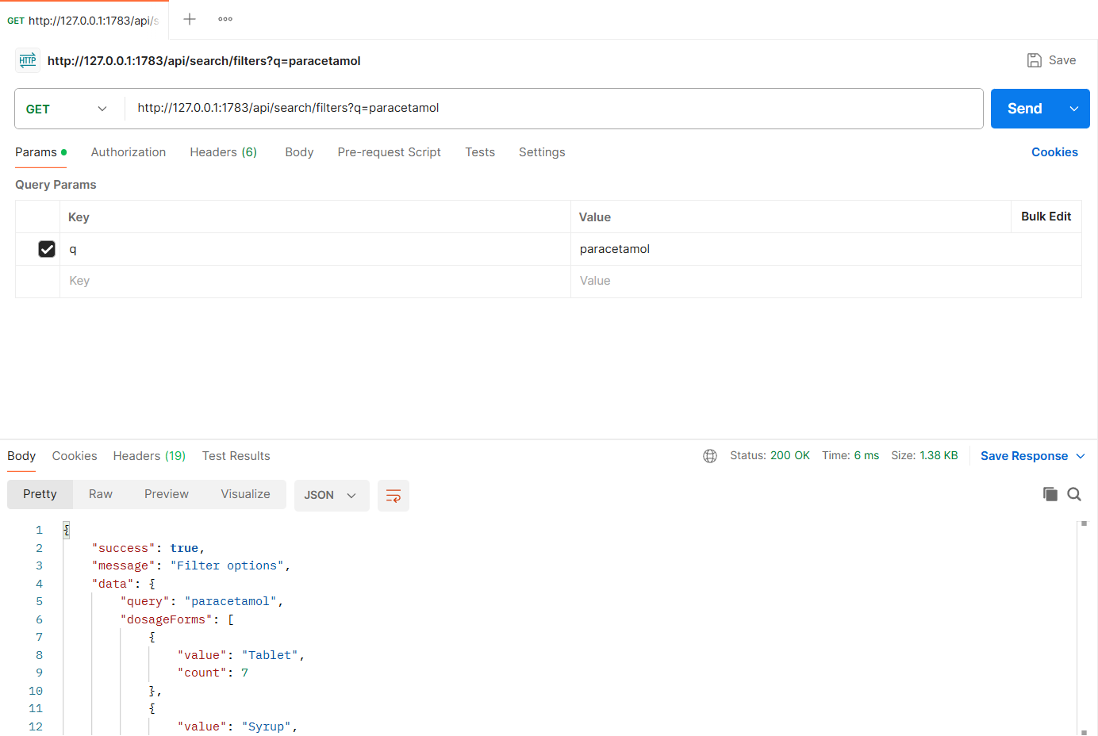
Figure: M3-F1-04 - GET /api/search/filters tested in Postman (status 200)
API 5: Popular searches
Purpose | Popular search chips, from the search log (falls back to the most widely listed medicines).
Endpoint URL | http://127.0.0.1:1783/api/search/popular
HTTP Method | GET
Headers | None
Authentication | Public (no login required)
Body / Parameters | Query parameters:  limit = 6
Status code | Expected 200 OK; returned 200 OK in the Postman test below

Example request (cURL):
curl -X GET "http://127.0.0.1:1783/api/search/popular?limit=6"

Example response (200 OK, recorded from the Postman collection run):
{
"success": true,
"message": "Popular searches",
"data": {
"source": "search-log",
"popular": [
{
"term": "Napa",
"searches": 42
},
{
"term": "Seclo 20",
"searches": 25
},
{
"term": "Fexo 120",
"searches": 19
},
{
"term": "Monas 10",
"searches": 15
},
{
"term": "Ostocal",
"searches": 9
},
{
"term": "Orsaline",
... (truncated - full response in the Postman screenshot / collection run)

Code snippet (route -> controller -> service):
// src/routes/search.routes.js
router.get('/search/popular', validate(v.popularQuery, 'query'), ctrl.popular);

// src/controllers/search.controller.js
async function popular(req, res) {
ok(res, await service.popularSearches(req.validatedQuery.limit), 'Popular searches');
}

// src/services/search.service.js
/** Popular searches; falls back to the most widely listed medicines when nobody has searched yet. */
async function popularSearches(limit = 6) {
const logs = await SearchLog.find().sort({ count: -1, lastSearchedAt: -1 }).limit(limit);
if (logs.length >= limit) return { source: 'search-log', popular: logs.map((l) => ({ term: l.displayTerm, searches: l.count })) };

const pharmacyIds = await publicPharmacyIds();
const top = await CatalogItem.aggregate([
{ $match: { isActive: true, pharmacy: { $in: pharmacyIds } } },
{ $group: { _id: '$medicine', listings: { $sum: 1 } } },
{ $sort: { listings: -1 } },
{ $limit: limit * 2 },
{ $lookup: { from: MasterMedicine.collection.name, localField: '_id', foreignField: '_id', as: 'm' } },
{ $unwind: '$m' },
]);
const seen = new Set(logs.map((l) => l.term));
const popular = logs.map((l) => ({ term: l.displayTerm, searches: l.count }));
for (const t of top) {
if (popular.length >= limit) break;
if (seen.has(t.m.brandName.toLowerCase())) continue;
seen.add(t.m.brandName.toLowerCase());
popular.push({ term: t.m.brandName, listings: t.listings });
}
return { source: logs.length ? 'search-log+listings' : 'listings', popular };
}

Postman screenshot:
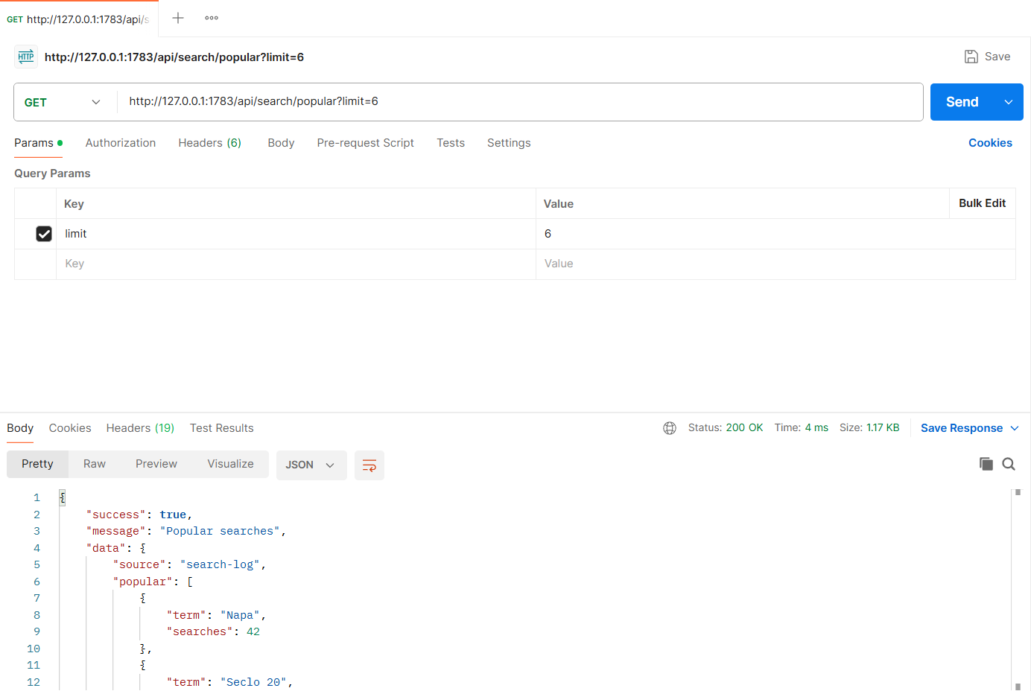
Figure: M3-F1-05 - GET /api/search/popular tested in Postman (status 200)
API 6: No results found
Purpose | Misspelled query returns an empty list with guidance (No Results Found screen).
Endpoint URL | http://127.0.0.1:1783/api/search/medicines
HTTP Method | GET
Headers | None
Authentication | Public (no login required)
Body / Parameters | Query parameters:  q = paracetamool
Status code | Expected 200 OK; returned 200 OK in the Postman test below

Example request (cURL):
curl -X GET "http://127.0.0.1:1783/api/search/medicines?q=paracetamool"

Example response (200 OK, recorded from the Postman collection run):
{
"success": true,
"message": "Search results",
"data": {
"query": "paracetamool",
"appliedFilters": {
"inStock": false
},
"total": 0,
"results": [],
"pagination": {
"page": 1,
"limit": 10,
"total": 0,
"totalPages": 1
},
"message": "No medicines found for \"paracetamool\". Check the spelling or try a generic name. You can also clear some filters.",
"disclaimer": "Availability and prices are reported by pharmacies. Please confirm with the pharmacy before travelling. MedFind BD does not give medical advice."
}
}

Code snippet (route -> controller -> service):
// src/routes/search.routes.js
router.get('/search/medicines', validate(v.searchQuery, 'query'), ctrl.searchMedicines);

// src/controllers/search.controller.js
async function searchMedicines(req, res) {
const q = req.validatedQuery;
ok(res, await service.searchMedicines({ ...q, ...getPagination(q, { limit: 10 }) }), 'Search results');
}

Postman screenshot:
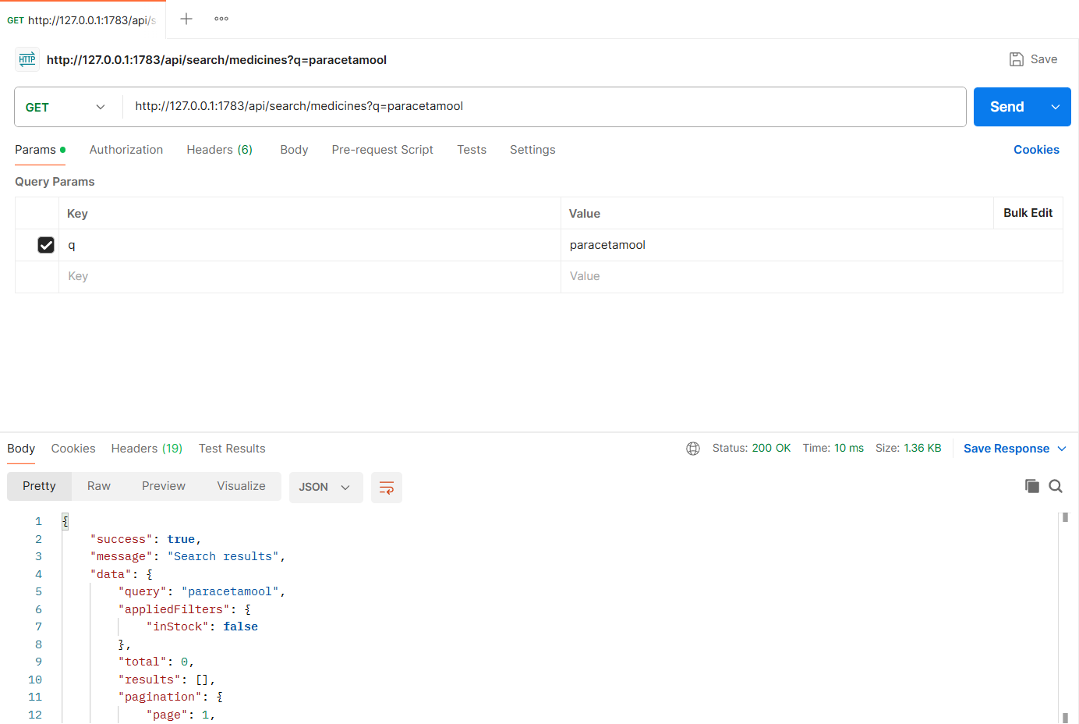
Figure: M3-F1-06 - GET /api/search/medicines tested in Postman (status 200)
Validation and error-handling tests (Feature 01)
The same APIs were also tested with invalid input, wrong roles and invalid state changes. Each request below was sent from Postman to the running server.
Invalid price range (400)
Request | GET http://127.0.0.1:1783/api/search/medicines
Scenario | minPrice greater than maxPrice is rejected.
Body / Parameters | Query parameters:  q = napa  minPrice = 50  maxPrice = 10
Result | Expected 400 Bad Request; returned 400 Bad Request

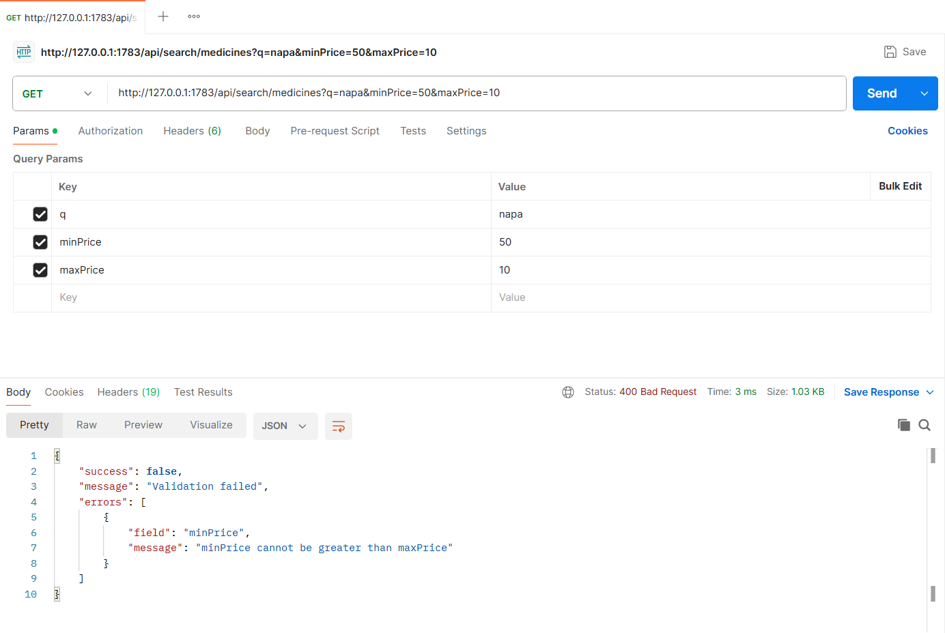
Figure: M3-F1-N1 - Invalid price range (400)
Suggestion query too short (400)
Request | GET http://127.0.0.1:1783/api/search/suggestions
Scenario | At least 2 characters are needed for suggestions.
Body / Parameters | Query parameters:  q = p
Result | Expected 400 Bad Request; returned 400 Bad Request

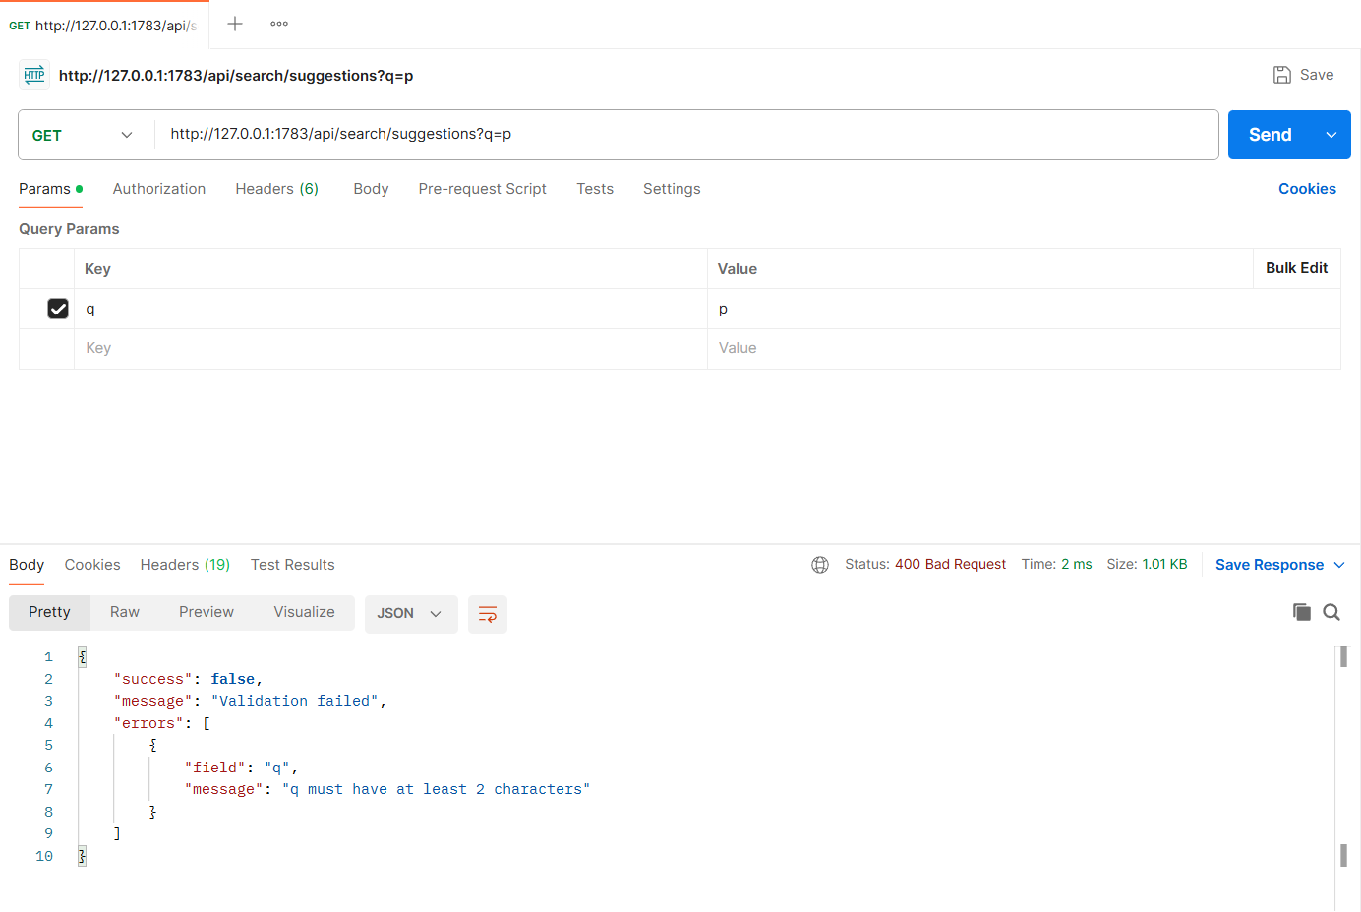
Figure: M3-F1-N2 - Suggestion query too short (400)
APIs of Feature - 02: Nearby Pharmacies & Sorting
Server: Member 3 backend, started with "npm run start:member3" on port 1783 (last four digits of student ID 22201783). Base URL: http://127.0.0.1:1783. Database: MongoDB (Mongoose ODM), connected at server start.
Method | Endpoint - API
1. GET | /api/locations/areas - Selectable areas (Choose location)
2. GET | /api/locations/resolve - Use my location (resolve coordinates)
3. GET | /api/nearby/pharmacies - Nearby pharmacies stocking a medicine (sort by distance)
4. GET | /api/nearby/pharmacies - Nearby pharmacies by selected area, sorted by price
5. GET | /api/nearby/pharmacies - Sort by rating
6. GET | /api/nearby/pharmacies - Open now + most recently updated stock
7. GET | /api/nearby/pharmacies - No pharmacies nearby
8. GET | /api/nearby/pharmacies/0367672641e1463cf4ee98cd - Pharmacy summary (map marker / details)

API 1: Selectable areas (Choose location)
Purpose | City > area list for "Select an area" and the radius options (1, 3, 5, 10, 20 km).
Endpoint URL | http://127.0.0.1:1783/api/locations/areas
HTTP Method | GET
Headers | None
Authentication | Public (no login required)
Body / Parameters | Query parameters:  city = Dhaka
Status code | Expected 200 OK; returned 200 OK in the Postman test below

Example request (cURL):
curl -X GET "http://127.0.0.1:1783/api/locations/areas?city=Dhaka"

Example response (200 OK, recorded from the Postman collection run):
{
"success": true,
"message": "Areas",
"data": {
"cities": [
{
"name": "Dhaka",
"areas": [
{
"id": "204db801456838bb0df33e24",
"name": "Banani",
"lat": 23.7937,
"lng": 90.4066
},
{
"id": "375762db6a967fe743a653b7",
"name": "Dhanmondi",
"lat": 23.7461,
"lng": 90.3742
},
{
"id": "f45ff18fe9c40a21d1089849",
"name": "Gulshan",
"lat": 23.7925,
"lng": 90.4078
},
{
"id": "c5912ba62e58f6125db0e3fa",
... (truncated - full response in the Postman screenshot / collection run)

Code snippet (route -> controller -> service):
// src/routes/nearby.routes.js
router.get('/locations/areas', validate(v.areasQuery, 'query'), ctrl.areas);

// src/controllers/nearby.controller.js
async function areas(req, res) {
ok(res, await service.listAreas(req.validatedQuery.city), 'Areas');
}

// src/services/nearby.service.js
async function listAreas(city) {
const filter = city ? { city: new RegExp(`^${city}$`, 'i') } : {};
const areas = await Area.find(filter).sort({ city: 1, name: 1 });
const cities = {};
for (const a of areas) {
(cities[a.city] = cities[a.city] || []).push({ id: a._id, name: a.name, lat: a.location.coordinates[1], lng: a.location.coordinates[0] });
}
return { cities: Object.entries(cities).map(([name, list]) => ({ name, areas: list })), radiusOptionsKm: RADIUS_OPTIONS };
}

Postman screenshot:
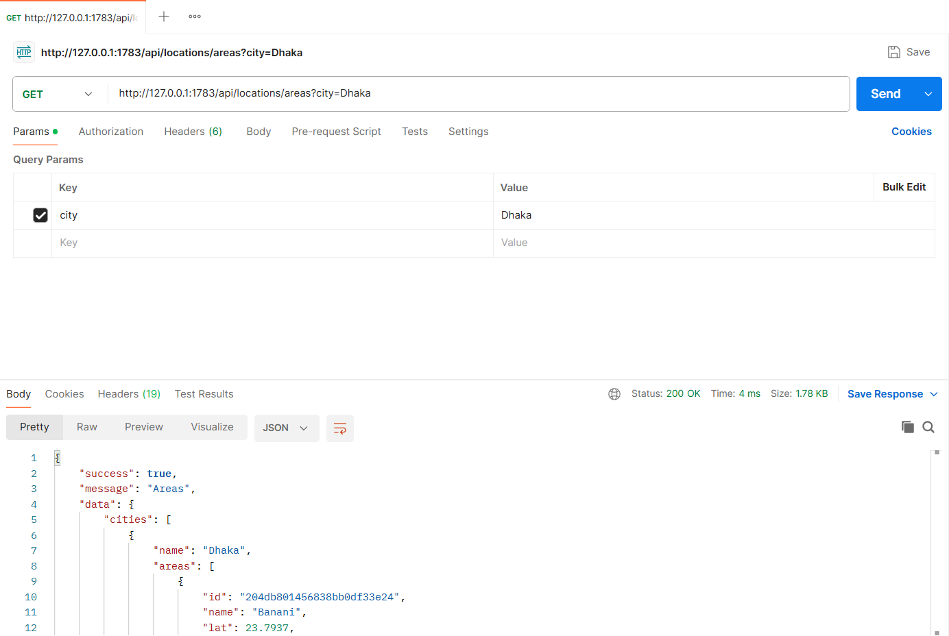
Figure: M3-F2-01 - GET /api/locations/areas tested in Postman (status 200)
API 2: Use my location (resolve coordinates)
Purpose | Turns shared GPS coordinates into the nearest area label (e.g. "Mirpur 10, Dhaka").
Endpoint URL | http://127.0.0.1:1783/api/locations/resolve
HTTP Method | GET
Headers | None
Authentication | Public (no login required)
Body / Parameters | Query parameters:  lat = 23.8069  lng = 90.3687
Status code | Expected 200 OK; returned 200 OK in the Postman test below

Example request (cURL):
curl -X GET "http://127.0.0.1:1783/api/locations/resolve?lat=23.8069&lng=90.3687"

Example response (200 OK, recorded from the Postman collection run):
{
"success": true,
"message": "Location resolved",
"data": {
"lat": 23.8069,
"lng": 90.3687,
"area": {
"id": "6eb7024f30ececf8f51c3e21",
"name": "Mirpur 10",
"city": "Dhaka",
"label": "Mirpur 10, Dhaka"
},
"label": "Mirpur 10, Dhaka",
"privacy": "Your exact location is only used to calculate distance and is not shared with pharmacies."
}
}

Code snippet (route -> controller -> service):
// src/routes/nearby.routes.js
router.get('/locations/resolve', validate(v.resolveQuery, 'query'), ctrl.resolve);

// src/controllers/nearby.controller.js
async function resolve(req, res) {
const { lat, lng } = req.validatedQuery;
ok(res, await service.resolveLocation(lat, lng), 'Location resolved');
}

// src/services/nearby.service.js
/** "Use my location": turns GPS coordinates into the nearest known area name. */
async function resolveLocation(lat, lng) {
const area = await Area.findOne({
location: { $near: { $geometry: { type: 'Point', coordinates: [lng, lat] }, $maxDistance: 15000 } },
});
return {
lat, lng,
area: area ? { id: area._id, name: area.name, city: area.city, label: `${area.name}, ${area.city}` } : null,
label: area ? `${area.name}, ${area.city}` : `${lat.toFixed(4)}, ${lng.toFixed(4)}`,
privacy: 'Your exact location is only used to calculate distance and is not shared with pharmacies.',
};
}

Postman screenshot:
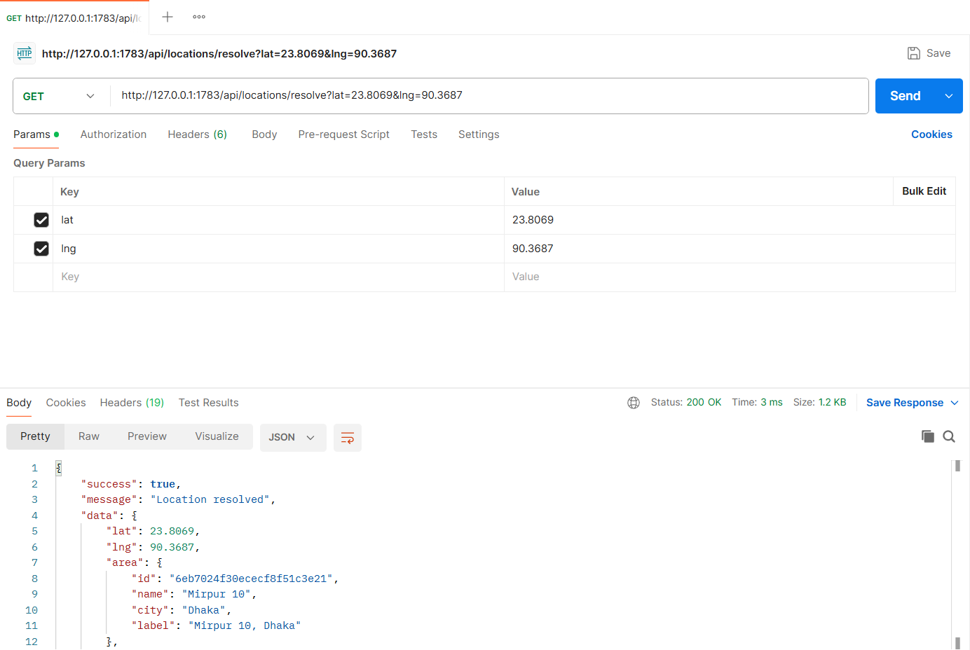
Figure: M3-F2-02 - GET /api/locations/resolve tested in Postman (status 200)
API 3: Nearby pharmacies stocking a medicine (sort by distance)
Purpose | Verified pharmacies within the radius that stock the searched medicine, using a MongoDB 2dsphere $geoNear query, nearest first.
Endpoint URL | http://127.0.0.1:1783/api/nearby/pharmacies
HTTP Method | GET
Headers | None
Authentication | Public (no login required)
Body / Parameters | Query parameters:  medicineId = 3bec8373567f1e169fbef9cb  lat = 23.8069  lng = 90.3687  radiusKm = 5  sort = distance
Status code | Expected 200 OK; returned 200 OK in the Postman test below

Example request (cURL):
curl -X GET "http://127.0.0.1:1783/api/nearby/pharmacies?medicineId=3bec8373567f1e169fbef9cb&lat=23.8069&lng=90.3687&radiusKm=5&sort=distance"

Example response (200 OK, recorded from the Postman collection run):
{
"success": true,
"message": "Nearby pharmacies",
"data": {
"location": {
"label": "23.8069, 90.3687",
"lat": 23.8069,
"lng": 90.3687
},
"medicine": {
"id": "3bec8373567f1e169fbef9cb",
"label": "Napa 500 mg",
"genericName": "Paracetamol"
},
"radiusKm": 5,
"sort": "distance",
"openNow": false,
"total": 4,
"summary": "4 pharmacies within 5 km that stock Napa 500 mg",
"pharmacies": [
{
"id": "0367672641e1463cf4ee98cd",
"name": "Lazz Pharma",
"address": "House 12, Road 3, Mirpur 10, Dhaka",
"area": "Mirpur 10",
"verified": true,
"openNow": false,
"openingHours": "Daily 9:00 AM - 10:00 PM",
... (truncated - full response in the Postman screenshot / collection run)

Code snippet (route -> controller -> service):
// src/routes/nearby.routes.js
router.get('/nearby/pharmacies', validate(v.nearbyQuery, 'query'), ctrl.nearby);

// src/controllers/nearby.controller.js
async function nearby(req, res) {
const q = req.validatedQuery;
ok(res, await service.nearbyPharmacies({ ...q, ...getPagination(q, { limit: 10 }) }), 'Nearby pharmacies');
}

// src/services/nearby.service.js
/**
* Verified pharmacies within radiusKm of the user that stock the searched medicine.
* sort: distance | price | rating | updated ; openNow=true keeps only pharmacies open at this moment.
*/
async function nearbyPharmacies({ medicineId, lat, lng, areaId, radiusKm = 5, sort = 'distance', openNow = false, page, limit, skip }) {
const origin = await originFrom({ lat, lng, areaId });
let medicine = null;
if (medicineId) {
medicine = await MasterMedicine.findOne({ _id: medicineId, isActive: true });
if (!medicine) throw ApiError.notFound('Medicine not found');
}

const pipeline = [
{
$geoNear: {
near: { type: 'Point', coordinates: origin.coordinates },
distanceField: 'distance',
maxDistance: radiusKm * 1000,
spherical: true,
query: Pharmacy.publicFilter(),
},
},
];
if (medicine) {
pipeline.push(
{
$lookup: {
from: CatalogItem.collection.name,
let: { pid: '$_id' },
pipeline: [{
$match: {
$expr: {
$and: [
{ $eq: ['$pharmacy', '$$pid'] },
{ $eq: ['$medicine', new mongoose.Types.ObjectId(String(medicine._id))] },
{ $eq: ['$isActive', true] },
{ $gt: ['$stockQuantity', 0] },
],
},
},
}],
as: 'listing',
},
},
{ $unwind: '$listing' }
);
}

const rows = await Pharmacy.aggregate(pipeline);
let cards = rows.map((row) => {
const p = Pharmacy.hydrate(row);
const card = pharmacyCard(p, row.distance);
if (row.listing) {
const l = row.listing;
card.listing = {
catalogItemId: l._id,
price: l.price,
stock: l.stockQuantity,
stockStatus: l.stockQuantity <= l.minStockLevel ? 'Low stock' : 'In stock',
lastUpdatedAt: l.lastUpdatedAt,
};
}
return card;
});

if (openNow) cards = cards.filter((c) => c.openNow);

const sorters = {
distance: (a, b) => a.distanceKm - b.distanceKm,
price: (a, b) => (a.listing ? a.listing.price : Infinity) - (b.listing ? b.listing.price : Infinity) || a.distanceKm - b.distanceKm,
rating: (a, b) => b.rating - a.rating || b.ratingCount - a.ratingCount,
updated: (a, b) => (b.listing ? +new Date(b.listing.lastUpdatedAt) : 0) - (a.listing ? +new Date(a.listing.lastUpdatedAt) : 0),
};
cards.sort(sorters[sort]);

const total = cards.length;
const medicineLabel = medicine ? `${medicine.brandName} ${medicine.strength}` : null;
const result = {
location: { label: origin.label, lat: origin.coordinates[1], lng: origin.coordinates[0] },
medicine: medicine ? { id: medicine._id, label: medicineLabel, genericName: medicine.genericName } : null,
radiusKm,
sort,
openNow,
total,
summary: medicine
? `${total} pharmac${total === 1 ? 'y' : 'ies'} within ${radiusKm} km that stock ${medicineLabel}`
: `${total} pharmac${total === 1 ? 'y' : 'ies'} within ${radiusKm} km`,
pharmacies: cards.slice(skip, skip + limit),
pagination: pageMeta(page, limit, total),
};

if (total === 0) {
result.emptyState = {
message: medicine ? `No pharmacies within ${radiusKm} km stock ${medicineLabel}` : `No pharmacies within ${radiusKm} km`,
suggestions: {
largerRadiusKm: RADIUS_OPTIONS.filter((r) => r > radiusKm),
turnOffOpenNow: openNow,
},
};
}
return result;
}

Postman screenshot:
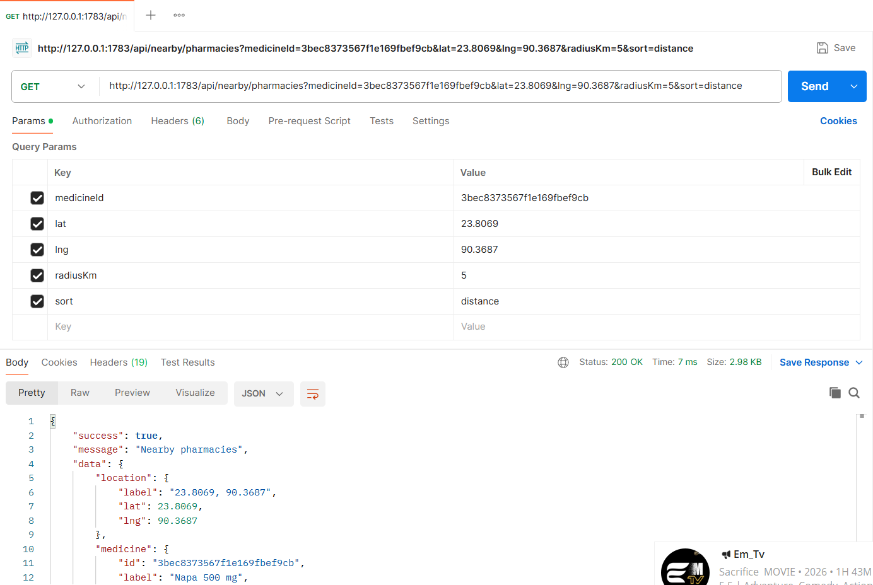
Figure: M3-F2-03 - GET /api/nearby/pharmacies tested in Postman (status 200)
API 4: Nearby pharmacies by selected area, sorted by price
Purpose | Same search starting from a selected area instead of GPS, cheapest first.
Endpoint URL | http://127.0.0.1:1783/api/nearby/pharmacies
HTTP Method | GET
Headers | None
Authentication | Public (no login required)
Body / Parameters | Query parameters:  medicineId = 3bec8373567f1e169fbef9cb  areaId = 6eb7024f30ececf8f51c3e21  radiusKm = 5  sort = price
Status code | Expected 200 OK; returned 200 OK in the Postman test below

Example request (cURL):
curl -X GET "http://127.0.0.1:1783/api/nearby/pharmacies?medicineId=3bec8373567f1e169fbef9cb&areaId=6eb7024f30ececf8f51c3e21&radiusKm=5&sort=price"

Example response (200 OK, recorded from the Postman collection run):
{
"success": true,
"message": "Nearby pharmacies",
"data": {
"location": {
"label": "Mirpur 10, Dhaka",
"lat": 23.8069,
"lng": 90.3687
},
"medicine": {
"id": "3bec8373567f1e169fbef9cb",
"label": "Napa 500 mg",
"genericName": "Paracetamol"
},
"radiusKm": 5,
"sort": "price",
"openNow": false,
"total": 4,
"summary": "4 pharmacies within 5 km that stock Napa 500 mg",
"pharmacies": [
{
"id": "762db1f8dd93e1a8c9999f02",
"name": "Tamanna Pharmacy",
"address": "Plot 5, Section 1 Main Road, Mirpur 1, Dhaka",
"area": "Mirpur 1",
"verified": true,
"openNow": false,
"openingHours": "Daily 8:00 AM - 11:00 PM",
... (truncated - full response in the Postman screenshot / collection run)

Code snippet (route -> controller -> service):
// src/routes/nearby.routes.js
router.get('/nearby/pharmacies', validate(v.nearbyQuery, 'query'), ctrl.nearby);

// src/controllers/nearby.controller.js
async function nearby(req, res) {
const q = req.validatedQuery;
ok(res, await service.nearbyPharmacies({ ...q, ...getPagination(q, { limit: 10 }) }), 'Nearby pharmacies');
}

Postman screenshot:
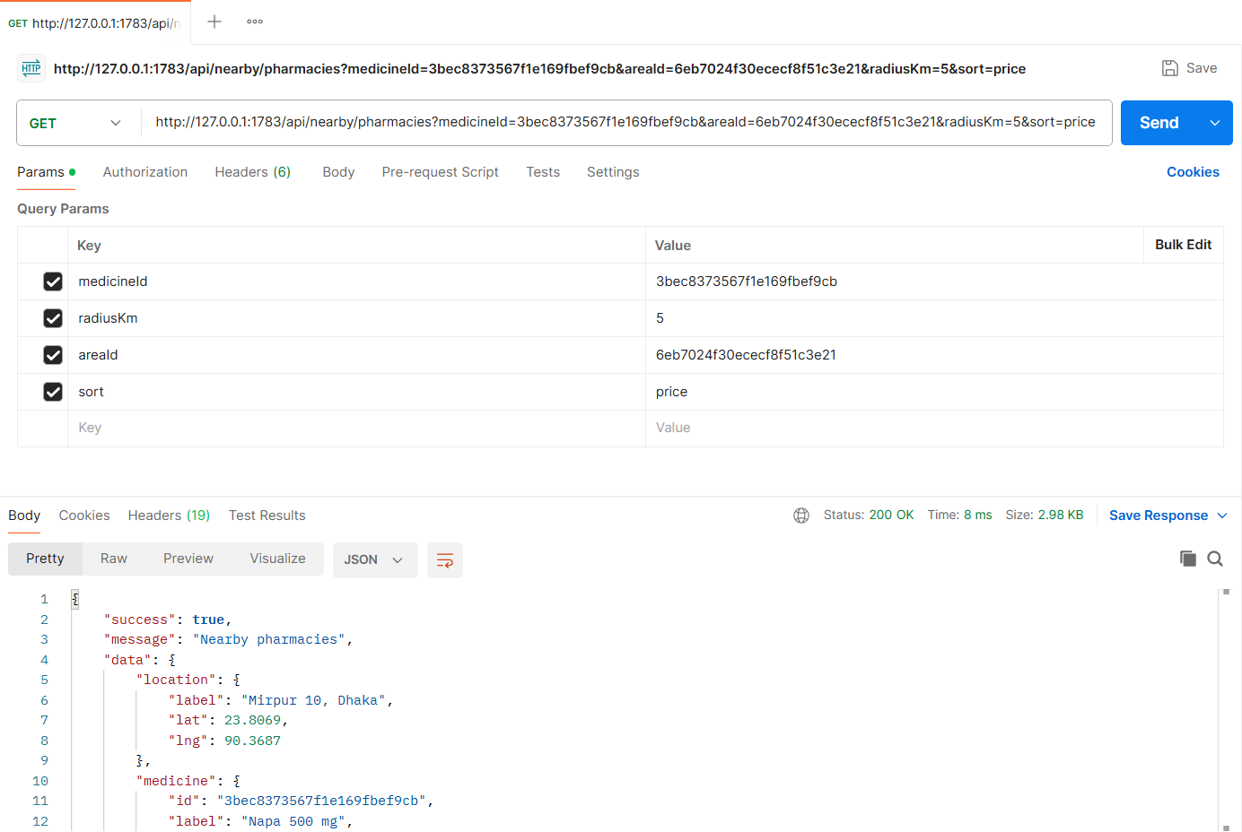
Figure: M3-F2-04 - GET /api/nearby/pharmacies tested in Postman (status 200)
API 5: Sort by rating
Purpose | Highest-rated pharmacies first.
Endpoint URL | http://127.0.0.1:1783/api/nearby/pharmacies
HTTP Method | GET
Headers | None
Authentication | Public (no login required)
Body / Parameters | Query parameters:  medicineId = 3bec8373567f1e169fbef9cb  lat = 23.8069  lng = 90.3687  radiusKm = 10  sort = rating
Status code | Expected 200 OK; returned 200 OK in the Postman test below

Example request (cURL):
curl -X GET "http://127.0.0.1:1783/api/nearby/pharmacies?medicineId=3bec8373567f1e169fbef9cb&lat=23.8069&lng=90.3687&radiusKm=10&sort=rating"

Example response (200 OK, recorded from the Postman collection run):
{
"success": true,
"message": "Nearby pharmacies",
"data": {
"location": {
"label": "23.8069, 90.3687",
"lat": 23.8069,
"lng": 90.3687
},
"medicine": {
"id": "3bec8373567f1e169fbef9cb",
"label": "Napa 500 mg",
"genericName": "Paracetamol"
},
"radiusKm": 10,
"sort": "rating",
"openNow": false,
"total": 5,
"summary": "5 pharmacies within 10 km that stock Napa 500 mg",
"pharmacies": [
{
"id": "0367672641e1463cf4ee98cd",
"name": "Lazz Pharma",
"address": "House 12, Road 3, Mirpur 10, Dhaka",
"area": "Mirpur 10",
"verified": true,
"openNow": false,
"openingHours": "Daily 9:00 AM - 10:00 PM",
... (truncated - full response in the Postman screenshot / collection run)

Code snippet (route -> controller -> service):
// src/routes/nearby.routes.js
router.get('/nearby/pharmacies', validate(v.nearbyQuery, 'query'), ctrl.nearby);

// src/controllers/nearby.controller.js
async function nearby(req, res) {
const q = req.validatedQuery;
ok(res, await service.nearbyPharmacies({ ...q, ...getPagination(q, { limit: 10 }) }), 'Nearby pharmacies');
}

Postman screenshot:
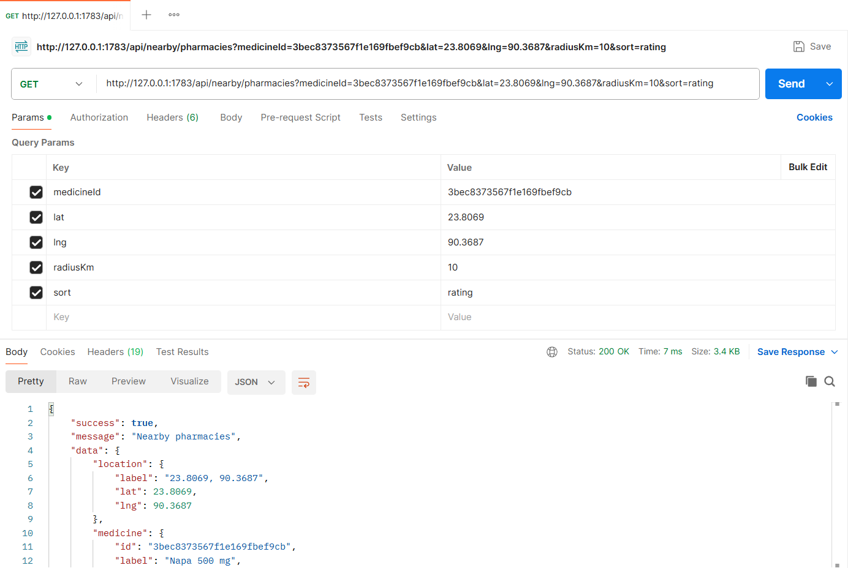
Figure: M3-F2-05 - GET /api/nearby/pharmacies tested in Postman (status 200)
API 6: Open now + most recently updated stock
Purpose | Only pharmacies open at this moment (Asia/Dhaka time), sorted by the latest stock update.
Endpoint URL | http://127.0.0.1:1783/api/nearby/pharmacies
HTTP Method | GET
Headers | None
Authentication | Public (no login required)
Body / Parameters | Query parameters:  medicineId = 3bec8373567f1e169fbef9cb  lat = 23.8069  lng = 90.3687  radiusKm = 10  sort = updated  openNow = true
Status code | Expected 200 OK; returned 200 OK in the Postman test below

Example request (cURL):
curl -X GET "http://127.0.0.1:1783/api/nearby/pharmacies?medicineId=3bec8373567f1e169fbef9cb&lat=23.8069&lng=90.3687&radiusKm=10&sort=updated&openNow=true"

Example response (200 OK, recorded from the Postman collection run):
{
"success": true,
"message": "Nearby pharmacies",
"data": {
"location": {
"label": "23.8069, 90.3687",
"lat": 23.8069,
"lng": 90.3687
},
"medicine": {
"id": "3bec8373567f1e169fbef9cb",
"label": "Napa 500 mg",
"genericName": "Paracetamol"
},
"radiusKm": 10,
"sort": "updated",
"openNow": true,
"total": 1,
"summary": "1 pharmacy within 10 km that stock Napa 500 mg",
"pharmacies": [
{
"id": "e9a8e974b7602290887787a9",
"name": "Green Life Pharmacy",
"address": "House 40, Avenue 5, Mirpur 11, Dhaka",
"area": "Mirpur 11",
"verified": true,
"openNow": true,
"openingHours": "Open 24 hours",
... (truncated - full response in the Postman screenshot / collection run)

Code snippet (route -> controller -> service):
// src/routes/nearby.routes.js
router.get('/nearby/pharmacies', validate(v.nearbyQuery, 'query'), ctrl.nearby);

// src/controllers/nearby.controller.js
async function nearby(req, res) {
const q = req.validatedQuery;
ok(res, await service.nearbyPharmacies({ ...q, ...getPagination(q, { limit: 10 }) }), 'Nearby pharmacies');
}

Postman screenshot:
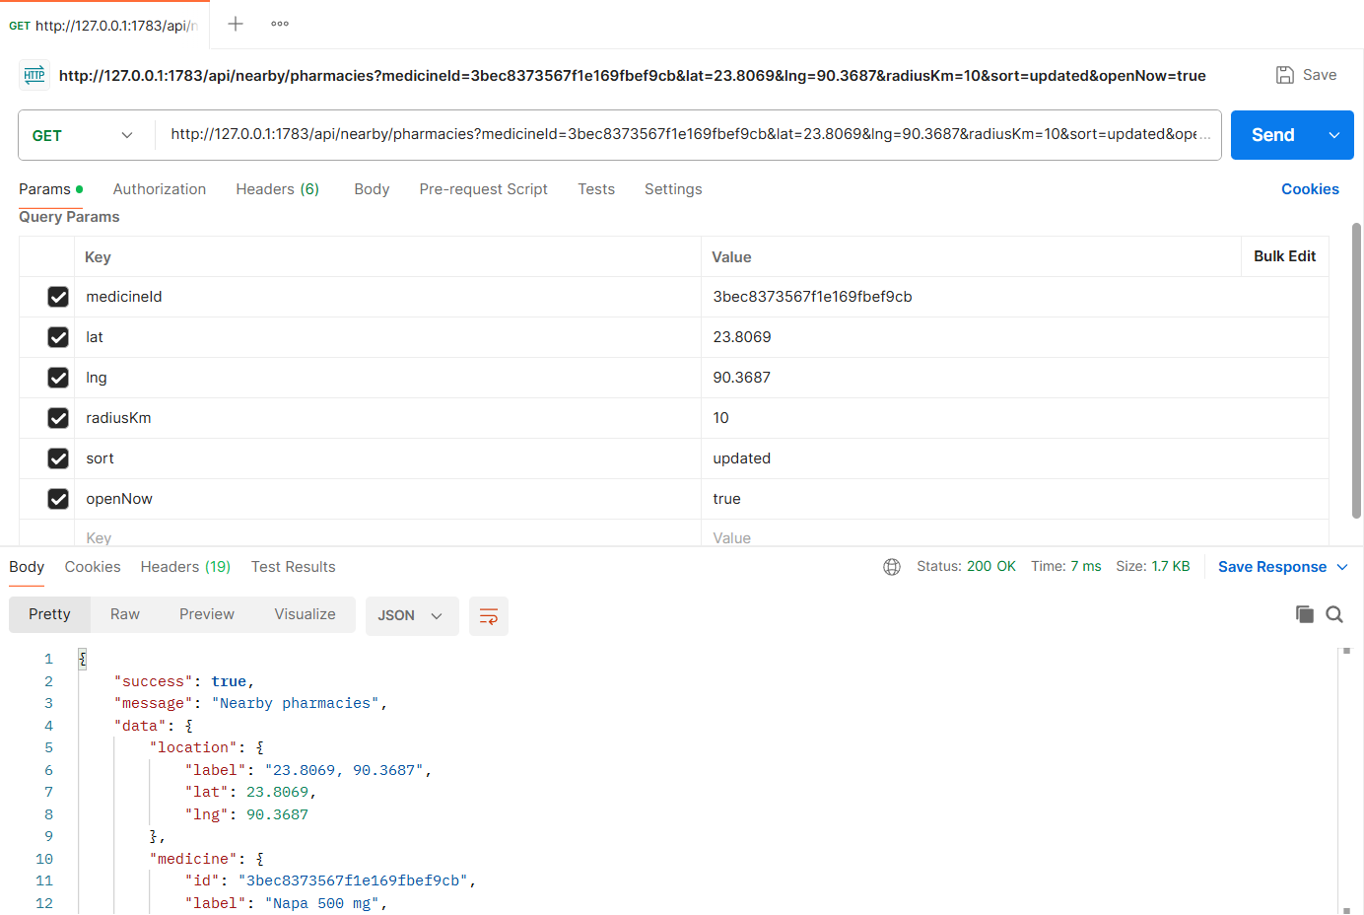
Figure: M3-F2-06 - GET /api/nearby/pharmacies tested in Postman (status 200)
API 7: No pharmacies nearby
Purpose | Empty state suggests a bigger radius or turning off "Open now".
Endpoint URL | http://127.0.0.1:1783/api/nearby/pharmacies
HTTP Method | GET
Headers | None
Authentication | Public (no login required)
Body / Parameters | Query parameters:  medicineId = 3bec8373567f1e169fbef9cb  lat = 22.326  lng = 91.812  radiusKm = 5
Status code | Expected 200 OK; returned 200 OK in the Postman test below

Example request (cURL):
curl -X GET "http://127.0.0.1:1783/api/nearby/pharmacies?medicineId=3bec8373567f1e169fbef9cb&lat=22.326&lng=91.812&radiusKm=5"

Example response (200 OK, recorded from the Postman collection run):
{
"success": true,
"message": "Nearby pharmacies",
"data": {
"location": {
"label": "22.3260, 91.8120",
"lat": 22.326,
"lng": 91.812
},
"medicine": {
"id": "3bec8373567f1e169fbef9cb",
"label": "Napa 500 mg",
"genericName": "Paracetamol"
},
"radiusKm": 5,
"sort": "distance",
"openNow": false,
"total": 0,
"summary": "0 pharmacies within 5 km that stock Napa 500 mg",
"pharmacies": [],
"pagination": {
"page": 1,
"limit": 10,
"total": 0,
"totalPages": 1
},
"emptyState": {
"message": "No pharmacies within 5 km stock Napa 500 mg",
... (truncated - full response in the Postman screenshot / collection run)

Code snippet (route -> controller -> service):
// src/routes/nearby.routes.js
router.get('/nearby/pharmacies', validate(v.nearbyQuery, 'query'), ctrl.nearby);

// src/controllers/nearby.controller.js
async function nearby(req, res) {
const q = req.validatedQuery;
ok(res, await service.nearbyPharmacies({ ...q, ...getPagination(q, { limit: 10 }) }), 'Nearby pharmacies');
}

Postman screenshot:
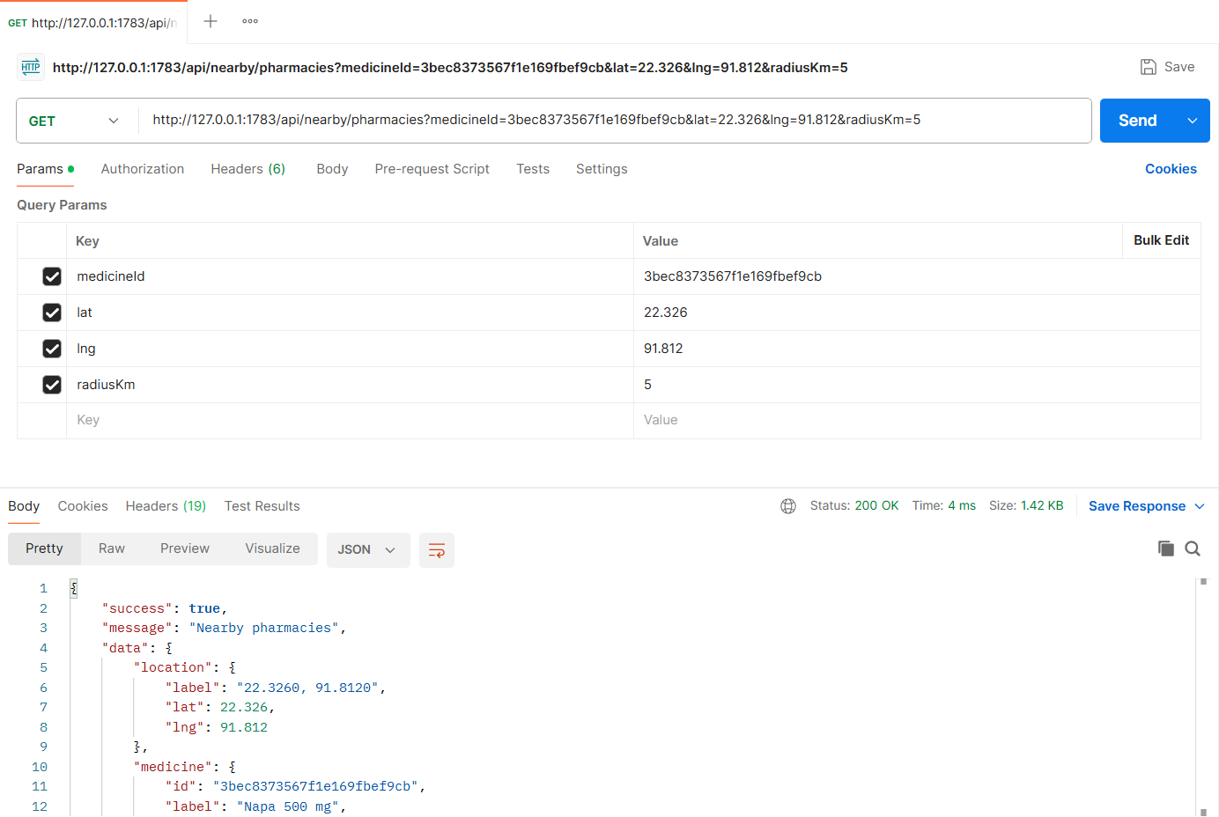
Figure: M3-F2-07 - GET /api/nearby/pharmacies tested in Postman (status 200)
API 8: Pharmacy summary (map marker / details)
Purpose | One pharmacy's summary with distance from the user, stock of the searched medicine and a directions link.
Endpoint URL | http://127.0.0.1:1783/api/nearby/pharmacies/0367672641e1463cf4ee98cd
HTTP Method | GET
Headers | None
Authentication | Public (no login required)
Body / Parameters | Query parameters:  lat = 23.8069  lng = 90.3687  medicineId = 3bec8373567f1e169fbef9cb
Status code | Expected 200 OK; returned 200 OK in the Postman test below

Example request (cURL):
curl -X GET "http://127.0.0.1:1783/api/nearby/pharmacies/0367672641e1463cf4ee98cd?lat=23.8069&lng=90.3687&medicineId=3bec8373567f1e169fbef9cb"

Example response (200 OK, recorded from the Postman collection run):
{
"success": true,
"message": "Pharmacy summary",
"data": {
"id": "0367672641e1463cf4ee98cd",
"name": "Lazz Pharma",
"address": "House 12, Road 3, Mirpur 10, Dhaka",
"area": "Mirpur 10",
"verified": true,
"openNow": false,
"openingHours": "Daily 9:00 AM - 10:00 PM",
"rating": 4.8,
"ratingCount": 5,
"distanceKm": 0.1,
"location": {
"lat": 23.8075,
"lng": 90.368
},
"phone": "01712345678",
"directionsUrl": "https://www.google.com/maps/dir/?api=1&destination=23.8075,90.368",
"listing": {
"medicine": "Napa 500 mg",
"price": 1.2,
"stock": 340,
"stockStatus": "In stock",
"lastUpdatedAt": "2026-11-04T17:56:16.432Z"
}
}
... (truncated - full response in the Postman screenshot / collection run)

Code snippet (route -> controller -> service):
// src/routes/nearby.routes.js
router.get('/nearby/pharmacies/:pharmacyId', validate(idParam('pharmacyId'), 'params'), validate(v.pharmacySummaryQuery, 'query'), ctrl.pharmacySummary);

// src/controllers/nearby.controller.js
async function pharmacySummary(req, res) {
ok(res, await service.pharmacySummary(req.params.pharmacyId, req.validatedQuery), 'Pharmacy summary');
}

// src/services/nearby.service.js
/** Map marker / "Details": one pharmacy's summary with distance and its stock of the searched medicine. */
async function pharmacySummary(pharmacyId, { lat, lng, medicineId }) {
const p = await Pharmacy.findOne({ _id: pharmacyId, ...Pharmacy.publicFilter() });
if (!p) throw ApiError.notFound('Pharmacy not found or not verified');
let distanceMeters = null;
if (lat !== undefined && lng !== undefined) {
const [row] = await Pharmacy.aggregate([
{ $geoNear: { near: { type: 'Point', coordinates: [lng, lat] }, distanceField: 'distance', spherical: true, query: { _id: p._id } } },
]);
distanceMeters = row ? row.distance : null;
}
const card = pharmacyCard(p, distanceMeters ?? 0);
if (distanceMeters === null) card.distanceKm = null;
card.phone = p.phone;
card.directionsUrl = `https://www.google.com/maps/dir/?api=1&destination=${p.location.coordinates[1]},${p.location.coordinates[0]}`;
if (medicineId) {
const item = await CatalogItem.findOne({ pharmacy: p._id, medicine: medicineId, isActive: true }).populate('medicine');
card.listing = item
? { medicine: `${item.medicine.brandName} ${item.medicine.strength}`, price: item.price, stock: item.stockQuantity, stockStatus: item.stockStatus, lastUpdatedAt: item.lastUpdatedAt }
: null;
}
return card;
}

Postman screenshot:
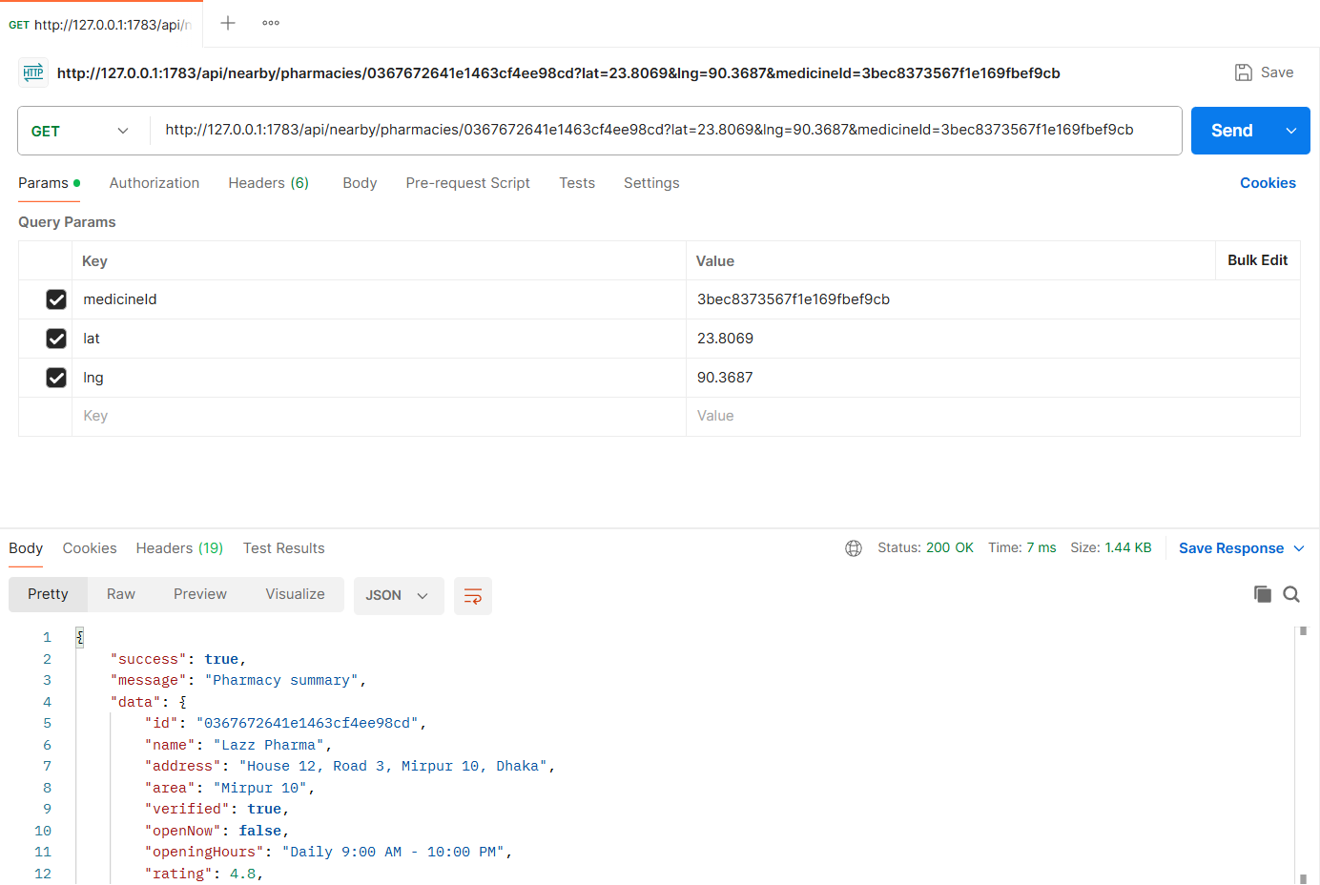
Figure: M3-F2-08 - GET /api/nearby/pharmacies/0367672641e1463cf4ee98cd tested in Postman (status 200)
Validation and error-handling tests (Feature 02)
The same APIs were also tested with invalid input, wrong roles and invalid state changes. Each request below was sent from Postman to the running server.
Missing location (400)
Request | GET http://127.0.0.1:1783/api/nearby/pharmacies
Scenario | Either lat & lng or an areaId is required.
Body / Parameters | Query parameters:  medicineId = 3bec8373567f1e169fbef9cb
Result | Expected 400 Bad Request; returned 400 Bad Request

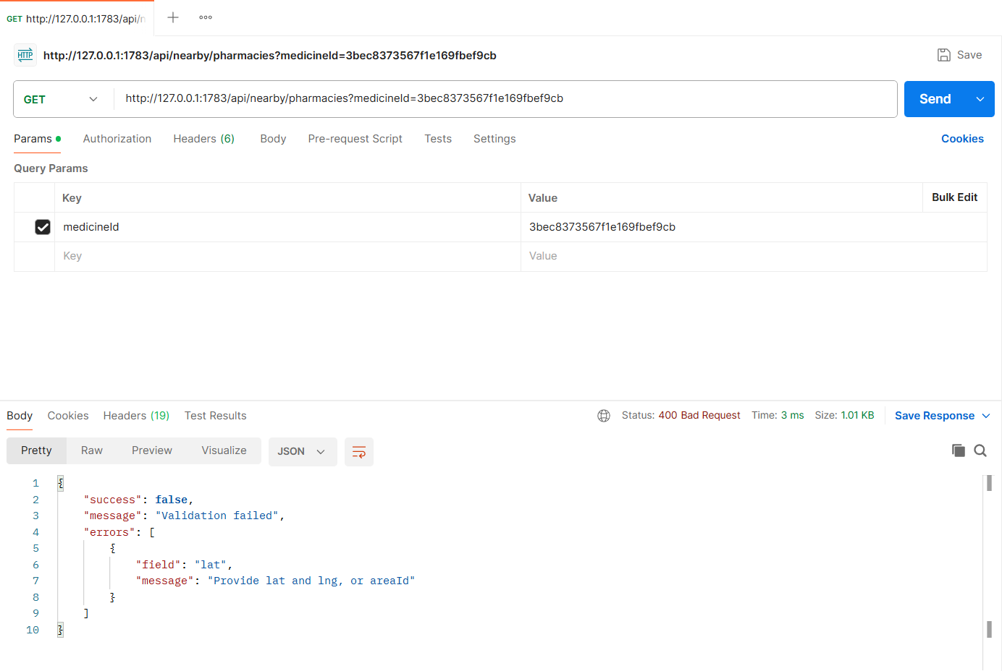
Figure: M3-F2-N1 - Missing location (400)
Implementation Notes
Project | MedFind BD - medicine availability and reservation platform (CSE471, Group 02, Section 03)
Tech stack | Node.js, Express.js 5, MongoDB (MongoDB Atlas in deployment, local replica set in development), Mongoose 8, JWT + bcrypt, Multer + Cloudinary (local-disk fallback), node-cron, zod validation
My server | cd backend  npm install  npm run seed  npm run start:member3  -> http://127.0.0.1:1783/api/health
Environment | backend/.env (copy of .env.example): MONGODB_URI, JWT_SECRET, PORT_MEMBER1..4, CLOUDINARY_*, SENDGRID_API_KEY, business-rule settings
Postman | Import postman/Member3/Member3_22201783.postman_collection.json, run the "00 Setup" login requests (if present), then run each feature folder top to bottom. File fields use postman/assets/*.
Architecture | routes (URL + middleware) -> controllers (HTTP in/out) -> services (business logic) -> Mongoose models. Central error handler returns { success, message, errors }.

Database connection (src/config/db.js):
const mongoose = require('mongoose');
const env = require('./env');

mongoose.set('strictQuery', true);

async function connectDB(uri = env.mongoUri) {
await mongoose.connect(uri, { serverSelectionTimeoutMS: 10000 });
const { host, name } = mongoose.connection;
console.log(`[db] connected to MongoDB ${host}/${name}`);
return mongoose.connection;
}

async function disconnectDB() {
await mongoose.disconnect();
}

module.exports = { connectDB, disconnectDB };

