

CSE471 : System Analysis and Design
Lab Assignment on API Postman Collection

Project Title : MedFind BD
Group Number : 02
Backend Framework : Node.js + Express.js (MongoDB Atlas, Mongoose)

Submitted by : Md Didarul Islam Nayan
Student ID : 23301274
Section: 03

Date : 05 November 2026
APIs of Feature - 01: Pharmacy Verification & Reviews
Server: Member 4 backend, started with "npm run start:member4" on port 1274 (last four digits of student ID 23301274). Base URL: http://127.0.0.1:1274. Database: MongoDB (Mongoose ODM), connected at server start.
Method | Endpoint - API
1. POST | /api/pharmacies/register - Register pharmacy with licence details
2. GET | /api/pharmacies/mine/verification - Owner checks verification status
3. GET | /api/admin/pharmacies - Admin: pharmacies pending verification
4. GET | /api/admin/pharmacies/:newPharmacyId - Admin: review submitted licence details
5. PATCH | /api/admin/pharmacies/:newPharmacyId/verification - Admin: verify pharmacy
6. PATCH | /api/admin/pharmacies/24157e5f946b95812b4b9b3d/verification - Admin: reject pharmacy with note
7. PUT | /api/pharmacies/mine/licence - Owner resubmits licence (with licence document image)
8. GET | /api/pharmacies/0367672641e1463cf4ee98cd - Public pharmacy profile with rating summary
9. GET | /api/pharmacies/0367672641e1463cf4ee98cd/reviews - Pharmacy reviews
10. GET | /api/pharmacies/0367672641e1463cf4ee98cd/reviewable-reservations - Reservations eligible for review
11. POST | /api/pharmacies/0367672641e1463cf4ee98cd/reviews - Write a review (1-5 stars)

API 1: Register pharmacy with licence details
Purpose | Pharmacy owner submits pharmacy details, map location (lat/lng), opening hours and trade / drug licence numbers. Verification starts as Pending and admins are notified. (The endpoint also accepts multipart/form-data with an optional licenceDocument image; the image upload is shown in API 7.)
Endpoint URL | http://127.0.0.1:1274/api/pharmacies/register
HTTP Method | POST
Headers | Authorization: Bearer <JWT of newOwner account>  Content-Type: application/json
Authentication | JWT required - role: Pharmacy owner (no pharmacy yet)
Body / Parameters | JSON body:  {  "name": "Nadia Drug House",  "phone": "01720123456",  "email": "nadia.pharmacy@example.com",  "addressLine": "House 8, Road 11",  "area": "Banani",  "city": "Dhaka",  "lat": 23.794,  "lng": 90.405,  "openingHours": [  {  "day": 0,  "open": "09:00",  "close": "22:00"  },  {  "day": 1,  "open": "09:00",  "close": "22:00"  },  {  "day": 2,  "open": "09:00",  "close": "22:00"  },  {  "day": 3,  "open": "09:00",  "close": "22:00"  },  {  "day": 4,  "open": "09:00",  "close": "22:00"  },  {  "day": 6,  "open": "09:00",  "close": "22:00"  }  ],  "openingHoursText": "Sat-Thu 9:00 AM - 10:00 PM",  "tradeLicenceNo": "TRD-2026-777001",  "drugLicenceNo": "DL-DHK-77701"  }
Status code | Expected 201 Created; returned 201 Created in the Postman test below

Example request (cURL):
curl -X POST "http://127.0.0.1:1274/api/pharmacies/register" \
-H "Authorization: Bearer <newOwnerToken>" \
-H "Content-Type: application/json" \
-d '{"name": "Nadia Drug House", "phone": "01720123456", "email": "nadia.pharmacy@example.com", "addressLine": "House 8, Road 11", "area": "Banani", "city": "Dhaka", "lat": 23.794, "lng": 90.405, "openingHours": [{"day": 0, "open": "09:00", "close": "22:00"}, {"day": 1, "open": "09:00", "close": "22:00"}, {"day": 2, "open": "09:00", "close": "22:00"}, {"day": 3, "open": "09:00", "close": "22:00"}, {"day": 4, "open": "09:00", "close": "22:00"}, {"day": 6, "open": "09:00", "close": "22:00"}], "openingHoursText": "Sat-Thu 9:00 AM - 10:00 PM", "tradeLicenceNo": "TRD-2026-777001", "drugLicenceNo": "DL-DHK-77701"}'

Example response (201 Created, recorded from the Postman collection run):
{
"success": true,
"message": "Pharmacy registered; verification is Pending",
"data": {
"pharmacyId": "6aeb92235d3cdae6a0e944d8",
"name": "Nadia Drug House",
"status": "Pending",
"verifiedBadge": false,
"visibleInSearch": false,
"isSuspended": false,
"note": null,
"checklist": {
"tradeLicenceMatches": false,
"drugLicenceValid": false,
"contactComplete": false,
"noDuplicate": false
},
"licence": {
"tradeLicenceNo": "TRD-2026-777001",
"drugLicenceNo": "DL-DHK-77701",
"submittedAt": "2026-11-04T20:14:27.298Z"
},
"reviewedAt": null,
"history": [
{
"status": "Pending",
"note": "Registration submitted",
"by": "7392a0fe886119e705bb4263",
... (truncated - full response in the Postman screenshot / collection run)

Code snippet (route -> controller -> service):
// src/routes/verification.routes.js
router.post('/pharmacies/register', owner, imageUpload.single('licenceDocument'), validate(v.registerPharmacy), ctrl.registerPharmacy);

// src/controllers/verification.controller.js
async function registerPharmacy(req, res) {
created(res, await service.registerPharmacy(req.user, req.body, req.file), 'Pharmacy registered; verification is Pending');
}

// src/services/verification.service.js
async function registerPharmacy(owner, data, licenceFile) {
if (await Pharmacy.exists({ owner: owner._id })) throw ApiError.conflict('You have already registered a pharmacy');
const tradeNo = data.tradeLicenceNo.toUpperCase();
const drugNo = data.drugLicenceNo.toUpperCase();
const dup = await Pharmacy.findOne({ $or: [{ 'licence.tradeLicenceNo': tradeNo }, { 'licence.drugLicenceNo': drugNo }] });
if (dup) throw ApiError.conflict('A pharmacy with this trade or drug licence number is already registered');

const doc = licenceFile ? await storage.saveImage(licenceFile, 'licences') : null;
const pharmacy = await Pharmacy.create({
owner: owner._id,
name: data.name,
phone: data.phone,
email: data.email,
address: { line: data.addressLine, area: data.area, city: data.city },
location: { type: 'Point', coordinates: [data.lng, data.lat] },
openingHours: data.openingHours,
openingHoursText: data.openingHoursText,
licence: { tradeLicenceNo: tradeNo, drugLicenceNo: drugNo, documentUrl: doc ? doc.url : undefined, submittedAt: new Date() },
verification: { status: 'Pending', history: [{ status: 'Pending', by: owner._id, note: 'Registration submitted' }] },
});

const admins = await User.find({ role: 'admin', isActive: true }, '_id');
for (const a of admins) {
notify(a._id, { type: 'verification', title: 'New pharmacy to verify', message: `${pharmacy.name} submitted licence details for verification.`, data: { pharmacyId: pharmacy._id } }, { email: false });
}
return verificationView(pharmacy);
}

Postman screenshot:
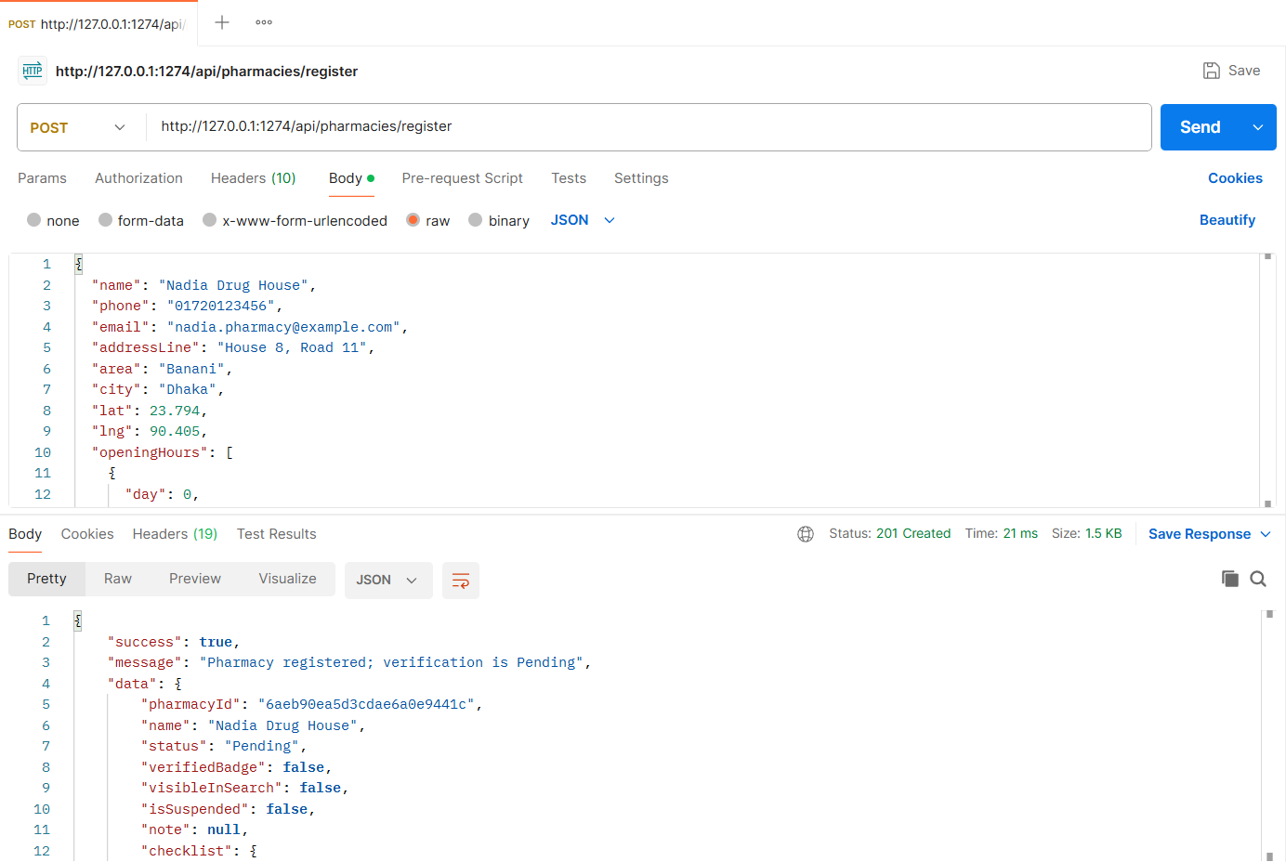
Figure: M4-F1-01 - POST /api/pharmacies/register tested in Postman (status 201)
API 2: Owner checks verification status
Purpose | Owner sees Pending / Verified / Rejected, the admin note, checklist and history.
Endpoint URL | http://127.0.0.1:1274/api/pharmacies/mine/verification
HTTP Method | GET
Headers | Authorization: Bearer <JWT of newOwner account>
Authentication | JWT required - role: Pharmacy owner (no pharmacy yet)
Body / Parameters | None
Status code | Expected 200 OK; returned 200 OK in the Postman test below

Example request (cURL):
curl -X GET "http://127.0.0.1:1274/api/pharmacies/mine/verification" \
-H "Authorization: Bearer <newOwnerToken>"

Example response (200 OK, recorded from the Postman collection run):
{
"success": true,
"message": "Verification status",
"data": {
"pharmacyId": "6aeb92235d3cdae6a0e944d8",
"name": "Nadia Drug House",
"status": "Pending",
"verifiedBadge": false,
"visibleInSearch": false,
"isSuspended": false,
"note": null,
"checklist": {
"tradeLicenceMatches": false,
"drugLicenceValid": false,
"contactComplete": false,
"noDuplicate": false
},
"licence": {
"tradeLicenceNo": "TRD-2026-777001",
"drugLicenceNo": "DL-DHK-77701",
"submittedAt": "2026-11-04T20:14:27.298Z"
},
"reviewedAt": null,
"history": [
{
"status": "Pending",
"note": "Registration submitted",
"by": "7392a0fe886119e705bb4263",
... (truncated - full response in the Postman screenshot / collection run)

Code snippet (route -> controller -> service):
// src/routes/verification.routes.js
router.get('/pharmacies/mine/verification', owner, ctrl.myVerification);

// src/controllers/verification.controller.js
async function myVerification(req, res) {
ok(res, await service.myVerification(req.user), 'Verification status');
}

// src/services/verification.service.js
async function myVerification(owner) {
const p = await Pharmacy.findOne({ owner: owner._id });
if (!p) throw ApiError.notFound('You have not registered a pharmacy yet');
return verificationView(p);
}

Postman screenshot:
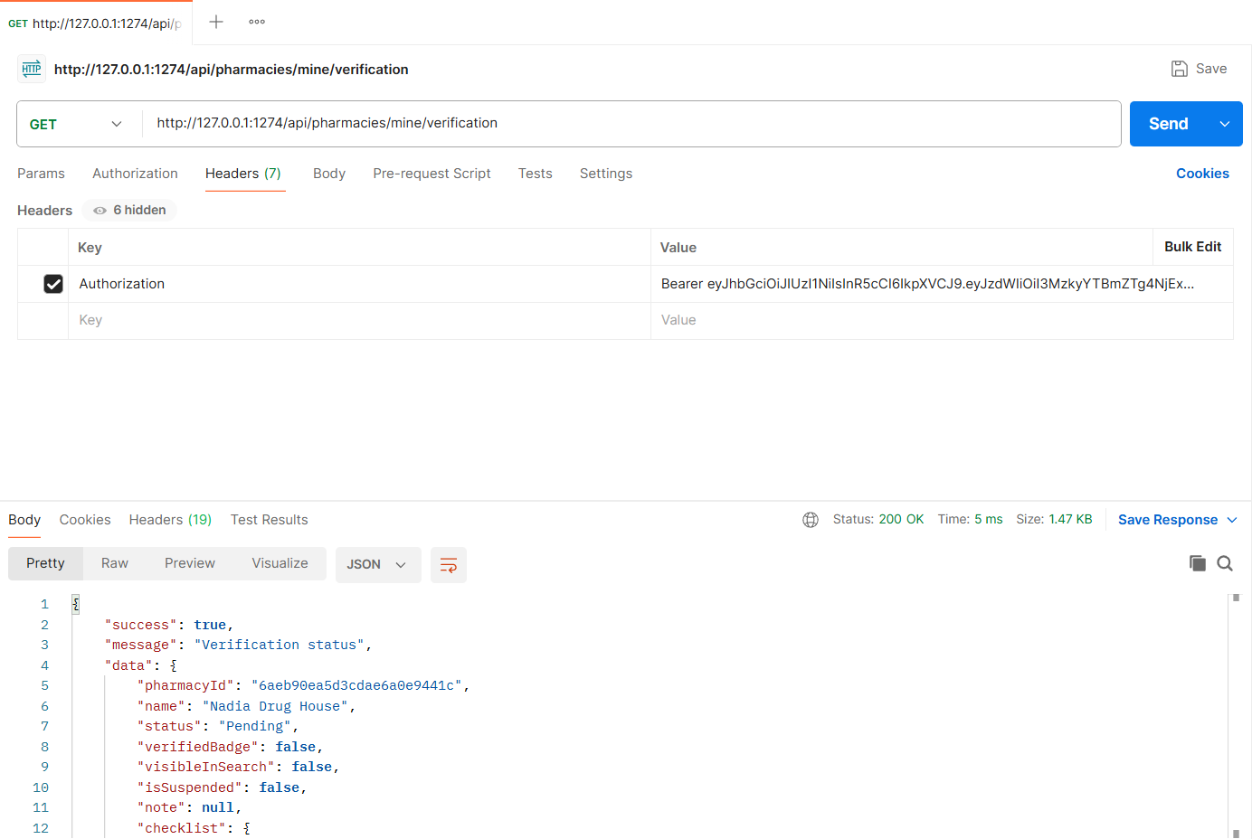
Figure: M4-F1-02 - GET /api/pharmacies/mine/verification tested in Postman (status 200)
API 3: Admin: pharmacies pending verification
Purpose | Admin list filtered by status with counts (Pending, Verified, Rejected, Suspended).
Endpoint URL | http://127.0.0.1:1274/api/admin/pharmacies
HTTP Method | GET
Headers | Authorization: Bearer <JWT of admin account>
Authentication | JWT required - role: Admin
Body / Parameters | Query parameters:  status = Pending
Status code | Expected 200 OK; returned 200 OK in the Postman test below

Example request (cURL):
curl -X GET "http://127.0.0.1:1274/api/admin/pharmacies?status=Pending" \
-H "Authorization: Bearer <adminToken>"

Example response (200 OK, recorded from the Postman collection run):
{
"success": true,
"message": "Pharmacies",
"data": {
"counts": {
"pending": 3,
"verified": 5,
"rejected": 1,
"suspended": 0
},
"pharmacies": [
{
"id": "24157e5f946b95812b4b9b3d",
"name": "Shapla Pharmacy",
"area": "Uttara, Dhaka",
"owner": "Farhana Akter",
"tradeLicenceNo": "TRD-2026-011122",
"drugLicenceNo": "DL-DHK-60117",
"status": "Pending",
"isSuspended": false,
"submittedAt": "2026-11-02T20:14:20.527Z"
},
{
"id": "f6289c77bd8917169b0eece6",
"name": "Dhanmondi Health Pharmacy",
"area": "Dhanmondi, Dhaka",
"owner": "Mahmud Hasan",
"tradeLicenceNo": "TRD-2026-013344",
... (truncated - full response in the Postman screenshot / collection run)

Code snippet (route -> controller -> service):
// src/routes/verification.routes.js
router.get('/admin/pharmacies', admin, validate(v.adminPharmacyQuery, 'query'), ctrl.adminList);

// src/controllers/verification.controller.js
async function adminList(req, res) {
const q = req.validatedQuery;
ok(res, await service.adminListPharmacies({ status: q.status, search: q.search, ...getPagination(q) }), 'Pharmacies');
}

// src/services/verification.service.js
async function adminListPharmacies({ status, search, page, limit, skip }) {
const filter = {};
if (status === 'Suspended') filter.isSuspended = true;
else if (status) filter['verification.status'] = status;
if (search) filter.name = new RegExp(escapeRegex(search), 'i');

const [total, list, pending, verified, rejected, suspended] = await Promise.all([
Pharmacy.countDocuments(filter),
Pharmacy.find(filter).populate('owner', 'name').sort({ 'licence.submittedAt': 1 }).skip(skip).limit(limit),
Pharmacy.countDocuments({ 'verification.status': 'Pending' }),
Pharmacy.countDocuments({ 'verification.status': 'Verified' }),
Pharmacy.countDocuments({ 'verification.status': 'Rejected' }),
Pharmacy.countDocuments({ isSuspended: true }),
]);
return {
counts: { pending, verified, rejected, suspended },
pharmacies: list.map((p) => ({
id: p._id,
name: p.name,
area: `${p.address.area}, ${p.address.city}`,
owner: p.owner ? p.owner.name : null,
tradeLicenceNo: p.licence.tradeLicenceNo,
drugLicenceNo: p.licence.drugLicenceNo,
status: p.verification.status,
isSuspended: p.isSuspended,
submittedAt: p.licence.submittedAt,
})),
pagination: pageMeta(page, limit, total),
};
}

Postman screenshot:
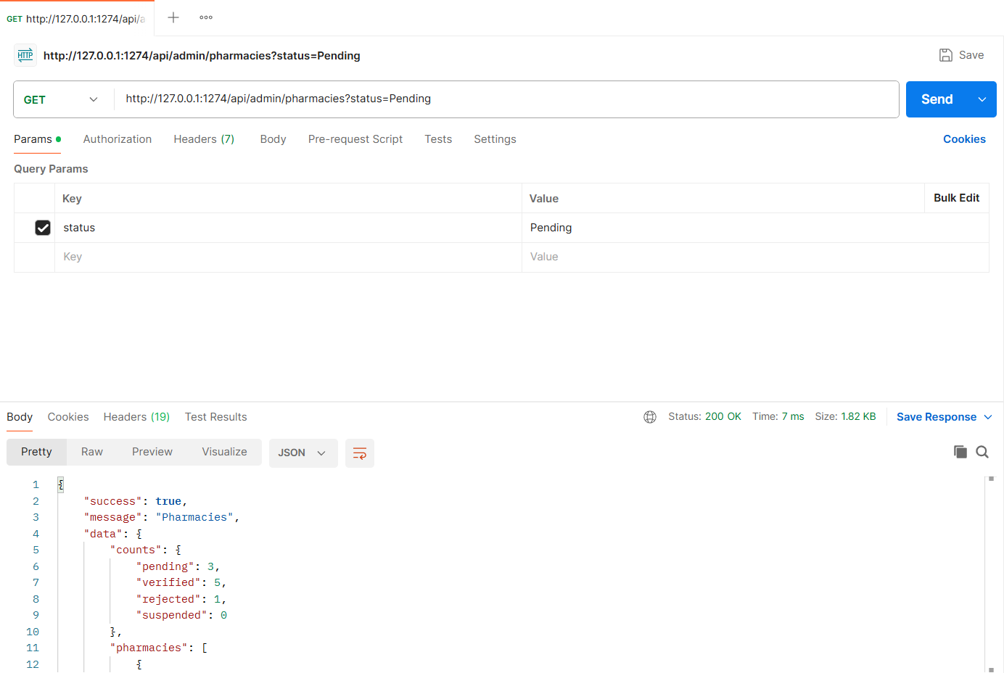
Figure: M4-F1-03 - GET /api/admin/pharmacies tested in Postman (status 200)
API 4: Admin: review submitted licence details
Purpose | Submitted details, licence document, checklist and automated checks (contact complete, possible duplicates).
Endpoint URL | http://127.0.0.1:1274/api/admin/pharmacies/:newPharmacyId
HTTP Method | GET
Headers | Authorization: Bearer <JWT of admin account>
Authentication | JWT required - role: Admin
Body / Parameters | Path parameters: newPharmacyId (id returned by an earlier request)
Status code | Expected 200 OK; returned 200 OK in the Postman test below

Example request (cURL):
curl -X GET "http://127.0.0.1:1274/api/admin/pharmacies/<newPharmacyId>" \
-H "Authorization: Bearer <adminToken>"

Example response (200 OK, recorded from the Postman collection run):
{
"success": true,
"message": "Pharmacy verification details",
"data": {
"id": "6aeb92235d3cdae6a0e944d8",
"name": "Nadia Drug House",
"status": "Pending",
"submitted": {
"owner": "Nadia Rahman",
"phone": "01720123456",
"email": "nadia.pharmacy@example.com",
"tradeLicenceNo": "TRD-2026-777001",
"drugLicenceNo": "DL-DHK-77701",
"licenceDocumentUrl": null,
"address": "House 8, Road 11, Banani, Dhaka",
"openingHours": "Sat-Thu 9:00 AM - 10:00 PM",
"location": {
"lat": 23.794,
"lng": 90.405
},
"submittedAt": "2026-11-04T20:14:27.298Z"
},
"checklist": {
"tradeLicenceMatches": false,
"drugLicenceValid": false,
"contactComplete": false,
"noDuplicate": false
},
... (truncated - full response in the Postman screenshot / collection run)

Code snippet (route -> controller -> service):
// src/routes/verification.routes.js
router.get('/admin/pharmacies/:id', admin, validate(idParam(), 'params'), ctrl.adminDetail);

// src/controllers/verification.controller.js
async function adminDetail(req, res) {
ok(res, await service.adminPharmacyDetail(req.params.id), 'Pharmacy verification details');
}

// src/services/verification.service.js
async function adminPharmacyDetail(id) {
const p = await Pharmacy.findById(id).populate('owner', 'name phone email');
if (!p) throw ApiError.notFound('Pharmacy not found');
const possibleDuplicates = await Pharmacy.find({
_id: { $ne: p._id },
$or: [{ phone: p.phone }, { name: new RegExp(`^${escapeRegex(p.name)}$`, 'i'), 'address.area': p.address.area }],
}, 'name address.area phone verification.status');

return {
id: p._id,
name: p.name,
status: p.verification.status,
submitted: {
owner: p.owner ? p.owner.name : null,
phone: p.phone,
email: p.email,
tradeLicenceNo: p.licence.tradeLicenceNo,
drugLicenceNo: p.licence.drugLicenceNo,
licenceDocumentUrl: p.licence.documentUrl || null,
address: `${p.address.line}, ${p.address.area}, ${p.address.city}`,
openingHours: p.openingHoursText,
location: { lat: p.location.coordinates[1], lng: p.location.coordinates[0] },
submittedAt: p.licence.submittedAt,
},
checklist: p.verification.checklist,
automatedChecks: {
contactComplete: Boolean(p.phone && p.email && p.address.line && p.address.area),
noDuplicate: possibleDuplicates.length === 0,
possibleDuplicates,
},
note: p.verification.note || null,
history: p.verification.history,
isSuspended: p.isSuspended,
};
}

Postman screenshot:
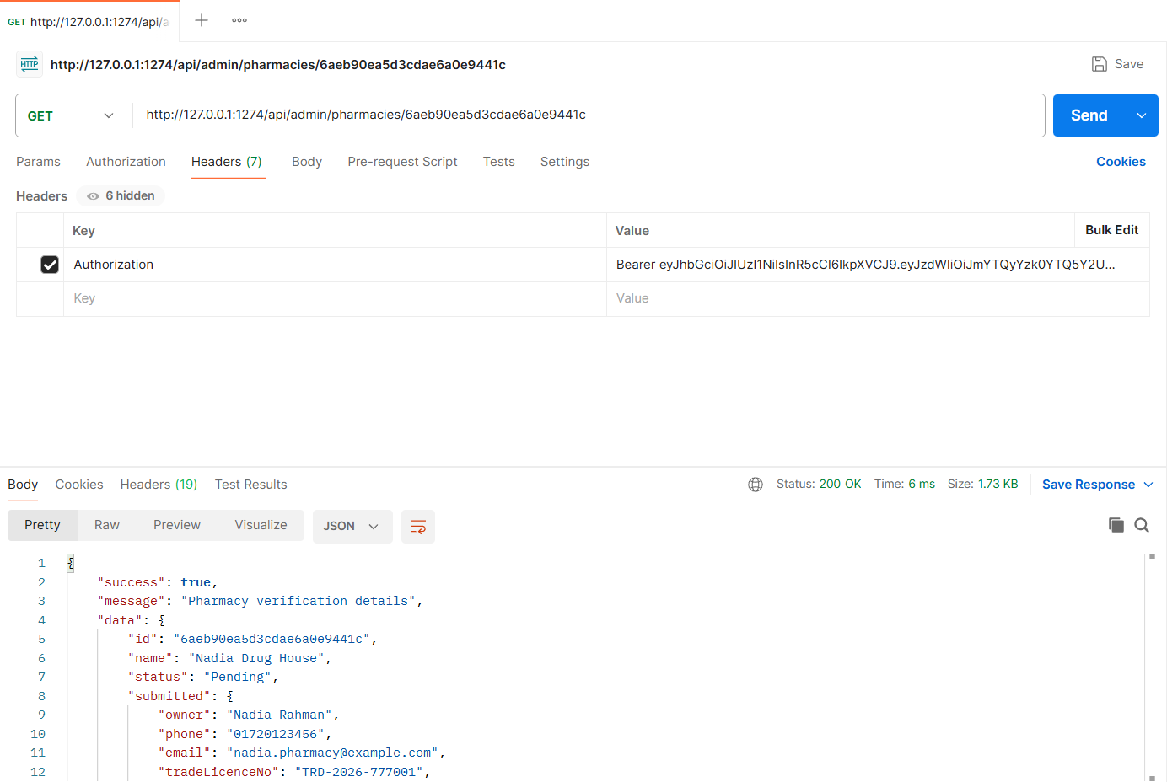
Figure: M4-F1-04 - GET /api/admin/pharmacies/:newPharmacyId tested in Postman (status 200)
API 5: Admin: verify pharmacy
Purpose | Mark as Verified after every checklist item is confirmed. The pharmacy gets the Verified badge and appears in search.
Endpoint URL | http://127.0.0.1:1274/api/admin/pharmacies/:newPharmacyId/verification
HTTP Method | PATCH
Headers | Authorization: Bearer <JWT of admin account>  Content-Type: application/json
Authentication | JWT required - role: Admin
Body / Parameters | JSON body:  {  "status": "Verified",  "note": "Trade and drug licence verified with DGDA records",  "checklist": {  "tradeLicenceMatches": true,  "drugLicenceValid": true,  "contactComplete": true,  "noDuplicate": true  }  }  Path parameters: newPharmacyId (id returned by an earlier request)
Status code | Expected 200 OK; returned 200 OK in the Postman test below

Example request (cURL):
curl -X PATCH "http://127.0.0.1:1274/api/admin/pharmacies/<newPharmacyId>/verification" \
-H "Authorization: Bearer <adminToken>" \
-H "Content-Type: application/json" \
-d '{"status": "Verified", "note": "Trade and drug licence verified with DGDA records", "checklist": {"tradeLicenceMatches": true, "drugLicenceValid": true, "contactComplete": true, "noDuplicate": true}}'

Example response (200 OK, recorded from the Postman collection run):
{
"success": true,
"message": "Verification decision saved",
"data": {
"pharmacyId": "6aeb92235d3cdae6a0e944d8",
"name": "Nadia Drug House",
"status": "Verified",
"verifiedBadge": true,
"visibleInSearch": true,
"isSuspended": false,
"note": "Trade and drug licence verified with DGDA records",
"checklist": {
"tradeLicenceMatches": true,
"drugLicenceValid": true,
"contactComplete": true,
"noDuplicate": true
},
"licence": {
"tradeLicenceNo": "TRD-2026-777001",
"drugLicenceNo": "DL-DHK-77701",
"submittedAt": "2026-11-04T20:14:27.298Z"
},
"reviewedAt": "2026-11-04T20:14:27.668Z",
"history": [
{
"status": "Pending",
"note": "Registration submitted",
"by": "7392a0fe886119e705bb4263",
... (truncated - full response in the Postman screenshot / collection run)

Code snippet (route -> controller -> service):
// src/routes/verification.routes.js
router.patch('/admin/pharmacies/:id/verification', admin, validate(idParam(), 'params'), validate(v.decision), ctrl.decide);

// src/controllers/verification.controller.js
async function decide(req, res) {
ok(res, await service.decideVerification(req.user, req.params.id, req.body), 'Verification decision saved');
}

// src/services/verification.service.js
/** Admin decision: Verified (badge + appears in search), Rejected (note required) or back to Pending. */
async function decideVerification(admin, id, { status, note, checklist = {} }) {
const p = await Pharmacy.findById(id);
if (!p) throw ApiError.notFound('Pharmacy not found');
if (p.verification.status === status) throw ApiError.conflict(`Pharmacy is already ${status}`);
if (status === 'Rejected' && !note) throw ApiError.badRequest('A note to the owner is required when rejecting');
if (status === 'Verified') {
const missing = CHECKLIST_KEYS.filter((k) => checklist[k] !== true);
if (missing.length) throw ApiError.badRequest(`All checklist items must be confirmed before verifying. Missing: ${missing.join(', ')}`);
}

p.verification.status = status;
p.verification.note = note;
const currentChecklist = JSON.parse(JSON.stringify(p.verification.checklist || {}));
p.verification.checklist = { ...currentChecklist, ...checklist };
p.verification.reviewedBy = admin._id;
p.verification.reviewedAt = new Date();
p.verification.history.push({ status, by: admin._id, note });
await p.save();

notify(p.owner, {
type: 'verification',
title: `Pharmacy ${status.toLowerCase()}`,
message: status === 'Verified'
? `${p.name} is now verified and visible in search results with a Verified badge.`
: `${p.name} verification status: ${status}.${note ? ` Note: ${note}` : ''}`,
data: { pharmacyId: p._id },
});
return verificationView(p);
}

Postman screenshot:
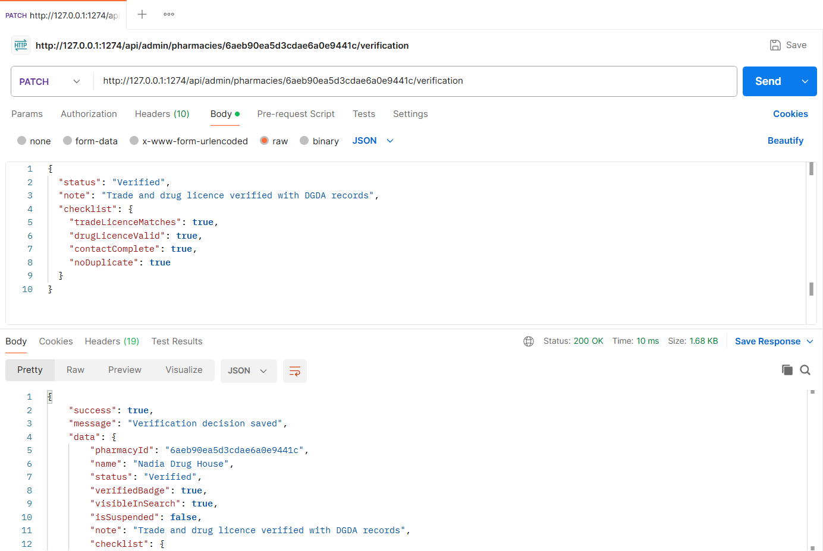
Figure: M4-F1-05 - PATCH /api/admin/pharmacies/:newPharmacyId/verification tested in Postman (status 200)
API 6: Admin: reject pharmacy with note
Purpose | Rejection requires a note to the owner.
Endpoint URL | http://127.0.0.1:1274/api/admin/pharmacies/24157e5f946b95812b4b9b3d/verification
HTTP Method | PATCH
Headers | Authorization: Bearer <JWT of admin account>  Content-Type: application/json
Authentication | JWT required - role: Admin
Body / Parameters | JSON body:  {  "status": "Rejected",  "note": "Drug licence number could not be found in DGDA records",  "checklist": {  "tradeLicenceMatches": true,  "drugLicenceValid": false  }  }
Status code | Expected 200 OK; returned 200 OK in the Postman test below

Example request (cURL):
curl -X PATCH "http://127.0.0.1:1274/api/admin/pharmacies/24157e5f946b95812b4b9b3d/verification" \
-H "Authorization: Bearer <adminToken>" \
-H "Content-Type: application/json" \
-d '{"status": "Rejected", "note": "Drug licence number could not be found in DGDA records", "checklist": {"tradeLicenceMatches": true, "drugLicenceValid": false}}'

Example response (200 OK, recorded from the Postman collection run):
{
"success": true,
"message": "Verification decision saved",
"data": {
"pharmacyId": "24157e5f946b95812b4b9b3d",
"name": "Shapla Pharmacy",
"status": "Rejected",
"verifiedBadge": false,
"visibleInSearch": false,
"isSuspended": false,
"note": "Drug licence number could not be found in DGDA records",
"checklist": {
"tradeLicenceMatches": true,
"drugLicenceValid": false,
"contactComplete": false,
"noDuplicate": false
},
"licence": {
"tradeLicenceNo": "TRD-2026-011122",
"drugLicenceNo": "DL-DHK-60117",
"submittedAt": "2026-11-02T20:14:20.527Z"
},
"reviewedAt": "2026-11-04T20:14:27.780Z",
"history": [
{
"status": "Pending",
"note": "Registration submitted",
"at": "2026-11-02T20:14:20.527Z"
... (truncated - full response in the Postman screenshot / collection run)

Code snippet (route -> controller -> service):
// src/routes/verification.routes.js
router.patch('/admin/pharmacies/:id/verification', admin, validate(idParam(), 'params'), validate(v.decision), ctrl.decide);

// src/controllers/verification.controller.js
async function decide(req, res) {
ok(res, await service.decideVerification(req.user, req.params.id, req.body), 'Verification decision saved');
}

Postman screenshot:
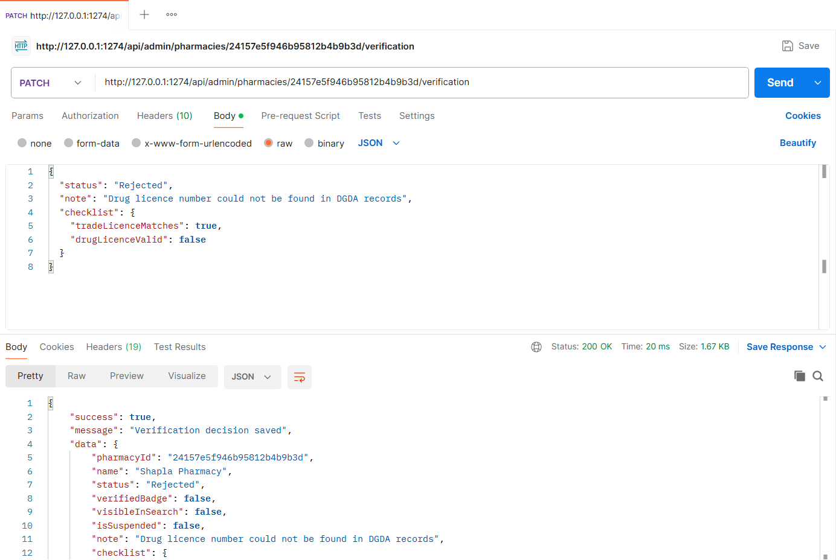
Figure: M4-F1-06 - PATCH /api/admin/pharmacies/24157e5f946b95812b4b9b3d/verification tested in Postman (status 200)
API 7: Owner resubmits licence (with licence document image)
Purpose | A rejected owner submits corrected licence numbers and a licence document image (PNG/JPG up to 5 MB, stored in Cloudinary or local uploads); verification returns to Pending.
Endpoint URL | http://127.0.0.1:1274/api/pharmacies/mine/licence
HTTP Method | PUT
Headers | Authorization: Bearer <JWT of rejectedOwner account>  Content-Type: multipart/form-data (set automatically by Postman)
Authentication | JWT required - role: Pharmacy owner (rejected pharmacy)
Body / Parameters | form-data:  tradeLicenceNo = TRD-2026-019900  drugLicenceNo = DL-DHK-61000  licenceDocument = (file) sample-trade-licence.png
Status code | Expected 200 OK; returned 200 OK in the Postman test below

Example request (cURL):
curl -X PUT "http://127.0.0.1:1274/api/pharmacies/mine/licence" \
-H "Authorization: Bearer <rejectedOwnerToken>" \
-F "tradeLicenceNo=TRD-2026-019900" \
-F "drugLicenceNo=DL-DHK-61000" \
-F "licenceDocument=@sample-trade-licence.png"

Example response (200 OK, recorded from the Postman collection run):
{
"success": true,
"message": "Licence resubmitted; verification is Pending",
"data": {
"pharmacyId": "f56353dddac0b6dcf7c5591d",
"name": "Medicare Point",
"status": "Pending",
"verifiedBadge": false,
"visibleInSearch": false,
"isSuspended": false,
"note": null,
"checklist": {},
"licence": {
"tradeLicenceNo": "TRD-2026-019900",
"drugLicenceNo": "DL-DHK-61000",
"submittedAt": "2026-11-04T20:14:27.991Z",
"documentUrl": "/uploads/licences/1793823267990-701528e24224.png"
},
"reviewedAt": "2026-10-30T20:14:20.527Z",
"history": [
{
"status": "Pending",
"note": "Registration submitted",
"at": "2026-10-28T20:14:20.527Z"
},
{
"status": "Rejected",
"note": "Drug licence number does not match DGDA records",
... (truncated - full response in the Postman screenshot / collection run)

Code snippet (route -> controller -> service):
// src/routes/verification.routes.js
router.put('/pharmacies/mine/licence', owner, imageUpload.single('licenceDocument'), validate(v.resubmitLicence), ctrl.resubmitLicence);

// src/controllers/verification.controller.js
async function resubmitLicence(req, res) {
ok(res, await service.resubmitLicence(req.user, req.body, req.file), 'Licence resubmitted; verification is Pending');
}

// src/services/verification.service.js
/** Resubmit licence details (e.g. after a rejection). Moves the pharmacy back to Pending. */
async function resubmitLicence(owner, { tradeLicenceNo, drugLicenceNo }, licenceFile) {
const p = await Pharmacy.findOne({ owner: owner._id });
if (!p) throw ApiError.notFound('You have not registered a pharmacy yet');
if (p.verification.status === 'Verified') throw ApiError.conflict('Your pharmacy is already verified');

const dup = await Pharmacy.findOne({
_id: { $ne: p._id },
$or: [{ 'licence.tradeLicenceNo': tradeLicenceNo.toUpperCase() }, { 'licence.drugLicenceNo': drugLicenceNo.toUpperCase() }],
});
if (dup) throw ApiError.conflict('These licence numbers belong to another registered pharmacy');

const doc = licenceFile ? await storage.saveImage(licenceFile, 'licences') : null;
p.licence.tradeLicenceNo = tradeLicenceNo;
p.licence.drugLicenceNo = drugLicenceNo;
if (doc) p.licence.documentUrl = doc.url;
p.licence.submittedAt = new Date();
p.verification.status = 'Pending';
p.verification.note = undefined;
p.verification.checklist = {};
p.verification.history.push({ status: 'Pending', by: owner._id, note: 'Licence details resubmitted' });
await p.save();
return verificationView(p);
}

Postman screenshot:
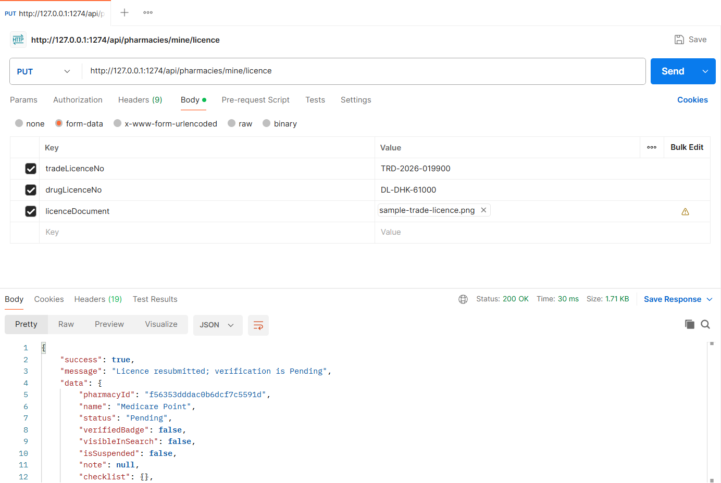
Figure: M4-F1-07 - PUT /api/pharmacies/mine/licence tested in Postman (status 200)
API 8: Public pharmacy profile with rating summary
Purpose | Verified badge, open-now, address, hours, average rating and 5-star distribution.
Endpoint URL | http://127.0.0.1:1274/api/pharmacies/0367672641e1463cf4ee98cd
HTTP Method | GET
Headers | None
Authentication | Public (no login required)
Body / Parameters | None
Status code | Expected 200 OK; returned 200 OK in the Postman test below

Example request (cURL):
curl -X GET "http://127.0.0.1:1274/api/pharmacies/0367672641e1463cf4ee98cd"

Example response (200 OK, recorded from the Postman collection run):
{
"success": true,
"message": "Pharmacy profile",
"data": {
"id": "0367672641e1463cf4ee98cd",
"name": "Lazz Pharma",
"verifiedBadge": true,
"openNow": false,
"address": "House 12, Road 3, Mirpur 10, Dhaka",
"openingHours": "Daily 9:00 AM - 10:00 PM",
"phone": "01712345678",
"location": {
"lat": 23.8075,
"lng": 90.368
},
"rating": {
"average": 4.8,
"count": 5,
"distribution": [
{
"stars": 5,
"count": 4,
"percent": 80
},
{
"stars": 4,
"count": 1,
"percent": 20
... (truncated - full response in the Postman screenshot / collection run)

Code snippet (route -> controller -> service):
// src/routes/verification.routes.js
router.get('/pharmacies/:id', validate(idParam(), 'params'), ctrl.publicProfile);

// src/controllers/verification.controller.js
async function publicProfile(req, res) {
ok(res, await service.publicProfile(req.params.id), 'Pharmacy profile');
}

// src/services/verification.service.js
async function publicProfile(id) {
const p = await findPublicPharmacy(id);
return {
id: p._id,
name: p.name,
verifiedBadge: true,
openNow: isOpenAt(p.openingHours),
address: `${p.address.line}, ${p.address.area}, ${p.address.city}`,
openingHours: p.openingHoursText,
phone: p.phone,
location: { lat: p.location.coordinates[1], lng: p.location.coordinates[0] },
rating: await ratingSummary(p._id),
reviewPolicy: 'Only patients who collected a reservation can review.',
};
}

// src/services/verification.service.js
async function ratingSummary(pharmacyId) {
const rows = await Review.aggregate([
{ $match: { pharmacy: new mongoose.Types.ObjectId(String(pharmacyId)) } },
{ $group: { _id: '$rating', count: { $sum: 1 } } },
]);
const total = rows.reduce((s, r) => s + r.count, 0);
const sum = rows.reduce((s, r) => s + r._id * r.count, 0);
const distribution = [5, 4, 3, 2, 1].map((stars) => {
const count = (rows.find((r) => r._id === stars) || { count: 0 }).count;
return { stars, count, percent: total ? Math.round((count / total) * 100) : 0 };
});
return { average: total ? Number((sum / total).toFixed(1)) : 0, count: total, distribution };
}

Postman screenshot:
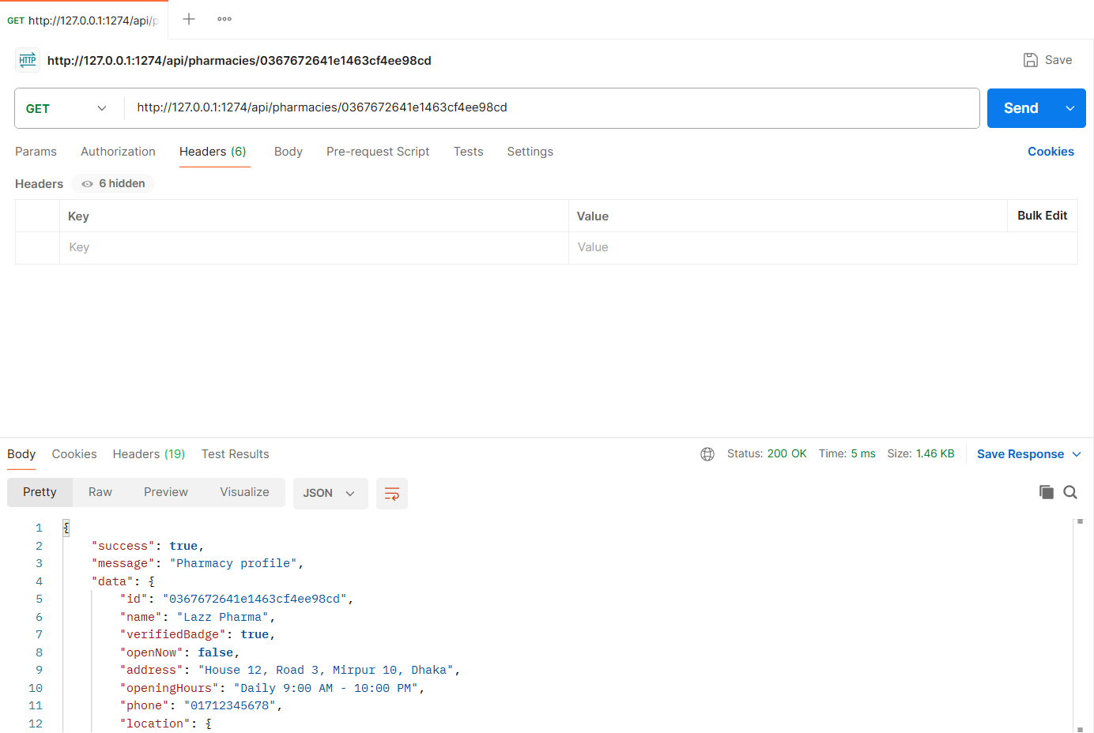
Figure: M4-F1-08 - GET /api/pharmacies/0367672641e1463cf4ee98cd tested in Postman (status 200)
API 9: Pharmacy reviews
Purpose | Reviews, most recent first, marked as verified purchases.
Endpoint URL | http://127.0.0.1:1274/api/pharmacies/0367672641e1463cf4ee98cd/reviews
HTTP Method | GET
Headers | None
Authentication | Public (no login required)
Body / Parameters | Query parameters:  page = 1  limit = 5
Status code | Expected 200 OK; returned 200 OK in the Postman test below

Example request (cURL):
curl -X GET "http://127.0.0.1:1274/api/pharmacies/0367672641e1463cf4ee98cd/reviews?page=1&limit=5"

Example response (200 OK, recorded from the Postman collection run):
{
"success": true,
"message": "Reviews",
"data": {
"pharmacy": {
"id": "0367672641e1463cf4ee98cd",
"name": "Lazz Pharma",
"ratingAverage": 4.8,
"ratingCount": 5
},
"reviews": [
{
"id": "6aeb921f0f523725a4aad768",
"author": "Ayesha S.",
"rating": 5,
"text": "Had the medicine in stock exactly as listed. Quick and polite.",
"verifiedPurchase": true,
"createdAt": "2026-11-02T20:14:20.527Z"
},
{
"id": "6aeb921f0f523725a4aad76a",
"author": "Imran H.",
"rating": 4,
"text": "Good price. Waited 10 minutes at pickup.",
"verifiedPurchase": true,
"createdAt": "2026-10-28T20:14:20.527Z"
},
{
... (truncated - full response in the Postman screenshot / collection run)

Code snippet (route -> controller -> service):
// src/routes/verification.routes.js
router.get('/pharmacies/:id/reviews', validate(idParam(), 'params'), validate(v.reviewsQuery, 'query'), ctrl.listReviews);

// src/controllers/verification.controller.js
async function listReviews(req, res) {
ok(res, await service.listReviews(req.params.id, getPagination(req.validatedQuery)), 'Reviews');
}

// src/services/verification.service.js
async function listReviews(id, { page, limit, skip }) {
const p = await findPublicPharmacy(id);
const [total, reviews] = await Promise.all([
Review.countDocuments({ pharmacy: p._id }),
Review.find({ pharmacy: p._id }).populate('patient', 'name').sort({ createdAt: -1 }).skip(skip).limit(limit),
]);
return {
pharmacy: { id: p._id, name: p.name, ratingAverage: p.ratingAverage, ratingCount: p.ratingCount },
reviews: reviews.map((r) => ({
id: r._id,
author: r.patient ? shortName(r.patient.name) : 'Patient',
rating: r.rating,
text: r.text || '',
verifiedPurchase: true,
createdAt: r.createdAt,
})),
pagination: pageMeta(page, limit, total),
};
}

Postman screenshot:
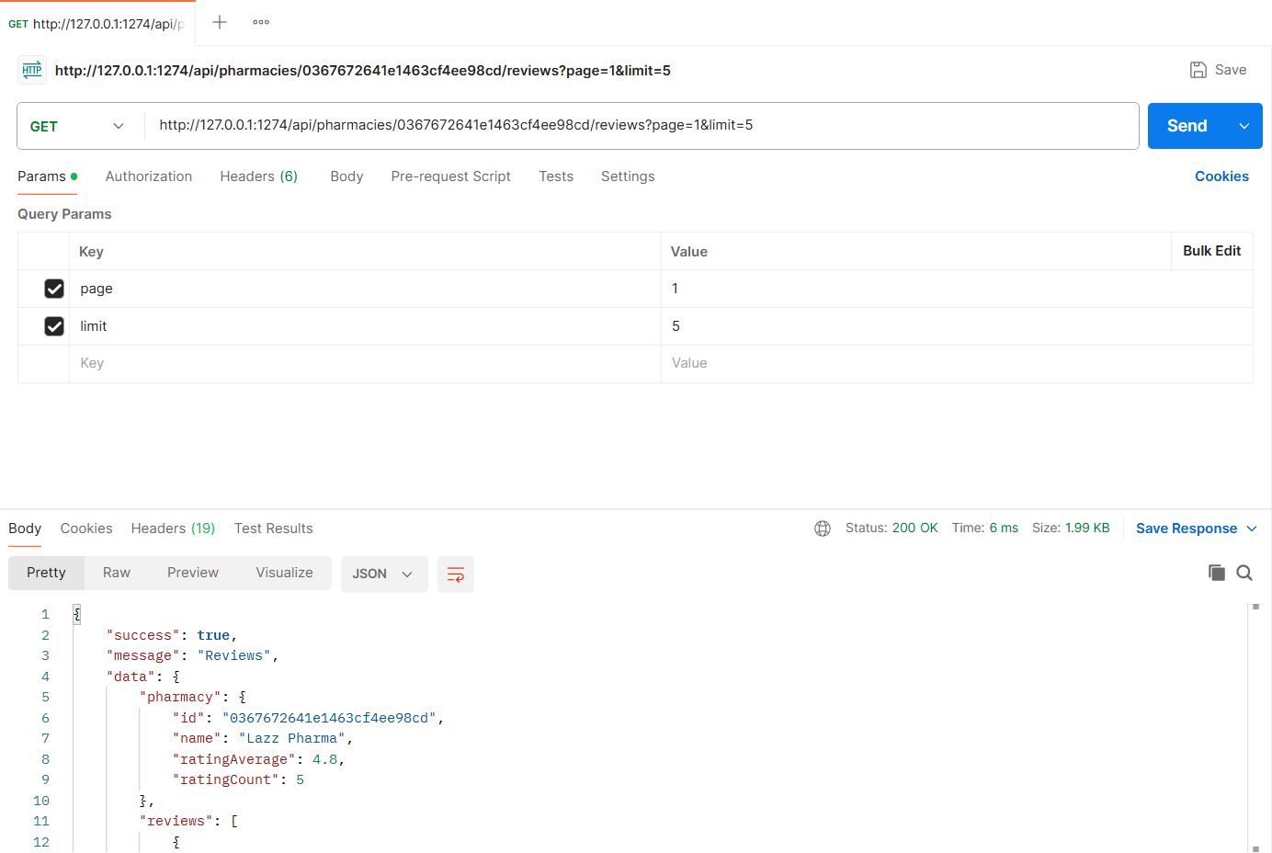
Figure: M4-F1-09 - GET /api/pharmacies/0367672641e1463cf4ee98cd/reviews tested in Postman (status 200)
API 10: Reservations eligible for review
Purpose | The patient's collected, not-yet-reviewed reservations at this pharmacy (Reservation dropdown on "Write a review").
Endpoint URL | http://127.0.0.1:1274/api/pharmacies/0367672641e1463cf4ee98cd/reviewable-reservations
HTTP Method | GET
Headers | Authorization: Bearer <JWT of patient account>
Authentication | JWT required - role: Patient
Body / Parameters | None
Status code | Expected 200 OK; returned 200 OK in the Postman test below

Example request (cURL):
curl -X GET "http://127.0.0.1:1274/api/pharmacies/0367672641e1463cf4ee98cd/reviewable-reservations" \
-H "Authorization: Bearer <patientToken>"

Example response (200 OK, recorded from the Postman collection run):
{
"success": true,
"message": "Reservations you can review",
"data": {
"reservations": [
{
"id": "6aeb921f0f523725a4aad732",
"code": "R-1001",
"label": "#R-1001 Monas 10 x 30 (Collected)",
"collectedAt": "2026-10-20T12:00:00.000Z"
}
]
}
}

Code snippet (route -> controller -> service):
// src/routes/verification.routes.js
router.get('/pharmacies/:id/reviewable-reservations', patient, validate(idParam(), 'params'), ctrl.reviewableReservations);

// src/controllers/verification.controller.js
async function reviewableReservations(req, res) {
ok(res, await service.reviewableReservations(req.user, req.params.id), 'Reservations you can review');
}

// src/services/verification.service.js
/** Reservation dropdown on "Write a review": the patient's collected, not-yet-reviewed reservations here. */
async function reviewableReservations(patient, pharmacyId) {
const list = await Reservation.find({ patient: patient._id, pharmacy: pharmacyId, status: 'Collected', reviewed: false }).sort({ collectedAt: -1 });
return {
reservations: list.map((r) => ({
id: r._id,
code: r.code,
label: `#${r.code} ${r.medicineSnapshot.brandName} x ${r.quantity} (Collected)`,
collectedAt: r.collectedAt,
})),
};
}

Postman screenshot:
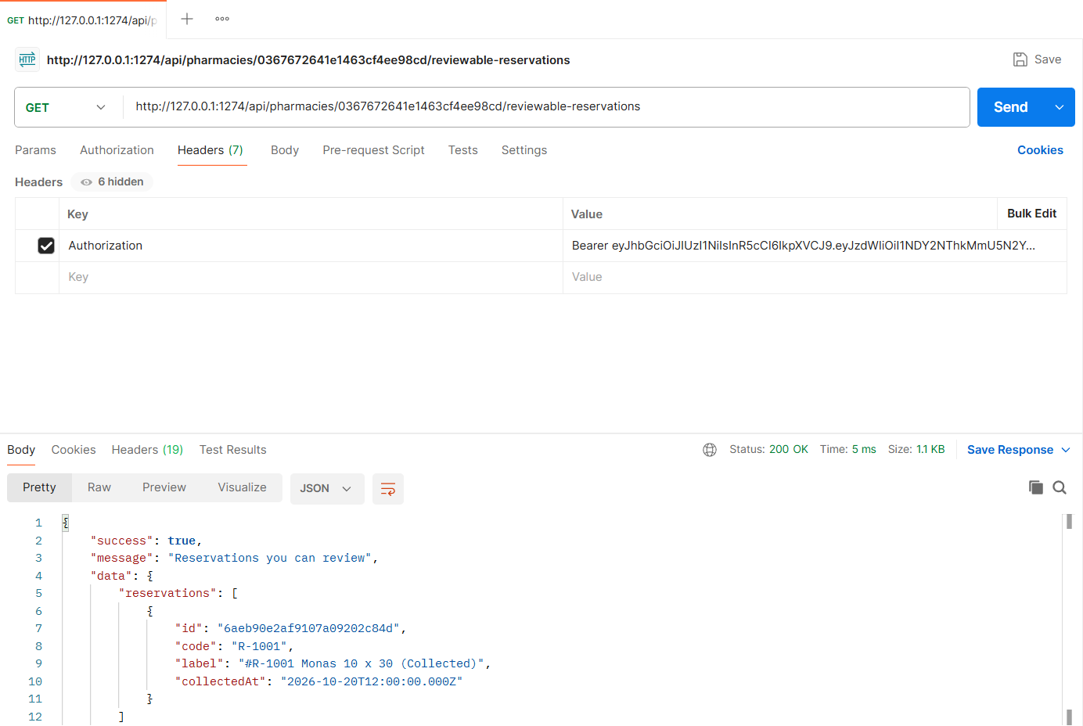
Figure: M4-F1-10 - GET /api/pharmacies/0367672641e1463cf4ee98cd/reviewable-reservations tested in Postman (status 200)
API 11: Write a review (1-5 stars)
Purpose | Only a patient with a collected reservation can rate the pharmacy; the average rating is recalculated in the same transaction.
Endpoint URL | http://127.0.0.1:1274/api/pharmacies/0367672641e1463cf4ee98cd/reviews
HTTP Method | POST
Headers | Authorization: Bearer <JWT of patient account>  Content-Type: application/json
Authentication | JWT required - role: Patient
Body / Parameters | JSON body:  {  "reservationId": "{{reviewReservationId}}",  "rating": 4,  "text": "Stock was exactly as listed and the staff were helpful."  }
Status code | Expected 201 Created; returned 201 Created in the Postman test below

Example request (cURL):
curl -X POST "http://127.0.0.1:1274/api/pharmacies/0367672641e1463cf4ee98cd/reviews" \
-H "Authorization: Bearer <patientToken>" \
-H "Content-Type: application/json" \
-d '{"reservationId": "{{reviewReservationId}}", "rating": 4, "text": "Stock was exactly as listed and the staff were helpful."}'

Example response (201 Created, recorded from the Postman collection run):
{
"success": true,
"message": "Review submitted",
"data": {
"review": {
"id": "6aeb92245d3cdae6a0e9450a",
"rating": 4,
"text": "Stock was exactly as listed and the staff were helpful.",
"reservation": "R-1001",
"createdAt": "2026-11-04T20:14:28.470Z"
},
"pharmacyRating": {
"ratingAverage": 4.67,
"ratingCount": 6
}
}
}

Code snippet (route -> controller -> service):
// src/routes/verification.routes.js
router.post('/pharmacies/:id/reviews', patient, validate(idParam(), 'params'), validate(v.createReview), ctrl.createReview);

// src/controllers/verification.controller.js
async function createReview(req, res) {
created(res, await service.createReview(req.user, req.params.id, req.body), 'Review submitted');
}

// src/services/verification.service.js
async function createReview(patient, pharmacyId, { reservationId, rating, text }) {
const pharmacy = await Pharmacy.findById(pharmacyId);
if (!pharmacy) throw ApiError.notFound('Pharmacy not found');
const r = await Reservation.findById(reservationId);
if (!r) throw ApiError.notFound('Reservation not found');
if (!r.patient.equals(patient._id)) throw ApiError.forbidden('You can only review your own reservations');
if (!r.pharmacy.equals(pharmacy._id)) throw ApiError.badRequest('This reservation was not made at this pharmacy');
if (r.status !== 'Collected') throw ApiError.forbidden(`Only collected reservations can be reviewed (this one is ${Reservation.STATUS_LABELS[r.status]})`);
if (r.reviewed || (await Review.exists({ reservation: r._id }))) throw ApiError.conflict('You have already reviewed this reservation');

const result = await withTransaction(async (session) => {
const [review] = await Review.create([{ pharmacy: pharmacy._id, patient: patient._id, reservation: r._id, rating, text }], { session });
await Reservation.updateOne({ _id: r._id }, { reviewed: true }, { session });
const pharmacyRating = await recalculateRating(pharmacy._id, session);
return { review, pharmacyRating };
});

return {
review: { id: result.review._id, rating, text: text || '', reservation: r.code, createdAt: result.review.createdAt },
pharmacyRating: result.pharmacyRating,
};
}

// src/services/verification.service.js
async function recalculateRating(pharmacyId, session) {
const [row] = await Review.aggregate([
{ $match: { pharmacy: new mongoose.Types.ObjectId(String(pharmacyId)) } },
{ $group: { _id: null, avg: { $avg: '$rating' }, count: { $sum: 1 } } },
]).session(session || null);
const ratingAverage = row ? Number(row.avg.toFixed(2)) : 0;
const ratingCount = row ? row.count : 0;
await Pharmacy.updateOne({ _id: pharmacyId }, { ratingAverage, ratingCount }, { session });
return { ratingAverage, ratingCount };
}

Postman screenshot:
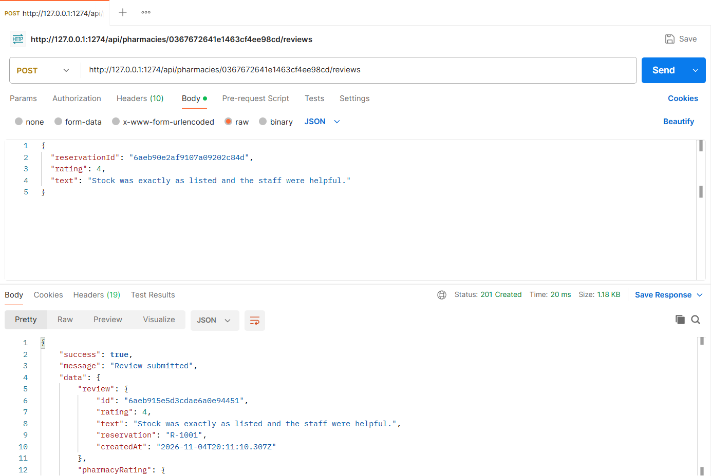
Figure: M4-F1-11 - POST /api/pharmacies/0367672641e1463cf4ee98cd/reviews tested in Postman (status 201)
Validation and error-handling tests (Feature 01)
The same APIs were also tested with invalid input, wrong roles and invalid state changes. Each request below was sent from Postman to the running server.
Verify without completing the checklist (400)
Request | PATCH http://127.0.0.1:1274/api/admin/pharmacies/f6289c77bd8917169b0eece6/verification
Scenario | All four checklist items must be confirmed.
Body / Parameters | JSON body:  {  "status": "Verified"  }
Result | Expected 400 Bad Request; returned 400 Bad Request

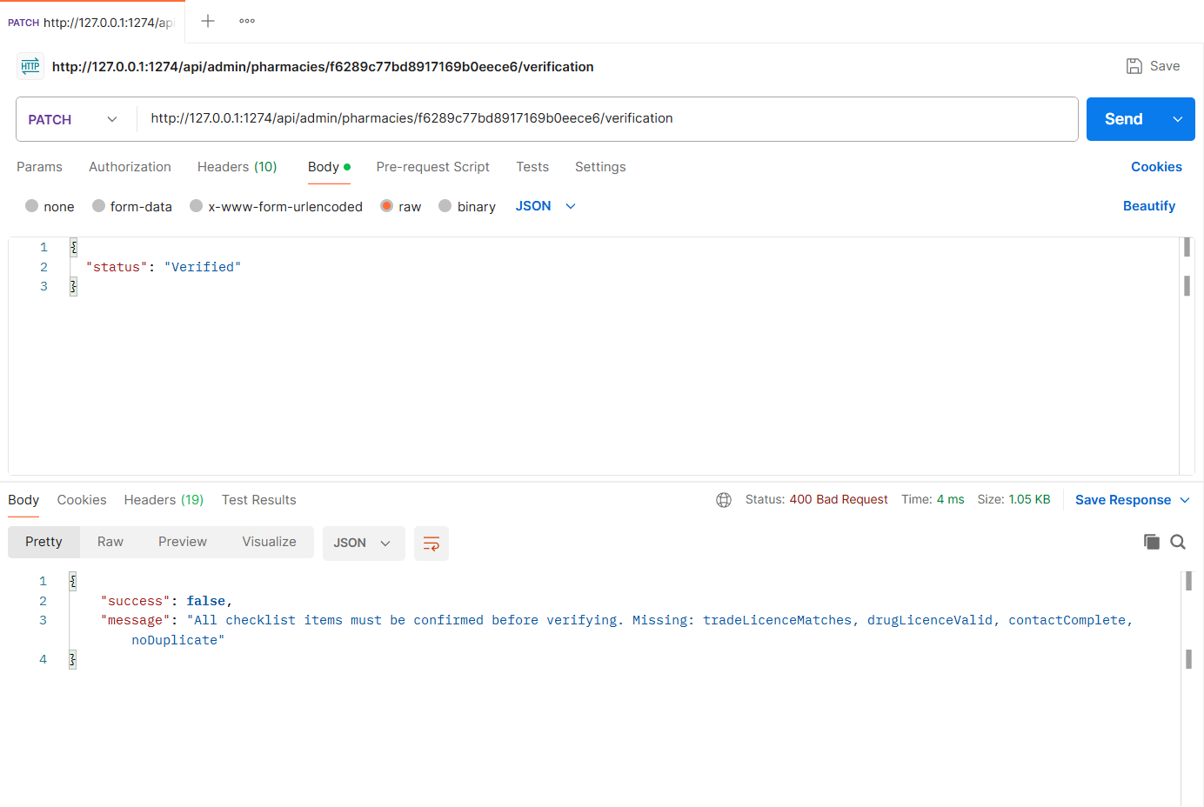
Figure: M4-F1-N1 - Verify without completing the checklist (400)
Unverified pharmacy hidden from public (404)
Request | GET http://127.0.0.1:1274/api/pharmacies/f6289c77bd8917169b0eece6
Scenario | Pending/Rejected pharmacies have no public profile.
Body / Parameters | None
Result | Expected 404 Not Found; returned 404 Not Found

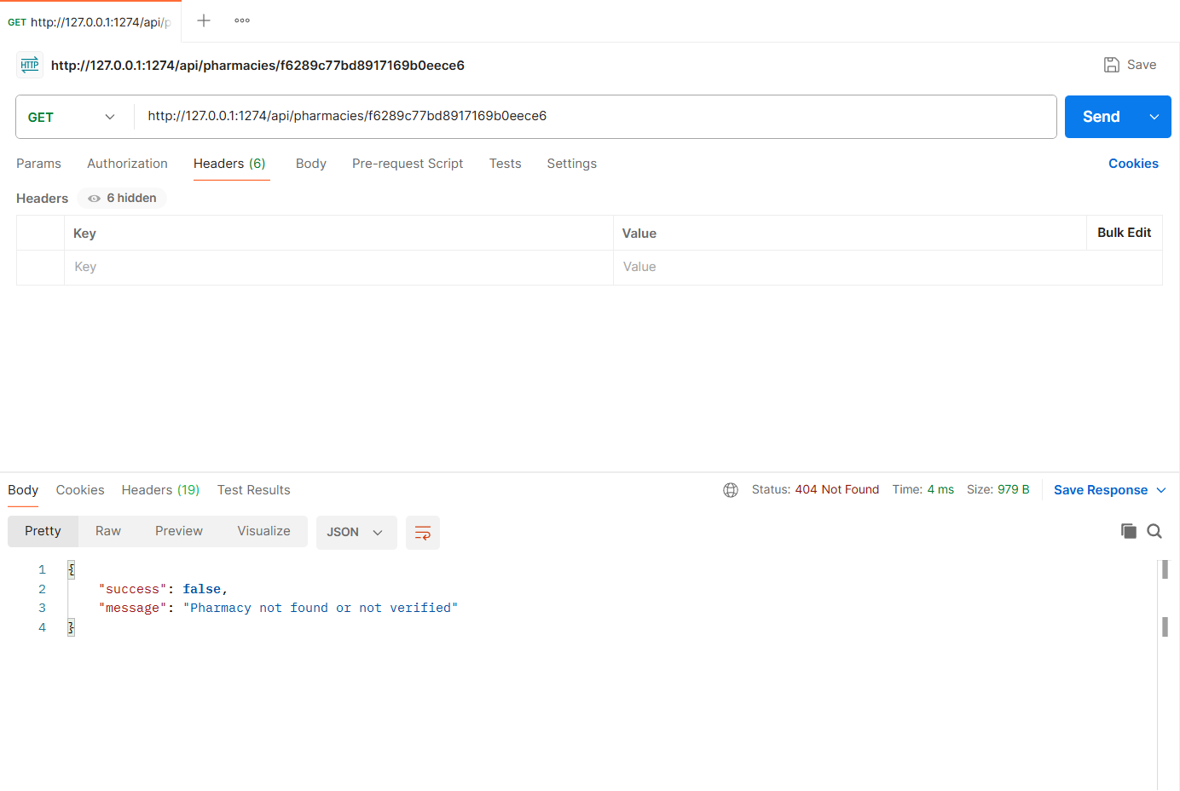
Figure: M4-F1-N2 - Unverified pharmacy hidden from public (404)
Duplicate review (409)
Request | POST http://127.0.0.1:1274/api/pharmacies/0367672641e1463cf4ee98cd/reviews
Scenario | One review per collected reservation.
Body / Parameters | JSON body:  {  "reservationId": "{{reviewReservationId}}",  "rating": 5  }
Result | Expected 409 Conflict; returned 409 Conflict

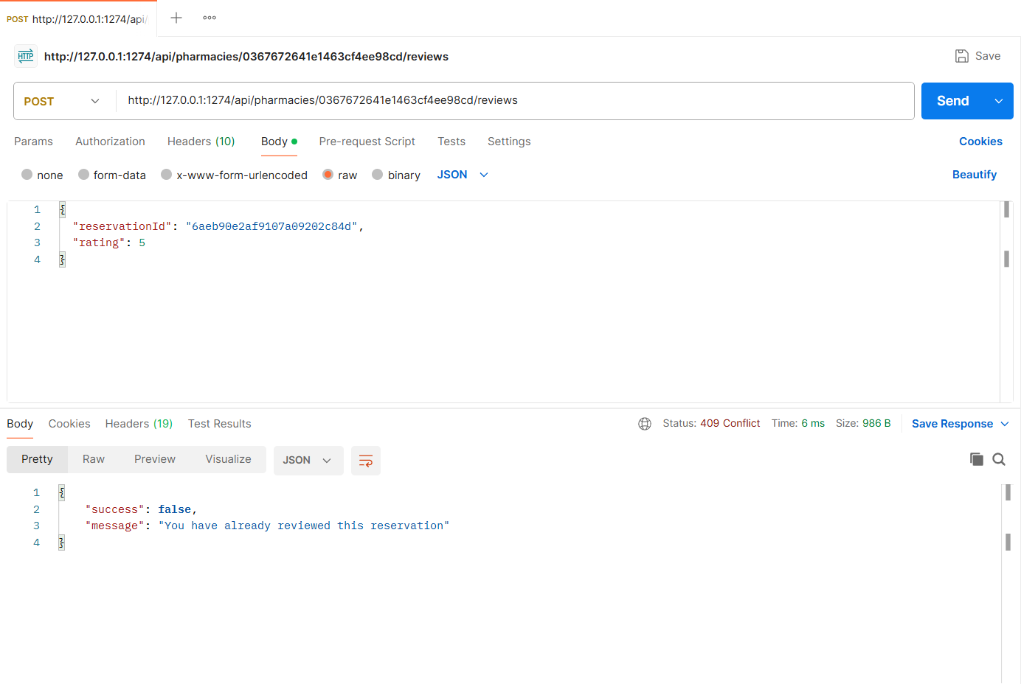
Figure: M4-F1-N3 - Duplicate review (409)
Owner cannot use admin verification (403)
Request | GET http://127.0.0.1:1274/api/admin/pharmacies
Scenario | Admin-only action.
Body / Parameters | None
Result | Expected 403 Forbidden; returned 403 Forbidden

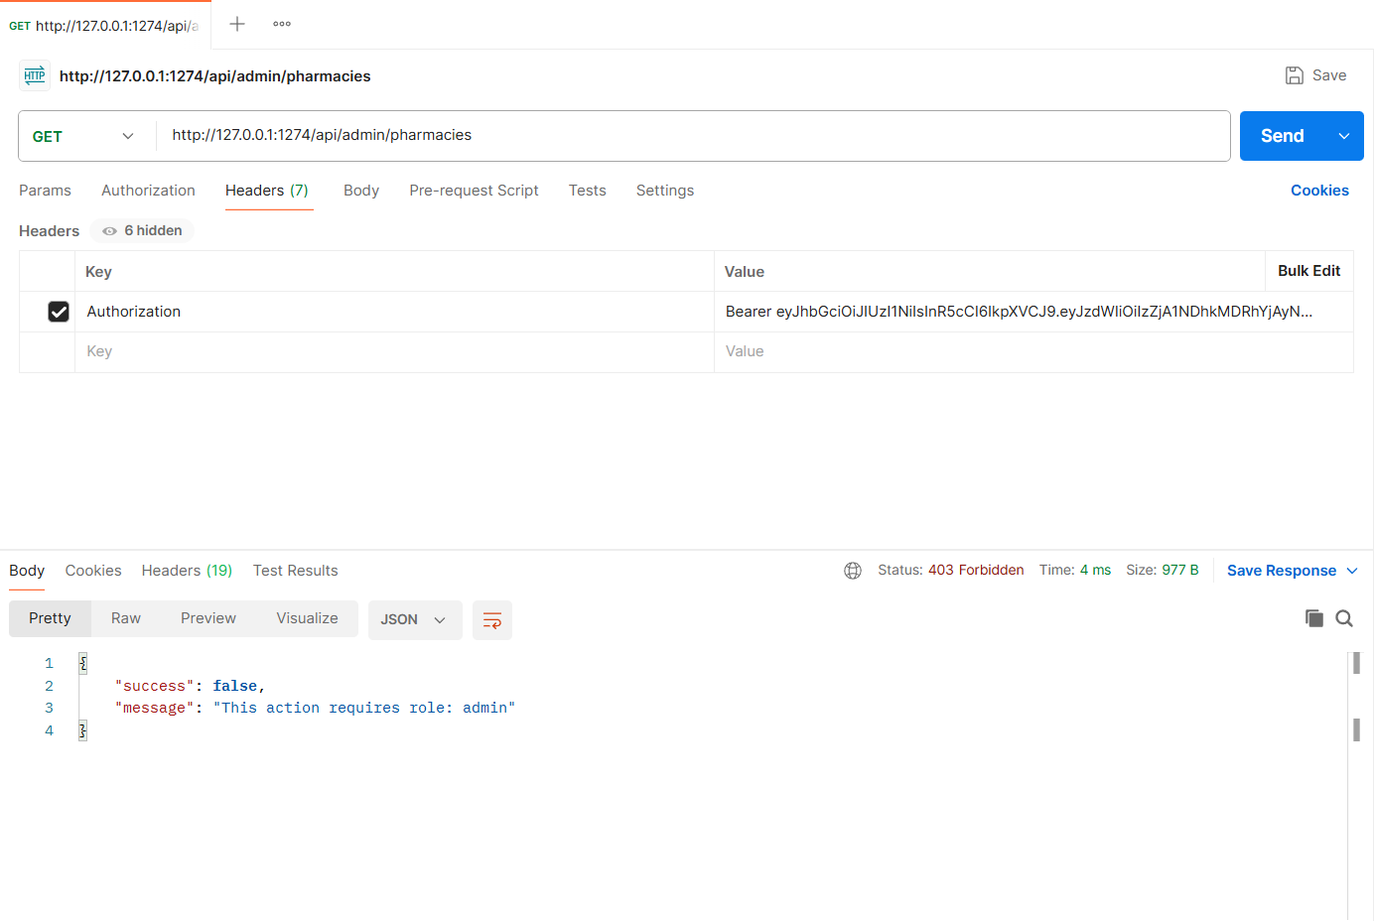
Figure: M4-F1-N4 - Owner cannot use admin verification (403)
APIs of Feature - 02: Complaints & Disputes
Server: Member 4 backend, started with "npm run start:member4" on port 1274 (last four digits of student ID 23301274). Base URL: http://127.0.0.1:1274. Database: MongoDB (Mongoose ODM), connected at server start.
Method | Endpoint - API
1. POST | /api/complaints - File a complaint about a reservation
2. POST | /api/complaints - File a complaint about a pharmacy
3. GET | /api/complaints/my - My complaints
4. GET | /api/owner/complaints - Owner: complaints about my pharmacy
5. PATCH | /api/owner/complaints/:complaintId/response - Owner responds to complaint
6. GET | /api/admin/complaints - Admin: complaints list
7. GET | /api/complaints/:complaintId - Complaint detail with history
8. PATCH | /api/admin/complaints/:complaintId/status - Admin: move to Under Review
9. PATCH | /api/admin/complaints/:complaintId/status - Admin: resolve complaint
10. PATCH | /api/admin/pharmacies/690efc4e8f369b935e83cb6b/suspend - Admin: suspend pharmacy after repeated valid complaints
11. PATCH | /api/admin/pharmacies/690efc4e8f369b935e83cb6b/reinstate - Admin: reinstate pharmacy

API 1: File a complaint about a reservation
Purpose | Patient files a complaint about a specific reservation (or a pharmacy) with issue type, description and evidence images. Status starts as Open and the owner is notified.
Endpoint URL | http://127.0.0.1:1274/api/complaints
HTTP Method | POST
Headers | Authorization: Bearer <JWT of patient account>  Content-Type: multipart/form-data (set automatically by Postman)
Authentication | JWT required - role: Patient
Body / Parameters | form-data:  targetType = reservation  reservationId = {{reviewReservationId}}  issueType = Overcharging  description = I was charged Tk 16 per tablet but the app listed Tk 14 per tablet for Monas 10.  evidence = (file) sample-evidence-receipt.png
Status code | Expected 201 Created; returned 201 Created in the Postman test below

Example request (cURL):
curl -X POST "http://127.0.0.1:1274/api/complaints" \
-H "Authorization: Bearer <patientToken>" \
-F "targetType=reservation" \
-F "reservationId={{reviewReservationId}}" \
-F "issueType=Overcharging" \
-F "description=I was charged Tk 16 per tablet but the app listed Tk 14 per tablet for Monas 10." \
-F "evidence=@sample-evidence-receipt.png"

Example response (201 Created, recorded from the Postman collection run):
{
"success": true,
"message": "Complaint submitted",
"data": {
"id": "6aeb92245d3cdae6a0e94519",
"code": "C-207",
"issueType": "Overcharging",
"pharmacy": "Lazz Pharma",
"reservation": "R-1001",
"status": "Open",
"statusLabel": "Open",
"latestUpdate": "Waiting for the pharmacy to respond.",
"createdAt": "2026-11-04T20:14:28.771Z",
"targetType": "reservation",
"description": "I was charged Tk 16 per tablet but the app listed Tk 14 per tablet for Monas 10.",
"evidence": [
"/uploads/evidence/1793823268759-2f9b9cca7d72.png"
],
"pharmacyResponse": null,
"resolutionNote": null,
"history": [
{
"action": "filed",
"status": "Open",
"statusLabel": "Open",
"note": "Overcharging",
"at": "2026-11-04T20:14:28.771Z"
}
... (truncated - full response in the Postman screenshot / collection run)

Code snippet (route -> controller -> service):
// src/routes/complaint.routes.js
router.post('/complaints', patient, imageUpload.array('evidence', 3), validate(v.fileComplaint), ctrl.fileComplaint);

// src/controllers/complaint.controller.js
async function fileComplaint(req, res) {
created(res, await service.fileComplaint(req.user, req.body, req.files || []), 'Complaint submitted');
}

// src/services/complaint.service.js
async function fileComplaint(patient, { targetType, pharmacyId, reservationId, issueType, description }, files = []) {
let pharmacy;
let reservation = null;

if (targetType === 'reservation') {
if (!reservationId) throw ApiError.badRequest('reservationId is required for a reservation complaint');
reservation = await Reservation.findById(reservationId);
if (!reservation) throw ApiError.notFound('Reservation not found');
if (!reservation.patient.equals(patient._id)) throw ApiError.forbidden('You can only complain about your own reservations');
pharmacy = await Pharmacy.findById(reservation.pharmacy);
const open = await Complaint.exists({ reservation: reservation._id, status: { $in: ['Open', 'UnderReview'] } });
if (open) throw ApiError.conflict('You already have an open complaint for this reservation');
} else {
if (!pharmacyId) throw ApiError.badRequest('pharmacyId is required for a pharmacy complaint');
pharmacy = await Pharmacy.findById(pharmacyId);
}
if (!pharmacy) throw ApiError.notFound('Pharmacy not found');

const evidence = await storage.saveImages(files, 'evidence');
const seq = await Counter.next('complaint', 200);
const complaint = await Complaint.create({
code: `C-${seq}`,
patient: patient._id,
pharmacy: pharmacy._id,
targetType,
reservation: reservation ? reservation._id : undefined,
issueType,
description,
evidence,
status: 'Open',
history: [{ action: 'filed', status: 'Open', by: patient._id, note: issueType }],
});

notify(pharmacy.owner, {
type: 'complaint_update',
title: `New complaint ${complaint.code}`,
message: `A patient filed a complaint (${issueType}) against ${pharmacy.name}. Please respond.`,
data: { complaintId: complaint._id },
});

await complaint.populate([{ path: 'pharmacy', select: 'name' }, { path: 'reservation', select: 'code' }]);
return detail(complaint);
}

Postman screenshot:
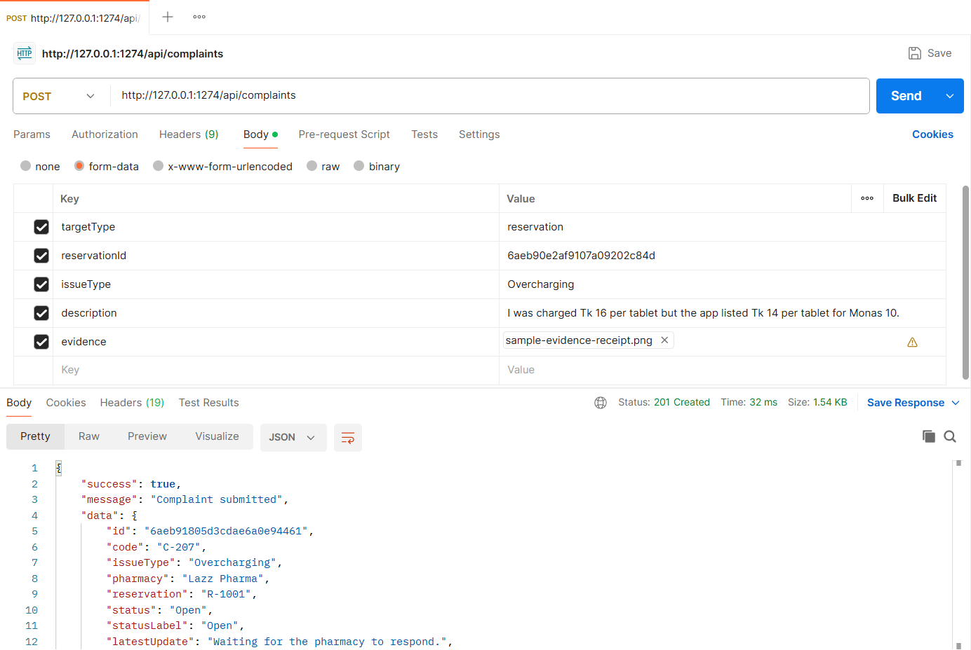
Figure: M4-F2-01 - POST /api/complaints tested in Postman (status 201)
API 2: File a complaint about a pharmacy
Purpose | Complaint against a pharmacy without a specific reservation.
Endpoint URL | http://127.0.0.1:1274/api/complaints
HTTP Method | POST
Headers | Authorization: Bearer <JWT of patient account>  Content-Type: application/json
Authentication | JWT required - role: Patient
Body / Parameters | JSON body:  {  "targetType": "pharmacy",  "pharmacyId": "e9a8e974b7602290887787a9",  "issueType": "Medicine listed but unavailable",  "description": "Napa Syrup was listed in stock but the pharmacy said it was sold out."  }
Status code | Expected 201 Created; returned 201 Created in the Postman test below

Example request (cURL):
curl -X POST "http://127.0.0.1:1274/api/complaints" \
-H "Authorization: Bearer <patientToken>" \
-H "Content-Type: application/json" \
-d '{"targetType": "pharmacy", "pharmacyId": "e9a8e974b7602290887787a9", "issueType": "Medicine listed but unavailable", "description": "Napa Syrup was listed in stock but the pharmacy said it was sold out."}'

Example response (201 Created, recorded from the Postman collection run):
{
"success": true,
"message": "Complaint submitted",
"data": {
"id": "6aeb92245d3cdae6a0e94524",
"code": "C-208",
"issueType": "Medicine listed but unavailable",
"pharmacy": "Green Life Pharmacy",
"reservation": null,
"status": "Open",
"statusLabel": "Open",
"latestUpdate": "Waiting for the pharmacy to respond.",
"createdAt": "2026-11-04T20:14:28.884Z",
"targetType": "pharmacy",
"description": "Napa Syrup was listed in stock but the pharmacy said it was sold out.",
"evidence": [],
"pharmacyResponse": null,
"resolutionNote": null,
"history": [
{
"action": "filed",
"status": "Open",
"statusLabel": "Open",
"note": "Medicine listed but unavailable",
"at": "2026-11-04T20:14:28.884Z"
}
]
}
... (truncated - full response in the Postman screenshot / collection run)

Code snippet (route -> controller -> service):
// src/routes/complaint.routes.js
router.post('/complaints', patient, imageUpload.array('evidence', 3), validate(v.fileComplaint), ctrl.fileComplaint);

// src/controllers/complaint.controller.js
async function fileComplaint(req, res) {
created(res, await service.fileComplaint(req.user, req.body, req.files || []), 'Complaint submitted');
}

Postman screenshot:
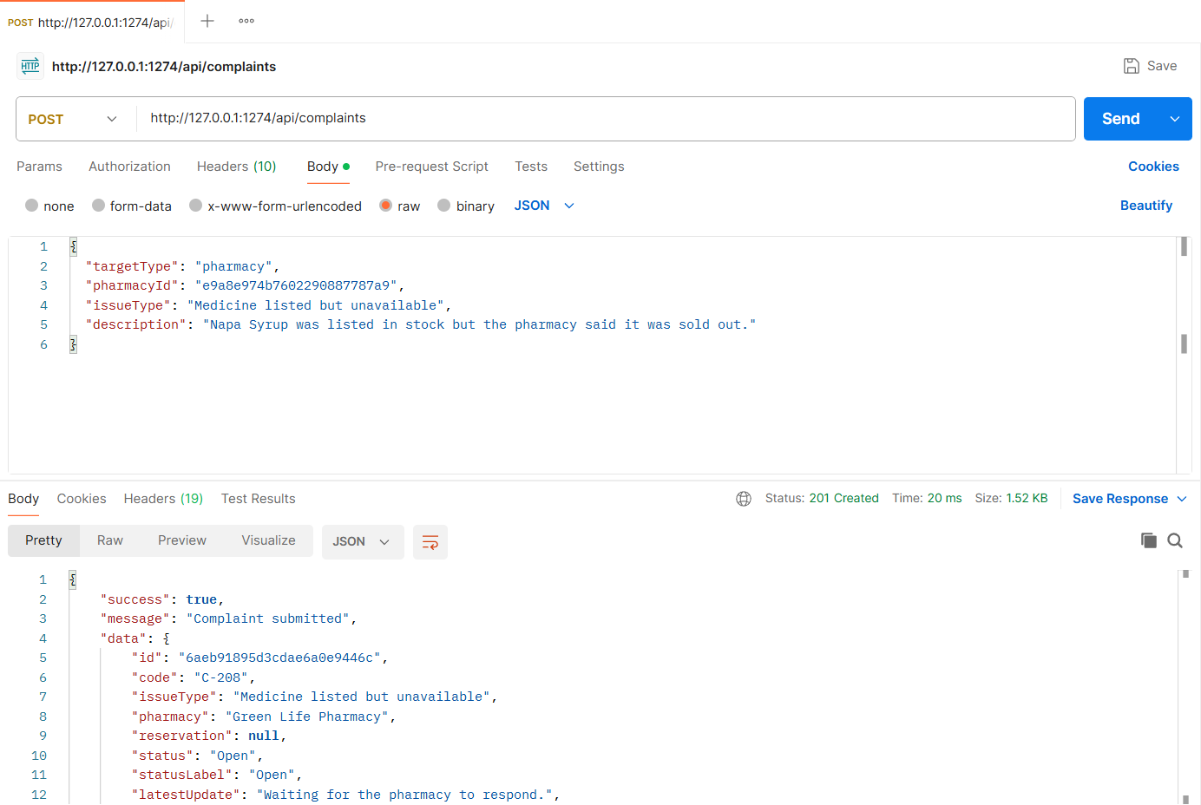
Figure: M4-F2-02 - POST /api/complaints tested in Postman (status 201)
API 3: My complaints
Purpose | Patient's complaints with tab counts (All / Open / Under review / Closed) and the latest update.
Endpoint URL | http://127.0.0.1:1274/api/complaints/my
HTTP Method | GET
Headers | Authorization: Bearer <JWT of patient account>
Authentication | JWT required - role: Patient
Body / Parameters | Query parameters:  tab = all
Status code | Expected 200 OK; returned 200 OK in the Postman test below

Example request (cURL):
curl -X GET "http://127.0.0.1:1274/api/complaints/my?tab=all" \
-H "Authorization: Bearer <patientToken>"

Example response (200 OK, recorded from the Postman collection run):
{
"success": true,
"message": "My complaints",
"data": {
"counts": {
"all": 4,
"open": 2,
"underReview": 1,
"closed": 1
},
"complaints": [
{
"id": "6aeb92245d3cdae6a0e94524",
"code": "C-208",
"issueType": "Medicine listed but unavailable",
"pharmacy": "Green Life Pharmacy",
"reservation": null,
"status": "Open",
"statusLabel": "Open",
"latestUpdate": "Waiting for the pharmacy to respond.",
"createdAt": "2026-11-04T20:14:28.884Z"
},
{
"id": "6aeb92245d3cdae6a0e94519",
"code": "C-207",
"issueType": "Overcharging",
"pharmacy": "Lazz Pharma",
"reservation": "R-1001",
... (truncated - full response in the Postman screenshot / collection run)

Code snippet (route -> controller -> service):
// src/routes/complaint.routes.js
router.get('/complaints/my', patient, validate(v.myComplaintsQuery, 'query'), ctrl.myComplaints);

// src/controllers/complaint.controller.js
async function myComplaints(req, res) {
const q = req.validatedQuery;
ok(res, await service.myComplaints(req.user, { tab: q.tab, ...getPagination(q) }), 'My complaints');
}

// src/services/complaint.service.js
async function myComplaints(patient, { tab = 'all', page, limit, skip }) {
const base = { patient: patient._id };
const filter = { ...base, ...PATIENT_TABS[tab] };
const [total, list, counts] = await Promise.all([
Complaint.countDocuments(filter),
Complaint.find(filter).populate('pharmacy', 'name').populate('reservation', 'code').sort({ createdAt: -1 }).skip(skip).limit(limit),
Promise.all(Object.values(PATIENT_TABS).map((f) => Complaint.countDocuments({ ...base, ...f }))),
]);
return {
counts: { all: counts[0], open: counts[1], underReview: counts[2], closed: counts[3] },
complaints: list.map(summary),
pagination: pageMeta(page, limit, total),
};
}

Postman screenshot:
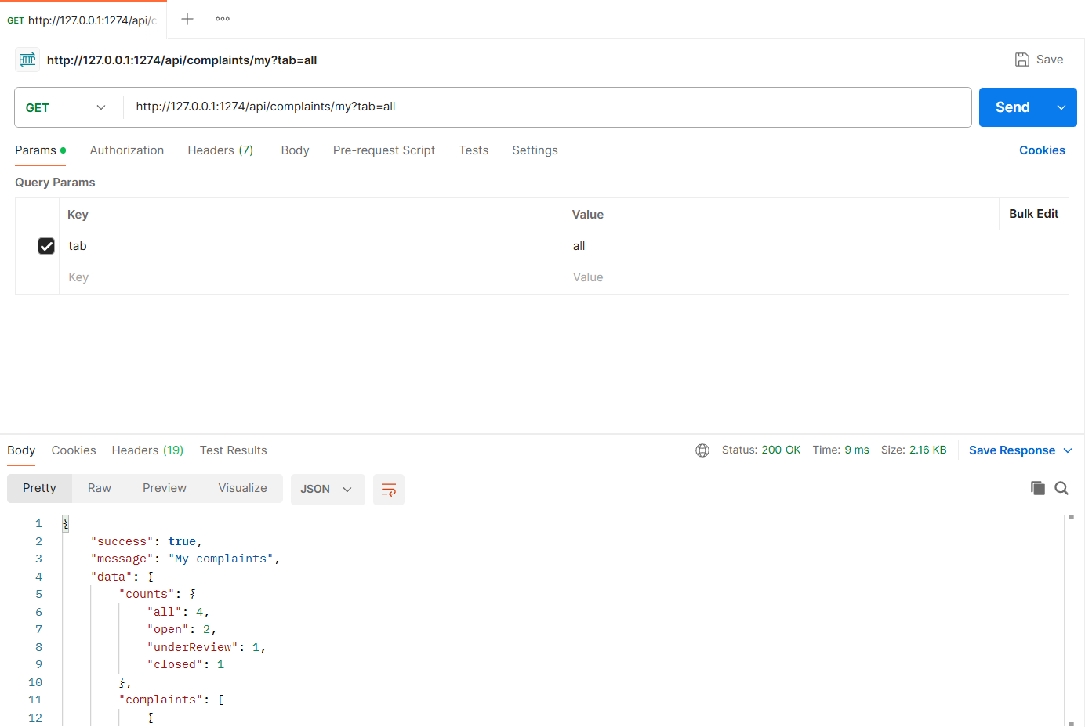
Figure: M4-F2-03 - GET /api/complaints/my tested in Postman (status 200)
API 4: Owner: complaints about my pharmacy
Purpose | Owner sees complaints about their pharmacy with description and evidence.
Endpoint URL | http://127.0.0.1:1274/api/owner/complaints
HTTP Method | GET
Headers | Authorization: Bearer <JWT of owner account>
Authentication | JWT required - role: Pharmacy owner
Body / Parameters | None
Status code | Expected 200 OK; returned 200 OK in the Postman test below

Example request (cURL):
curl -X GET "http://127.0.0.1:1274/api/owner/complaints" \
-H "Authorization: Bearer <ownerToken>"

Example response (200 OK, recorded from the Postman collection run):
{
"success": true,
"message": "Complaints about your pharmacy",
"data": {
"complaints": [
{
"id": "6aeb92245d3cdae6a0e94519",
"code": "C-207",
"issueType": "Overcharging",
"pharmacy": "Lazz Pharma",
"reservation": "R-1001",
"status": "Open",
"statusLabel": "Open",
"latestUpdate": "Waiting for the pharmacy to respond.",
"createdAt": "2026-11-04T20:14:28.771Z",
"from": "Ayesha Siddika",
"description": "I was charged Tk 16 per tablet but the app listed Tk 14 per tablet for Monas 10.",
"evidence": [
"/uploads/evidence/1793823268759-2f9b9cca7d72.png"
],
"responded": false
},
{
"id": "6aeb92200f523725a4aad793",
"code": "C-206",
"issueType": "Rude behaviour",
"pharmacy": "Lazz Pharma",
"reservation": null,
... (truncated - full response in the Postman screenshot / collection run)

Code snippet (route -> controller -> service):
// src/routes/complaint.routes.js
router.get('/owner/complaints', owner, validate(v.statusQuery, 'query'), ctrl.ownerComplaints);

// src/controllers/complaint.controller.js
async function ownerComplaints(req, res) {
const q = req.validatedQuery;
ok(res, await service.ownerComplaints(req.pharmacy, { status: q.status, ...getPagination(q) }), 'Complaints about your pharmacy');
}

// src/services/complaint.service.js
async function ownerComplaints(pharmacy, { status, page, limit, skip }) {
const filter = { pharmacy: pharmacy._id, ...(status ? { status } : {}) };
const [total, list] = await Promise.all([
Complaint.countDocuments(filter),
Complaint.find(filter).populate('patient', 'name').populate('reservation', 'code').sort({ createdAt: -1 }).skip(skip).limit(limit),
]);
return {
complaints: list.map((c) => ({ ...summary(c), pharmacy: pharmacy.name, from: c.patient.name, description: c.description, evidence: c.evidence.map((e) => e.url), responded: Boolean(c.pharmacyResponse && c.pharmacyResponse.message) })),
pagination: pageMeta(page, limit, total),
};
}

Postman screenshot:
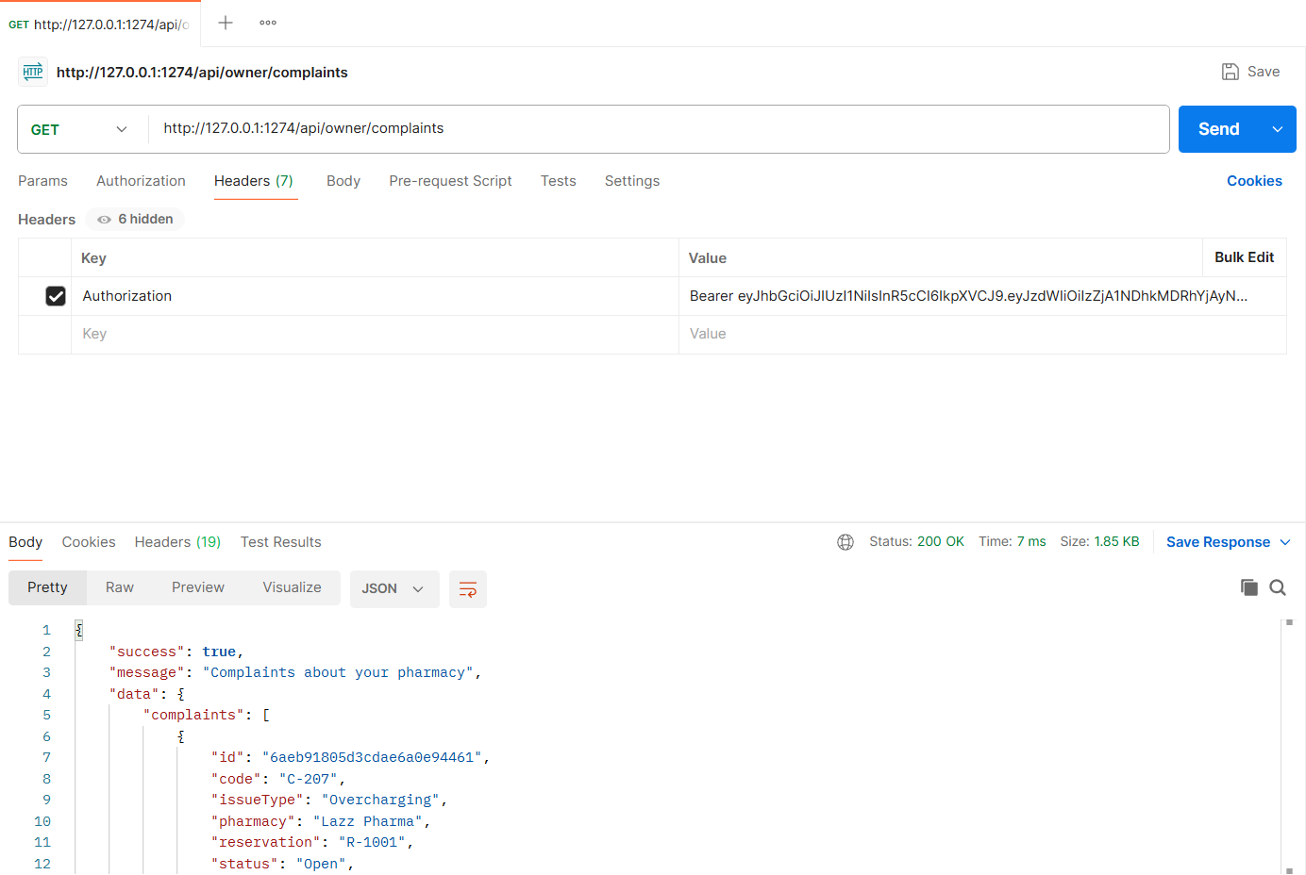
Figure: M4-F2-04 - GET /api/owner/complaints tested in Postman (status 200)
API 5: Owner responds to complaint
Purpose | The pharmacy owner replies; the patient is notified.
Endpoint URL | http://127.0.0.1:1274/api/owner/complaints/:complaintId/response
HTTP Method | PATCH
Headers | Authorization: Bearer <JWT of owner account>  Content-Type: application/json
Authentication | JWT required - role: Pharmacy owner
Body / Parameters | JSON body:  {  "message": "We apologise. The difference has been refunded and our price list is now updated."  }  Path parameters: complaintId (id returned by an earlier request)
Status code | Expected 200 OK; returned 200 OK in the Postman test below

Example request (cURL):
curl -X PATCH "http://127.0.0.1:1274/api/owner/complaints/<complaintId>/response" \
-H "Authorization: Bearer <ownerToken>" \
-H "Content-Type: application/json" \
-d '{"message": "We apologise. The difference has been refunded and our price list is now updated."}'

Example response (200 OK, recorded from the Postman collection run):
{
"success": true,
"message": "Response sent",
"data": {
"id": "6aeb92245d3cdae6a0e94519",
"code": "C-207",
"issueType": "Overcharging",
"pharmacy": "Lazz Pharma",
"reservation": "R-1001",
"status": "Open",
"statusLabel": "Open",
"latestUpdate": "Pharmacy replied.",
"createdAt": "2026-11-04T20:14:28.771Z",
"targetType": "reservation",
"description": "I was charged Tk 16 per tablet but the app listed Tk 14 per tablet for Monas 10.",
"evidence": [
"/uploads/evidence/1793823268759-2f9b9cca7d72.png"
],
"pharmacyResponse": {
"message": "We apologise. The difference has been refunded and our price list is now updated.",
"respondedAt": "2026-11-04T20:14:29.367Z",
"respondedBy": "3f0548d04ab026d93b0952c5"
},
"resolutionNote": null,
"history": [
{
"action": "filed",
"status": "Open",
... (truncated - full response in the Postman screenshot / collection run)

Code snippet (route -> controller -> service):
// src/routes/complaint.routes.js
router.patch('/owner/complaints/:id/response', owner, validate(idParam(), 'params'), validate(v.respond), ctrl.respond);

// src/controllers/complaint.controller.js
async function respond(req, res) {
ok(res, await service.respondToComplaint(req.user, req.pharmacy, req.params.id, req.body), 'Response sent');
}

// src/services/complaint.service.js
async function respondToComplaint(owner, pharmacy, id, { message }) {
const c = await Complaint.findById(id);
if (!c) throw ApiError.notFound('Complaint not found');
if (!c.pharmacy.equals(pharmacy._id)) throw ApiError.forbidden('This complaint is not about your pharmacy');
if (['Resolved', 'Dismissed'].includes(c.status)) throw ApiError.conflict(`Complaint is already ${LABELS[c.status]}; responses are closed`);

const isUpdate = Boolean(c.pharmacyResponse && c.pharmacyResponse.message);
c.pharmacyResponse = { message, respondedAt: new Date(), respondedBy: owner._id };
c.history.push({ action: 'pharmacy_response', status: c.status, by: owner._id, note: isUpdate ? 'Response updated' : 'Pharmacy responded' });
await c.save();

notify(c.patient, { type: 'complaint_update', title: `Pharmacy replied to ${c.code}`, message: `${pharmacy.name} responded to your complaint ${c.code}.`, data: { complaintId: c._id } });
await c.populate([{ path: 'pharmacy', select: 'name' }, { path: 'reservation', select: 'code' }]);
return detail(c);
}

Postman screenshot:
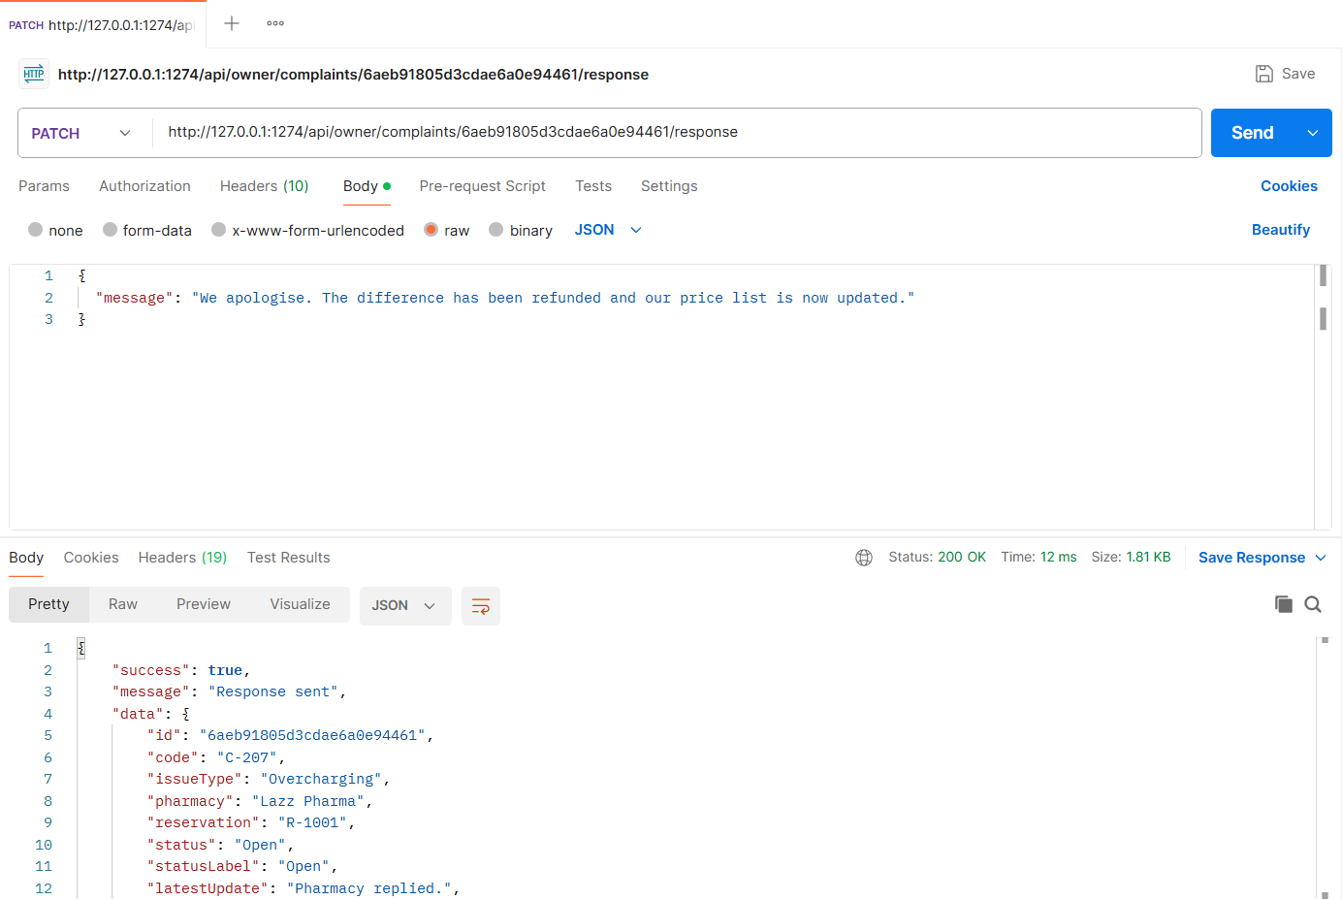
Figure: M4-F2-05 - PATCH /api/owner/complaints/:complaintId/response tested in Postman (status 200)
API 6: Admin: complaints list
Purpose | Admin list filtered by status with counts (Open, Under review, Resolved, Dismissed).
Endpoint URL | http://127.0.0.1:1274/api/admin/complaints
HTTP Method | GET
Headers | Authorization: Bearer <JWT of admin account>
Authentication | JWT required - role: Admin
Body / Parameters | Query parameters:  status = Open
Status code | Expected 200 OK; returned 200 OK in the Postman test below

Example request (cURL):
curl -X GET "http://127.0.0.1:1274/api/admin/complaints?status=Open" \
-H "Authorization: Bearer <adminToken>"

Example response (200 OK, recorded from the Postman collection run):
{
"success": true,
"message": "Complaints",
"data": {
"counts": {
"open": 3,
"underReview": 1,
"resolved": 3,
"dismissed": 1
},
"complaints": [
{
"id": "6aeb92245d3cdae6a0e94524",
"code": "C-208",
"issueType": "Medicine listed but unavailable",
"pharmacy": "Green Life Pharmacy",
"reservation": null,
"status": "Open",
"statusLabel": "Open",
"latestUpdate": "Waiting for the pharmacy to respond.",
"createdAt": "2026-11-04T20:14:28.884Z",
"filedBy": "Ayesha Siddika"
},
{
"id": "6aeb92245d3cdae6a0e94519",
"code": "C-207",
"issueType": "Overcharging",
"pharmacy": "Lazz Pharma",
... (truncated - full response in the Postman screenshot / collection run)

Code snippet (route -> controller -> service):
// src/routes/complaint.routes.js
router.get('/admin/complaints', admin, validate(v.statusQuery, 'query'), ctrl.adminComplaints);

// src/controllers/complaint.controller.js
async function adminComplaints(req, res) {
const q = req.validatedQuery;
ok(res, await service.adminComplaints({ status: q.status, ...getPagination(q) }), 'Complaints');
}

// src/services/complaint.service.js
async function adminComplaints({ status, page, limit, skip }) {
const filter = status ? { status } : {};
const [total, list, ...counts] = await Promise.all([
Complaint.countDocuments(filter),
Complaint.find(filter).populate('pharmacy', 'name').populate('patient', 'name').populate('reservation', 'code').sort({ createdAt: -1 }).skip(skip).limit(limit),
...['Open', 'UnderReview', 'Resolved', 'Dismissed'].map((s) => Complaint.countDocuments({ status: s })),
]);
return {
counts: { open: counts[0], underReview: counts[1], resolved: counts[2], dismissed: counts[3] },
complaints: list.map((c) => ({ ...summary(c), filedBy: c.patient.name })),
pagination: pageMeta(page, limit, total),
};
}

Postman screenshot:
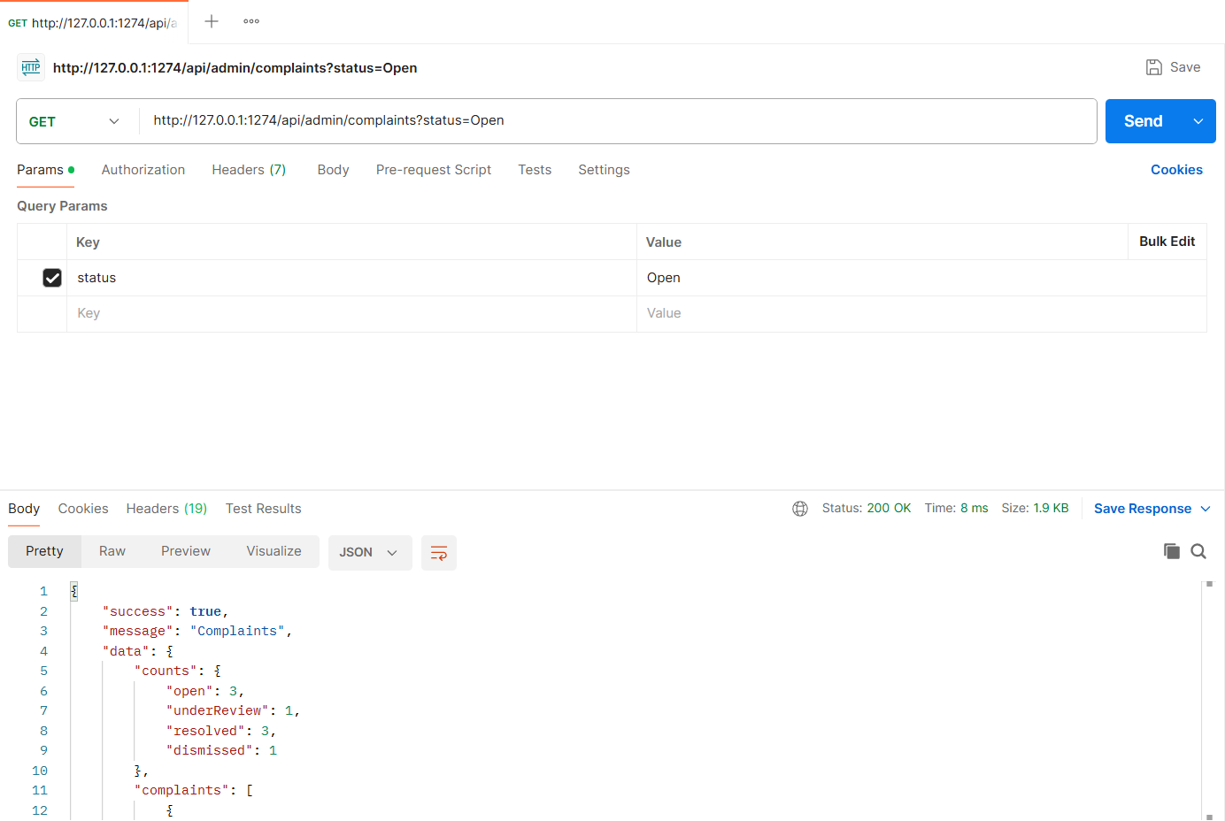
Figure: M4-F2-06 - GET /api/admin/complaints tested in Postman (status 200)
API 7: Complaint detail with history
Purpose | Full complaint with evidence, pharmacy response and history. Admins also see the pharmacy's valid-complaint record.
Endpoint URL | http://127.0.0.1:1274/api/complaints/:complaintId
HTTP Method | GET
Headers | Authorization: Bearer <JWT of admin account>
Authentication | JWT required - role: Admin
Body / Parameters | Path parameters: complaintId (id returned by an earlier request)
Status code | Expected 200 OK; returned 200 OK in the Postman test below

Example request (cURL):
curl -X GET "http://127.0.0.1:1274/api/complaints/<complaintId>" \
-H "Authorization: Bearer <adminToken>"

Example response (200 OK, recorded from the Postman collection run):
{
"success": true,
"message": "Complaint details",
"data": {
"id": "6aeb92245d3cdae6a0e94519",
"code": "C-207",
"issueType": "Overcharging",
"pharmacy": "Lazz Pharma",
"reservation": "R-1001",
"status": "Open",
"statusLabel": "Open",
"latestUpdate": "Pharmacy replied.",
"createdAt": "2026-11-04T20:14:28.771Z",
"targetType": "reservation",
"description": "I was charged Tk 16 per tablet but the app listed Tk 14 per tablet for Monas 10.",
"evidence": [
"/uploads/evidence/1793823268759-2f9b9cca7d72.png"
],
"filedBy": "Ayesha Siddika",
"pharmacyResponse": {
"message": "We apologise. The difference has been refunded and our price list is now updated.",
"respondedAt": "2026-11-04T20:14:29.367Z",
"respondedBy": "3f0548d04ab026d93b0952c5"
},
"resolutionNote": null,
"history": [
{
"action": "filed",
... (truncated - full response in the Postman screenshot / collection run)

Code snippet (route -> controller -> service):
// src/routes/complaint.routes.js
router.get('/complaints/:id', authenticate, validate(idParam(), 'params'), ctrl.getComplaint);

// src/controllers/complaint.controller.js
async function getComplaint(req, res) {
ok(res, await service.getComplaint(req.user, req.params.id), 'Complaint details');
}

// src/services/complaint.service.js
/** Complaint detail: visible to the patient who filed it, the owner of the pharmacy, and admins. */
async function getComplaint(user, id) {
const c = await Complaint.findById(id).populate('pharmacy', 'name owner').populate('reservation', 'code').populate('patient', 'name');
if (!c) throw ApiError.notFound('Complaint not found');
const isPatient = c.patient._id.equals(user._id);
const isOwner = c.pharmacy.owner.equals(user._id);
if (!isPatient && !isOwner && user.role !== 'admin') throw ApiError.forbidden('You cannot view this complaint');
const data = detail(c);
if (user.role === 'admin') {
const valid = await validComplaintCount(c.pharmacy._id);
data.pharmacyRecord = {
validComplaintsLast30Days: valid,
suspensionThreshold: env.suspension.minValidComplaints,
canSuspend: valid >= env.suspension.minValidComplaints,
};
}
return data;
}

Postman screenshot:
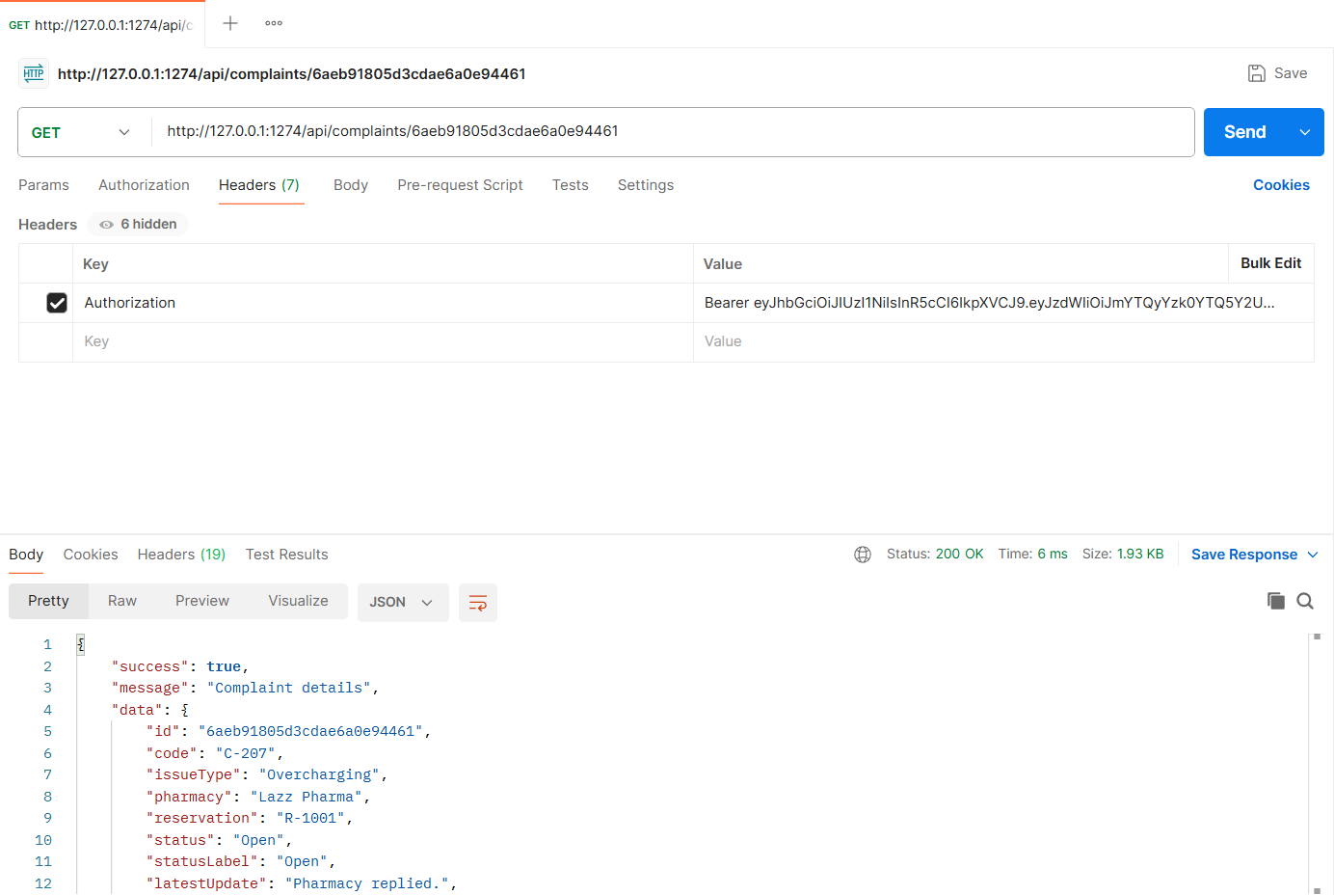
Figure: M4-F2-07 - GET /api/complaints/:complaintId tested in Postman (status 200)
API 8: Admin: move to Under Review
Purpose | Status workflow Open -> Under Review -> Resolved / Dismissed.
Endpoint URL | http://127.0.0.1:1274/api/admin/complaints/:complaintId/status
HTTP Method | PATCH
Headers | Authorization: Bearer <JWT of admin account>  Content-Type: application/json
Authentication | JWT required - role: Admin
Body / Parameters | JSON body:  {  "status": "UnderReview"  }  Path parameters: complaintId (id returned by an earlier request)
Status code | Expected 200 OK; returned 200 OK in the Postman test below

Example request (cURL):
curl -X PATCH "http://127.0.0.1:1274/api/admin/complaints/<complaintId>/status" \
-H "Authorization: Bearer <adminToken>" \
-H "Content-Type: application/json" \
-d '{"status": "UnderReview"}'

Example response (200 OK, recorded from the Postman collection run):
{
"success": true,
"message": "Complaint status updated",
"data": {
"complaint": {
"id": "6aeb92245d3cdae6a0e94519",
"code": "C-207",
"issueType": "Overcharging",
"pharmacy": "Lazz Pharma",
"reservation": "R-1001",
"status": "UnderReview",
"statusLabel": "Under Review",
"latestUpdate": "Pharmacy replied. Admin is reviewing.",
"createdAt": "2026-11-04T20:14:28.771Z",
"targetType": "reservation",
"description": "I was charged Tk 16 per tablet but the app listed Tk 14 per tablet for Monas 10.",
"evidence": [
"/uploads/evidence/1793823268759-2f9b9cca7d72.png"
],
"pharmacyResponse": {
"message": "We apologise. The difference has been refunded and our price list is now updated.",
"respondedAt": "2026-11-04T20:14:29.367Z",
"respondedBy": "3f0548d04ab026d93b0952c5"
},
"resolutionNote": null,
"history": [
{
"action": "filed",
... (truncated - full response in the Postman screenshot / collection run)

Code snippet (route -> controller -> service):
// src/routes/complaint.routes.js
router.patch('/admin/complaints/:id/status', admin, validate(idParam(), 'params'), validate(v.complaintStatus), ctrl.updateStatus);

// src/controllers/complaint.controller.js
async function updateStatus(req, res) {
ok(res, await service.updateComplaintStatus(req.user, req.params.id, req.body), 'Complaint status updated');
}

// src/services/complaint.service.js
async function updateComplaintStatus(admin, id, { status, resolutionNote }) {
const c = await Complaint.findById(id);
if (!c) throw ApiError.notFound('Complaint not found');
if (!COMPLAINT_TRANSITIONS[c.status].includes(status)) {
throw ApiError.conflict(`Invalid status change ${LABELS[c.status]} -> ${LABELS[status]}. Allowed: ${COMPLAINT_TRANSITIONS[c.status].map((s) => LABELS[s]).join(', ') || 'none (final state)'}`);
}
if (['Resolved', 'Dismissed'].includes(status) && !resolutionNote) {
throw ApiError.badRequest('A resolution note is required to resolve or dismiss a complaint');
}
c.status = status;
if (resolutionNote) c.resolutionNote = resolutionNote;
c.reviewedBy = admin._id;
if (['Resolved', 'Dismissed'].includes(status)) c.resolvedAt = new Date();
c.history.push({ action: 'status_change', status, by: admin._id, note: resolutionNote });
await c.save();

const pharmacy = await Pharmacy.findById(c.pharmacy, 'name owner');
const msg = `Complaint ${c.code} is now ${LABELS[status]}.${resolutionNote ? ` Note: ${resolutionNote}` : ''}`;
notify(c.patient, { type: 'complaint_update', title: `Complaint ${c.code} updated`, message: msg, data: { complaintId: c._id } });
notify(pharmacy.owner, { type: 'complaint_update', title: `Complaint ${c.code} updated`, message: msg, data: { complaintId: c._id } });

const valid = await validComplaintCount(c.pharmacy);
await c.populate([{ path: 'pharmacy', select: 'name' }, { path: 'reservation', select: 'code' }]);
return {
complaint: detail(c),
pharmacyRecord: { validComplaintsLast30Days: valid, suspensionThreshold: env.suspension.minValidComplaints, canSuspend: valid >= env.suspension.minValidComplaints },
};
}

Postman screenshot:
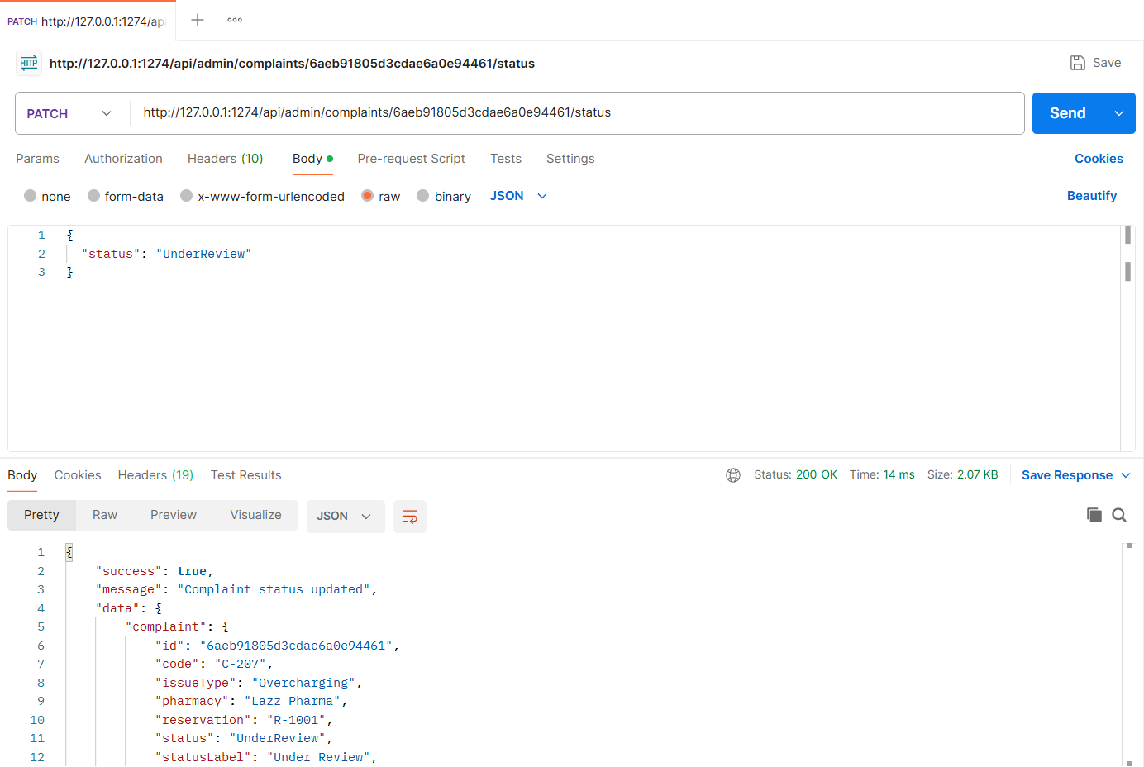
Figure: M4-F2-08 - PATCH /api/admin/complaints/:complaintId/status tested in Postman (status 200)
API 9: Admin: resolve complaint
Purpose | Resolving or dismissing requires a resolution note visible to the patient and pharmacy.
Endpoint URL | http://127.0.0.1:1274/api/admin/complaints/:complaintId/status
HTTP Method | PATCH
Headers | Authorization: Bearer <JWT of admin account>  Content-Type: application/json
Authentication | JWT required - role: Admin
Body / Parameters | JSON body:  {  "status": "Resolved",  "resolutionNote": "Overcharge confirmed and refunded. Warning issued to the pharmacy."  }  Path parameters: complaintId (id returned by an earlier request)
Status code | Expected 200 OK; returned 200 OK in the Postman test below

Example request (cURL):
curl -X PATCH "http://127.0.0.1:1274/api/admin/complaints/<complaintId>/status" \
-H "Authorization: Bearer <adminToken>" \
-H "Content-Type: application/json" \
-d '{"status": "Resolved", "resolutionNote": "Overcharge confirmed and refunded. Warning issued to the pharmacy."}'

Example response (200 OK, recorded from the Postman collection run):
{
"success": true,
"message": "Complaint status updated",
"data": {
"complaint": {
"id": "6aeb92245d3cdae6a0e94519",
"code": "C-207",
"issueType": "Overcharging",
"pharmacy": "Lazz Pharma",
"reservation": "R-1001",
"status": "Resolved",
"statusLabel": "Resolved",
"latestUpdate": "Admin: Overcharge confirmed and refunded. Warning issued to the pharmacy.",
"createdAt": "2026-11-04T20:14:28.771Z",
"targetType": "reservation",
"description": "I was charged Tk 16 per tablet but the app listed Tk 14 per tablet for Monas 10.",
"evidence": [
"/uploads/evidence/1793823268759-2f9b9cca7d72.png"
],
"pharmacyResponse": {
"message": "We apologise. The difference has been refunded and our price list is now updated.",
"respondedAt": "2026-11-04T20:14:29.367Z",
"respondedBy": "3f0548d04ab026d93b0952c5"
},
"resolutionNote": "Overcharge confirmed and refunded. Warning issued to the pharmacy.",
"history": [
{
"action": "filed",
... (truncated - full response in the Postman screenshot / collection run)

Code snippet (route -> controller -> service):
// src/routes/complaint.routes.js
router.patch('/admin/complaints/:id/status', admin, validate(idParam(), 'params'), validate(v.complaintStatus), ctrl.updateStatus);

// src/controllers/complaint.controller.js
async function updateStatus(req, res) {
ok(res, await service.updateComplaintStatus(req.user, req.params.id, req.body), 'Complaint status updated');
}

Postman screenshot:
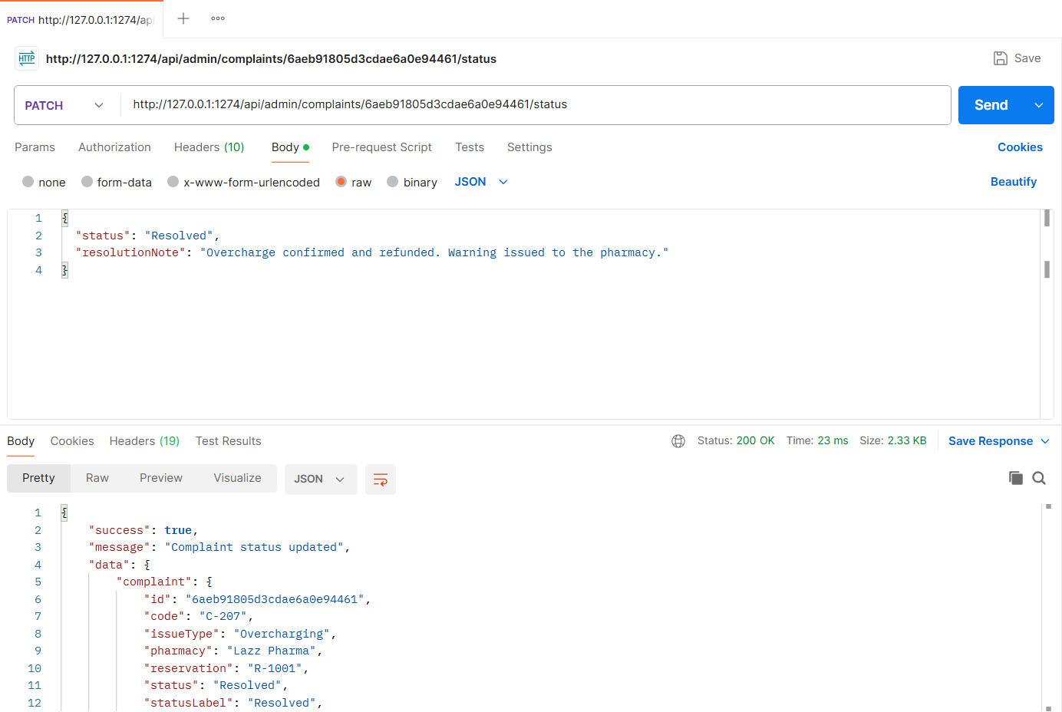
Figure: M4-F2-09 - PATCH /api/admin/complaints/:complaintId/status tested in Postman (status 200)
API 10: Admin: suspend pharmacy after repeated valid complaints
Purpose | Allowed only when the pharmacy has at least 3 resolved complaints in the last 30 days. Suspended pharmacies disappear from search.
Endpoint URL | http://127.0.0.1:1274/api/admin/pharmacies/690efc4e8f369b935e83cb6b/suspend
HTTP Method | PATCH
Headers | Authorization: Bearer <JWT of admin account>  Content-Type: application/json
Authentication | JWT required - role: Admin
Body / Parameters | JSON body:  {  "reason": "Three upheld complaints (overcharging, unavailable stock, refusal) in 30 days"  }
Status code | Expected 200 OK; returned 200 OK in the Postman test below

Example request (cURL):
curl -X PATCH "http://127.0.0.1:1274/api/admin/pharmacies/690efc4e8f369b935e83cb6b/suspend" \
-H "Authorization: Bearer <adminToken>" \
-H "Content-Type: application/json" \
-d '{"reason": "Three upheld complaints (overcharging, unavailable stock, refusal) in 30 days"}'

Example response (200 OK, recorded from the Postman collection run):
{
"success": true,
"message": "Pharmacy suspended",
"data": {
"id": "690efc4e8f369b935e83cb6b",
"name": "Care Medicine Corner",
"isSuspended": true,
"suspension": {
"reason": "Three upheld complaints (overcharging, unavailable stock, refusal) in 30 days",
"at": "2026-11-04T20:14:30.185Z",
"by": "fa42c94a49ce2fbf483a219d"
},
"validComplaintsLast30Days": 3,
"visibleInSearch": false
}
}

Code snippet (route -> controller -> service):
// src/routes/complaint.routes.js
router.patch('/admin/pharmacies/:id/suspend', admin, validate(idParam(), 'params'), validate(v.suspend), ctrl.suspend);

// src/controllers/complaint.controller.js
async function suspend(req, res) {
ok(res, await service.suspendPharmacy(req.user, req.params.id, req.body), 'Pharmacy suspended');
}

// src/services/complaint.service.js
/** Suspend a pharmacy that received repeated valid (Resolved) complaints in the last N days. */
async function suspendPharmacy(admin, pharmacyId, { reason }) {
const p = await Pharmacy.findById(pharmacyId);
if (!p) throw ApiError.notFound('Pharmacy not found');
if (p.isSuspended) throw ApiError.conflict('Pharmacy is already suspended');
const valid = await validComplaintCount(p._id);
if (valid < env.suspension.minValidComplaints) {
throw ApiError.conflict(`Suspension requires at least ${env.suspension.minValidComplaints} valid complaints in the last ${env.suspension.windowDays} days (this pharmacy has ${valid})`);
}
p.isSuspended = true;
p.suspension = { reason, at: new Date(), by: admin._id };
await p.save();
notify(p.owner, { type: 'complaint_update', title: 'Pharmacy suspended', message: `${p.name} has been suspended and hidden from search. Reason: ${reason}`, data: { pharmacyId: p._id } });
return { id: p._id, name: p.name, isSuspended: true, suspension: p.suspension, validComplaintsLast30Days: valid, visibleInSearch: false };
}

Postman screenshot:
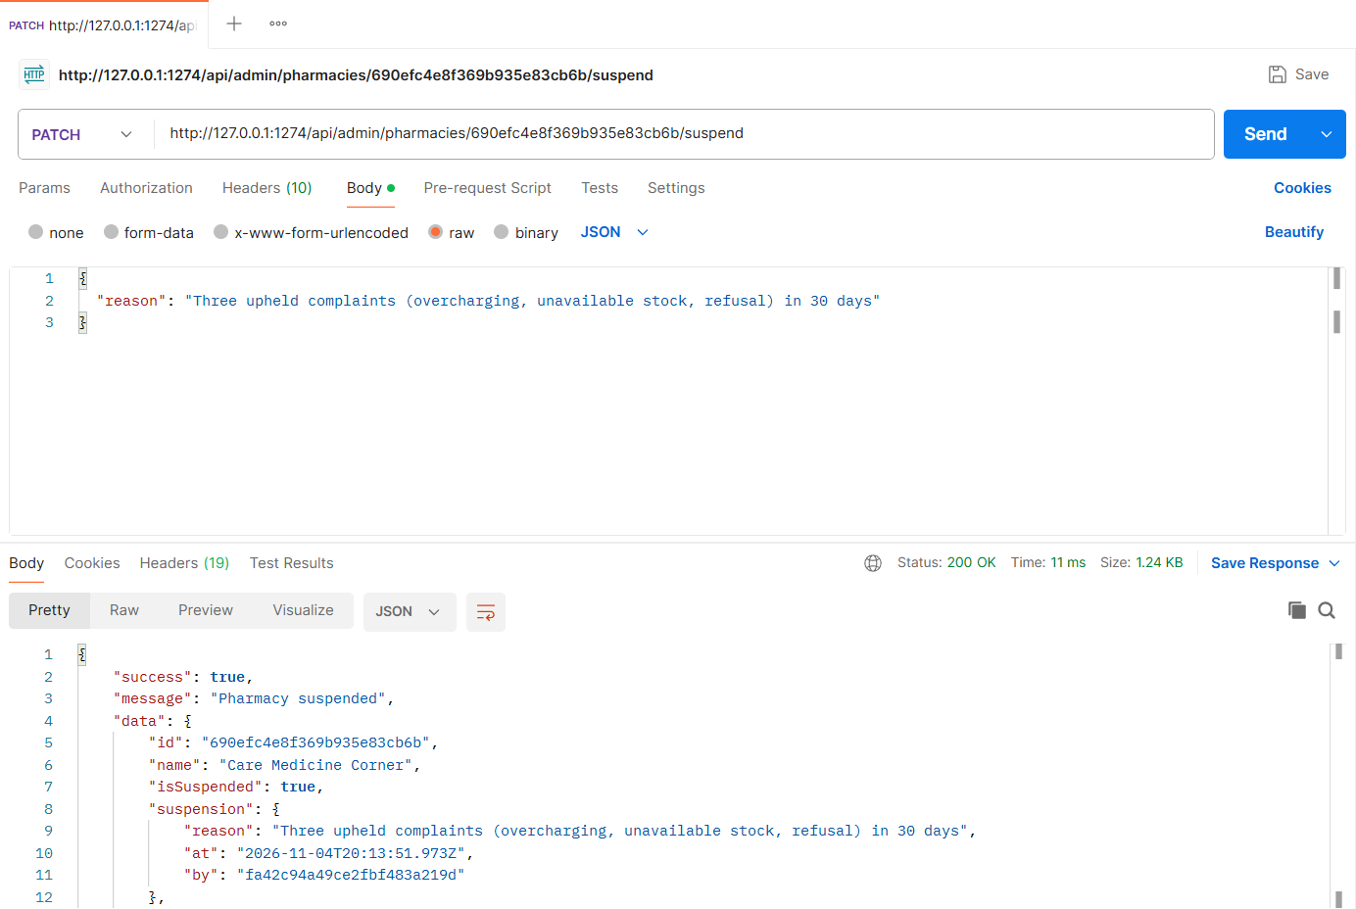
Figure: M4-F2-10 - PATCH /api/admin/pharmacies/690efc4e8f369b935e83cb6b/suspend tested in Postman (status 200)
API 11: Admin: reinstate pharmacy
Purpose | Lift a suspension after an appeal.
Endpoint URL | http://127.0.0.1:1274/api/admin/pharmacies/690efc4e8f369b935e83cb6b/reinstate
HTTP Method | PATCH
Headers | Authorization: Bearer <JWT of admin account>  Content-Type: application/json
Authentication | JWT required - role: Admin
Body / Parameters | JSON body:  {  "note": "Appeal accepted after staff training"  }
Status code | Expected 200 OK; returned 200 OK in the Postman test below

Example request (cURL):
curl -X PATCH "http://127.0.0.1:1274/api/admin/pharmacies/690efc4e8f369b935e83cb6b/reinstate" \
-H "Authorization: Bearer <adminToken>" \
-H "Content-Type: application/json" \
-d '{"note": "Appeal accepted after staff training"}'

Example response (200 OK, recorded from the Postman collection run):
{
"success": true,
"message": "Pharmacy reinstated",
"data": {
"id": "690efc4e8f369b935e83cb6b",
"name": "Care Medicine Corner",
"isSuspended": false,
"visibleInSearch": true
}
}

Code snippet (route -> controller -> service):
// src/routes/complaint.routes.js
router.patch('/admin/pharmacies/:id/reinstate', admin, validate(idParam(), 'params'), validate(v.reinstate), ctrl.reinstate);

// src/controllers/complaint.controller.js
async function reinstate(req, res) {
ok(res, await service.reinstatePharmacy(req.user, req.params.id, req.body), 'Pharmacy reinstated');
}

// src/services/complaint.service.js
async function reinstatePharmacy(admin, pharmacyId, { note }) {
const p = await Pharmacy.findById(pharmacyId);
if (!p) throw ApiError.notFound('Pharmacy not found');
if (!p.isSuspended) throw ApiError.conflict('Pharmacy is not suspended');
p.isSuspended = false;
p.suspension = { reason: `Reinstated: ${note || 'by admin'}`, at: new Date(), by: admin._id };
await p.save();
notify(p.owner, { type: 'complaint_update', title: 'Pharmacy reinstated', message: `${p.name} has been reinstated and is visible again.`, data: { pharmacyId: p._id } });
return { id: p._id, name: p.name, isSuspended: false, visibleInSearch: p.verification.status === 'Verified' };
}

Postman screenshot:
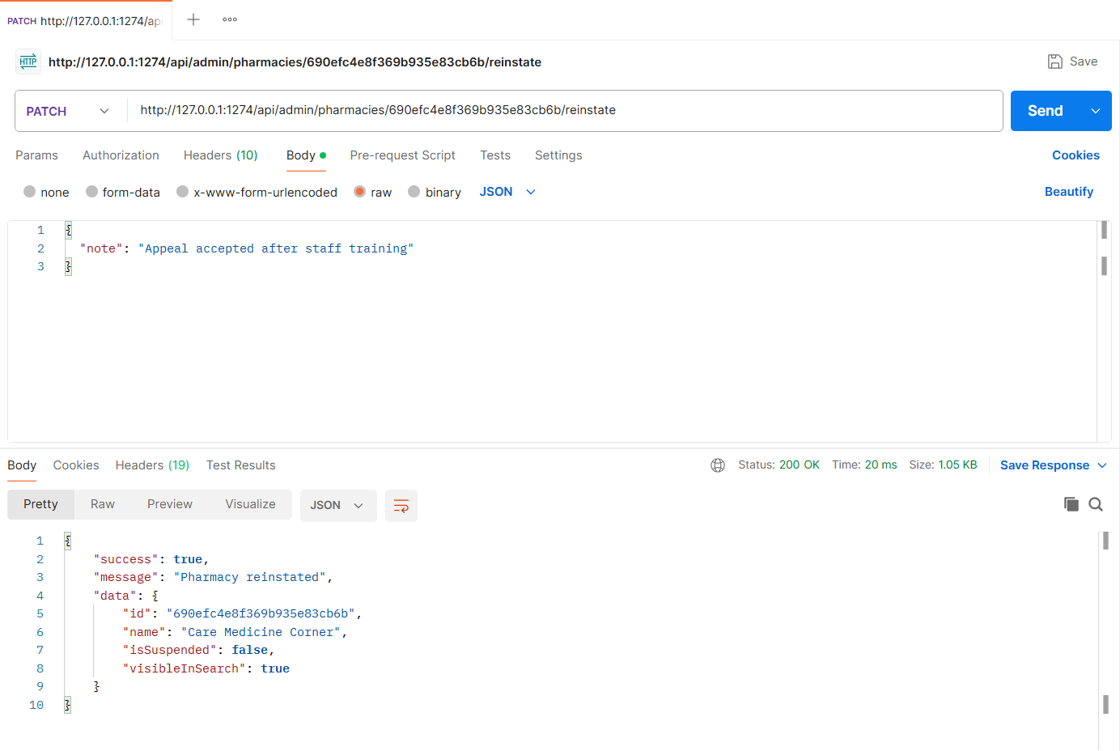
Figure: M4-F2-11 - PATCH /api/admin/pharmacies/690efc4e8f369b935e83cb6b/reinstate tested in Postman (status 200)
Validation and error-handling tests (Feature 02)
The same APIs were also tested with invalid input, wrong roles and invalid state changes. Each request below was sent from Postman to the running server.
Invalid complaint (400)
Request | POST http://127.0.0.1:1274/api/complaints
Scenario | Unknown issue type, short description and missing pharmacyId are rejected.
Body / Parameters | JSON body:  {  "targetType": "pharmacy",  "issueType": "Bad service",  "description": "bad"  }
Result | Expected 400 Bad Request; returned 400 Bad Request

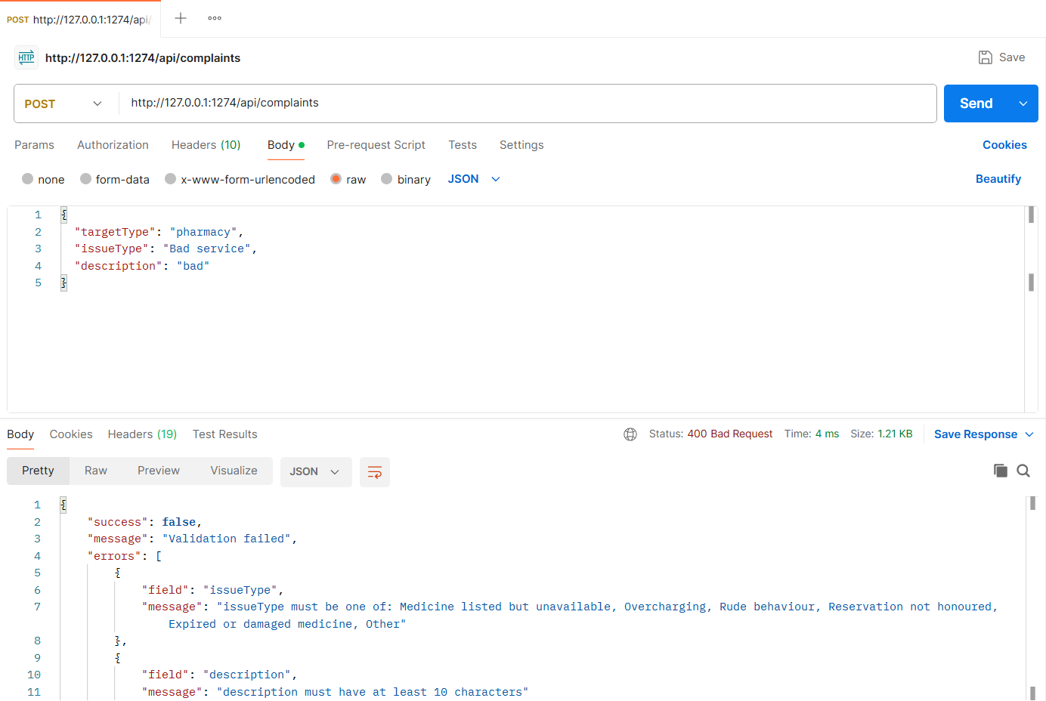
Figure: M4-F2-N1 - Invalid complaint (400)
Complaint on someone else's reservation (403)
Request | POST http://127.0.0.1:1274/api/complaints
Scenario | Patients can only complain about their own reservations.
Body / Parameters | JSON body:  {  "targetType": "reservation",  "reservationId": "{{reviewReservationId}}",  "issueType": "Overcharging",  "description": "This is not my reservation at all."  }
Result | Expected 403 Forbidden; returned 403 Forbidden

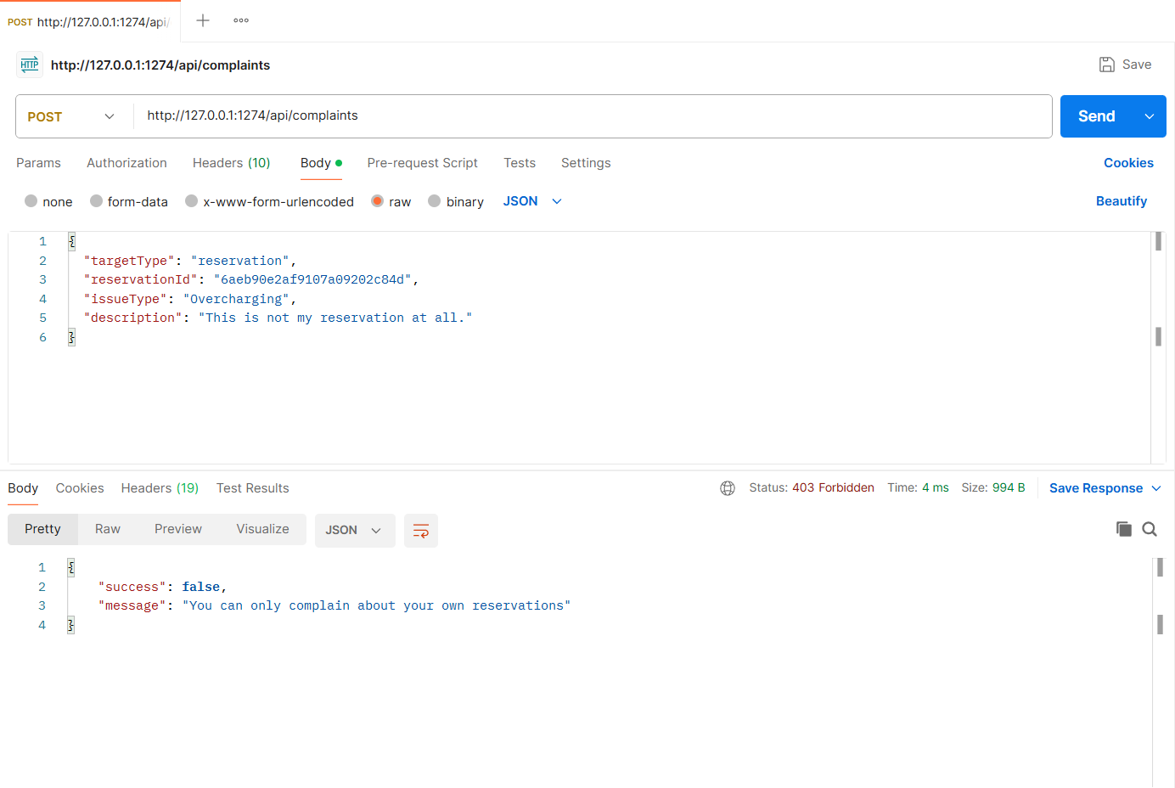
Figure: M4-F2-N2 - Complaint on someone else's reservation (403)
Other pharmacy owner cannot respond (403)
Request | PATCH http://127.0.0.1:1274/api/owner/complaints/:complaintId/response
Scenario | Only the owner of the pharmacy concerned can respond.
Body / Parameters | JSON body:  {  "message": "This is not our complaint."  }  Path parameters: complaintId (id returned by an earlier request)
Result | Expected 403 Forbidden; returned 403 Forbidden

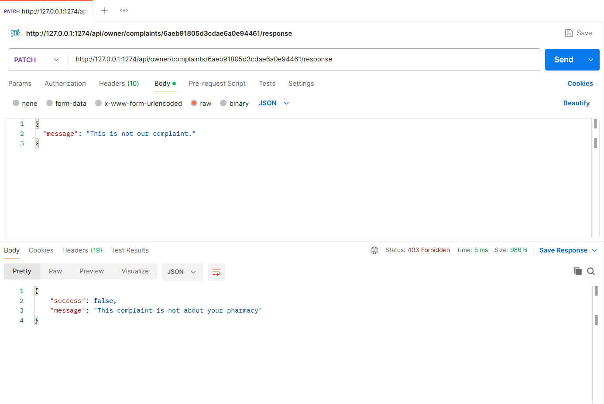
Figure: M4-F2-N3 - Other pharmacy owner cannot respond (403)
Invalid status change on a closed complaint (409)
Request | PATCH http://127.0.0.1:1274/api/admin/complaints/:complaintId/status
Scenario | Resolved and Dismissed are final states.
Body / Parameters | JSON body:  {  "status": "UnderReview"  }  Path parameters: complaintId (id returned by an earlier request)
Result | Expected 409 Conflict; returned 409 Conflict

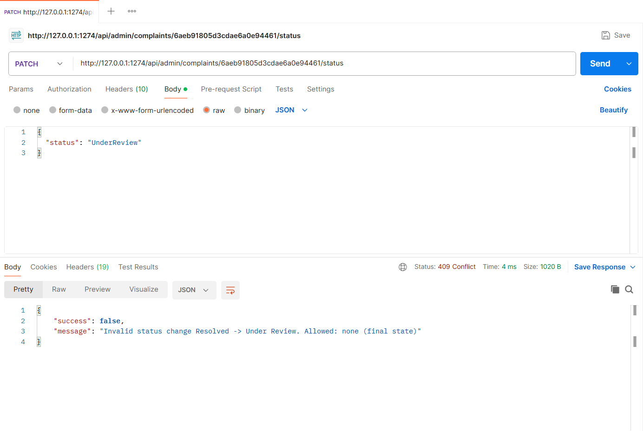
Figure: M4-F2-N4 - Invalid status change on a closed complaint (409)
Suspension without repeated valid complaints (409)
Request | PATCH http://127.0.0.1:1274/api/admin/pharmacies/e9a8e974b7602290887787a9/suspend
Scenario | Green Life Pharmacy does not meet the suspension threshold.
Body / Parameters | JSON body:  {  "reason": "Testing the threshold rule"  }
Result | Expected 409 Conflict; returned 409 Conflict

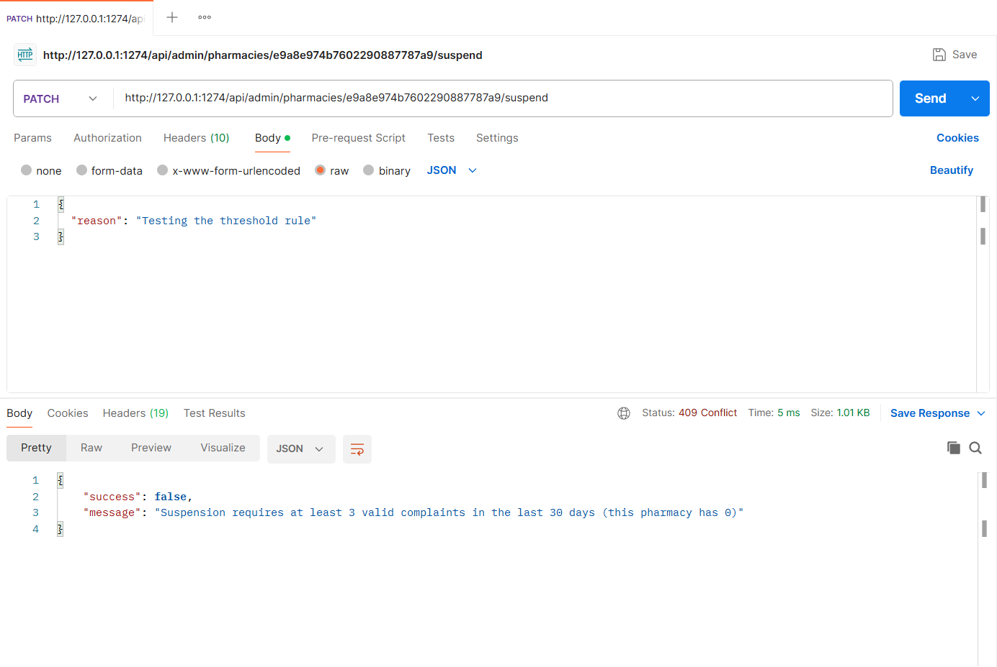
Figure: M4-F2-N5 - Suspension without repeated valid complaints (409)
Implementation Notes
Project | MedFind BD - medicine availability and reservation platform (CSE471, Group 02, Section 03)
Tech stack | Node.js, Express.js 5, MongoDB (MongoDB Atlas in deployment, local replica set in development), Mongoose 8, JWT + bcrypt, Multer + Cloudinary (local-disk fallback), node-cron, zod validation
My server | cd backend  npm install  npm run seed  npm run start:member4  -> http://127.0.0.1:1274/api/health
Environment | backend/.env (copy of .env.example): MONGODB_URI, JWT_SECRET, PORT_MEMBER1..4, CLOUDINARY_*, SENDGRID_API_KEY, business-rule settings
Postman | Import postman/Member4/Member4_23301274.postman_collection.json, run the "00 Setup" login requests (if present), then run each feature folder top to bottom. File fields use postman/assets/*.
Architecture | routes (URL + middleware) -> controllers (HTTP in/out) -> services (business logic) -> Mongoose models. Central error handler returns { success, message, errors }.

Database connection (src/config/db.js):
const mongoose = require('mongoose');
const env = require('./env');

mongoose.set('strictQuery', true);

async function connectDB(uri = env.mongoUri) {
await mongoose.connect(uri, { serverSelectionTimeoutMS: 10000 });
const { host, name } = mongoose.connection;
console.log(`[db] connected to MongoDB ${host}/${name}`);
return mongoose.connection;
}

async function disconnectDB() {
await mongoose.disconnect();
}

module.exports = { connectDB, disconnectDB };

