Author: Chanho Yang

ISU Netid : chanhoy  
Date :  March 7th, 2023

The promise was first pending, and then it became fulfilled after finishing the execution.

The result is undefined.

The promise was first pending, and then, it became pending after the execution. The result is undefined. And, in running timer, it shows the error what is caught during the execution.

5.

1)Then. has been added so that if the promise is resolved and receives a result a value, then the first argument of .then runs. On the other hand, the second argument of .then runs. Also, the function has been added to show the message.

2)

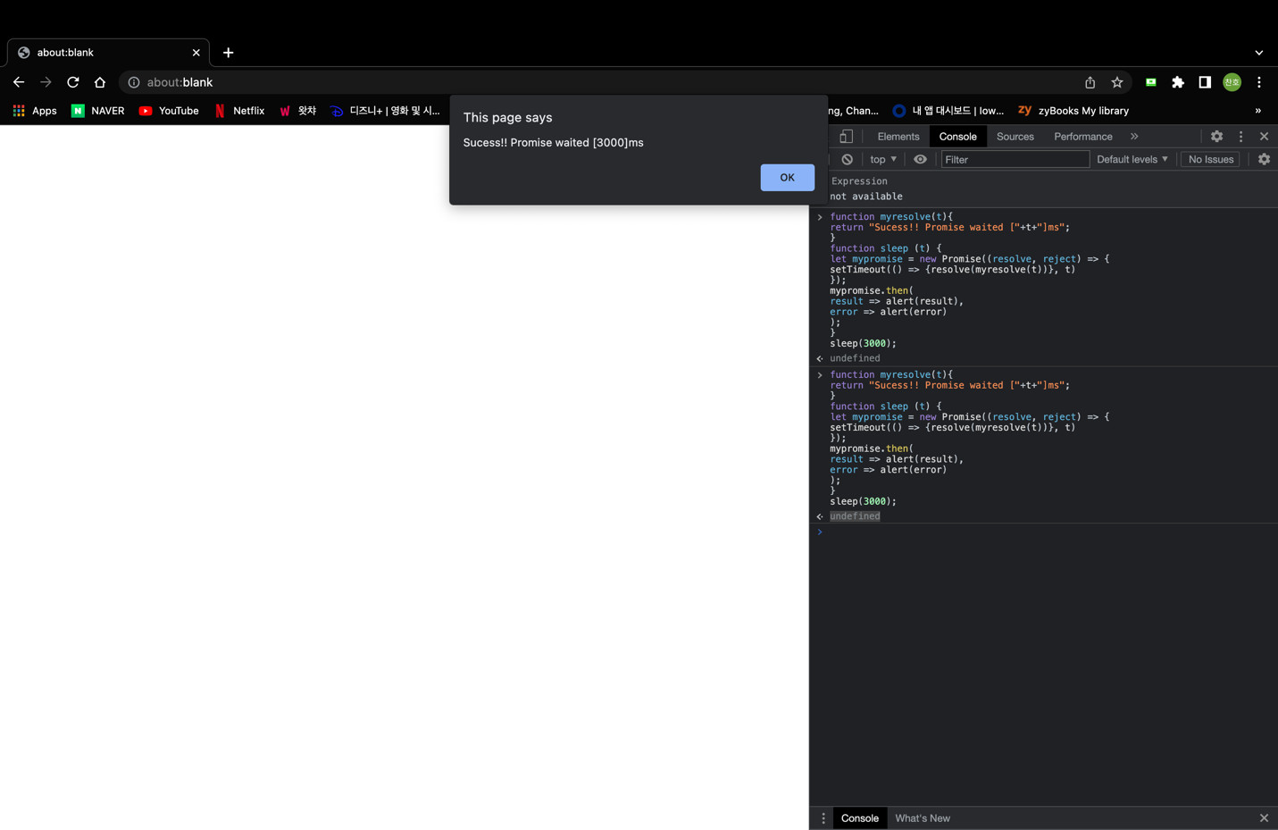

Because the promise is resolved and receives a result value, the first .then argument runs. And, the message pops up and shows the return value of the first function.

6.

1) .then has been added and the function which shows the message of error has been added, as well. This works with basically same principal.

2)

The second .then argument runs because the promise is rejected and receives the result an error. And, then the message pops up and shows the return value of the first function.

