Project: Retrieval-Augmented Generation (RAG)

1. Name of Project
Rare Disease Knowledge Assistant

2. Business Details about Project
Rare disease information is widely fragmented across disparate sources, including clinical trial registries, genetic databases, medical literature, research papers, and patient advocacy documentation. Patients, caregivers, researchers, and clinical teams struggle to synthesize this information efficiently to evaluate disease symptoms, genetic mutations, diagnostic options, and specialist referrals.
This project delivers an AI-driven Retrieval-Augmented Generation (RAG) assistant designed to centralize and synthesize unstructured rare disease documents into structured, reference-backed medical insights. By providing reliable citations for every answer, the platform minimizes hallucinations, accelerates clinical decision-making, and drastically reduces research overhead for care teams and researchers.

3. Technical Details about Project
The Rare Disease Knowledge Assistant integrates semantic vector search with a targeted LLM generation pipeline using Python, LangChain, ChromaDB (an open-source vector database), and OpenAI models (text-embedding-3-small and gpt-4o-mini).

Architecture & Data Flow
- Ingestion & Metadata Tagging: Unstructured rare disease overview files, clinical literature, and genetic datasets are chunked using RecursiveCharacterTextSplitter. Chunks are annotated with strict metadata identifiers, including source IDs, document titles, disease names, and specific sections.
- Embedding & Vector Storage: Vector embeddings for document chunks are generated via OpenAI's text-embedding-3-small model and indexed in ChromaDB for high-throughput similarity search.
- Contextual Retrieval: When a user submits a query regarding a specific condition, ChromaDB conducts a similarity search to retrieve the top-k most relevant knowledge chunks alongside their metadata.
- Structured Prompt Synthesis & Generation: The retrieved chunks are structured with reference tags and fed to gpt-4o-mini alongside a system prompt enforcing clinical summary templates (Overview, Genetic Causes, Symptoms, Diagnostics, Treatments, Referrals) and strict source citations.

Technical Considerations
- Scalability & Performance: ChromaDB provides efficient persistent storage and fast similarity searches as medical knowledge databases scale.
- Data Privacy & Security: API interactions with OpenAI are strictly constrained to query processing. Local data can be containerized, and sensitive patient interactions are isolated from vector persistence layers.
- Hallucination Mitigation: The pipeline enforces deterministic context groundings (temperature setting set to 0.0) and requires source attribution for all output categories.

4. Implementation (in 5 lines)
Step 1 – Initial setup/data ingestion: Import core dependencies (LangChain, ChromaDB, OpenAI), define configuration variables, and format rare disease document records with clinical metadata attributes

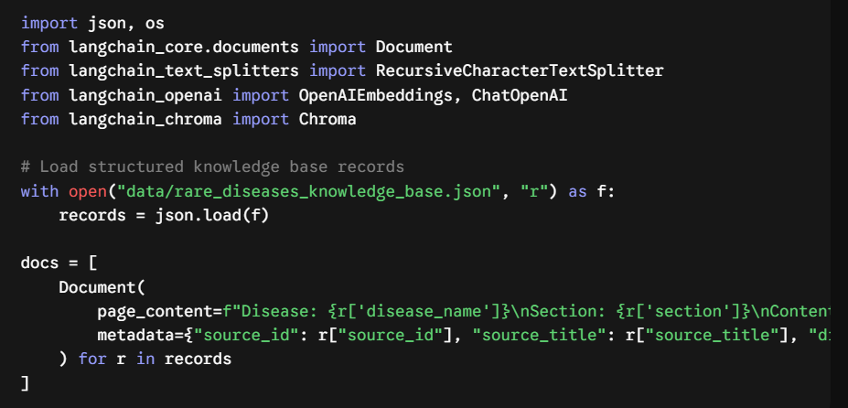

Step 2 – Retrieval process: Split complex medical documents into contextual chunks and generate vector embeddings using ChromaDB and OpenAI.
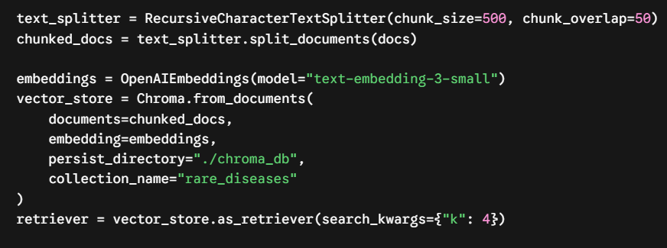

Step 3 – Generation step: Formulate a structured prompt template requiring standard clinical headings and citations, then execute the generation chain using gpt-4o-mini

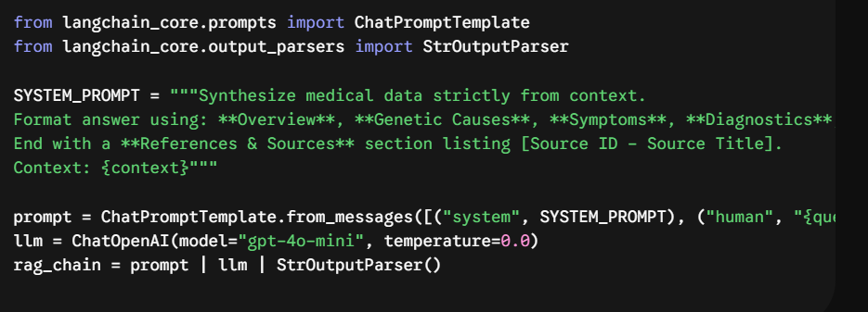

Step 4 – Integration/User Interface: Bind retrieval contexts into the generation pipeline to deliver reference-backed answers for medical queries.

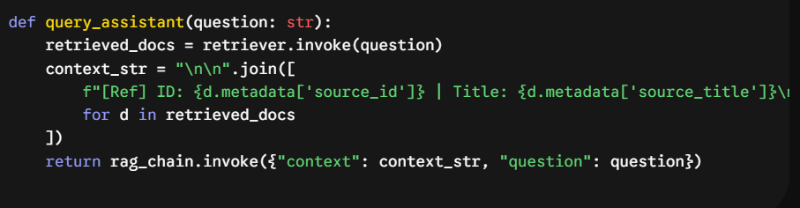

- Step 5 – Deployment/Monitoring: The solution is packaged as a modular Python service ready for API integration (e.g., FastAPI, Streamlit) with response validation against medical knowledge source IDs.

5. Sample Input and Output
- Sample Input: "What are the genetic causes, diagnostic tests, and specialist referral needs for Huntington's Disease?"

Sample Output: Disease Overview & Prevalence Huntington's Disease (HD) is a progressive neurodegenerative disorder.
Genetic Causes & Inheritance Patterns
- Caused by an autosomal dominant mutation in the HTT gene on chromosome 4 involving an expanded CAG trinucleotide repeat (>36 repeats).
- Offspring of an affected parent have a 50% chance of inheriting the mutation.
Key Clinical Symptoms
- Motor dysfunction (chorea, dystonia), cognitive decline, and psychiatric symptoms.
Diagnostic Tests & Biomarkers
- Clinical neurological evaluation paired with targeted genetic testing to quantify CAG repeat lengths.
Treatment & Management
- Symptomatic treatment utilizing VMAT2 inhibitors (e.g., Deutetrabenazine) for chorea.
Specialist Referral Needs
- Movement Disorder Specialist, Medical Geneticist, and Speech-Language Pathologist.
References & Sources
- [GARD-001] NIH Genetic and Rare Diseases Information Center (GARD)
- [NORD-101] National Organization for Rare Disorders (NORD)
- [ORPHANET-201] Orphanet Rare Disease Database

6. Tech Stack
• Core Language: Python 3.10+
• Orchestration Framework: LangChain
• Vector Database: ChromaDB (Open-Source)
• Embedding Model: OpenAI text-embedding-3-small
• LLM Model: OpenAI gpt-4o-mini

7. One Best Benefit for Business
The primary business benefit is drastically accelerating time-to-insight for care teams and researchers by aggregating scattered medical data into verifiable, reference-backed clinical summaries, thereby improving diagnostic speed and accuracy while eliminating manual literature consolidation.

