10.1

Bepaal de x- en y-componenten van vectoren $\vec{a, }\vec{b}, \vec{c}, \vec{d}$ in de figuur hieronder.  
Gegeven is dat a = 19, b = 13, c = 6 en d = 24

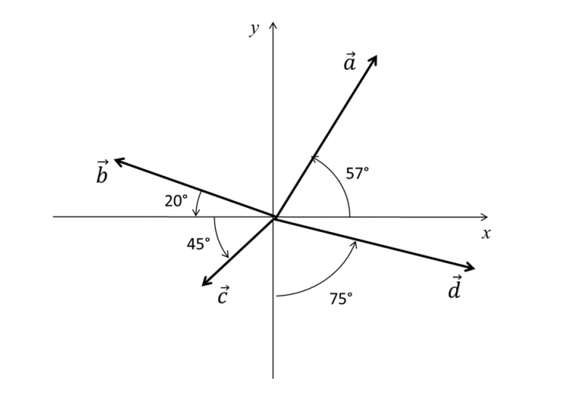

a­x = 19 cos(57°) = 10,35  
ay = 19 sin(57°) = 15.93

bx = 13 cos(160°) = -12,22  
by = 13 sin(160°) = 4,45

cx = 6 cos(-135°) = -4,24  
cy = 6 sin(-135°) = -4,24

dx = 24 cos(-15°) = 23,18  
dy = 24 sin(-15°) = -6.21