**CasparCG-Add-In for Excel – Getting Started**

**Introduction**

The CasparCG-Add-In for Excel allows that Microsoft Excel can be used as a client for CasparCG server. At the core the add-in does not much more, than sending the content of a marked cell range as data to a dataset or a template. Excel’s advanced formula and query infrastructures can be used to format the data, before it is sent to Caspar.

**Installation**

There is a setup program for this add-in, that installs it into Microsoft Excel (for Windows). It is made with a German version of Visual Studio, that’s why the UI of the setup is in German. No panic, I will explain every step here.

|  |  |
| --- | --- |
| Click on “Weiter”. | Select the upper “Ich akzeptiere die…” and click on “Weiter”. |
|  |  |
| Write your name in the field “Benutzername”  and your company into “Unternehmen”, then  click on “Weiter”. | Then click on “Installieren” and let it roll. |

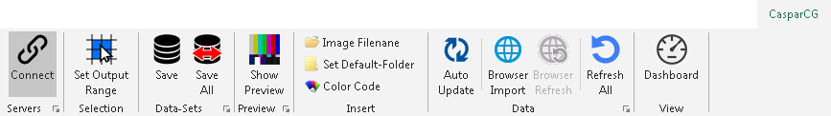**Ribbon Toolbar**

All main settings and functions are accessible from the CasparCG toolbar in the ribbon area of Excel. After the installation of the add-in this tollbar is displayed.

**Servers**

|  |  |
| --- | --- |
|  | This button connects to the CasparCG server(s). The Dialog launcher in the lower right corner (red circle) opens the CasparCG server connections dialog box. |

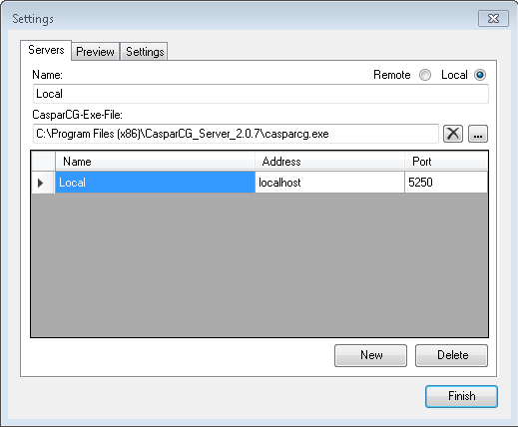

In this dialog the connections to the CasparCG servers will be defined. The “New” button adds a connection, the “Delete” button removes an existing connection. There can be local connections (usually only one), that means the CasparCG server runs on the same PC as Excel.

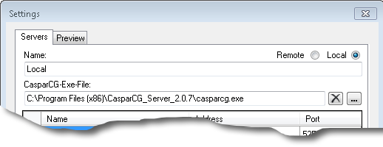

In the “Name” field an informative name can be added. In the “CasparCG Exe-File” box the path to the servers exe file can be given. This will auto-start the server, before the add-in connects to it.

And there can be remote connections, where the CasparCG server runs on another PC.

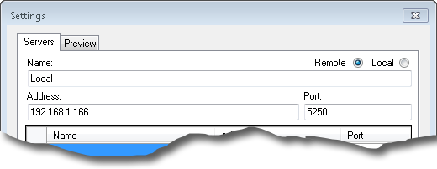

In the “Name” field an informative name can be added. In the “Address” field a network name or IP-address is given. The “Port” defaults to 5250 and usually does not need to be changed.

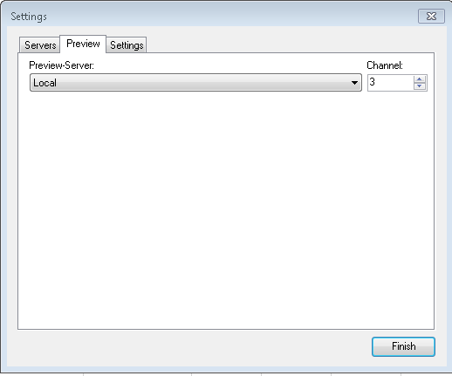

On the “Preview” registry card one of the CasparCG connections can be selected to be used as a preview. The channel of this server can also be selected.

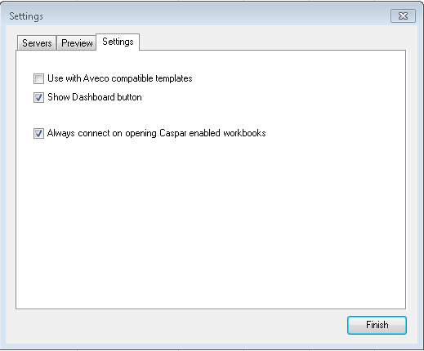

On the “Settings” registry card other settings can be made.

The “Use with Aveco compatible templates” should only be activated, when you use an Aveco Astra studio automation system, because then a few variables need to be named differently.

The “Show Dashboard button” displays the dashboard button on the ribbon. You can deselect that to keep the user interface simpler, when you don’t only want to use Excel as a means to update datasets on the CasparCG server(s).

“Always connect on opening Caspar enabled workbooks” does auto-connect to all CasparCG servers, if at least one output range is defined in the workbook.

**Selection**

|  |  |
| --- | --- |
|  | This button is used to define a range of cells, that are sent to CasparCG. The range is named “CasparOutput”. Per worksheet only one range can be defined. The idea here is to have a worksheet per template or dataset. |
|  |  |
|  | This is an example of the most basic range: In the “A” column the names of the variables, that are sent to CasparCG are listed, in the “B” column the contents of these variables are listed. In this case the template will receive 3 varables: “Title” with the text “Eurovision…”, “Subtitle” containing “Final Ranking” and “Venue” containing “Tel Aviv, Israel”. |

**Data-Sets**

|  |  |
| --- | --- |
|  | These buttons send the content of the selected range to all CasparCG servers connected. The “Save” button saves the dataset of the current worksheet. The “Save All” button saves the datasets of all worksheets.  The dialog launcher shows the following dialog: |

|  |  |
| --- | --- |
| **Sheet Properties** |  |

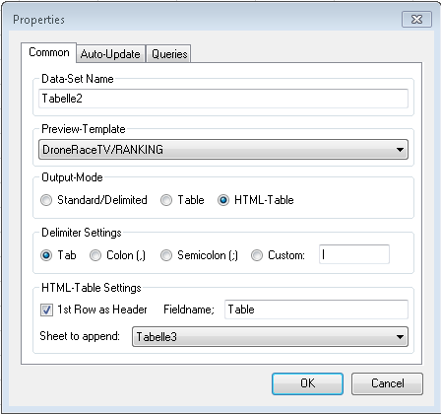

The field “Data-Set Name” defines the name of the dataset of the current worksheet. Under “Preview-Template” a template for the preview function can be selected.

**Output-Mode**

There are tree output modes.

* Standard/Delimited: This is either a basic range, like described earlier or a range that will contain delimited data. If “Standard/Delimited” is activated, the “Output-Delimiter Settings” are used (see below).
* Table: This mode allows to send a range of cell in a “raw” mode. The cell’s address will be used as the name of the variable, for instance A1, B1, A2 etc. The value/text of the cell is sent as the data of the variable. In addition, the XML, that is sent to Caspar, also contains a few additional attributes, like FontName, FontSize, FontStyle, FontColor, Background (Color), HorizontalAlignment, VerticalAlignment, Width and Height. This allows a template to render itself according to these properties. There are no settings for this mode.
* HTML-Table: This mode also sends out all cells in the range. But it does this by putting everything into a HTML-Table tag. If cells in the range are formatted using Excel-Stylesheets, the name of the stylesheet is attached as a class attribute to the cell’s TR tag. This allows a programmer to define a CSS style sheet, that goes along with the Caspar-HTML-template, that defines the formatting of the cells. As Excel allows stylesheet names to contain spaces, all spaces are replaced with underscores (_). In this mode the “HTML-Table Settings” take effect (see below).

**Output-Delimiter Settings**

Sometimes, for templates with tables, it makes sense to put multiple data items into the same variable, using a delimited text format. Here a delimiter can be selected. “Tab” adds a tabulator character (ASCII 9) between each value. “Colon (,)” or “Semicolon (;) are other options. By selecting “Custom and writing something in the associated field a custom delimiter character can be given.

Let’s make an example: This range is defined for a football table graphic.

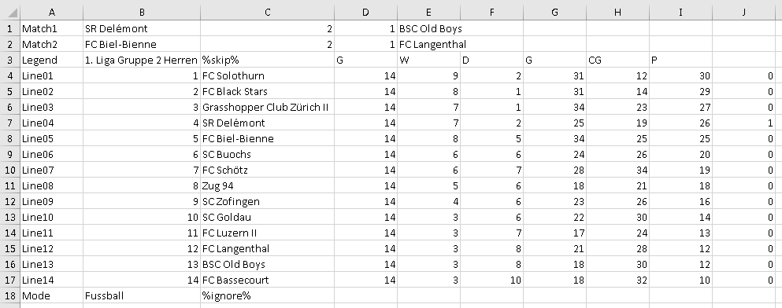

All fields will be filled with the different texts from the cells in their line, separated by the selected delimiter. So, for instance “Match1” Will get the text “SR Delémont<TAB>2<TAB>1<TAB>BSC Old Boys”. While <TAB> stands for the tabulator character ASCII 9.

There are two cell values, that changes the way these texts are assembled:

%skip% (see cell C3) does skip that cell, so that no empty item is added.

%ignore% (see cell C18) does ignore the current and all following cells.

**HTML-Table Settings**

If “1st Row as Header” is activated, the first row of the range will be rendered as “TH” tags instead of “TD”. The “Fieldname” field defines the name of the CasparCG variable, that contains the whole HTML table tag. “Sheet to append” allows to append another worksheets CasparCG range to the template data. This is use full, if the template has a title or other additional information’s.

**Preview**

|  |  |
| --- | --- |
|  | This button, in combination with the settings on the “Preview” registry card and the selected template in the “Sheet Properties” dialog, displays the data in the output range of the current worksheet, as a preview.  The dialog launcher shows also the “Sheet Properties” dialog. |

**Insert**

|  |  |
| --- | --- |
|  | The “Image Filename” button opens a file open dialog. The selected image files path and filename is formatted as a File-URL and inserted in the current cell. That helps to send dynamic images to a template.  The “Set Default-Folder” opens a path selection dialog, that sets the folder from where the “Image Filename” button starts to browse.  The “Color Code” opens a color selection dialog. The selected colors hexadecimal value is inserted into the current cell. As a guide the selected color is also set as the background color of that cell. |

**Auto-Update facilities**

There are a bunch of functions and settings, that are related to the automatically updating of external data. Microsoft Excel contains very powerful functions to import and shape external data, called “PowerQuery”. These queries can feed data to a worksheet, that contains a CasparCG output range. The “Sheet Properties” dialog contains a few settings for this.

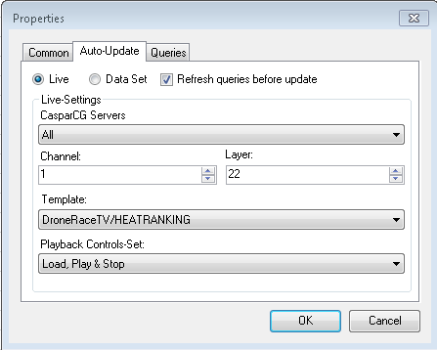

If “Live” is activated, the settings below are valid. If “Data-Set” is activated, a Data-Set is automatically updated, when the data changes.

In the “Live-Settings” group the following settings can be managed: “CasparCG-Server” selects the server that gets the updated data. “Channel” and “Layer” define where the “Template” selected will be shown. Under “Playback-Control-Set” a button set for the Dashboard can be selected.

In the top row of the dialog there is a checkbox “Refresh queries before update”. If that is activated, the following registry card comes into play.

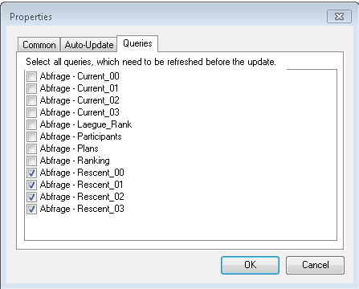

All selected PowerQueries will be refreshed before the data is sent to CasparCG.

|  |  |
| --- | --- |
|  | This button is a toggle. If activated all the auto-update functionality is engaged. If not activated, the auto-update of the current worksheet does not happen. This is use full if the external data is currently not available. |
|  | The PowerQuery inside Microsoft Excel are very power full. Never the less sometimes a query from a website does not show the desired data, because some java-script does not run. In these cases, a “Browser Import” can help. Clicking this button opens the “Browser Import” dialog, that let you open a web page and search for data. See below. |
|  | If a “Browser Import” has been created, this button refreshes the data in the current worksheet from it. |
|  | “Refresh all” first refreshes all browser imports and after that all PowerQueries in the current workbook. The idea behind this is, that a browser import can be the source for a PowerQuery. This helps to shape the raw data that is coming from these browser imports, before they get used in Caspar.  Dependent on the number of imports and queries, this can take a few minutes to complete. |

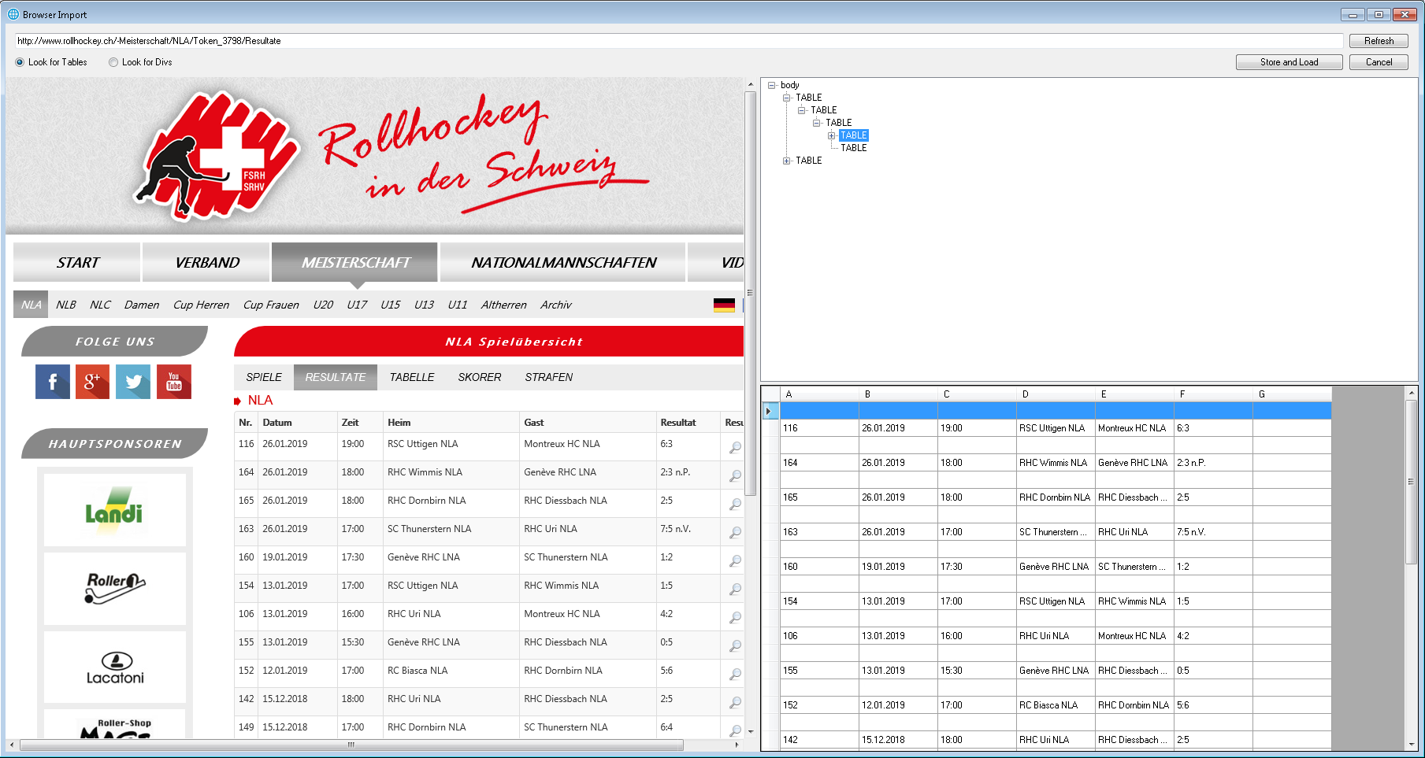

The text-field on top hold the websites address. “Refresh” loads the page in the browser pane on the left. After the page has finished loading, the upper pane on the right is filled with a tree of objects. On the left above the browser you can select, if the tree lists HTML table tags or if it should list div tags. By crawling through the tree in the top right pane, the list in the lower right pane gets updated. If you found the data, that you were looking for, a click on “Store and Load” stores the web-address and the location of the data into the current worksheet and loads the data into it. It also closes the dialog.

This raw list of data can now serve as source to a PowerQuery that shape them the way they can be further used to send to Caspar. This part of the story is handling functions of Microsoft Excel PowerQueries and formulas and are not part of this manual.

**Dashboard**

|  |  |  |
| --- | --- | --- |
|  |  | This button shows the Dashboard. |
|  |  |  |
|  |  | The Dashboard contains a set of playback buttons for every worksheet, that contains a CasparCG output range. The button “…” opens a dialog were the caption and the background color can be set. The button “PVW” plays the preview.   |  |  | | --- | --- | |  | Updates all queries (if any) and loads the template. | |  | If there are queries to update AND the template has not been loaded, the queries are updated before template is played. | |  | The NEXT command is sent to the template. | |  | The STOP command is sent to the template. | |  | If there are queries to update the queries are updated before the template is updated. | |
|  |  |  |
|  |  | The list pane can be used to create a worksheet (page), which is a list of events. Each row will serve an individual event.   |  |  | | --- | --- | |  | This button opens the “List Settings” dialog, see below. | |  | “Create list in document” adds a new first worksheet, with columns according to the settings in the “List Settings” dialog. | |

|  |  |
| --- | --- |
|  | The “List Settings” dialog sets the properties for the “List” worksheet.  “CasparCG Server” selects the server used to playout the items of the List.  “Default-Channel” and “Default-Layer” set the default channel and layer used when creating a new entry (row).  “Playback Control Set” sets the buttons that are visible in the playback area.  “Create-List-Datafields” contains all data-fields (or variables) that the list should contain, to be sent to templates. Separate fields by a new line.  Auto-Clear sets the effect and duration for auto clear. |

This is how the “List” worksheet looks like:

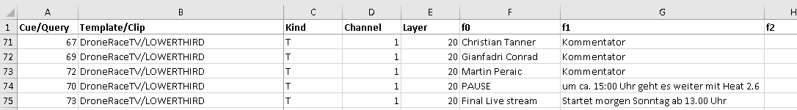

|  |  |  |  |  |  |  |  |  |  |  |
| --- | --- | --- | --- | --- | --- | --- | --- | --- | --- | --- |
|  |  | The “List” pane of the dashboard is used to add and update the entries (rows) of the list. The upper set of buttons are used to add entries of different type.   |  |  | | --- | --- | |  | Select the current entry (row) to be a template. Writes “T” into the “Kind” Column. The dropdown-list field contains all templates on the server. | |  | Select the current entry (row) to be an audio clip. Writes “A” into the “Kind” Column. The dropdown-list field contains all audio clips on the server. | |  | Select the current entry (row) to be an image. Writes “I” into the “Kind” Column. The dropdown-list field contains all images on the server. | |  | Select the current entry (row) to be a video clip. Writes “V” into the “Kind” Column. The dropdown-list field contains all video clips on the server. |   “Refresh Lists” refreshes all the lists in the dropdown list fields. Click this if you added templates or media files to the server.  “Query” opens a dialog box that let you choose one of the PowerQueries defined in the workbook to be refreshed before the items play. |

**List columns and what they are for**

|  |  |
| --- | --- |
| Cue/Query | Contains a cue-number (automatically). This number can be changed, if a script with cue numbers for the show exists. If a query has been selected, this column contains the name of the query enclosed in curly brackets {}. |
| Template/Clip | Contains the name of the template or media clip. |
| Kind | Contains a “T” for template, a “A” for an audio-clip, and “I” for an image or a “V” for a videoclip. Used to send the correct command to Caspar. |
| Channel | Sets the CasparCG channel to use. |
| Layer | Sets the CasparCG layer to use. |
| f0… (data fields) | Contains the data fields, that are sent to templates. If a query has been selected, it would make sense to add formulas, that query-data appears in these cells. |
|  | The empty column ends the list of data fields, as it can be of variable length. |
| Loop | For audio and video-clips: Write a “1” into this column to let the clip loop. |
| Effect | For audio and video-clips: The name of the effect to use on playback. Valid: “Cut”, “Mix”, “Push”, “Slide” and “Wipe”. If the field is empty a “Cut” is used. |
| Duration | For audio and video-clips: The duration of the effect in frames. |
| Direction | For video-clips: For “Push”, “Slide” and “Wipe” effects: the direction of the effect. Valid: “Left” and “Right”. |
| Autoplay | For audio and video-clips: Write a “1” into this column to let the clip auto-play after load. So that the clip playing on the same channel and layer is immediately followed by the current clip. |
| Show 1st Frame | For audio and video-clips: Write a “1” into this column to let the clip cue on the first frame, other ways black is outputted. Don’t use this together with “Autoplay”. |
| Auto Clear | If set to “1” the file will stop an clear. Set the effect for doing this in the “List Settings” dialog box |

|  |  |
| --- | --- |
|  | The “Show Preview” button in the ribbon can also be used to preview the current item (row). |

**Additions as of March 2020**

These additions are partially sponsored by Pipervision of Italy. It consists of these parts:

**Dashboard**

The Dashboard can now move freely on the desktop and can also pulled out of Excels main window.

**View Pane**

|  |  |
| --- | --- |
|  | The “List-pane” button shows or hides the portion of the Dashboard, that is used for the list.  The “Timer Groups” button shows or hides the timer related user interface.  The “Sheet Props” button opens the Sheet Property Dialog. |

**Timer Groups**

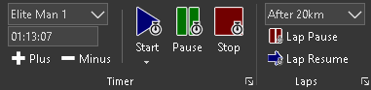

A number of timers can be defined. These were handled in the left group of user interface controls and can be defined by clicking on the dialog launcher on the bottom right corner of this area. In the right group the laps are handled. The dialog launcher shows the dialog to define them.

**Timer Settings Dialog**

|  |  |
| --- | --- |
|  | The list on the left contains all defined timers. On the right you can set the various options.  The “Name” contains the name of the timer. Can be a category etc.  The “Preview format” selects the display for the little preview text box.  “Timer can use Laps” and “Timer can be paused” do just what it says. “Inhibit query on stop” prevents the dialog to confirm the stop action.  “Start from (Offset)” allows to start the timer from another time than zero. See below.  The “Triggers” section allows the control of another timer together with the selected one. Therefore, two dropdowns for each action are provided. The first selects, what action to perform, the second on what timer. |

The “Distance-Simulator” section is used to calculate an estimate of the distance for a running or cycling competition. The “Whole distance” contains the distance of the whole course. Enter the number in meters or yards. The “Part…” contains a part of the distance and the time contains the time it takes to go this far.

The “+” button adds a new timer. The “-“ button removes the selected timer. The duplicate button in the middle create a duplicate of an existing timer. If it has laps defined for that timer, these were also copied.

**Timer Group**

|  |  |
| --- | --- |
|  | You select the current timer in the combo-box in the top left corner. Bellow you see the preview of that timer.  “Plus” adds one second, while “Minus” subtracts a second.  “Start” starts the timer from zero, “Pause” suspends it, if that option is activated in the settings and “Stop” stops the timer.  In the flyout below the “Start” button you can “Start from offset” and you can “Set the start offset…” |

**Set the start offset dialog**

|  |  |
| --- | --- |
|  | This dialog combines the possibility to set the start offset with the buttons to start and stop the timer. You can set the offset here and close the dialog to use the “Start from offset” button, or you could use the buttons in the dialog. |

**Laps Dialog**

|  |  |
| --- | --- |
|  | The list on the left contains all defined laps. On the right you can set the various options.  The “Name” contains the name. It can denote a distance etc. The “Time” is the time, that is captured.  If the lap is used for the “Distance-Simulation” you can “Enable” that and you can set the distance here.  If you want to write the captured time to a worksheet you can do just that.  “Worksheet” selects the worksheet, “Cell” the cell to write into and the “Display format” selects how the time is formatted.  “+” and “-“ add and remove a lap. |

**Laps Group**

|  |  |
| --- | --- |
|  | You select the current lap of the currently selected timer in the combo-box on the top.  “Lap Pause” does capture the time and triggers all actions, that were previously defined in the Laps dialog..  “Lap Resume” resume the timer display updates.  If you just want to do a lap, whit out any processing, you can select “(None)” in the combo-box. You then still can lap-pause the timer, but none of the defined actions will take place. |

**Timer Sheet Properties**

|  |  |
| --- | --- |
|  | The sheet properties dialog has a new tab called “Timer” where you define the fields, that are updated by the timers.  In “Field-Names” you set the name of the template-field.  In “Timers” you select the timer supplying the timing data.  And in “Query-Values” you select the format of the data. There are a lot of possibilities and different ways to format the data. Beginning with “Lap” you get the display that stops, when a lap is taken. The ones beginning with “Main” do not stop. Then there are “Raw Distance” and “Formatted Distance” entries. The first shows no unit and no thousand separators, while the later do. |

**DVE Sheet Properties**

|  |  |
| --- | --- |
|  | The sheet properties dialog has a new tab called “DVE” where you can define a DVE for the template to move or size it.  “Use DVE” enable this functionality.  In the “Position” group you can move the template around. The double arrows move ten pixels while the single arrows move one pixel. The circle button in the middle resets to center.  The “Zoom” group works very similar.  The “Copy” and “Paste” links can be used to copy a DVE to another sheet.  The “Preview” group are used to preview the effect. If you activate the “Preview” button you will see the effect on the preview out. By activating “Program” you see it on the Program out. You need to play the template to these outputs before you open the dialog. |

**Auto-Update & Live Sheet Properties**

|  |  |
| --- | --- |
|  | The Auto-Update & Live of the sheet properties dialog also has a few new features.  Using the “Slave Worksheet” combo-box you can select another worksheet that is played out together with the current sheet. All settings of the selected worksheet must be made individually, only the playback controls of the slave worksheet will not be displayed in the dashboard, instead every time a playback function of the current sheet is triggered, the slave sheet will follow.  The “Change Template-Path…” button opens a dialog box to adjust all templates in the whole workbook (all sheets) if they are in another folder on the current CasparCG server as they were on the machine the Excel-file was created.  By the way: If you activate the corresponding setting in the settings dialog you see a “Flash-Layer” parameter. Use this functionality only when you need it badly. Using Flash layers has a performance penalty. |

Media Support – Didi Kunz – June 2020