**Djerba Yesteryear and Yesterday**

**Author : Wadï Mami**

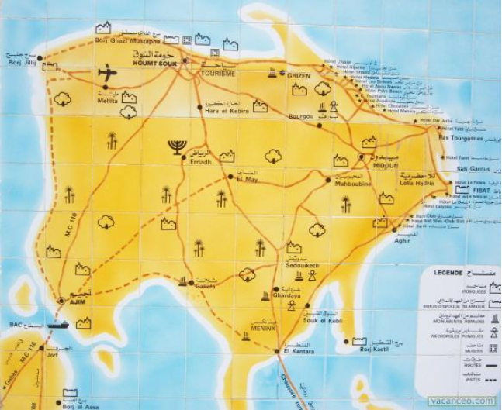

التاريخ في ظاهره لا يزيد عن الإخبار

وفي باطنه نظر و تحقيق

ابن خلدون

History, outside, looks only news

Inside, a look and an inquiry

Ibn Khaldun

**Introduction**

Under a rubric about England, a famous English author had written : « Dear reader, don’t you know ? England is an island !!! »

I replied that is the question ?

Indeed the question may appear bizarre, but the unknown well known writer wanted to stress something to catch readers’ attentions. « To live in islands is quite different from living in continents, there are moral organizations, mores, habits, social usages that differ from continents’ ones.

In fact, between islanders there is a code we didn’t find it elsewhere. Islands’ nature imposes to their inhabitants mutual solidarity and union to endure loneliness pains which makes them an independent people.

Moreover the houses are close which forces inhabitants to an individuals’ neighbours coalition and to a strong union to support the remoteness’ penalties and isolation’s consequences. Therefore their separation itself makes them a nation.

These qualities noticed by researchers, anthropologists, are commonly generalized for most islanders scattered all over the world’s seas and oceans.

Let’s take for example Corsica which is not far from north of Tunisia or Sicily, Malta, Cyprus… We find a great life resemblance among their inhabitants: a union, a racist coalition, a help spirit for better and for worse. A kind of qualities not shared with their continents’ pairs.

For the same reason Djerbians are different from other Tunisian country’s people.

The Djerbians are known by their labour activity, their courageous struggle and their life endurance.

Forever, they were doomed to leave the island to new horizon taking risks by immigrating to new lands. Meanwhile they try to gain money honestly assuming many privatizations.

The Djerbian was even an adventurer, he braves all difficulties and he solves life problems wisely to carry out his business in order to earn and save goods apart. He spares money, he is economical, he is generous but not prodigal nor spender.

The ambition of every Djerbian trader –mainly grocer- is to invest, once back home land, in building a beautiful comfortable house with a garden (palm trees, olives and fruit trees around). There he will spend his retirement in peace. He also invests in other commercial branches to secure a pension that would help him retire when he reaches a certain age, an age when he would no longer be able to continue his yesteryear's activity.

Thus we had known Djerbians and so they had been known by our fathers, grandfathers, our ancestors and all who settled down Djerba or had often dealt with Djerbians.

Besides a Djerbian saying states: « when a Djerbian comes back home, do not ask his family how long he has been away? But what has he brought?

Hard works, seriousness, endurance and perseverance are among the Djerbian qualities, qualities envied by all those who know and venerate the work, its value and consider it as a simple and effective way to raise the country and ensure its development and its rise. Furthermore the island’s inhabitants fight for liberation and protection against misery and need.

Before, the Djerbians’ mercantile mentality has left them reluctant to the idea of embracing civil services or the government and its services. They don’t want to be under leader’s authority. In fact, they particularly prefer the free trade and trades, they rightly claim more lucrative. That does not mean they adopt the maxim « high risks high returns ». But, (mainly grocers), their choice can be profitable only after a long experience, a continuous relentless practices and tasks’ accomplishment with a lot of seriousness and patience.

Without disgusting any job so painful, to achieve the desired result and succeed in life. The Djerbian applies the maxim : « There are many fools but no foolish jobs »

Maybe we are unfairly taxing the Djerbians with cupidity and avarice. However, these so called kind of behaviours are in reality wisdom and skill’s qualities because countries with poor or infertile lands cannot ensure in any case inhabitants’ food self-sufficiency despite all the efforts made to obtain best and abundant harvests.

Indeed trade, immigration searching for work and gain remain for islanders and especially the Djerbians the main recourse to get out of business and succeed in life with obviously keeping in mind economy and savings.

The wise Djerbians know that prodigality, wasteful expenditure, vanity and wealth false appearance are the greatest economic and socials factors of underdevelopment that systematically lead to people’s decadence and failure. This is what a great Arab poet had said about it : « Friends prodigality has ruined those so called generous ones ».

And who among us does not know or knew some Djerbians who started their lives as mere quarter grocers to become after a few years of labour and perseverance, in unbearable conditions, rich persons owing many shops and properties. While the most lucky retired officer earns a pension that suffices his needs.

On the other hand begging is unknown in Djerba and the true Djerbian never dares to reach out to beg for alms. No Djerbian family, however poor it is, lives at the expense of another and the poorest Djerbian one works day and night to ward off misery and live from the sweat of his brow.

Sometimes we wonder about the origin of these noble characteristics that distinguish the inhabitants of Djerba. The answer is simple, just review the sacred principles and the main causes which characterize the islanders and the true, sincere and cordial socialism to which the old Djerbians had attached themselves to.

Unfortunately, times have changed and everything has changed with. Even the usages have changed, and today’s Djerbians have adapted to the actual new life following old Tunisian proverbs saying : « To learn to swim you have to follow the stream » or «  Do like your neighbour or move the door of your house ». And another says : « Follow the course of the river you will reach the sea ».

« A hundred years ago in this same place another traveller as desperate as me mourns the disappearance of what I will have seen and who has escaped ».

Claude Levis Strauss

**Happy who like Ulysses lived in Djerba**

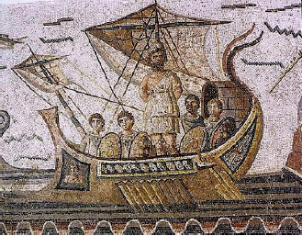

[**http://remacle.org/bloodwolf/poetes/homere/odyssee/livre9.htm**](http://remacle.org/bloodwolf/poetes/homere/odyssee/livre9.htm)

62 »We embark, happy to avoid death, but heartbroken to have lost our

companions. Meanwhile, our ships tossed by the islets do not advance

before we have called three times the unfortunate warriors who perished

on this shore conquered by the Ciconians ( 03 ).Then Jupiter, the god who

commands the clouds, sends us Borée accompanied by a terrible storm,

and he hides under the thick clouds the earth and the

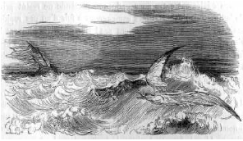

waves: suddenly a dreadful night falls from the sky. Our

ships are swept across the seas, and the sails are torn

to shreds by the violence of the winds. We, fearing to

perish, we bend the sails, and we immediately move

our ships to the mainland. For two days and two nights

we stay on this beach members overwhelmed with

fatigue and heart devoured by grief. But as soon as the

morning girl, Aurora with the beautiful hair, has

brought back the third day, we raise the masts, we

unfurl the sails, and we place ourselves in our ships

guided by the winds and by our pilots. I hoped at last

to arrive happily in my homeland, when doubling the

Malé cape I see myself surrounded by the violent

Borée, by the waves and by the fast currents which

push me away from Kythera.

For nine days I wandered on the sea full of fish, carried

away by the impetuous breath of the winds; but on the

tenth day I finally reached the land of the Lotophages,

people who feed on the flower of lotos ( 04 ). Then we

go down to the shore, we draw water from the

fountains, and my companions take their meals from

our fast ships. When they have finished eating and

drinking, I choose two of my warriors and send them,

accompanied by a herald, to find out who are the

inhabitants of these places, who eat the sweet fruits of

the earth. They leave and arrive soon near the

Lotophages, who, far from meditating the loss of my

companions, give them lots to taste. The warriors who

ate this excellent fruit did not want to come back to

realize the message; but they wished to remain among

the Lotophagi to gather the lotos and forget their dear

country. However, I drag them by force towards our

hollow ships, and despite their tears I tie them with

ropes on the rowers' benches. Then I order the other

Greeks to get on our ships quickly, lest they, by eating

lotos, also forget their native land. My companions are

immediately placed on the benches, and all seated in

order they strike with their oars the sea whitening.

105. With heart broken with pain, we abandon these

ribs;

Homer Odyssey

BOOK IX

**Djerba**

If you want to go for a cure, go to Djerba.

The mild climate, the breeze’s coolness, the brightness that bathes the landscape, the countryside's laughing aspect, the gardens’ luxuriance, inhabitants’ affability, the economic activity, the work’s song that goes from the weavers’ workshops, fisherman's melodies at the ports repairing their nets, legends’ poetry and the history’s teachings : all these are factors to seduce at the same time the mind, the sight and the heart.

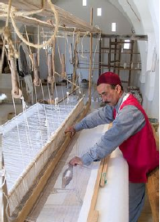

A traditional Djerbian weaver

They surround the traveller's mood of such scents of wild flowers, happiness, curiosity always awake and immediately satisfied let go to joy of living in a perfect balance.

It is not laziness that distils the atmosphere but a kind of beatitude that, if it does not erase the county’s attachment or mother land’s duty as it happened to Ulysses’ companions, at least, it steals the notion of time.

From the continent, we are already in love with this island which by far seems a floating terrestrial wreck. It emerges so little above the waves that instinctively, we stand on tiptoe to better embrace look : only Palm trees’ boles and their leafy tops stand out. As the poet Millevoy has written « go swinging their soft colonnades ».

Boughrara sea, called by Djerbians (bahiret) or little sea, communicates with the Mediterranean on the west by the Ajim canal, and on the east by the Borj Kastil canal. It is a vast inner harbour admirably sheltered where the water’s depth sometimes reaches fifteen meters.

At the time of the Romans, it had on its west edges, at the end of a channel which put it in communication with the pit that separates the Jorf of Ajim, an important emporium : « **Gightis** » which was an important city from which Mercury and Seradis’ temples, the forum’s colonnades and a whole marbles’ mass and mosaics stand out.

The Ajim channel is of short length about (2500M) and its water is deep. On the other hand, the El kantara canal is longer, around (7500M), but it is only suitable for low draft boats. The boating industry has established and prospered there and was the main reason of clear hostility to the idea of repairing the Roman roadway of which one can still see the solid seats supporting the telegraphic line’s poles. A little to the west, vestiges of this causeway exists : a real ford, which at low tide, is barely covered with 60 cm of water : the Trik Ejmel or (Camel way)

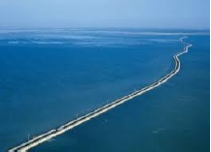

The Roman roadway

A prodigal boatman in "salamalecs" boasts about the speed with which his boat splits the waves. It's the best of all the El Kantara flotilla, he asserts. It appears to be loaded with autumn and winter goods. But really of a very low tonnage to be able to transport from one bank to another, the comfortable car which brought us from the continent of SFAX to El Kantara.

The difficulty is quickly overcome; another Rais is requisitioned; he directs his boat to the first boat, and flank against flank, here they are tied up. Two thick planks are quickly placed across this twin convoy and fixed as well as possible with the help of ropes which have been stricken by the wear of time.

The (10CV), the car, moves forward on this makeshift bridge while a Bahri (sailor) deploys and slowly hoist a sail whose Antislhene's coat must be shy, due to the innumerable patching it had to undergo giving the illusion of a new kind of puzzle. Another (Bahri) was armed with a net and was not to be the least active of the crew because the bottom of the two boats offered with a skimmer a disturbing relationship.

The wind is favorable to us. The crossing takes place quickly. An hour after our embarkation, we dock near the places where ... Meninx stood.

According to L Vaillat (The necklace of jasmine)

Edition of the craftsman. Paris

**MONOGRAPH OF THE ISLAND OF**

**DJERBA By A.Brunaud**

« Bismillahi Er Rahmami Er Rahim »

« In the name of God, the Gracious, the Merciful. »

From ancient times, "Djerba Island" has had its place in history and there are few ancient or modern authors who dealt with Africa without at least mentioning it. But so far no complete work has been undertaken. Unique in its geography compared to the Africa's Roman province, the late member of the Institute, Mr. Charles TISSOT, dedicates a few pages of which the archaeological data have been of precious help... Gathering these scattered documents in the ancient or modern books and in the manuscripts found in the country, joining to them the fruit of our observations during our stay on the island, to make a whole to know this little piece of land that we have agreed to call « Tunisia's garden » was the purpose of this modest study and it was not an easy task.

We would also believe that we were missing a sacred duty, if we did not give our thanks to Mr FERAUD, Plenipotentiary Tangier France Minister, to Mr. POIGNON, General Tripoli France Consul of Barbaria, to RP DELATTRE, the learned missionary and archaeologist of Saint-Louis of Carthage, who kindly showed us the way and to our countryman and friend M. Patrose with whom we have so often traversed the island in all directions, and who has so obligingly placed at our disposal his great knowledge of the country.

A.BRULARD

Lieutenant at the 24th Foot Hunters Battalion

Villefranche-sur-Mer, May 1st, 1885

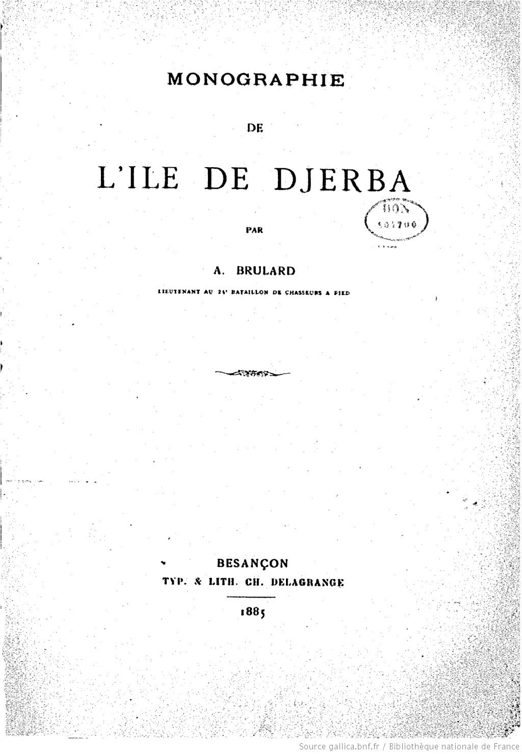

**Island's name Origin**

Should we believe in the legend that made Djerba the famous Calypso's island, and seek there the goddess' cave. This cave, on the slope of a hill from where we discover the sea sometimes clear and united like an ice cream, other times wildly irritated against the rocks where it brokes moaning and raising the waves like mountains.

We do not think so; because no point on the island has seemed to us to be capable of inspiring such ardent imagination with such descriptions, very poetic, no doubt, but too unlikely.

Must we also believe with the contemporaries of STRABON[1] that this island served as a refuge for Ulysses pursued by the anger of the Gods and look for this hero's altar and any other trace of his passage?

It is unthinkable either. Indeed, the land of the lotophages had been mentioned by Herodotus, then by Homer on which STRABON has based his theory, a theory that applies to all the little Sirte which is also called in the journey of Syclax Sirte Cercinnitique, and in STRABON? Lotophagic Sirte.

Therefore, it is in this large sense that we must interpret the Odyssey, and to rather admit, as more probable, that the Lotophages' island was only known to the Greeks after the Cyrene's first explorations. The only Punic name that comes close to the Greek name is THEOPHRASTE's Zizyphus. It refers a plant species similar to the lotus.

As for the name of Meninx, by which, Djerba, was designated either simultaneously, or afterwards, everything suggests that it is of Libyan origin, and that the island was one of the main centers of the primitive race that occupied northern Africa before the Phoenicians' arrival. The Berber element that still dominates today is yet a proof.

Towards the middle of the third century, at the time when Gallus and Volusianis were elevated to the dignity of august, the name Girba was substituted for that of Meninx.

The Aurelius Victor's passage in his Caesars' history « Créati in insula Méninge quae nune Girba dicitur » leaves no doubt in this regard. It is from this word Girba that came by contraction the present name of Djerba.

There is still this ancient legend that brings the name of a golden statue called "Jerba", very venerated of the ancients and which would had been found in a church, now in ruins located in a city which was occupied by the Greeks west of El Kantara.

Another popular legend, no less humorous, said that a Berber king had an only daughter who had scabies and that her doctors admitted that they could not cure her despite all the care she had been given. A saga magician advised the king to isolate his daughter in a quiet site with beautiful greenery and where the water is soft and the air is pure. The king then chooses the island of Djerba that met the recommended criteria. After a stay in the place, the king's daughter was miraculously healed, and the island was nicknamed since: "Jaziret Ej Jarba" (the island of the mangy).

**Holiday**

Scorpions[2]

Let me take you far away

You'd like a holiday

Let me take you far away

You'd like a holiday

Exchange the cold days for the sun

A good time and fun

Let me take you far away

You'd like a holiday

Let me take you far away

You'd like a holiday

Let me take you far away

You'd like a holiday

Exchange your troubles for some love

Wherever you are

Let me take you far away

You'd like a holiday

Longing for the sun, you will come

**To the island without name**

Longing for…

**THE ISLAND OF DJERBA**

**Situation, outlines, limits**

The island of Djerba is located at 9 ° 10 'longitude and 33 ° 40' north latitude, at the southeastern limit of Gabes' Gulf, which is south-east of the small antique Sirte.

Its position gives about 150 km distance between Cape Kaboudia and Djerba and 111 km at the opening of the small Sirte, measured between Cercinna and Méninx.

It is separated from the mainland by two canals:

1. **The eastern canal** between Rass Ech Chemmakh and the Bougal's tip, 5 km wide and narrowing to its inner end where it is only 2.700 km long. Moreover, Kaliates and other rocky islands form a dam over almost its entire width, leaving a channel four meters to the east, which is almost 1 meter to the west towards the entrance to the inner basin. Two passages at low tide make it possible to communicate with the continent, one by Tarbella, but requires a great knowledge of the path to follow; the other called by the Arabs "Trik Ej Jmal" (Camel Trail) and which is none other than the Zitha Bridge of ancient routes from El Kantara. The few remaining vestiges found there led to conclude the existence of a certain old road with drawbridge. It is apparently the way that the Arabs of the continent took to drive the camels they stole to the Djerbians[3].
2. **The western channel**, whose depth varies from 3 to 22 meters, offers only a very narrow channel, which is bordered on the continent side by fairly high escarpments.

The dimensions of these two channels, which therefore allow navigation only for boats of low pulling, have also undergone serious changes since ancient times...We have learned that the Mediterranean coastline, mainly from Djerba to Tripoli, has suffered a series of subsidence since Roman times. This was supported by the presence of vestiges of Roman constructions and on the disappearance of Zirou and Edresi's islands.

Do not we find any evidence in Pliny[4] which attributes only 200 steps of length to the channel separating Méninx from the continent. In Sheikh ETTIJANI's[5] stories (the history of the sixteenth century), he, Sheikh ETTIJANI, deals with a ford a canal that the Stadiasm's route gave us as navigable in the Punic era, finally showed us DRAGUT[6] forced to dig this ford to be able to win with his galleys the western part of the strait.

The shape of the island is substantially quadrilateral. The northern side stretching from Borj Djilidj to Ras Taguermess, has a length of 30 km, from north to south, and 32 km from east to west. As for its periphery, it reaches about 160 km following the sinuosities of the coast... These dimensions are much smaller than those attributed by the ancient authors. We find indeed in SCYPHAX's[7] Journey, 300 stadiums[8] long over 180 stadiums wide, and at PLINY 25 miles long by 22 miles wide, while AGATHEMEN[9], he counts 600 stadiums long and 180 wide, and which according to all likelihood attributes to Meninx the dimensions of Cercinna.

Is it not necessary to look for the cause of these differences in this phenomenon which we pointed out above and which is relative to the collapse of the soil of the island?

In fact, the dimensions indicated by the authors that we have just quoted correspond fairly and exactly to the belt of the lowlands that surround the coast of the island while reproducing exactly the contours. We thus found antique Méninx.

The island extends between 9 ° 32 '77' 'and 9 ° 69' 64 '' east longitude and between 37 ° 37 'and 37 ° 67' north latitude, which means that its greatest width from east to west is 30.5 km and from North to South 29.8km. Its surface area is 514 km². Because of its indented shape to the south by the two bays of Boughrara and Bin El Wedyane, its perimeter reaches 125km. Its maximum altitude is 52 meters at Guellala's elevation, but generally it is between 10meters and 20 meters only. The east path to the mainland crosses the sea on 5.8km, however, to the west, the channel separating the island from the mainland (Adjim-Jorf) measures in footsteps following ferries path 3.5 km.

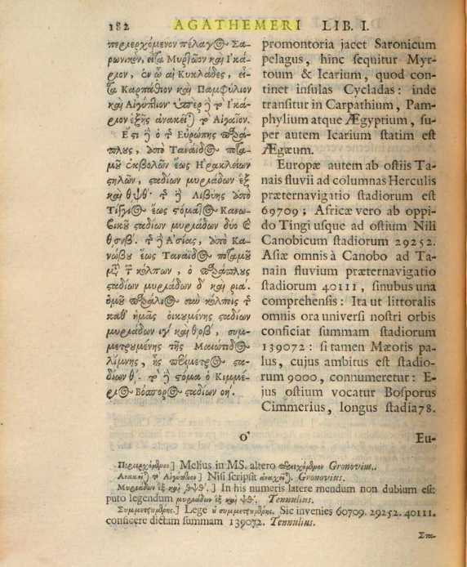

All Djerba can be summed up in this way and participates as for its topography and its geological structure to the dispositions of the nearby continent from which it has been detached.

An important notion concerns the marine platform which extends the coasts very offshore: to reach depths of 5 meters, it is necessary in most cases to reach distances of 5 to 10 km from the coast.

This circumstance which caused Djerba to be named: "The Isle of Shoals" had a significant impact on the unfolding of its event history and economic life accentuating according to the circumstances its desire of easy access to the continent or of desirable isolation if one looks to the open sea. Moreover, the Mediterranean Sea knows its strongest tides in the Little Sirte's Gulf, so that 80 cm of maximum drift can be recorded in the south on the shores of the Boughrara's Gulf. But even at the level of the lighthouse Djilij at the North-West point where the movement of the tides is free, the ebb tide can according to the days uncover on several kilometres of the low coasts to the North, but also to the south-east and south. A circumstance which, on several occasions, has historically caused the bitter failure of reckless invaders and must it be believed ignorant!!!

**THE ISLAND'S GEOLOGICAL STRUCTURE**

The whole island was once an integral part of the continent and consists of an important bedrock of red to blue clays. On the surface after a thickness of 20 cm to 2 meters was formed a very hard calcareous crust formed of rubble with traces of helix locally named "Som" extracted to formerly cobble roads and used for foundations or powerful constructions. After this crust, generally less than one meter, there is a silty layer rich in powdered limestone, then comes a sedimentary strata that have allowed the formation of aquifers surface which reach 10 and 60 meters and of variable salinity often at the limit of an agricultural use. Drilling at great depth reveals between 450 to 550 meters, a so-called Miocene aquifer connected to the Intercalary Continental formations that feeds the southern Tunisia's oases. This artesian emergent layer, of an increasing salinity, from west to east, is used for certain agricultural purposes (sorghum cultivation, dates palms irrigation, vetch cultivation etc…)

The surface crust is generally covered with sandy loam, and towards the north-east, by notable dune formations that attest the aeolian origin of these sediments.

This very regular arrangement was broken by relatively recent tectonic movements in 7 nearly parallel longitudinal faults, extending from north-west to south-east, which, with spacings of 2 to 3 km, appear escarpments from 5 to 10 meters of unevenness constituting the majority of the island's relief accidents. From these prominent places, the eye can embrace wider horizons, and under perspective's effects, it is believed that the entire island is covered with greenery.

These tectonic accidents, so clearly asserted, must have occurred simultaneously with the great submerged chasm of Jorf-Adjim, which today, in the south-west, separates the island from the mainland.

Geologists tell us that consecutively, but at recent times 120000 years, 80000 years, then 6000 years have occurred 3 marine transgressions penetrating inside the lower parts of the island, and which gave birth to sand deposits white tan or shellfish, generally cemented that are still exploited today in riparian areas in the form of quarries giving a very white stone, light and soft, because porous, easy to work and visibly ideal as isothermal material used for all parts of construction above ground and generally above one meter high walls. Until recently, all Djerba's houses and mosques were built in this way, clay and palm trunks serving as binders and means of chaining, prior to the use of profiled irons and before nowadays' concrete reinforcing bars adoption.

Naturally, we can not forget in this context the last major natural island's element, the most recent, the most unstable and the most precious of all, this accumulation of shores of white sand, and with which the wind forms dunes particularly in the north-east coast, dunes that constitute by their magnitude these marvellous beaches which are undoubtedly, with the Djerba's mild climate at the origin of the island's formidable tourist interest.

ASPECT

The island of Djerba is very low and looks like a vast oasis of palm trees emerging from the waters. A large number of "koubbas" (cupolas), were successively built in memory of famous or revered men, white domes that are so many small spots on this large green slick, a kind of label specific to Djerba and which we can not find it in any other Tunisia's town.

SOIL RELIEF

As we have just described, the island is generally flat. Only a few hills' chains whose altitudes hardly exceed thirty meters come to break, in the central part, the surface's uniformity.

WATER'S COURSES

1. **Strabon** ( Ancient Greek : Στράβων / Str.bôn , "who ladley ", in Latin *Strabo* ), is a Greek geographer and historian born at Amaseus in the Bridge (now Amasya in Turkey ) around 60 BC. J. C. 1 and died around 20 AD.AD
2. Scorpions is a German hard rock band from Hanover. Their first album was

   released in 1972. The band enjoyed worldwide prestige - especially from the

   1980s - thanks to hard rock tracks such as *No One Like You* in 1982 or *Rock*

   *You Like a Hurricane* in 1984 and ballads to the world. Like *Still Loving*

   *You* (1984) or *Wind of Change* (1990) [ 10 ] and *Send Me an Angel* in 1990 , songs

   with great commercial success. The media decline came from the 1990s, the

   protagonists turned to new experiences, including the album *Moment of*

   *Glory* (with the Berlin Philharmonic ),*Acoustica* (acoustic live album) but return

   to their traditional recipes in 2010 with the album*Sting in the Tail* .

   In 2010 , the group lists more than one hundred million albums sold

   worldwide [ 11 ] . On January 23, 2010, the group announces on its official

   website that, after their world tour accompanying the release of the new

   album, they will put an end to their career. The group, however, comes back on

   its decision at the end of 2012, explaining not to make big tours after the

   release of their future studio albums.
3. "chronicle of the island of Jerba" « Mounis El Ahibba » by Mohamed ABOURAS (Arabic edition)

   Year 1960 page 76
4. **Pliny** Two Latin authors - uncle and nephew - bore the name of **Pliny** :

   · Pliny the Elder (23-79), author and naturalist Roman, including author of a

   monumental encyclopedia entitled *Natural History* ;

   · Pliny the Younger (61-114), writer and Roman politician, known for

   his *Correspondence* with Emperor Trajan.

   Two French scholars of the Age of Enlightenment have been nicknamed:

   · "Pliny of the EIGHTEENTH century" designating Reaumur ;

   · "French Pliny" designating Buffon .

   *Pliny* is also a historical manga about the life of Pliny the Elder of Mari

   Yamazaki and Miki Tori published since 2014.
5. **Abu Abbas Ahmed ibn Mohamed Tijani aka Ahmed Tijani** , born in 1737 or 1738

   (1150 AH ) in Ain Madhi (Algeria), and died on September 22,

   1815 (17 chawwal 1230) 1 in Fez (Morocco), is an Asharite theologian and Malikite jurist,

   founder of the brotherhood Tijaniyya .
6. **Dragut** (Turkish: *Turgut Reis*) (1485 – 23 June 1565), known as "The Drawn Sword of

   Islam",[1] was a Muslim [2 ] Ottoman naval commander, governor, and noble,

   of Greek descent. [3] [4 ] Under his command, the Ottoman Empire's maritime power was

   extended across North Africa.[3] Recognized for his military genius,[5] and as being

   among "the most dangerous"[6] of corsairs, Dragut has been referred to as "the greatest

   pirate warrior of all time",[7] "undoubtedly the most able of all the Turkish leaders",[5] and

   "the uncrowned king of the Mediterranean".[5]He was described by a French Admiral as

   "A living chart of the Mediterranean, skillful enough on land to be compared to the finest

   generals of the time. No one was more worthy than he to bear the name of king".[8]

   In addition to serving as Admiral and Corsair in the Ottoman

   Empire's Navy under Suleiman the Magnificent, Dragut was also

   appointed Bey of Algiers and Djerba, Beylerbey of the Mediterranean, as well as Bey,

   and subsequently Pasha, of Tripoli. While serving as Pasha of Tripoli, Dragut constructed

   great feats in the city, making it one of the most impressive to behold along all the North

   African Coast.[9]
7. **Syphax** (circa 250 - v. 202 BC ) was a king of Western Numidia (circa 215 to 203 BC ),

   whose capital was Siga(present-day Oulhaça El Gheraba). 1 ) in Algeria . His story is told

   by Livy , in *Ab Urbe condita libri* 2
8. The **stadium** is a unit of ancient length .

   There are several values for its running perimeter:

   · for the Egyptians, it was 157.50 meters and corresponded to the "Greek stage

   route". The estimate of the circumference of the Earth by Eratosthenes from the distance

   between Alexandria and Syene (the modern Aswan ) is probably based on the Egyptian

   stage 1 ;

   · for the Attic stadium, from Lehmann-Haupt 2 , the value is often 177.6 m , but

   values between 150 and 300 m exist. For ancient Greece, the oldest known stadium

   would be that of the track Olympia , built (at the latest) to the SIXTH century BC. J. - C. and

   its length is 192,27 m . That of Athens measures 185 m and forms the most probable

   reference for the Attic stadium which will be later taken over by the Romans.

   · for the Romans, it amounted to 1/8 of the Roman mile (Pliny, *HN* , II, 247,

   Strabon, VII, 7, 4), that is to say 185 m 3 , which is 1/10 modern nautical mile (1,852 m ).

   Also referred to as the **Chinese stage** 4 the unit length **li** , which was worth

   between 350 m and 550 m, and today is 500 m.
9. Agathemen Hypotyposis geographiæ ( see picture blow)