

**Online Market Place DBMS**

|  |  |
| --- | --- |
| **Member Name** | **ID** |
| TAJWAR, MD. ABTAHI | 19-40281-1 |
| Md Safkat Islam | 19-40629-1 |
| MD SEFAT | 19-39533-1 |
| Dipta saha | 19-39379-1 |

**Intro:** A database management system (DBMS) is a system software for creating and managing databases. The DBMS provides users and programmers with a systematic way to create, retrieve, update and manage data. A DBMS makes it possible for end users to create ,read update and delete data in a database.

In this project, we tried to create a database system of an online marketplace using the concept of DBMS.

An Online market place is a platform both buyer and seller. In these Platform a seller can display and sell his or her goods and also can ask for a price. On the other hand the buyer can see those shown products, choose according to his or her needs and also purchase the products.

The market place has two types of registration process among one is Seller. For the person who want to post some it can be an advertisement for selling his or her goods. For doing that, the person needs to register as a seller. In that case the seller needs to provide some information. Such as:

* Name, Email, contact no, Address etc.

After completing registration, the seller can post advertisement for his/her product. For that the seller needs to upload a proper description of the product such as Product Name, Product Colour , size ,price and all the other specification of that product.

Another very important registration process is Buyer. Buyer are the person who will purchase or seethe goods that has been uploaded by the seller.For that the buyer needs to register in the platform. They also need to provide some sort of information as :

* Name , contact, Address etc .

The Sellers can post advertisement. To keep track on those that the seller need to provide some information. The advertisement will have duration, id , uploaders name, uploaders id, region of the advertise, advertisement starting date and also ending date.

The Platform will regularly offer different types of Gifts to their customer as Gift card. The gift cards will have some key information. Like the applicable amount, and also generate a gift id or code.

The platform will also allow online payment. While every purchase the buyer can pay the price online for that s/he can choose the method of payment like cards etc. so the the platform will provide a payment id as reference for making the payment.

For every transaction the platform will let store the data for the seller and as well as the buyer.

The seller can see how many views his or her add has got.

The platform will provide some daily deals to the customers.

**ER Diagram:**

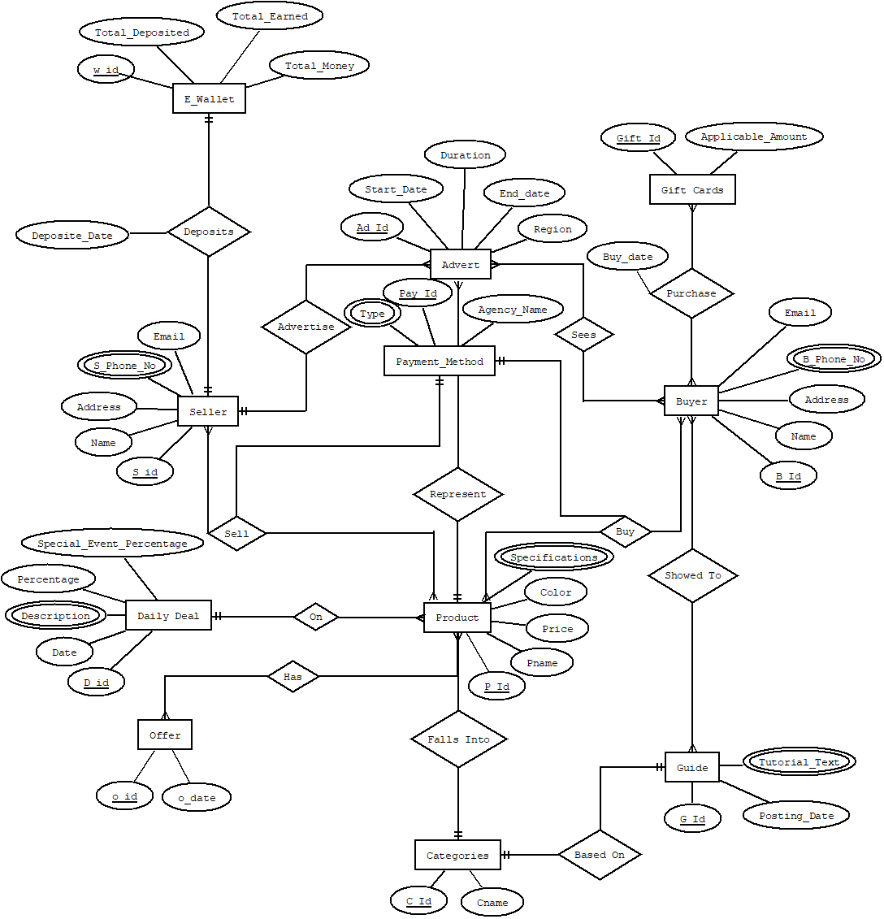

**Normalization:**

* **Deposits:**

**1NF:** S_Phone_no.

**2NF:** w_id, Total_deposited, Total_Earned, Total_Money

S_id, Name, Address, S_Phone_No, Email

**3NF:** w_id, Total_deposited, Total_Earned, Total_Money

**Tables For Deposits:**

* + W_id, Total_deposited, Total_Earned, Total_Money
  + S_id, Address, Name, Email, ***W_id,*** Deposite_Date
  + S_id, S_Phone_No
* **Advertise:**

**1NF:** S_Phone_No

**2NF:** S_id, Name, Address, S_Phone_No, Email

Ad_Id, Start_Date, End_Date, Duration, Region

**3NF:** S_id, Name, Address, S_Phone_no, Email

Ad_Id, Region

Uadvertise_Id, Start_Date, End_Date, Duration.

**Tables From Advertise:**

* + S_id, Address, Name, Email
  + S_id, S_Phone_No
  + Ad_Id, Region, ***S_id, Uadvertise_Id***
  + Uadvertise_Id, Start_Date, End_Date, Duration.
* **Sees**

**1NF:** B_Phone_No

**2NF:** Ad_Id, Start_Date, End_Date, Duration, Region

B_Id, Name, Address, B_Phone_No, Email

**3NF:** Ad_Id, Region

Uadvertise_Id, Start_Date, End_Date, Duration.

B_Id, Name, Address, B_Phone_No, Email

**Tables For Sees:**

* Ad_Id, Region, ***Uadvertise_Id***
* Uadvertise_Id, Start_Date, End_Date, Duration
* B_Id, Name, Address, Email
* B_Id, B_Phone_No
* Sees_Id, ***Ad_Id, B_Id***
* **Purchase**

**1NF:** B_Phone_no

**2NF:** Gift_Id, Applicable_Amount

B_Id, Name, Address, B_Phone_No, Email

**3NF:** No transitive Dependency

**Tables For Purchase:**

* + Gift_Id, Applicable_Amount
  + B_Id, Name, Address, B_Phone_No, Email
  + B_Id, B_Phone_No
  + Purchase_Id, ***Gift_Id***, ***B_Id***, Buy_Date
* **Sell**

**1NF:** S_Phone_No, Type, Specifications

**2NF:** S_id, Name, Address, S_Phone_no, Email

Pay_Id, Type, Agency_Name

P_id, Specifications, Color, Price, Pname

**3NF:** No Transitive Dependency

**Tables Of Sell:**

* + S_id, Name, Address, Email
  + S_Id, S_Phone_no
  + Pay_Id, Agency_Name
  + Pay_Id, Type
  + P_Id, Color, Price, Pname
  + P_Id, Specifications
  + Sell_Id, ***S_Id, P_Id, Pay_Id***
* **Buy**

**1NF:** Type, B_Phone_No, Specifications

**2NF:** Pay_Id, Type, Agency_Name

B_Id, Name, Address, B_Phone_No, Email

P_id, Specifications, Color, Price, Pname

**3NF:** No Transitive Dependency

**Tables of Buy:**

* + Pay_Id, Agency_Name
  + Pay_Id, Type
  + B_Id, Name Address, Email
  + B_Id, B_Phone_No
  + P_Id, Color, Price, Pname
  + P_Id, Specification
  + Buy_Id, ***B_Id, P_Id, Pay_Id***

* **Showed To**

**1NF:** B_Phone_No, Tutorial_Text

**2NF:** B_Id, B_Phone_No, Email, Address, Name

G_Id, Tutorial_Text, Posting_Date

**3NF:** No Tranisitive Dependency

**Tables of Showed To:**

* + B_Id, Email, Address, Name
  + B_Id, B_Phone_No
  + G_Id, Posting_Date
  + G_Id, Tutorial_Text
  + Showed_Id, ***B_Id, G_Id***
* **Represent**

**1NF:** Specifications

**2NF:** Ad_Id, Start_Date, End_Date, Duration, Region

P_id, Specifications, Color, Price, Pname

**3NF:** Ad_Id, Region

Uadvertise_Id, Start_Date, End_Date, Duration

P_id, Specifications, Color, Price, Pname

**Tables Of Represent:**

* + Ad_Id, Region, ***P_Id, Uadvertise_Id***
  + Uadvertise_Id, Start_Date, End_Date, Duration
  + P_id, Color, Price, Pname
  + P_id, Specifications
* **On**

**1NF:** Description, Specifications

**2NF:** D_Id, Date, Description, Percentage, Special_Event_Percentage

P_id, Specifications, Color, Price, Pname

**3NF:** No Transitive Dependency

**Tables Of On:**

* + D_Id, Date, Percentage, Special_Event_Percentage
  + D_Id, Description
  + P_id, Color, Price, Pname, ***D_Id***
  + P_id, Specifications
* **Has**

**1NF:** Specifications

**2NF:** O_Id, O_Date

P_id, Specifications, Color, Price, Pname

**3NF:** No Transitive Dependency

**Tables Of Has:**

* + O_Id, O_Date
  + P_id, Color, Price, Pname
  + P_id, Specifications
  + Has_Id, ***O_Id, P_Id***
* **Falls Into**

**1NF:** Specifications

**2NF:** C_Id, CName

P_id, Specifications, Color, Price, Pname

**3NF:** No Transitive Dependency

**Tables Of Falls Into**

* + C_Id, Cname
  + P_id, Color, Price, Pname, ***C_Id***
  + P_id, Specifications
* **Based On**

**1NF:** Tutorial_Text

**2NF:** C_Id, Cname

G_Id, Tutorial_Text, Posting_Date

**3NF:** No Transitive Dependency

**Tables Of Based On:**

* + C_Id, Cname, ***G_Id***
  + G_Id, Posting_Date
  + G_Id, Tutorial_Text

**Final Tables**

|  |  |
| --- | --- |
| **Table Name** | **Attributes** |
| E_Wallet | W_id, Total_Deposited, Total_Earned, Total_Money |
| Seller | S_id, Address, Name, Email, ***W_id,*** Deposite_Date |
| Seller_Contact | S_id, S_Phone_No. |
| Advert | Ad_Id, Region, ***S_id, Uadvertise_Id, P_Id*** |
| Advert_Duration | Uadvertise_Id, Start_Date, End_Date, Duration |
| Buyer | B_Id, Name, Address, Email |
| Buyer_Contact | B_Id, B_Phone_No |
| Sees | Sees_Id, ***Ad_Id, B_Id*** |
| Gift_Cards | Gift_Id, Applicable_Amount |
| Purchase | Purchase_Id, ***Gift_Id***, ***B_Id***, Buy_Date |
| Payment_Method | Pay_Id, Agency_Name |
| Payment_Type | Pay_Id, Type |
| Product | P_Id, Color, Price, Pname, ***D_Id, C_Id*** |
| Product_Specifications | P_Id , Specifications |
| Sell | Sell_Id, ***S_Id, P_Id, Pay_Id*** |
| Buy | Buy_Id, ***B_Id, P_Id, Pay_Id*** |
| Guide | G_Id, Posting_Date |
| Guide_Text | G_Id, Tutorial_Text |
| Showed_To | Showed_Id, ***B_Id, G_Id*** |
| Daily_Deal | D_Id, DDate, Percentage, Special_Event_Percentage |
| Daily_Deal_Description | D_Id, Description |
| Offer | O_Id, O_Date |
| Has | Has_Id, ***O_Id, P_Id*** |
| Categories | C_Id, Cname, ***G_Id*** |

**DDL/DML:**

**Descriptions:**

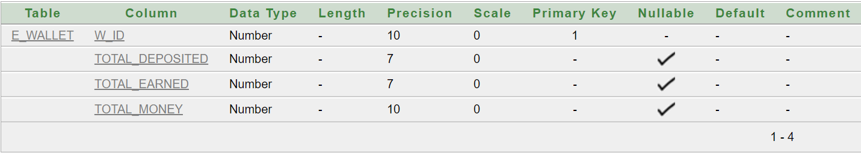

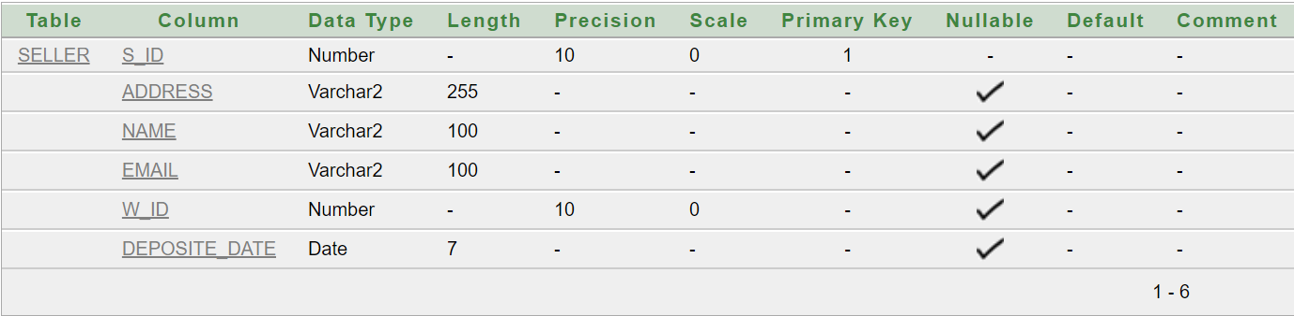

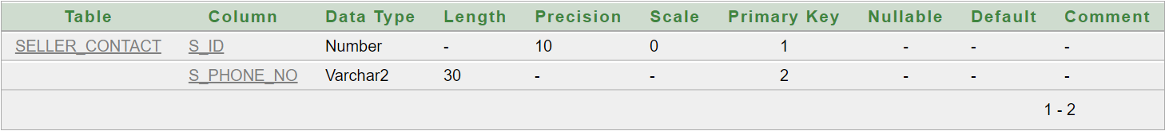

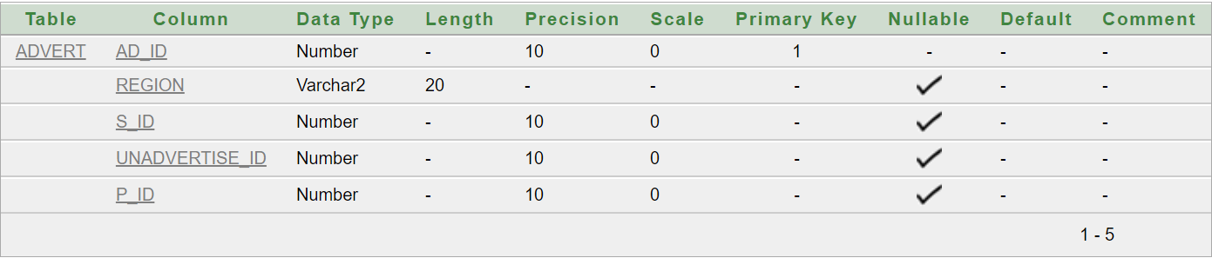

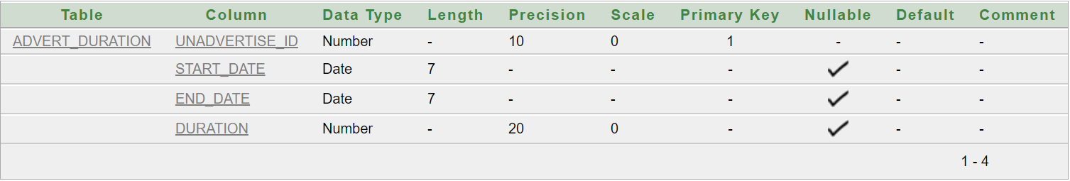

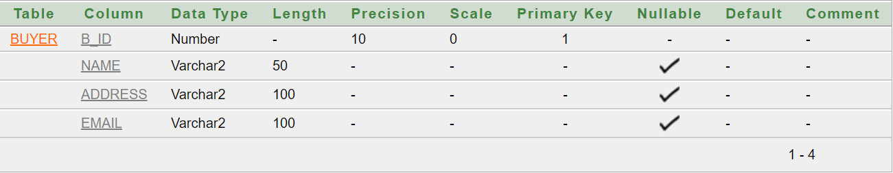

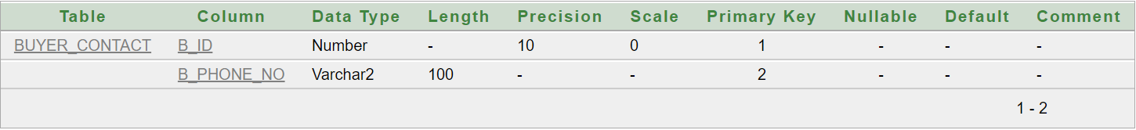

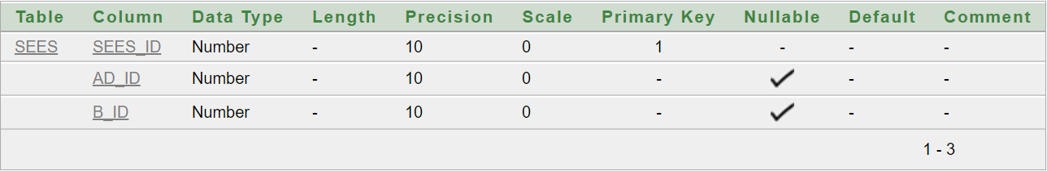

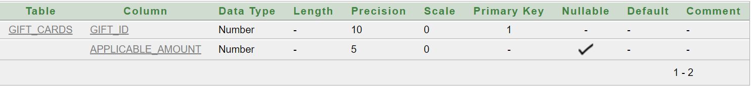

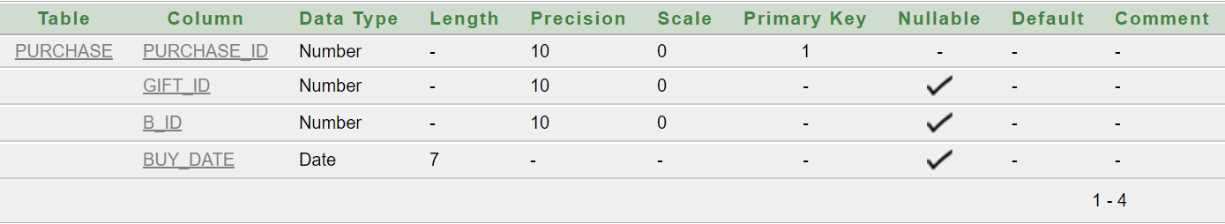

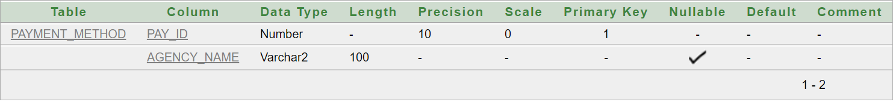

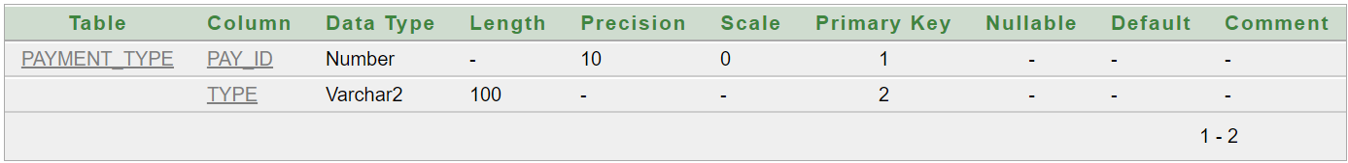

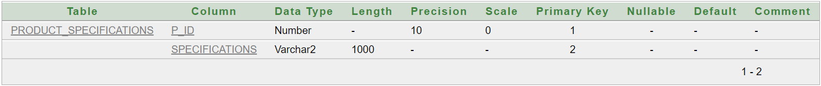

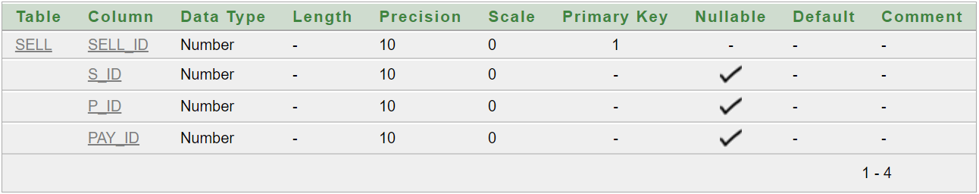

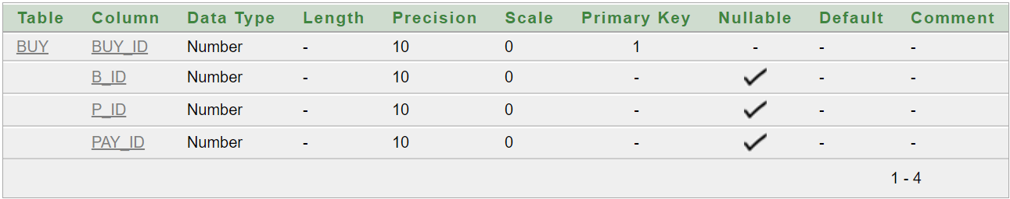

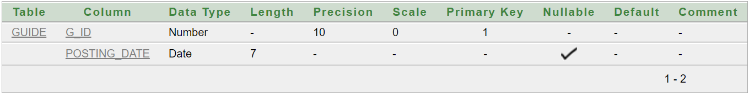

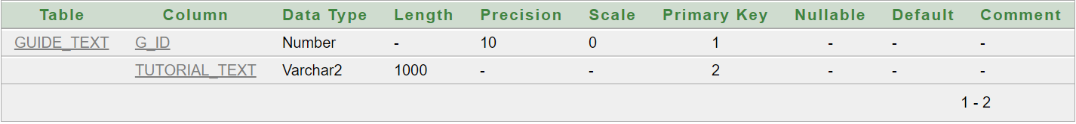

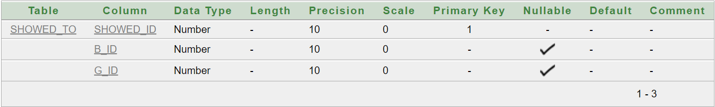

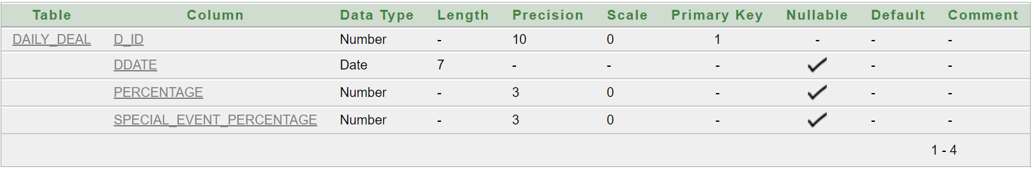

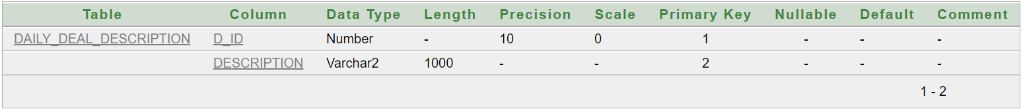

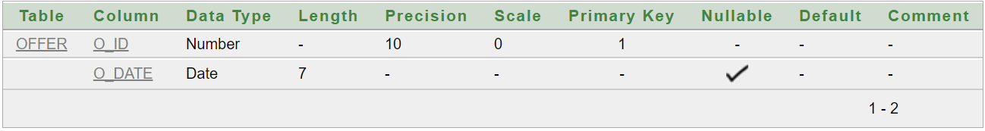

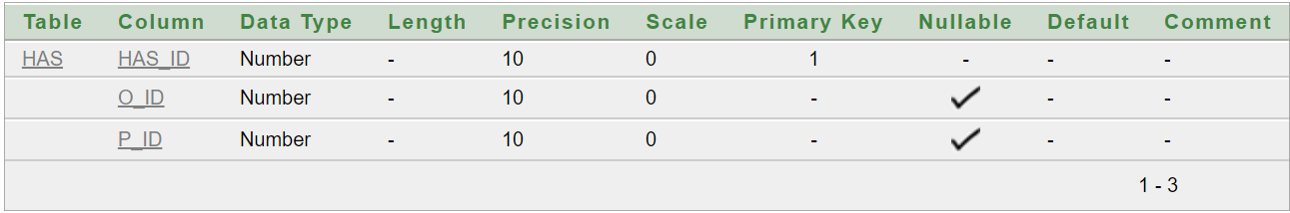

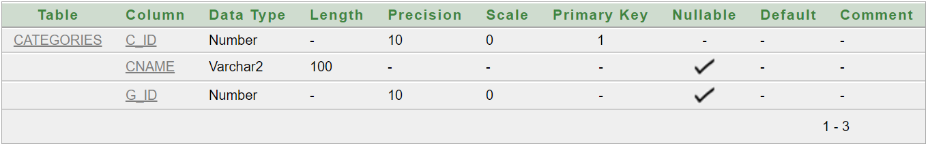

**DML:**

**E_Wallet**

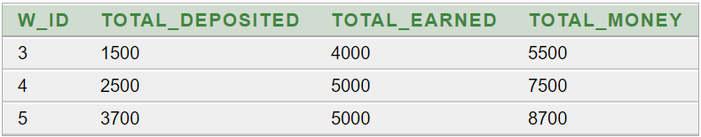

**Seller**

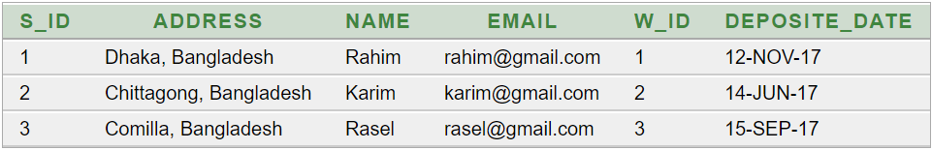

**Seller_Contact**

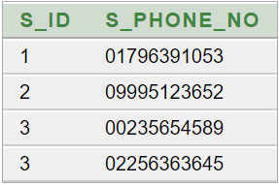

**Advert**

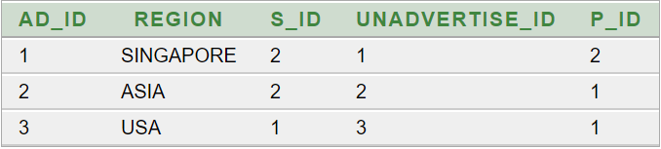

**Advert_Duration**

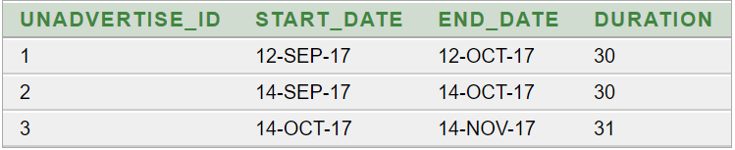

**Buyer**

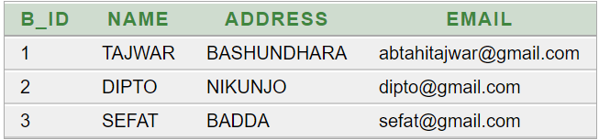

**Buyer_Contact**

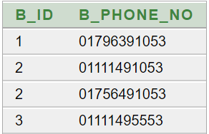

**Sees**

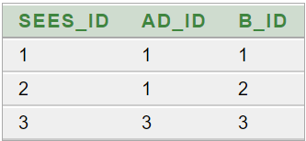

**Gift_Cards**

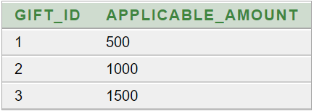

**Purchase**

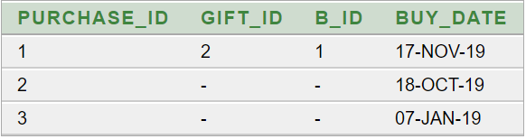

**Payment_Method**

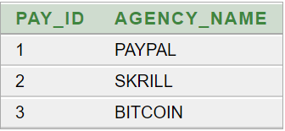

**Payment_Type**

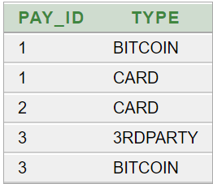

**Product**

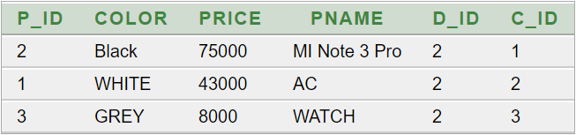

**Product_Specifications**

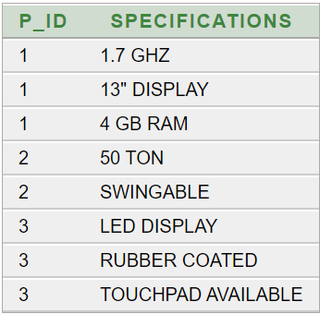

**Sell**

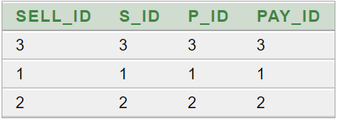

**Buy**

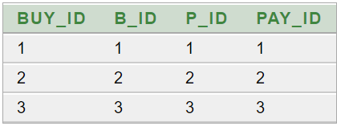

**Guide**

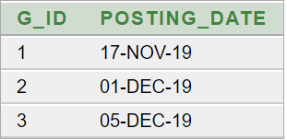

**Guide_Text**

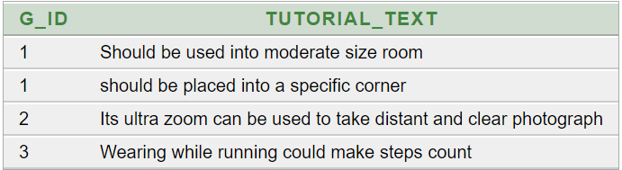

**Showed_To**

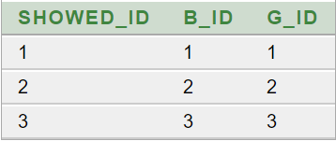

**Daily_Deal**

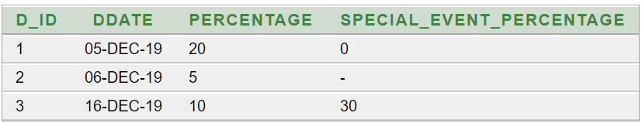

**Daily_Deal_Description**

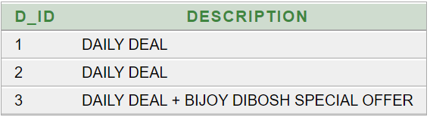

**Offer**

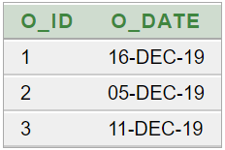

**Has**

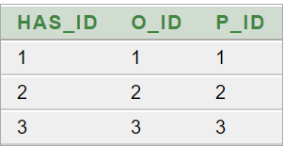

**Categories**

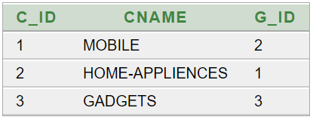

**Constraint:**

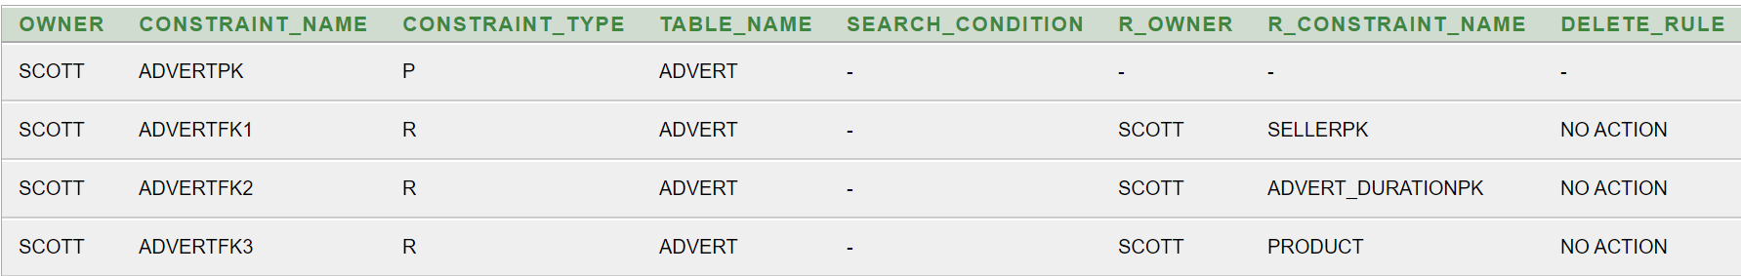

**Set Advert Default Region to USA**

* alter table advert modify region default 'USA'

**Add Unique Constraint to Seller Table**



**Adding Minimum Duration Constraint to Advert Duration**



**Query Question:**

1. To update seller profile in online market, find name, email & phone no of a seller.
2. To update buyer profile in online market, find name, email & phone no of a buyer
3. Find how much a seller earns from selling item by showing his/hername & total earned money.
4. Show how much money is deposited into sellers account so that seller could know about his earnings and total deposite.
5. Find in which Category a product falls into by showing product name and category name.
6. Show hoow much offer are there on a product.
7. To show guide to buyer based on category of product show name of buyer, Guide Text, Guide Positing Date.
8. To shop gift cards, show buyer list of gift cards and when it has been bought find gift card amount, buyer name and buy date.
9. Find payment method of buyer and seller
10. To show daily deal to buyer, find Daily deal date, percentage, special event percentage and Description of it.

**Relational Algebra:**

1. Π (Name, Email, S_Phone_No) (Seller)
2. Π (Name, Email, B_Phone_No) (Buyer)
3. Π (Name, Total_Earned)­ [σ(Seller.W_id = E.Wallet.w_id) (Seller × E_Wallet) ]
4. Π (Name, Total_Money)­ [σ(Seller.W_id = E_Wallet.w_id) (Seller × E_Wallet) ]
5. Π (Pname, Cname)­ [σ(Product.C_id = Categories.C_id) (Product × Categories) ]