Apriori Algorithm Technical Report
Generated: 2026-06-07 23:33:49
Scope: execution-threshold simulation, frequent itemsets, association rules, and significance analysis.

Implementation Summary
1) Item identity: Description (cleaned), with Quantity used only for filtering.
2) Transaction key: InvoiceNo, excluding cancelled invoices and non-positive quantity rows.
3) Threshold list used: 0.005, 0.010, 0.020, 0.030, 0.050

Significance
Lower support increases candidate growth and runtime. In this run, the slowest threshold is 0.005 (1154.327631 sec), while the fastest threshold is 0.050 (0.390656 sec).
Most valuable rules are selected by high confidence and lift (>1). High confidence indicates strong conditional reliability, and lift > 1 indicates positive association beyond chance.

Table A: Execution Time by Minimum Support
min_support | execution_time_sec | l1_count | l2_count | l3_count
0.005 | 1154.327631 | 1542 | 7604 | 5333
0.010 | 222.332586 | 803 | 818 | 215
0.020 | 28.352296 | 294 | 79 | 3
0.030 | 5.222238 | 128 | 8 | 0
0.050 | 0.390656 | 33 | 0 | 0

Table B: Top Items by Frequency
itemsets | count | support
WHITE HANGING HEART T-LIGHT HOLDER | 2260 | 0.1122
JUMBO BAG RED RETROSPOT | 2092 | 0.1039
REGENCY CAKESTAND 3 TIER | 1989 | 0.0988
PARTY BUNTING | 1686 | 0.0837
LUNCH BAG RED RETROSPOT | 1564 | 0.0777
ASSORTED COLOUR BIRD ORNAMENT | 1455 | 0.0723
SET OF 3 CAKE TINS PANTRY DESIGN | 1385 | 0.0688
PACK OF 72 RETROSPOT CAKE CASES | 1320 | 0.0656
LUNCH BAG BLACK SKULL. | 1273 | 0.0632
NATURAL SLATE HEART CHALKBOARD | 1249 | 0.0620

Table C: Top Correlated Itemsets
itemset | itemset_size | count | support | min_support
JUMBO BAG PINK POLKADOT + JUMBO BAG RED RETROSPOT | 2 | 825 | 0.0410 | 0.005
GREEN REGENCY TEACUP AND SAUCER + ROSES REGENCY TEACUP AND SAUCER | 2 | 768 | 0.0381 | 0.005
JUMBO BAG RED RETROSPOT + JUMBO STORAGE BAG SUKI | 2 | 724 | 0.0360 | 0.005
JUMBO BAG RED RETROSPOT + JUMBO SHOPPER VINTAGE RED PAISLEY | 2 | 680 | 0.0338 | 0.005
LUNCH BAG BLACK SKULL. + LUNCH BAG RED RETROSPOT | 2 | 641 | 0.0318 | 0.005
ALARM CLOCK BAKELIKE GREEN + ALARM CLOCK BAKELIKE RED | 2 | 640 | 0.0318 | 0.005
GREEN REGENCY TEACUP AND SAUCER + PINK REGENCY TEACUP AND SAUCER | 2 | 633 | 0.0314 | 0.005
LUNCH BAG PINK POLKADOT + LUNCH BAG RED RETROSPOT | 2 | 606 | 0.0301 | 0.005
PINK REGENCY TEACUP AND SAUCER + ROSES REGENCY TEACUP AND SAUCER | 2 | 599 | 0.0297 | 0.005
JUMBO BAG BAROQUE BLACK WHITE + JUMBO BAG RED RETROSPOT | 2 | 585 | 0.0291 | 0.005

Table D: Most Valuable Rules
rule | support | confidence | lift
CHARLIE+LOLA PINK HOT WATER BOTTLE + GREEN REGENCY TEACUP AND SAUCER -> DOTCOM POSTAGE | 0.0070 | 1.0000 | 28.44
BEADED CRYSTAL HEART PINK ON STICK + VINTAGE PAISLEY STATIONERY SET -> DOTCOM POSTAGE | 0.0068 | 1.0000 | 28.44
BEADED CRYSTAL HEART PINK ON STICK + FLORAL FOLK STATIONERY SET -> DOTCOM POSTAGE | 0.0066 | 1.0000 | 28.44
BEADED CRYSTAL HEART PINK ON STICK + JUMBO BAG RED RETROSPOT -> DOTCOM POSTAGE | 0.0066 | 1.0000 | 28.44
BEADED CRYSTAL HEART PINK ON STICK + GREEN REGENCY TEACUP AND SAUCER -> DOTCOM POSTAGE | 0.0065 | 1.0000 | 28.44
BEADED CRYSTAL HEART PINK ON STICK + SUKI SHOULDER BAG -> DOTCOM POSTAGE | 0.0065 | 1.0000 | 28.44
BIRTHDAY CARD, RETRO SPOT + SUKI SHOULDER BAG -> DOTCOM POSTAGE | 0.0064 | 1.0000 | 28.44
BEADED CRYSTAL HEART PINK ON STICK + JAM MAKING SET PRINTED -> DOTCOM POSTAGE | 0.0062 | 1.0000 | 28.44
CHARLIE+LOLA PINK HOT WATER BOTTLE + ROSES REGENCY TEACUP AND SAUCER -> DOTCOM POSTAGE | 0.0061 | 1.0000 | 28.44
CARD PARTY GAMES + SUKI SHOULDER BAG -> DOTCOM POSTAGE | 0.0060 | 1.0000 | 28.44

Charts
Chart 1: Execution Time vs Minimum Support
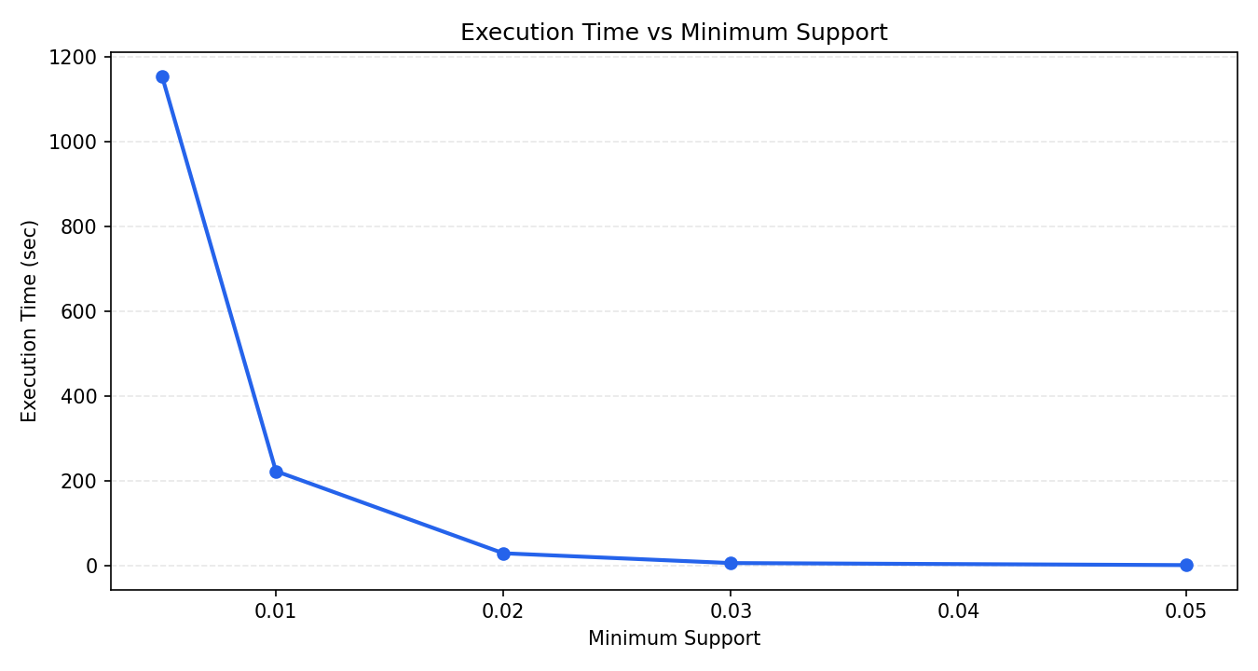
Chart 2: Top 10 Items by Frequency
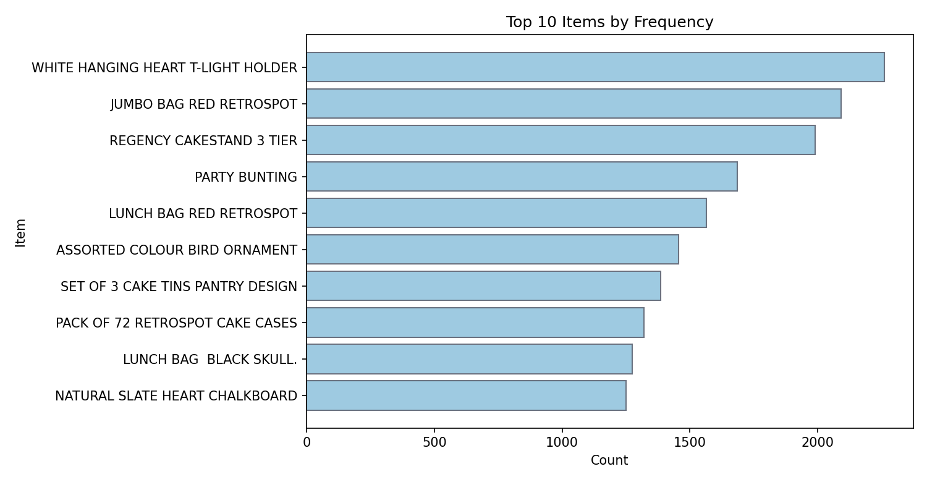
Chart 3: Top Correlated Itemsets by Support
