Apriori Algorithm Technical Report
Generated: 2026-06-08 12:47:51
Scope: execution-threshold simulation, frequent itemsets, association rules, and significance analysis.

Implementation Summary
1) Item identity: StockCode (cleaned), with Quantity used only for filtering.
2) Transaction key: InvoiceNo, excluding cancelled invoices and non-positive quantity rows.
3) Threshold list used: 0.005, 0.010, 0.020, 0.030, 0.050

Significance
Lower support increases candidate growth and runtime. In this run, the slowest threshold is 0.005 (1079.148019 sec), while the fastest threshold is 0.050 (0.423168 sec).
Most valuable rules are selected by high confidence and lift (>1). High confidence indicates strong conditional reliability, and lift > 1 indicates positive association beyond chance.

Table A: Execution Time by Minimum Support
min_support | abs_support_count | execution_time_sec | l1_count | l2_count | l3_count
0.005 | 103 | 1079.148019 | 1503 | 7445 | 5457
0.010 | 207 | 210.140799 | 792 | 827 | 220
0.020 | 414 | 25.723561 | 276 | 79 | 1
0.030 | 621 | 4.846283 | 120 | 8 | 0
0.050 | 1036 | 0.423168 | 33 | 0 | 0

Table B: Top Items by Frequency
itemsets | count | support
85123A | 2203 | 0.1063
85099B | 2092 | 0.1009
22423 | 1989 | 0.0960
47566 | 1686 | 0.0813
20725 | 1565 | 0.0755
84879 | 1455 | 0.0702
22197 | 1392 | 0.0672
22720 | 1387 | 0.0669
21212 | 1320 | 0.0637
22383 | 1285 | 0.0620

Table C: Top Correlated Itemsets
itemset | itemset_size | count | support | min_support
22386 + 85099B | 2 | 825 | 0.0398 | 0.005
22697 + 22699 | 2 | 768 | 0.0371 | 0.005
21931 + 85099B | 2 | 724 | 0.0349 | 0.005
22411 + 85099B | 2 | 680 | 0.0328 | 0.005
20725 + 22383 | 2 | 655 | 0.0316 | 0.005
20725 + 20727 | 2 | 641 | 0.0309 | 0.005
22726 + 22727 | 2 | 640 | 0.0309 | 0.005
22697 + 22698 | 2 | 633 | 0.0305 | 0.005
20725 + 22384 | 2 | 606 | 0.0292 | 0.005
22698 + 22699 | 2 | 599 | 0.0289 | 0.005

Table D: Most Valuable Rules
rule | support | confidence | lift
22697 + 84032A -> DOT | 0.0068 | 1.0000 | 29.24
21992 + 85131D -> DOT | 0.0066 | 1.0000 | 29.24
21993 + 85131D -> DOT | 0.0064 | 1.0000 | 29.24
85099B + 85131D -> DOT | 0.0064 | 1.0000 | 29.24
22697 + 85131D -> DOT | 0.0063 | 1.0000 | 29.24
21935 + 85131D -> DOT | 0.0063 | 1.0000 | 29.24
21935 + 22819 -> DOT | 0.0062 | 1.0000 | 29.24
22961 + 85131D -> DOT | 0.0060 | 1.0000 | 29.24
22699 + 84032A -> DOT | 0.0059 | 1.0000 | 29.24
21935 + 22814 -> DOT | 0.0058 | 1.0000 | 29.24

Charts
Chart 1: Execution Time vs Minimum Support
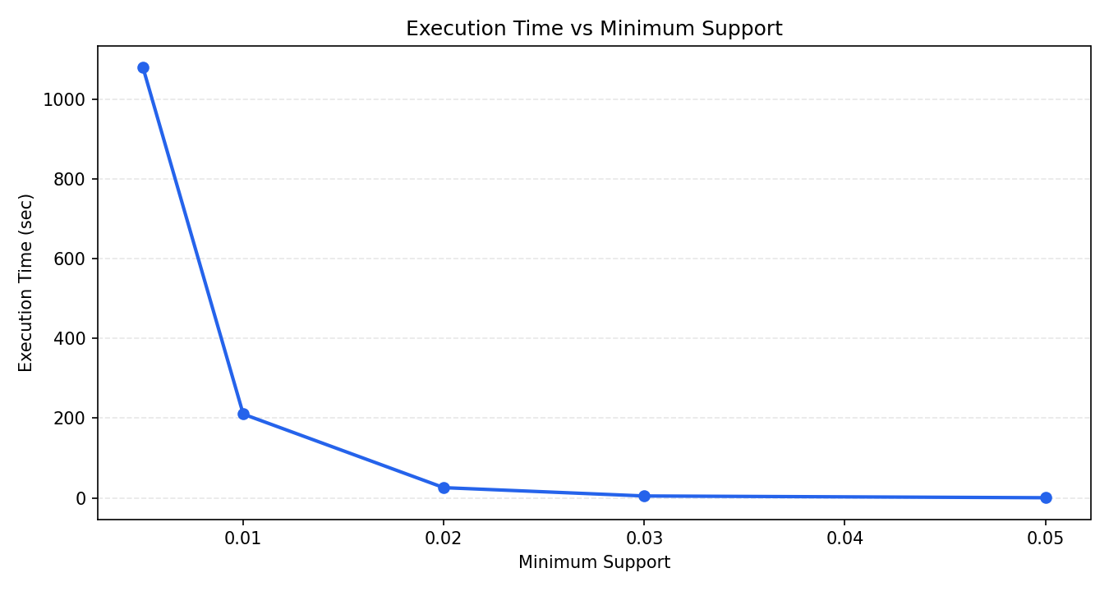
Chart 2: Top 10 Items by Frequency
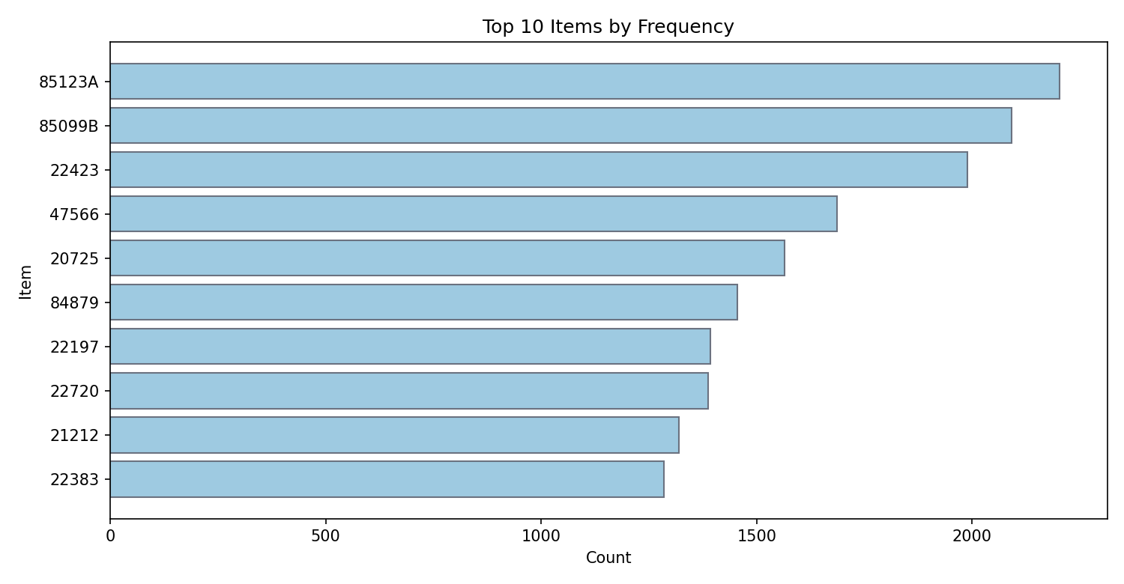
Chart 3: Top Correlated Itemsets by Support
