

DIDO SHOP

* **Faculty:**
* **Batch:**
* **Team Member:**
  + - * **Nguyễn Quang Thiện**
      * **Nguyễn Trần Mạnh Quân**
      * **Phan Văn Thành**

**Ho Chi Minh City, Sep 9 2018**

Table of Contents

1. Review 1

* **Problem Definition..…………………………………………………………………………………01**
* **Customer Request Specification……………………………………………………………… 02**

1. Review 2

* ***Use Case Diagram* 04**
* ***Class Diagram* 15**
* ***Sequence Diagram* 16**
* ***ERD* 18**
* ***Entity Description* 19**
* ***Table Relationship Diagram* 26**

1. Review 3

* Interface Design………………………………………………………………………………..... 27
* Site Map……………………………………………………………………………………………… 51
* Report ………………………………………………………………………………………………..53
* Tasksheet……………………………………………………………………………………………. 56

REVIEW 1

Problem Definition

1. **The Object Of The Project**

This project will aim at creation of a Web system. This will be accessible to all customers who have a valid User Id and Password. This system provides the following facilities:

* Customer view information of product and buy product.
* Admin manage customer and product, orders, bills.

Customer’s requirement   
 Specification

1. **Functional Requirements**

Following is a list of functionalities of the system. More functionalities that you find appropriate can be added to this list.

* As a guest, I want to enter the website and see all products find product by name, price, branch, year.
* As a guest, I want to see all information of the product and all comments of other users about that product as well.
* As a guest, I want to login or sign up a new account. (forget password)
* As a user, I want to buy, comment, (rating) the product.
* As a user, I want to manage my account’s information.
* As a user, I want to review all my order in the past.
* As an admin, I want to manage all products and user’s information, orders. ( separate to new role which manage comments section )
* As an admin, I want to retrieve an income report.

# Hardware/ Software Requirements

By adding new technologies such as ASP.NET 3.5, AJAX, Web Service and 3-tier architecture, the web site becomes more interactive with users, security and easily updated.

1. **System Requirement**

* **For Users**
  + **Hardware**
    - CPU: Pentium IV 2.0 GHz or higher
    - RAM: 512 MB or higher
  + **Software**
    - OS: Windows 7/XP Professional/Server 2003…
    - Browser: Internet Explorer 8.0 or higher
* **For Software Developers**
  + **Hardware**
    - CPU: Pentium IV 2.0 GHz or higher
    - RAM: 512 MB or higher
  + **Software**
    - OS: Windows 7/8/8.1/10
    - Environment: Microsoft .NET framework 4.6 or higher
    - Database Management System: Microsoft SQL Server 2017
    - IDE: Microsoft Visual Studio 2017, Visual Code
    - Web Server: Internet Information Services (IIS) JSP / Servlets Dev. Kit

|  |  |  |
| --- | --- | --- |
| **Date: Sep 10, 2012** | **Prepared by Project Group 4**  **Team Leader:** | **Approved by**  **Mr Ho Hoan Kiem** |
| **Signature** |  |  |

REVIEW 2

**USE CASE DIAGRAM**

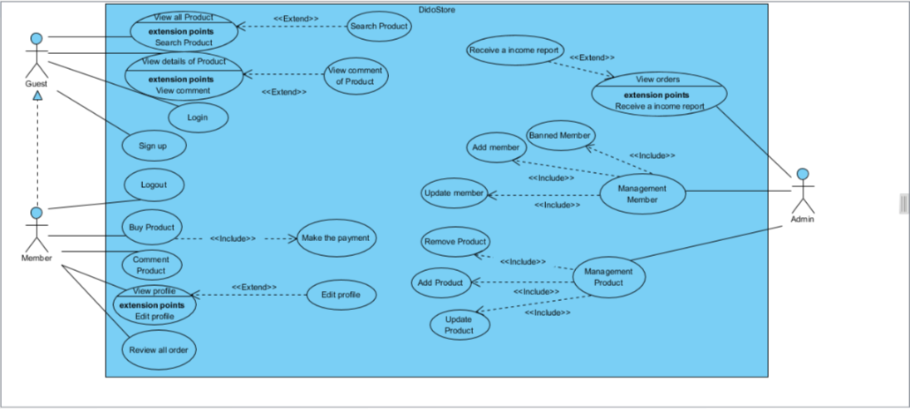

**USE CASE DESCRIPTION**

1. **Actor:**

* **Customers :** include all visitors that use this website. They are guests and members. ***Guest*** is the person that uses this website but doesn’t register. ***Member*** is the person that uses this website and register to become a member of us.
* **Website administrators :** The person(s) that manage and maintain this web site.

1. **Usecase:**

|  |  |
| --- | --- |
| **Usecase** | Register |
| **Short Description** | Register account to become a member of the web site. |
| **Pre-Conditions** |  |
| **Post-Conditions** |  |
| **Main flow** | _Guest must provide mandatory information :   * LoginID. * Password. * Confirm Password. * Email. * Identity card.   _Guest provides supplementary information : FirstName, BirthDay, PhoneNumber, Address, Email, Gender  _Guest clicks on Register button.  _System checks the information which guest provided  _System create new account for guest that registers to this website.  _Guest becomes a member of this website. |
| **Alternative flow(s)** | _If guest clicks on the Reset button, all the field will be reset.  _If the mandatory information that guest provided, is missed or not exactly, system notifys the error. All cases are :   * LoginID has existed in Database. * Password is less than 6 characters or more than 30 characters. * Confirm Password and Password are not the same. * Email is invalid or has existed in database. * Identity card has any is digit not a character. * Any fields are blank.   _If the suplementary information that guest provided, is invalid form, system nofitfys the error. All cases are :   * PhoneNumber has any character is not a digit. * Birthday is not along with format “dd/MM/yyyy”.   _System must be insert the date that guest register to become member.  _If server notifys any error when it’s processing, system must be write report into Log file. |

|  |  |
| --- | --- |
| **Usecase** | Login |
| **Short Description** | Log in website to use any function of member. |
| **Pre-Conditions** |  |
| **Post-Conditions** |  |
| **Main flow** | _Guest inputs the login information :   * Login ID. * Password.   _Guest clicks on the Login button.  _System check the Login ID and Password.  _If Login ID and Password are valid, system will move member to Homepage.  _ If a wrong password is given thrice in succession, that account will be locked and the customer will not be able to use it. When an invalid password is entered a warning is given to the user that his account is going to get locked. |
| **Alternative flow(s)** | _If guest clicks on “Reset” button, the Login ID field and Password field are blank.  _If Login ID field or Password field is invalid form or blank when guest clicks on the “Login” button, system will notify the error.  _If server notifies any error when it’s processing, system must be write report into Log file. |

|  |  |
| --- | --- |
| **Usecase** | Edit Account |
| **Short Description** | Edit member’s information. |
| **Pre-Conditions** |  |
| **Post-Conditions** |  |
| **Main flow** | _Guest login to this website.  _Member clicks on the link to edit his(her) information, and access the private information page.  _Member edits information and save this action.  _System check this information and save it on the server.  _System notify report to member. |
| **Alternative flow(s)** | _If any information edit are invalid, system will notify the error.  _If server notifies any error when it’s processing, system must be write report into Log file. |

|  |  |
| --- | --- |
| **Usecase** | Buy Product |
| **Short Description** | Customers can buy product |
| **Pre-Conditions** |  |
| **Post-Conditions** |  |
| **Main flow** | _Guest login to this website.  _Member clicks on the product to buy this product and user can make a payment to owned his/her product.  _System check this information and Transaction it on the server.  _System notify report to member. |
| **Alternative flow(s)** | _If any information transaction are invalid, system’ll notify the error, and rollback.  _If server notifies any error when it’s processing, system must be write report into Log file. |

|  |  |
| --- | --- |
| **Usecase** | Review all order |
| **Short Description** | See orders Report |
| **Pre-Conditions** |  |
| **Post-Conditions** |  |
| **Main flow** | _Customer access the transaction report page.  _Customer can see the Transaction report on this website.  _Customer can search the orders by time. |
| **Alternative flow(s)** | _If server notifies any error when it’s processing, system must be write report into Log file. |

|  |  |
| --- | --- |
| **Usecase** | Manage Customers |
| **Short Description** | Manage all information about customer. |
| **Pre-Conditions** |  |
| **Post-Conditions** |  |
| **Main flow** | _Manage all information of customer. |
| **Alternative flow(s)** | _If server notifies any error when it’s processing, system must be write report into Log file. |

|  |  |
| --- | --- |
| **Usecase** | Report Customers |
| **Short Description** | Show customer’s report. |
| **Pre-Conditions** |  |
| **Post-Conditions** |  |
| **Main flow** | _Administrator chooses the customer whose administrator wants to see report.  _Administrator clicks on the “Report” button.  _System show the customer’s report to administrator. |
| **Alternative flow(s)** | _If server notifies any error when it’s processing, system must be write report into Log file. |

|  |  |
| --- | --- |
| **Usecase** | View Customer’s Information |
| **Short Description** | Administrator view customer’s information. |
| **Pre-Conditions** |  |
| **Post-Conditions** |  |
| **Main flow** | _Administrator choose the customer that administrator wants to see information.  _Administrator clicks on the “View Information” button.  _System shows the customer’s information to the administrator. |
| **Alternative flow(s)** | _If server notifies any error when it’s processing, system must be write report into Log file. |

|  |  |
| --- | --- |
| **Usecase** | Administrator Edit Account |
| **Short Description** | Edit member’s information. |
| **Pre-Conditions** |  |
| **Post-Conditions** |  |
| **Main flow** | _Admin can banned, create, update member.  _System check this information and save it on the server.  _System notify report to member. |
| **Alternative flow(s)** | _If any information edit are invalid, system’ll notify the error.  _If server notifies any error when it’s processing, system must be write report into Log file. |

|  |  |
| --- | --- |
| **Usecase** | Manage Products |
| **Short Description** | Manage products of this website. |
| **Pre-Conditions** |  |
| **Post-Conditions** |  |
| **Main flow** | _Administrator can view, insert, update, delete products.  _Administrator chooses the correlative function.  _System passes administrator to the page that administrator can interact with system. |
| **Alternative flow(s)** | _If server notifys any error when it’s processing, system must be write report into Log file. |

|  |  |
| --- | --- |
| **Usecase** | Insert |
| **Short Description** | Insert all information about this website. |
| **Pre-Conditions** |  |
| **Post-Conditions** |  |
| **Main flow** | _Administrator can Insert , products… of this site.  _Administrator chooses the correlative function.  _System passes administrator to the page that administrator can interact with system. |
| **Alternative flow(s)** | _If server notifies any error when it’s processing, system must be write report into Log file. |

|  |  |
| --- | --- |
| **Usecase** | Manage Order |
| **Short Description** | Manage all information about Order. |
| **Pre-Conditions** |  |
| **Post-Conditions** |  |
| **Main flow** | _Administrator can view.  _ Order reporting in the days, months, years .  _System passes administrator to the page that administrator can interact with system. |
| **Alternative flow(s)** | _If server notifies any error when it’s processing, system must be write report into Log file. |

|  |  |
| --- | --- |
| **Usecase** | View Order Information |
| **Short Description** | View details information of order. |
| **Pre-Conditions** |  |
| **Post-Conditions** |  |
| **Main flow** | _Administrator chooses the order that administrator wants to see information.  _System shows the details information of this transaction. |
| **Alternative flow(s)** | _If server notifies any error when it’s processing, system must be write report into Log file. |

|  |  |
| --- | --- |
| **Usecase** | Search |
| **Short Description** | Search all information about this site. |
| **Pre-Conditions** |  |
| **Post-Conditions** |  |
| **Main flow** | _Administrator inputs the information that wants to see in the search field.  _Administrator clicks on the “Search” button Or onKeydown  _System shows the result to the administrator. |
| **Alternative flow(s)** | _If server notifies any error when it’s processing, system must be write report into Log file. |

**CLASS DIAGRAM**

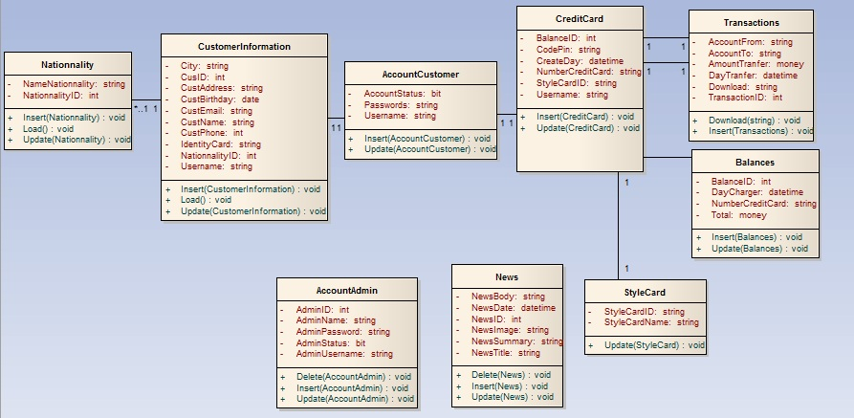

**ENTITY RELATIONSHIP DIAGRAM (ERD)**  
 **Note:  
  
  
ENTITY DESCRIPTION**

Have

Have

Belong

Have

Nationality

Customer  
Information

Account  
Customer

Account  
Admin

Style  
Card

News

Credit  
Card

Transaction

CountHitPage

Contain

Entity

Entity Relationship

One to  
 many relationship

**1.Account Customer :**

**Account  
Customers**

**2. Customer Information :  
3. Nationality :**

**Customer  
Information**

**4. Style Card :  
  
  
  
  
  
  
  
  
5. Transaction :  
  
6. News :**

**Transaction**

**Style Card**

**Nationality**

**News**

**7. Credit Card :**

**8. CountHitPage:**

**Credit Card**

**CountHitPage**

**9. Account Admin :**

**Account  
Admin**

**TABLE DESIGN**

1. **Account Customer :**

|  |  |  |  |  |  |
| --- | --- | --- | --- | --- | --- |
| **No** | **Column Name** | **Data Type** | **Size** | **Check** | **Description** |
| 1 | **🗝**Username | Varchar | 15 | Not Null | Customer ID |
| 2 | Passwords | Varchar | 20 | Not Null | Customer’s password |
| 3 | Account Status | Bit |  | Not Null | Customer’s user name |

1. **Customer Information :**

|  |  |  |  |  |  |
| --- | --- | --- | --- | --- | --- |
| **No** | **Column Name** | **Data Type** | **Size** | **Check** | **Description** |
| 1 | **🗝**CustID | Int | Identity | Not Null | ID |
| 2 | IdentityCard | Varchar | 9 | Null | IdentityCard Customer |
| 3 | CustName | Varchar | 30 | Null | Name Customer |
| 4 | CustBirthday | Date |  | Null | Birthday Customer |
| 5 | CustEmail | Varchar | 50 | Null | Email Customer |
| 6 | CustAddress | Varchar | 100 | Null | Address Customer |
| 7 | CustPhone | Varchar | 15 | Null | Phone Customer |
| 8 | NationalityID | Int |  | Null | Nationality Customer |
| 9 | City | Varchar | 15 | Null | City |
| 10 | Username | Varchar | 15 | Not Null | Customer ID |
| 11 | CustGender | Varchar | 6 | Null | Customer Gender |

1. **Nationality :**

|  |  |  |  |  |  |
| --- | --- | --- | --- | --- | --- |
| **No** | **Column Name** | **Data Type** | **Size** | **Check** | **Description** |
| 1 | **🗝**Nationality ID | Int |  | Not Null |  |
| 2 | Name Nationality | Varchar | 30 | Not Null |  |

1. **StyleCard:**

|  |  |  |  |  |  |
| --- | --- | --- | --- | --- | --- |
| **No** | **Column Name** | **Data Type** | **Size** | **Check** | **Description** |
| 1 | **🗝**Style Card ID | Varchar | 5 | Not Null | Style Card ID |
| 2 | Style Name | Varchar | 10 | Not Null | Name Style Card |

1. **Transactions:**

|  |  |  |  |  |  |
| --- | --- | --- | --- | --- | --- |
| **No** | **Column Name** | **Data Type** | **Size** | **Check** | **Description** |
| 1 | **🗝**Transaction ID | Int |  | Not Null | Transaction ID |
| 2 | Account From | Varchar | 12 | Not Null | Account From |
| 3 | Account To | Varchar | 12 | Not Null | Account To |
| 4 | Day Transfer | Datetime |  | Not Null | Day Tranfer |
| 5 | Amount Transfer | Money |  | Not Null | Amount Tranfer |

1. **News :**

|  |  |  |  |  |  |
| --- | --- | --- | --- | --- | --- |
| **No** | **Column Name** | **Data Type** | **Size** | **Check** | **Description** |
| 1 | **🗝**News ID | Int |  | Not Null | News ID |
| 2 | News Title | Varchar | 300 | Not Null | News Title |
| 3 | News Summary | Varchar | 200 | Not Null | News Summary |
| 4 | News Body | Varchar | Max | Not null | News Body |
| 5 | News Date | Datetime |  | Not Null | News Datetime |
| 6 | News Image | Varchar | 100 | Not Null | News Image |

1. **Credit Card:**

|  |  |  |  |  |  |
| --- | --- | --- | --- | --- | --- |
| **No** | **Column Name** | **Data Type** | **Size** | **Check** | **Description** |
| 1 | **🗝**NumberCreditCard | Varchar | 12 | Not Null | Number Credit Card |
| 2 | Balance | Money |  | Not Null | Balance ID |
| 3 | StyleCardID | Varchar | 15 | Not Null | StyleCard ID |
| 4 | CodePin | Varchar | 250 | Not Null | Code Pin |
| 5 | CreateDay | Datetime |  | Not Null | Create Day |
| 6 | Username | Varchar | 15 | Not Null | Customer ID |

1. **CountHitPage:**

|  |  |  |  |  |  |
| --- | --- | --- | --- | --- | --- |
| **No** | **Column Name** | **Data Type** | **Size** | **Check** | **Description** |
| 1 | Page_Name | Varchar | 100 | Not Null | Page_Name |
| 2 | Dem | int |  | Not Null | Count Page |

1. **Account Admin:**

|  |  |  |  |  |  |
| --- | --- | --- | --- | --- | --- |
| **No** | **Column Name** | **Data Type** | **Size** | **Check** | **Description** |
| 1 | **🗝**AdminID | Int |  | Not Null | Admin ID |
| 2 | AdminStatus | Bit |  | Not Null | Status Admin |
| 3 | AdminUsername | Varchar | 25 | Not Null | Username Admin |
| 4 | AdminPassword | Varchar | 12 | Not Null | Password Admin |
| 5 | AdminName | Varchar | 30 | Not Null | Name Admin |

**Note**

**🗝** Primary key

✓ Unique constraint

**TABLE RELATIONSHIP DIAGRAM**

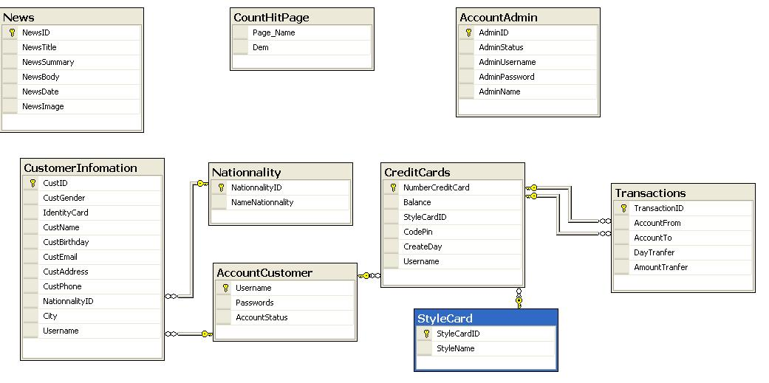

|  |  |  |
| --- | --- | --- |
| **Date: Sep 20, 2012** | **Prepared by Project Group 4**  **Team Leader:** | **Approved by**  **Mr. Ho Hoan Kiem** |
| **Signature** |  |  |

REVIEW 3

**INTERFACE DESIGN**

1. **Home Page**

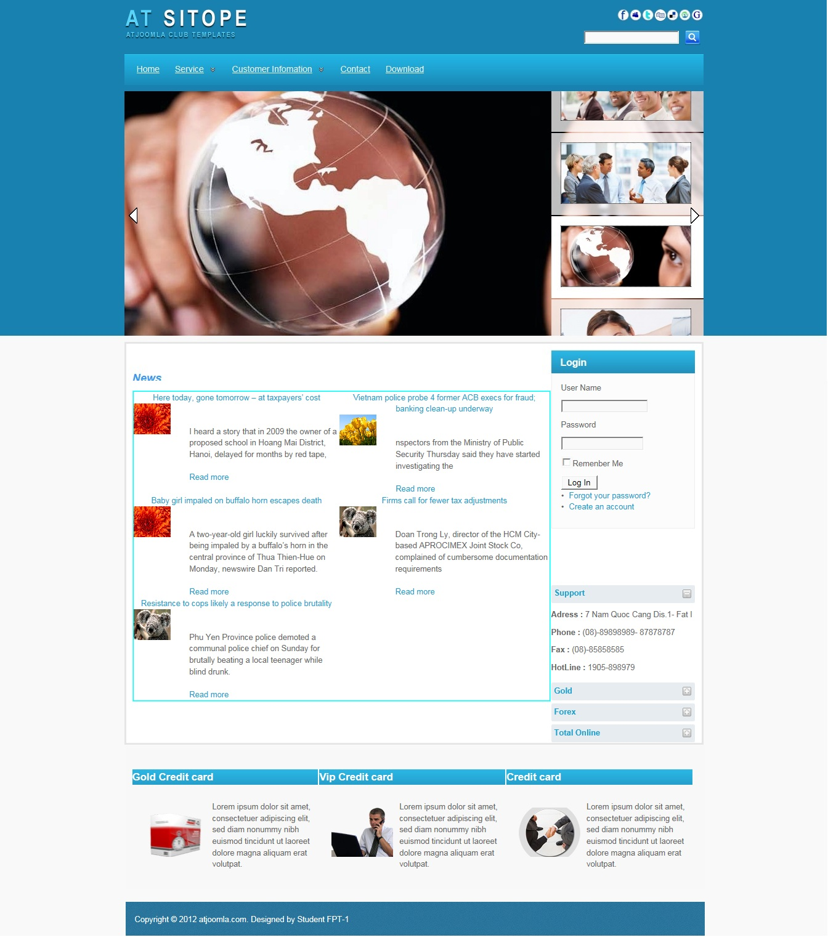

|  |  |  |  |  |  |
| --- | --- | --- | --- | --- | --- |
| **Name** | **Type** | **Event** | **Validation** | **Description** | **Status** |
| User Name | TextBox |  | String, not null | Input Customer’s user name |  |
| Password | TextBox |  | String, not null, | Input Customer’s password |  |
| Remember Me | Check Box |  | Stick | Remember Customer next time |  |
| Login | Button |  | Click | Choose Login |  |
| Forgot your Password | Hyperlink |  | Click | When Customer forgot password, they can help service supply again. |  |
| Create an Account | Hyperlink |  | Click | Create New Account when Customer like to create. |  |

1. **Login:**

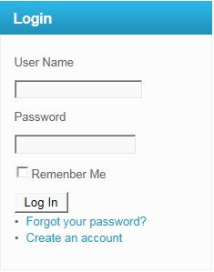

|  |  |  |  |  |  |
| --- | --- | --- | --- | --- | --- |
| **Name** | **Type** | **Event** | **Validation** | **Description** | **Status** |
| User Name | TextBox |  | String, not null | Input Customer’s user name |  |
| Password | TextBox |  | String, not null, | Input Customer’s password |  |
| Remember Me | Check Box |  | Stick | Remember Customer next time |  |
| Login | Button |  | Click | Login |  |

**3.Create Account Customer:**

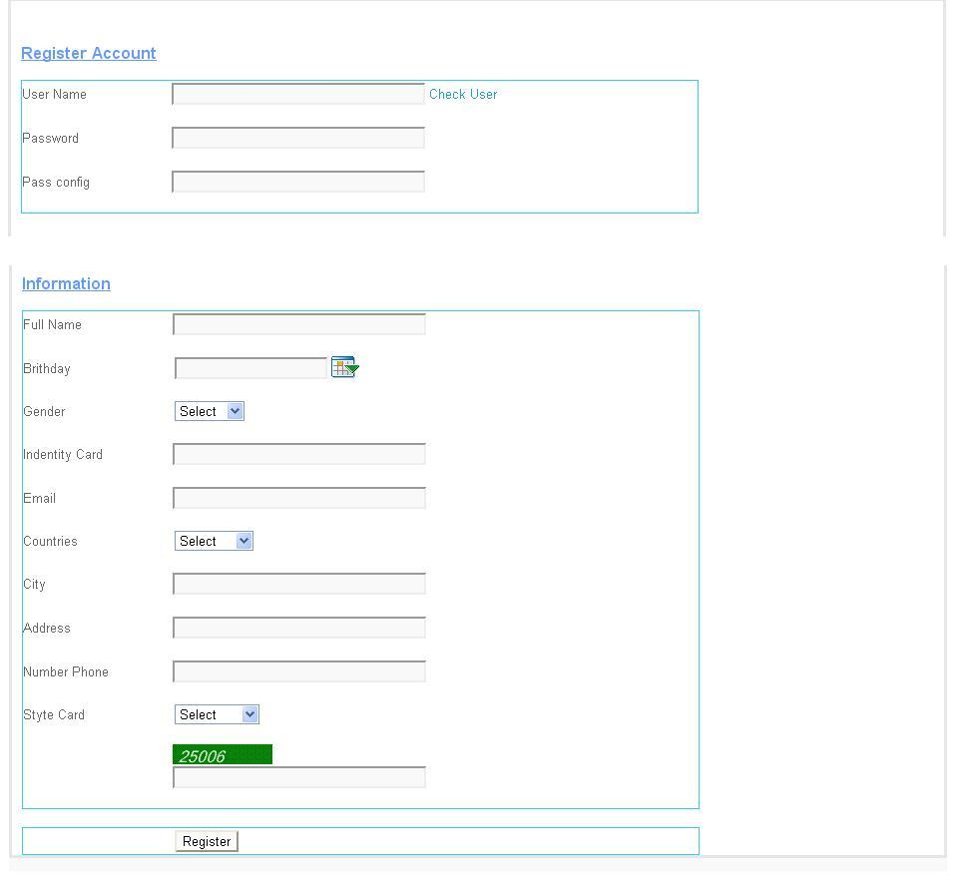

|  |  |  |  |  |  |
| --- | --- | --- | --- | --- | --- |
| **Name** | **Type** | **Event** | **Validation** | **Description** | **Status** |
| UserName | TextBox | Onchange | String, not null | Input UserName Customer |  |
| Password | TextBox |  | String, not null, | Input Customer’s New password |  |
| Config Password | TextBox |  | String,not null | Input Customer’s Config Password |  |
| Full Name | TextBox |  | String, not null | Input Full Name Customer |  |
| Birthday | BasicDate picker |  | Date,not null | Input BirthDay customer |  |
| Gender | DropdownList |  | Select Male,female | Input Male,Female |  |
| Identity Card | TextBox |  | Number, not null | Input Number Identity card |  |
| Email | TextBox |  | String ,not null, have Validation | Input Email Customer |  |
| Countries | Dropdownlist |  | Select | Input Countries Customer |  |
| City | TextBox |  | String, not null | Input City Customer |  |
| Address | TextBox |  | String, not null | Input Address Customer |  |
| Phone Number | TextBox |  | Number,not null | Input Phone Number Customer |  |
| Styte Card | DropDownList |  | Select | Input Styte Card Customer |  |
| CapChar | TextBox |  |  | Input number follow Image at above Text Box |  |
| Register | Button |  | Click | Register Customer |  |

**4.Forgot Password:**

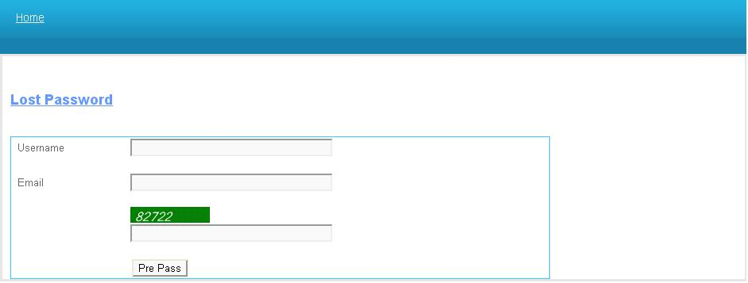

|  |  |  |  |  |  |
| --- | --- | --- | --- | --- | --- |
| **Name** | **Type** | **Event** | **Validation** | **Description** | **Status** |
| UserName | TextBox |  | String,not null | Input UserName Customer |  |
| Email | TextBox |  | String ,not null, have Validation | Input Email Customer |  |
| CapChar | TextBox |  |  | Input number follow Image at above Text Box |  |

**5.Change Password:**

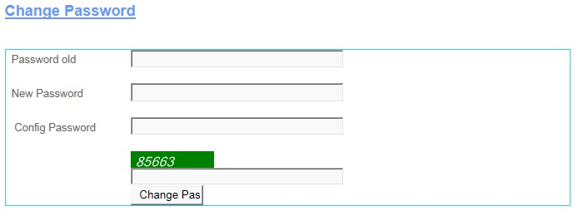

|  |  |  |  |  |  |
| --- | --- | --- | --- | --- | --- |
| **Name** | **Type** | **Event** | **Validation** | **Description** | **Status** |
| Password Old | TextBox |  | String, not null | Input Customer’s Password old |  |
| New Password | TextBox |  | String, not null, | Input Customer’s New password |  |
| Config Password | TextBox |  | String,not null | Input Customer’s Config Password |  |
| CapChar | TextBox |  |  | Input number follow Image at above Text Box |  |
| Change Password | Button |  | Click | Change Password |  |

**6.Change CodePin:**

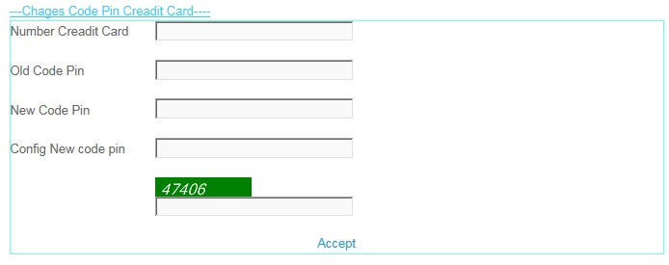

|  |  |  |  |  |  |
| --- | --- | --- | --- | --- | --- |
| **Name** | **Type** | **Event** | **Validation** | **Description** | **Status** |
| Number Credit Card | TextBox |  | int, not null | Input Customer’s Number Credit Card |  |
| Old Code Pin | TextBox |  | int, not null, | Input Customer’s Old Code Pin |  |
| New Code Pin | TextBox |  | int,not null | Input Customer’s New Code Pin |  |
| Config New Code Pin | TextBox |  | int, not null | Input Customer’s Config New Code Pin |  |
| CapChar | TextBox |  | int ,not null | Input number follow Image at above Text Box |  |
| Accept | LinkButton |  | Click | Accept Change code Pin . |  |

**7.Create Information:**

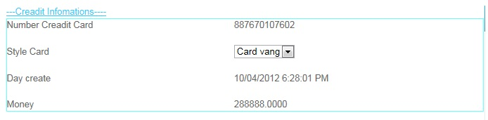

|  |  |  |  |  |  |
| --- | --- | --- | --- | --- | --- |
| **Name** | **Type** | **Event** | **Validation** | **Description** | **Status** |
| Number Credit Card | Label |  | Read Only | View Number Credit Card |  |
| Style Card | Drop Down List |  | Select | View and select Card |  |
| Day Create | Label |  | Read Only | View Day Create |  |
| Money | Label |  | Read Only | View Money |  |

**8.Edit Account User:**

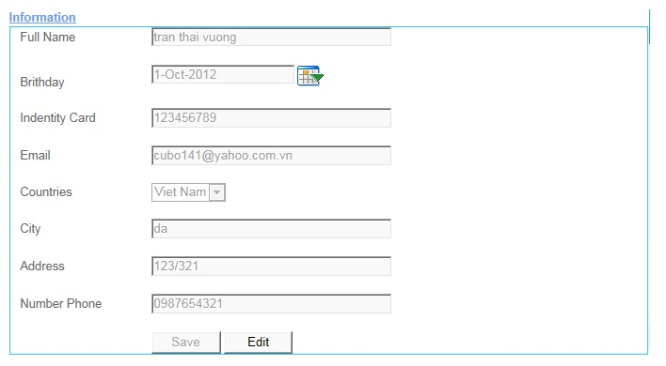

|  |  |  |  |  |  |
| --- | --- | --- | --- | --- | --- |
| **Name** | **Type** | **Event** | **Validation** | **Description** | **Status** |
| Full Name | TextBox |  | String, not null | Input Full Name |  |
| Birthday | TextBox |  | DatetTime | Input DateTime |  |
| Calendar Tool | Calendar |  | Select | Select Date on Calendar |  |
| Identity Card | TextBox |  | Int , not null | Input identity Card |  |
| Email | TextBox |  | String ,not null, have Validation | Input Customer’s Email |  |
| Country | DropDownList |  | Select | Select country |  |
| Address | TextBox |  | Int, not null | Input Customer’s Address |  |
| Number Phone | TextBox |  | Int, not null | Input Customer’s Number Phone |  |
| Save | Button |  | Click | click save edit enable |  |
| Edit | Button |  | Click | click edit Save unenable |  |

**9.Transaction:**

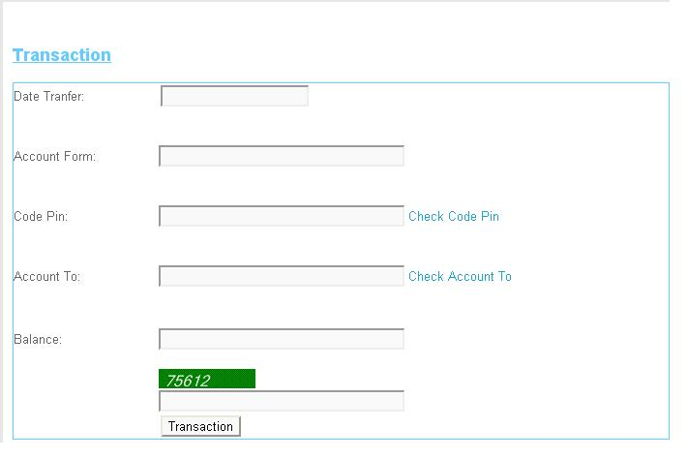

|  |  |  |  |  |  |
| --- | --- | --- | --- | --- | --- |
| **Name** | **Type** | **Event** | **Validation** | **Description** | **Status** |
| Date Tranfer | TextBox |  | DateTime, not null | Input Date Tranfer |  |
| Account From | TextBox |  | DatetTime | Input Account From |  |
| Code Pin | TextBox |  | Int, not null and Valiadaton | Input Code Pin |  |
| Account To | TextBox |  | DateTime, not null and Validation | Input Account To |  |
| Balance | TextBox |  | String ,not null, have Validation | Input Customer’s Balance |  |
| Transaction | Button |  | Click | Transaction |  |
| Check CodePin | LinkButton |  | Click | Check Codepin inval or not inval.. |  |
| Check Account To | LinkButton |  | Click | Check Account Inval or Not inval |  |
| CapChar | TextBox |  | int ,not null | Input number follow Image at above Text Box |  |

**10.Transaction Admin:**

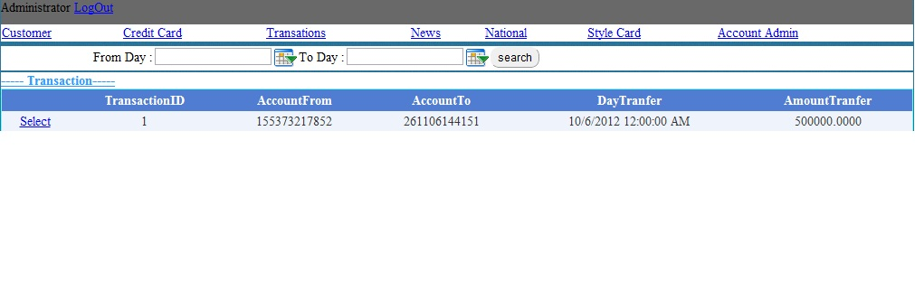

|  |  |  |  |  |  |
| --- | --- | --- | --- | --- | --- |
| **Name** | **Type** | **Event** | **Validation** | **Description** | **Status** |
| Log Out | LoginStatus |  | Click | Click Log Out |  |
| From Day | BasicdatePicker |  | Date time | Input From Date tranfer |  |
| To Day | BasicDatePicker |  | Date Time | Input To Date Tranfer |  |
| Transaction | Drop Down List |  | Select inform | Select Transaction |  |
| List Transaction | Grid view |  | Read Only | View inform Transaction |  |
| Select | LinkButton |  | Select | Select then view Detail |  |

**11.View Transaction:**

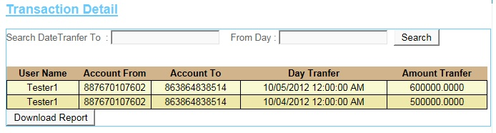

|  |  |  |  |  |  |
| --- | --- | --- | --- | --- | --- |
| **Name** | **Type** | **Event** | **Validation** | **Description** | **Status** |
| Search Date Transfer To | TextBox |  | DateTime , not null | Input DateTime |  |
| From Day | TextBox |  | DateTime , not null | Input DateTime |  |
| Search | Button |  | Click | Search |  |
| Transaction Detail | GridView |  | Read Only | View Inform of Detail’s Transaction |  |
| DownLoad Report | Button |  | Click | DownLoad Report |  |

**12.News:**

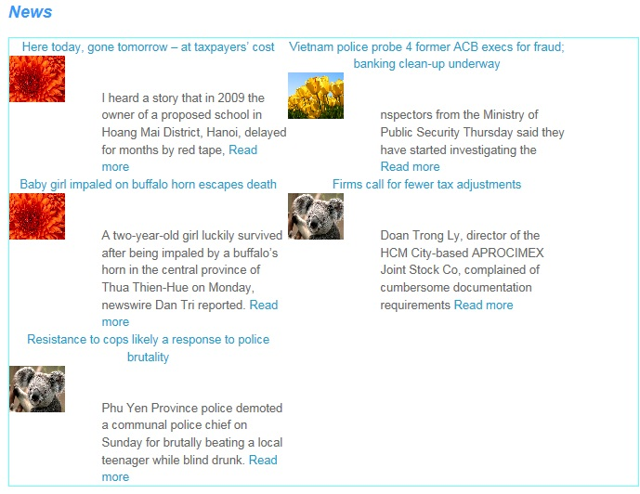

**13.AdminLogin:**

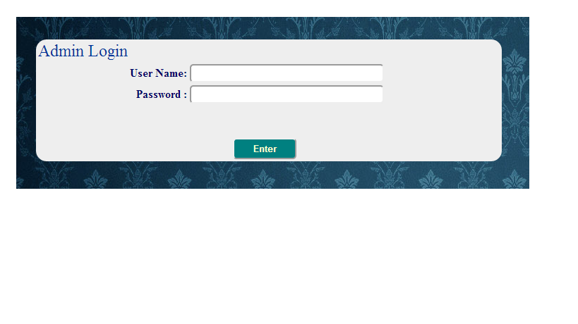

|  |  |  |  |  |  |
| --- | --- | --- | --- | --- | --- |
| **Name** | **Type** | **Event** | **Validation** | **Description** | **Status** |
| User Name | TextBox |  | String, not null | Input Admin’s user name |  |
| Password | TextBox |  | String, not null, | Input Admin’s password |  |
| Enter | Button |  | Click |  |  |

**14.AccountAdmin:**

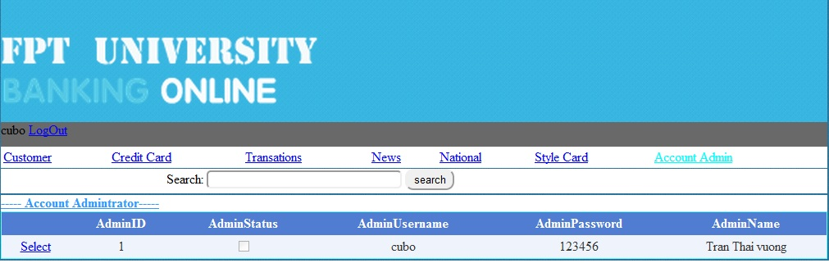

|  |  |  |  |  |  |
| --- | --- | --- | --- | --- | --- |
| **Name** | **Type** | **Event** | **Validation** | **Description** | **Status** |
| Search | TextBox | Onkeydown | String, | Search Admin’s Usernmae |  |
| Select Object | Hyperlink |  |  |  |  |
| DetailView1 | DetailsView |  |  | Select Account Admin |  |
| Select | Linbutton |  |  | Select Details Account Admin |  |

**15.AccountCustomer:**

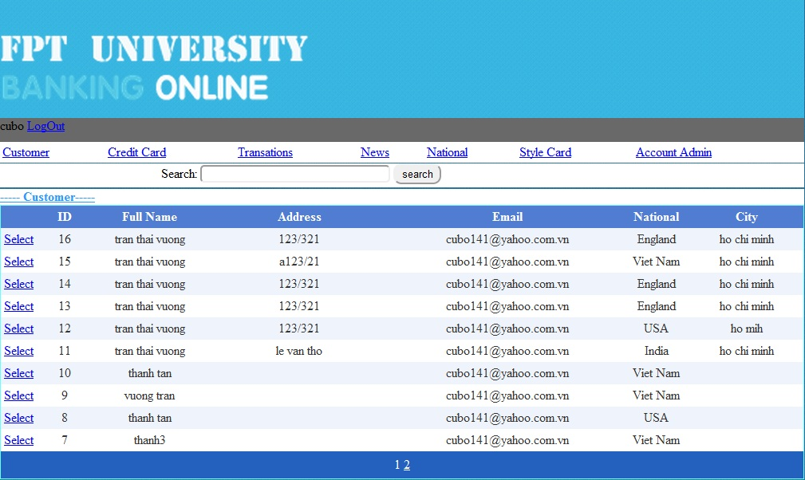

|  |  |  |  |  |  |
| --- | --- | --- | --- | --- | --- |
| **Name** | **Type** | **Event** | **Validation** | **Description** | **Status** |
| Search | TextBox |  | String | Search Customer’s Username |  |
| Select Object | Hyperlink |  |  |  |  |
| GridviewAccountCustomer | Gridview |  |  | Select Account Customer |  |
| Select | Linbutton |  |  | Select Details Account Customer |  |

**16.CreditCard:**

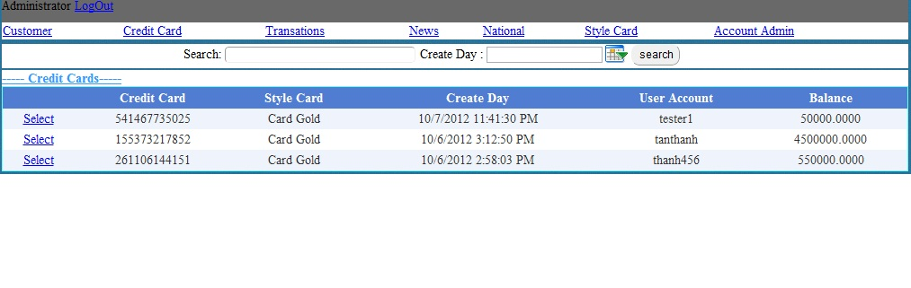

|  |  |  |  |  |  |
| --- | --- | --- | --- | --- | --- |
| **Name** | **Type** | **Event** | **Validation** | **Description** | **Status** |
| Search | TextBox | OnKeyDown | String | Search UserName |  |
| Select Object | Hyperlink |  |  |  |  |
| GvCreditCard | Gridview |  |  | Select ListCreditCard |  |
| Select | Linbutton |  |  | Select Details CreditCard |  |

**17.StyleCard:**

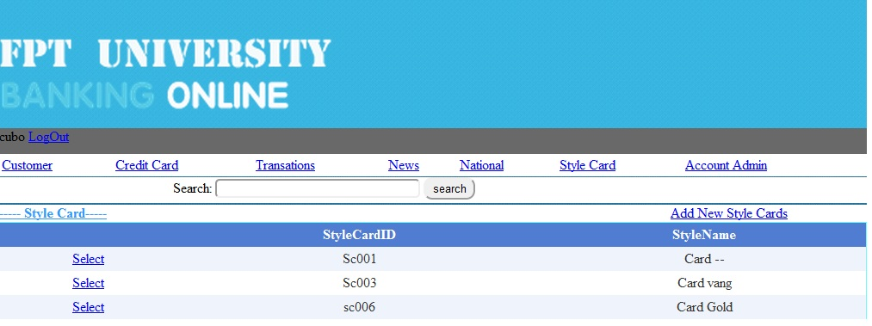

|  |  |  |  |  |  |
| --- | --- | --- | --- | --- | --- |
| **Name** | **Type** | **Event** | **Validation** | **Description** | **Status** |
| Search | TextBox | OnkeyDown | String | Search Style CardName |  |
| Select Object | Hyperlink |  |  |  |  |
| GvStyleCard | Gridview |  |  | Select Style Card |  |
| Select | Linbutton |  |  | Select Details Style Card |  |

**18.News:**

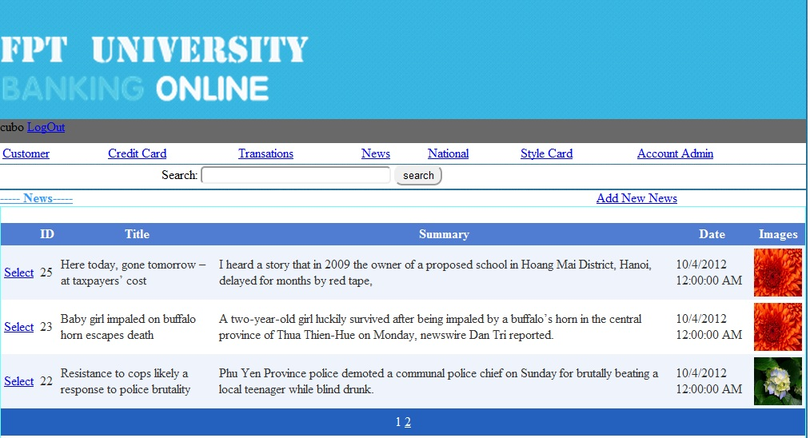

|  |  |  |  |  |  |
| --- | --- | --- | --- | --- | --- |
| **Name** | **Type** | **Event** | **Validation** | **Description** | **Status** |
| Search | TextBox | Onkeydown | String | Search Title News |  |
| Select Object | Hyperlink |  |  | Go Add new News |  |
| GvNews | Gridview |  |  | Select News |  |
| Select | Linbutton |  |  | Select Details News |  |

**19.National:**

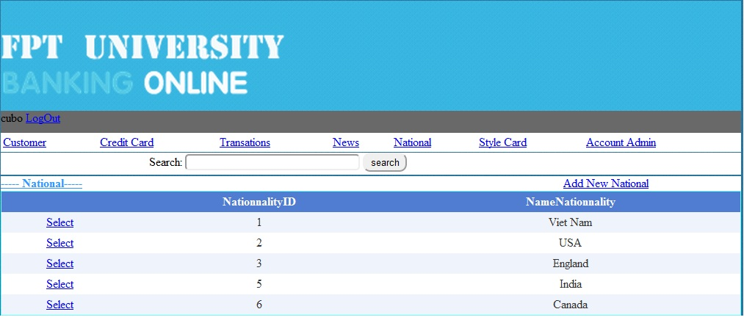

|  |  |  |  |  |  |
| --- | --- | --- | --- | --- | --- |
| **Name** | **Type** | **Event** | **Validation** | **Description** | **Status** |
| Search | TextBox | onKeydown | String | Search Name Nationality |  |
| Select Object | Hyperlink |  |  |  |  |
| Gv Nationality | Gridview |  |  | Select Nationality |  |
| Select | Linbutton |  |  | Select Details Nationality |  |

**20.Details Account Admin:**

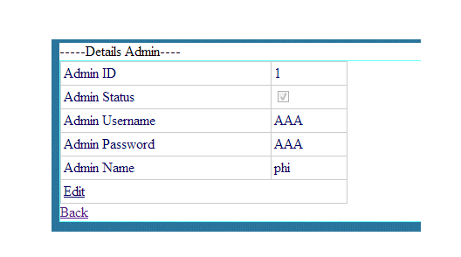

|  |  |  |  |  |  |
| --- | --- | --- | --- | --- | --- |
| **Name** | **Type** | **Event** | **Validation** | **Description** | **Status** |
| Edit | LinkButton |  |  | Edit Account Admin |  |
| Back | LinkButon |  |  | Back to MainAdmin.aspx |  |
| DetailsView1 | DetailsView |  |  | Select Details Admin |  |

**21.Details Account Customer:**

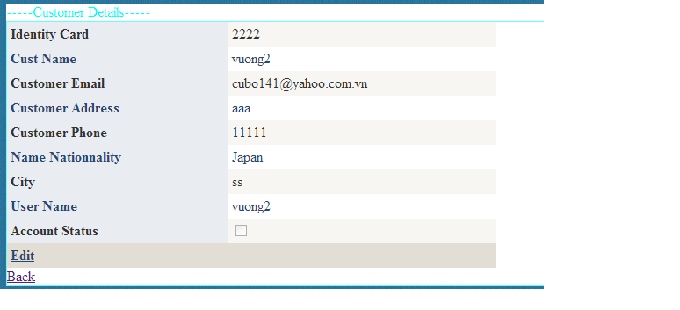

|  |  |  |  |  |  |
| --- | --- | --- | --- | --- | --- |
| **Name** | **Type** | **Event** | **Validation** | **Description** | **Status** |
| Edit | LinkButton |  |  | Edit Account Customer |  |
| Back | LinkButon |  |  | Back to MainAdmin.aspx |  |
| DetailsView1 | DetailsView |  |  | Select Customer Information |  |

**22.Details Credit Card:**

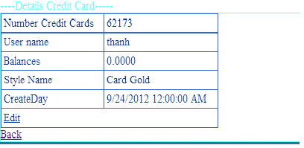

|  |  |  |  |  |  |
| --- | --- | --- | --- | --- | --- |
| **Name** | **Type** | **Event** | **Validation** | **Description** | **Status** |
| Edit | LinkButton |  |  | Edit Balance of Customer |  |
| Back | LinkButon |  |  | Back to MainAdmin.aspx |  |
| DetailsView1 | DetailsView |  |  | Select Details Credit Card of |  |

**23.Details Style Card:**

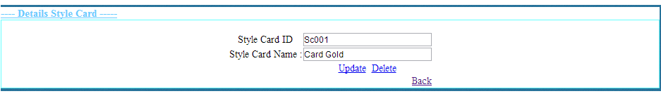

|  |  |  |  |  |  |
| --- | --- | --- | --- | --- | --- |
| **Name** | **Type** | **Event** | **Validation** | **Description** | **Status** |
| txtStyleCardID | TextBox |  | String,Not null | Input Style CardID |  |
| txtStyleCardName | TextBox |  | String,Not null | Input Style Card Name |  |
| Update | LinkButton |  |  | Update Style Card |  |
| Delete | LinkButton |  |  | Delete Style Card |  |
| Back | LinkButtom |  |  | Back to MainAdmin.aspx |  |

**24.News:**

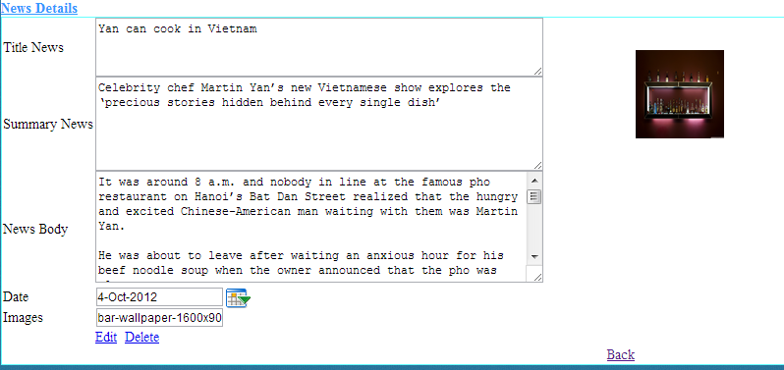

|  |  |  |  |  |  |
| --- | --- | --- | --- | --- | --- |
| **Name** | **Type** | **Event** | **Validation** | **Description** | **Status** |
| txtTitle News | TextBox |  | String,Not null | Input Title News |  |
| txtSummary News | TextBox |  | String,Not null | Input Summary News |  |
| txtNews Body | TextBox |  | String,Not null | Input News Body |  |
| txtDay | BasicDatePicker |  | Datetime,Not null | Input Datetime |  |
| txtImages | TextBox |  | String ,Not null | Input Images |  |
| Edit | LinkButton |  |  | Update Style Card |  |
| Delete | LinkButton |  |  | Delete Style Card |  |
| Back | LinkButtom |  |  | Back to MainAdmin.aspx |  |

**24.Details Nationality:**

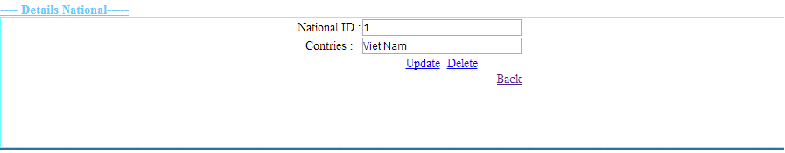

|  |  |  |  |  |  |
| --- | --- | --- | --- | --- | --- |
| **Name** | **Type** | **Event** | **Validation** | **Description** | **Status** |
| txtID | TextBox |  | String,Not null | Input CardID |  |
| txtNationalityName | TextBox |  | String,Not null | Input Nationality |  |
| Update | LinkButton |  |  | Update Nationality |  |
| Delete | LinkButton |  |  | Delete Nationality |  |
| Back | LinkButtom |  |  | Back to MainAdmin.aspx |  |

**Support:**

**+ Connected**

* **Gold :**

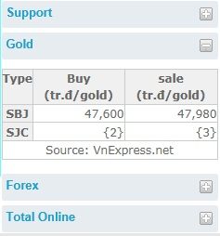

* **Forex :**

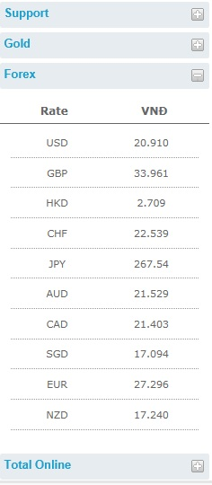

**+Disconnection**

* **Gold :**

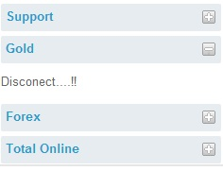

* **Forex :**

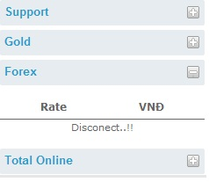

**+Total Online**

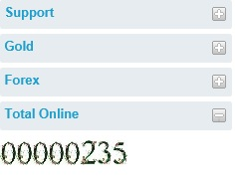

**TASK SHEET**

|  |  |  |  |  |  |  |
| --- | --- | --- | --- | --- | --- | --- |
| **Project Group FFG** | | **Project Title**  **Laptop Shop Online** | | **Date of Preparation** | | **Activity Plan Prepared by**  **Le Hoang Hai** |
| **No** | **Task Title** | | **Planned Start Date** | **Planned Completed Date** | **Team Mate Names** | **Status** |
| 1 | Login Customer | | Sep 10, 2012 | Oct 10, 2012 |  |  |
| 2 | Search admin evevnt onkeydown | |  |
| 3 | Change CodePin Credit Card | |  |
| 4 | Load News Masterpage Customer | |  |
| 5 | Design Masterpage Customer | |  |
| 6 | Register Customer | |  |  |
| 7 | Change Password | |  |
| 8 | Forget Password | |  |
| 9 | Credit card Infomation | |  |
| 10 | Your`s Profile | |  |
| 11 | Login Admin | |  |  |
| 12 | Edit Credit Card | |  |
| 13 | Edit Style Card | |  |
| 14 | Edit National | |  |
| 15 | Masterpage Admin | |  |
| 16 | Edit Status Customer | |  |  |
|  |
| 17 | Show Transaction | |  |
| 18 | Edit Balance | |  |
| 19 | Add, Edit, Delete news | |  |
| 20 | Customer Transaction | |  |  |
| 21 | Detail Transaction | |  |
| 22 | Download Report Transaction | |  |
| 23 | Create Report | |  |
| 25 | Contact | |  |
| 26 | Search Report | |  |
| 27 | Design Masterpage Customer | |  |

|  |  |  |
| --- | --- | --- |
| **Date: Oct 10, 2012** | **Prepared by Project Group 4**  **Team Leader:** | **Approved by**  **Mr. Ho Hoan Kiem** |
| **Signature** |  |  |