**Regular Star Polygons : Angles and Lengths**

Daniel Diaz ([didou.diaz@gmail.com](mailto:didou.diaz@gmail.com))

A [regular star polygon](https://en.wikipedia.org/wiki/Star_polygon) is defined by the radius of the circumscribing circle and by its Schlafli symbol {n/m} where n is the number of vertices and m is the step used to connect the vertices. The vertices are numbered from 0 to n-1 and regularly placed on the circle. Starting from the vertex 0, the star is built step by step by connecting the vertex i to the vertex (i+m) % n until the initial vertex 0 is reached (% is the modulo operator). If n and m are coprime (d=gcd(m,n)=1), all vertex are reached and the star is done. if n and m are not coprime (d>1) the construction is done via [stellation](https://en.wikipedia.org/wiki/Stellation): the figure is composed of d star polygons {(n/d) / (m/d)}. Examples: an hexagram {6/2} is composed of 2 triangles, i.e. {6/2} ⇒ 2×{3}; {12/3} ⇒ 3×{4} and {30/12} ⇒ 6×{5/2}.

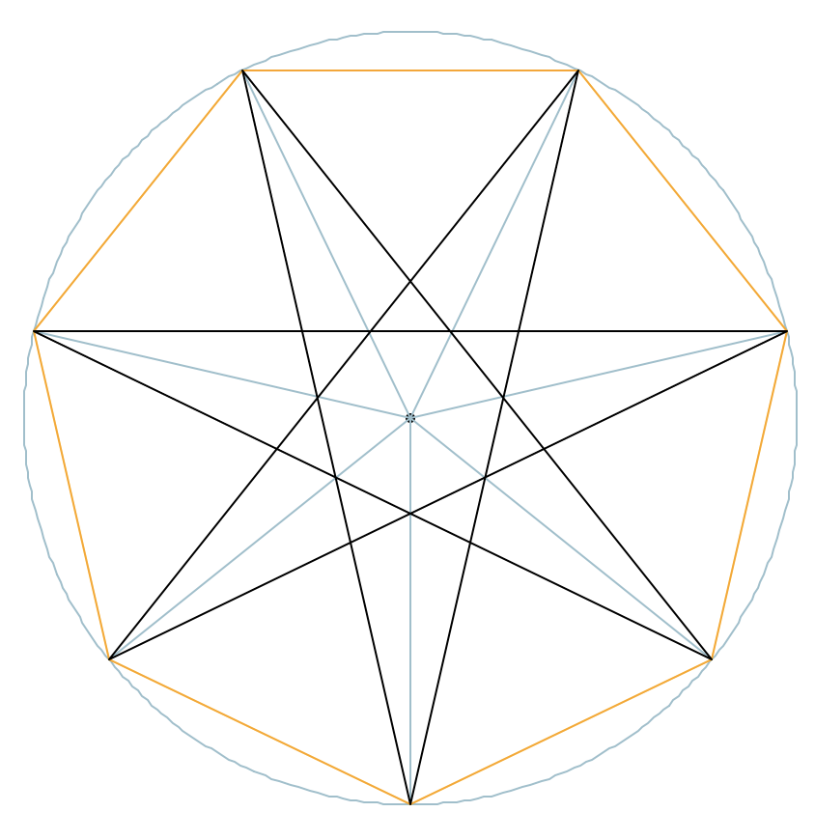

𝛼

**r**

𝛿

**s**

𝜃

𝜌

𝛾

𝜃

𝛾

**t**

𝜌

𝛽

𝛼

**u**

𝜎

𝜆

0

1

2

3

4

5

6

𝛽

**Input data 1**

r: radius of circumscribing circle (drawn in blue)  
n: number of vertices (numbered from 0 to n-1)  
m: step to connect edges, vertex *i* is linked to vertex (*i+m) % n*

1 corresponds to a convex polygon (drawn in orange)

n/2 is the “narrowest” concave polygon (drawn in black+red)

Case 1: the star is drawn with internal segments (e.g. as done  
by hand we tracing a 5-points star, i.e. pentagram)

Case 2: the star is drawn without internal segments.

**Input data 2**

r: radius of circumscribing circle  
n: number of vertices  
u: length of the edge

Case 3: from u compute angles 𝜃 and 𝜌 and then as Case 2

**Angles (degrees) and lengths**  **(font colors corresponds to values needed in the above cases)**

𝛼 = 360 / n

𝛽 = 𝛼 × (m + 1) / 2 or 𝛽 = 𝛾 – 𝜌

𝛾 = 𝛼 × m

𝛿 = (n – 2) / n * 180

𝜃 = 180 – 𝛾 or 𝜃 = 𝛿 - 2 × 𝜌

𝜌 = (𝛿 - 𝜃) / 2 or 𝜌 = acos(s / (2 × u))

𝜆 = 180 – (𝛼 + 𝜃) / 2

𝜎 = 180 – 2 * 𝜌

s = 2 × r × sin(𝛼 / 2)

t = 2 × r × sin(𝛾 / 2)

*Example: a {7/3} star polygon*

u = sin(𝛼 / 2) × r / sin(𝜆)