1. 数据处理：将缺失值补充为0
2. 问题二第一问采用聚类分析，spss中聚类分析，用谱线图表示出来，因为只有两类，高钾和铅钡，所以输入分为两类，反推出分高钾和铅钡的依据。

数据：（以下三个图）

|  |  |  |  |  |  |  |
| --- | --- | --- | --- | --- | --- | --- |
| **集中计划** | | | | | | |
| 阶段 | 组合聚类 | | 系数 | 首次出现聚类的阶段 | | 下一个阶段 |
| 聚类 1 | 聚类 2 | 聚类 1 | 聚类 2 |
| 1 | 12 | 13 | 14.799 | 0 | 0 | 2 |
| 2 | 5 | 12 | 51.145 | 0 | 1 | 3 |
| 3 | 5 | 7 | 119.574 | 2 | 0 | 4 |
| 4 | 2 | 5 | 253.845 | 0 | 3 | 5 |
| 5 | 2 | 14 | 364.224 | 4 | 0 | 6 |
| 6 | 2 | 8 | 556.271 | 5 | 0 | 7 |
| 7 | 2 | 4 | 702.025 | 6 | 0 | 8 |
| 8 | 2 | 11 | 1089.945 | 7 | 0 | 9 |
| 9 | 2 | 3 | 1291.223 | 8 | 0 | 10 |
| 10 | 2 | 6 | 1451.353 | 9 | 0 | 11 |
| 11 | 2 | 10 | 7014.918 | 10 | 0 | 12 |
| 12 | 2 | 9 | 57408.052 | 11 | 0 | 13 |
| 13 | 1 | 2 | 199481.914 | 0 | 12 | 0 |

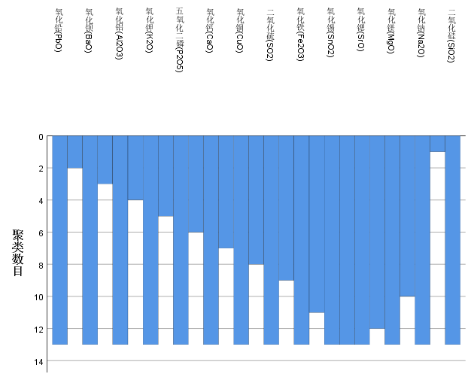

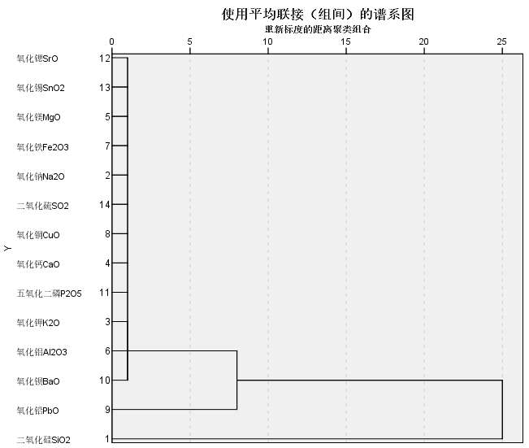

1. 问题二第二问，划分亚类的意思是在高钾和铅钡中继续聚类分析，具体分几类，可以试一试，依据指标的值是否分散来判断。又因为风化和无风化化学成分含量不相同，所以分为四类，高钾风化，高钾无风化，铅钡风化，铅钡无风化，因为二氧化硅是玻璃主要成分，所以在这里不再讨论

**高钾风化**

|  |  |  |  |  |  |  |
| --- | --- | --- | --- | --- | --- | --- |
| **集中计划** | | | | | | |
| 阶段 | 组合聚类 | | 系数 | 首次出现聚类的阶段 | | 下一个阶段 |
| 聚类 1 | 聚类 2 | 聚类 1 | 聚类 2 |
| 1 | 5 | 7 | .327 | 0 | 0 | 2 |
| 2 | 3 | 5 | .609 | 0 | 1 | 3 |
| 3 | 1 | 3 | 2.063 | 0 | 2 | 4 |
| 4 | 1 | 2 | 3.300 | 3 | 0 | 6 |
| 5 | 4 | 6 | 11.321 | 0 | 0 | 6 |
| 6 | 1 | 4 | 15.680 | 4 | 5 | 0 |

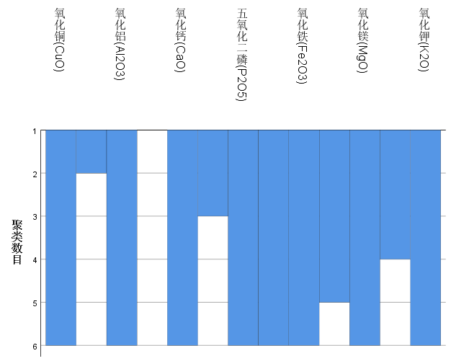

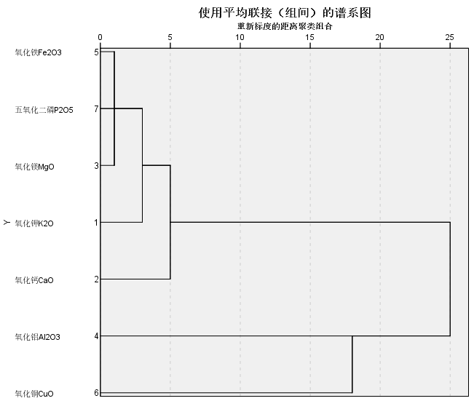

**高钾未风化**

|  |  |  |  |  |  |  |
| --- | --- | --- | --- | --- | --- | --- |
| **集中计划** | | | | | | |
| 阶段 | 组合聚类 | | 系数 | 首次出现聚类的阶段 | | 下一个阶段 |
| 聚类 1 | 聚类 2 | 聚类 1 | 聚类 2 |
| 1 | 11 | 13 | .493 | 0 | 0 | 2 |
| 2 | 11 | 12 | 5.679 | 1 | 0 | 4 |
| 3 | 8 | 9 | 7.591 | 0 | 0 | 4 |
| 4 | 8 | 11 | 12.199 | 3 | 2 | 5 |
| 5 | 4 | 8 | 17.608 | 0 | 4 | 7 |
| 6 | 6 | 10 | 20.598 | 0 | 0 | 8 |
| 7 | 1 | 4 | 41.697 | 0 | 5 | 9 |
| 8 | 6 | 7 | 48.816 | 6 | 0 | 9 |
| 9 | 1 | 6 | 65.907 | 7 | 8 | 12 |
| 10 | 3 | 5 | 189.624 | 0 | 0 | 11 |
| 11 | 2 | 3 | 395.275 | 0 | 10 | 12 |
| 12 | 1 | 2 | 653.047 | 9 | 11 | 0 |

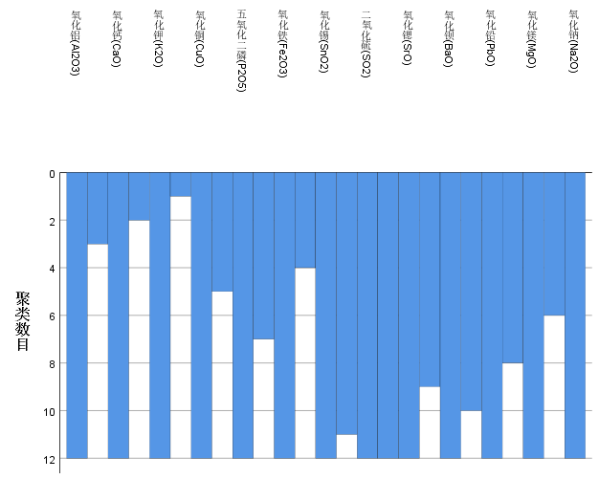

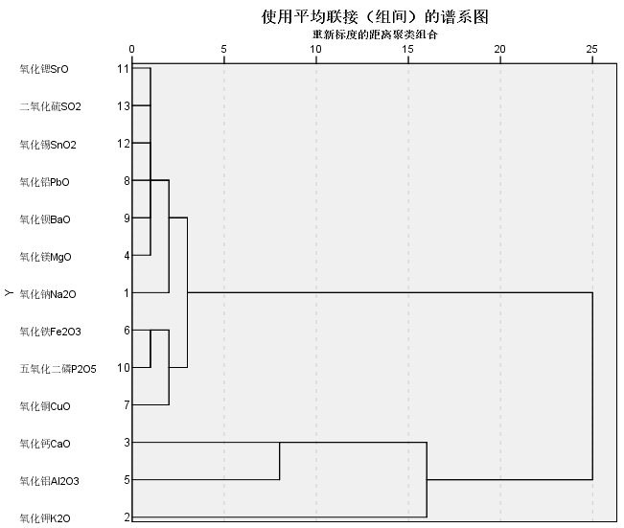

**铅钡风化**

|  |  |  |  |  |  |  |
| --- | --- | --- | --- | --- | --- | --- |
| **集中计划** | | | | | | |
| 阶段 | 组合聚类 | | 系数 | 首次出现聚类的阶段 | | 下一个阶段 |
| 聚类 1 | 聚类 2 | 聚类 1 | 聚类 2 |
| 1 | 2 | 12 | 3.001 | 0 | 0 | 2 |
| 2 | 2 | 11 | 6.137 | 1 | 0 | 4 |
| 3 | 4 | 6 | 8.435 | 0 | 0 | 5 |
| 4 | 1 | 2 | 9.967 | 0 | 2 | 5 |
| 5 | 1 | 4 | 19.450 | 4 | 3 | 7 |
| 6 | 3 | 5 | 190.765 | 0 | 0 | 7 |
| 7 | 1 | 3 | 259.376 | 5 | 6 | 8 |
| 8 | 1 | 7 | 321.550 | 7 | 0 | 9 |
| 9 | 1 | 13 | 331.456 | 8 | 0 | 10 |
| 10 | 1 | 10 | 863.435 | 9 | 0 | 11 |
| 11 | 1 | 9 | 4531.518 | 10 | 0 | 12 |
| 12 | 1 | 8 | 45930.153 | 11 | 0 | 0 |

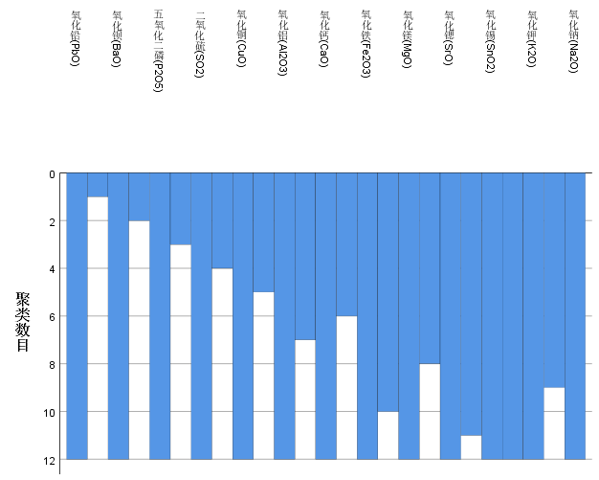

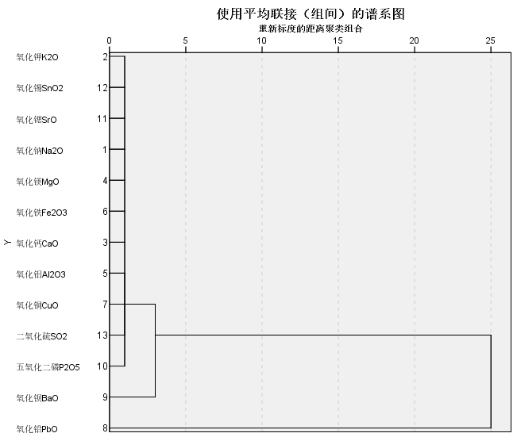

**铅钡无风化**

|  |  |  |  |  |  |  |
| --- | --- | --- | --- | --- | --- | --- |
| **集中计划** | | | | | | |
| 阶段 | 组合聚类 | | 系数 | 首次出现聚类的阶段 | | 下一个阶段 |
| 聚类 1 | 聚类 2 | 聚类 1 | 聚类 2 |
| 1 | 2 | 12 | 2.374 | 0 | 0 | 2 |
| 2 | 2 | 11 | 3.117 | 1 | 0 | 3 |
| 3 | 2 | 4 | 13.707 | 2 | 0 | 4 |
| 4 | 2 | 13 | 18.427 | 3 | 0 | 5 |
| 5 | 2 | 6 | 44.734 | 4 | 0 | 6 |
| 6 | 2 | 3 | 78.716 | 5 | 0 | 7 |
| 7 | 2 | 10 | 96.753 | 6 | 0 | 8 |
| 8 | 2 | 7 | 141.137 | 7 | 0 | 9 |
| 9 | 1 | 2 | 202.428 | 0 | 8 | 10 |
| 10 | 1 | 5 | 615.618 | 9 | 0 | 11 |
| 11 | 1 | 9 | 2260.688 | 10 | 0 | 12 |
| 12 | 1 | 8 | 11272.074 | 11 | 0 | 0 |

