问题二

1.数据预处理

|  |  |  |  |  |  |  |  |  |  |  |  |  |  |  |  |  |
| --- | --- | --- | --- | --- | --- | --- | --- | --- | --- | --- | --- | --- | --- | --- | --- | --- |
| **文物采样点（高钾）** | **二氧化硅(SiO2)** | **氧化钠(Na2O)** | **氧化钾(K2O)** | **氧化钙(CaO)** | **氧化镁(MgO)** | **氧化铝(Al2O3)** | **氧化铁(Fe2O3)** | **氧化铜(CuO)** | **氧化铅(PbO)** | **氧化钡(BaO)** | **五氧化二磷(P2O5)** | **氧化锶(SrO)** | **氧化锡(SnO2)** | **二氧化硫(SO2)** | **表面风化** | **成分累计** |
| 07 | 92.63 | 0 | 0 | 1.07 | 0 | 1.98 | 0.17 | 3.24 | 0 | 0 | 0.61 | 0 | 0 | 0 | 风化 | 99.7 |
| 09 | 95.02 | 0 | 0.59 | 0.62 | 0 | 1.32 | 0.32 | 1.55 | 0 | 0 | 0.35 | 0 | 0 | 0 | 风化 | 99.77 |
| 10 | 96.77 | 0 | 0.92 | 0.21 | 0 | 0.81 | 0.26 | 0.84 | 0 | 0 | 0 | 0 | 0 | 0 | 风化 | 99.81 |
| 12 | 94.29 | 0 | 1.01 | 0.72 | 0 | 1.46 | 0.29 | 1.65 | 0 | 0 | 0.15 | 0 | 0 | 0 | 风化 | 99.57 |
| 22 | 92.35 | 0 | 0.74 | 1.66 | 0.64 | 3.5 | 0.35 | 0.55 | 0 | 0 | 0.21 | 0 | 0 | 0 | 风化 | 100 |
| 27 | 92.72 | 0 | 0 | 0.94 | 0.54 | 2.51 | 0.2 | 1.54 | 0 | 0 | 0.36 | 0 | 0 | 0 | 风化 | 98.81 |
| 均值 | 93.96333 | 0 | 0.543333 | 0.87 | 0.196667 | 1.93 | 0.265 | 1.561667 | 0 | 0 | 0.28 | 0 | 0 | 0 |  |  |

表 高钾风化表

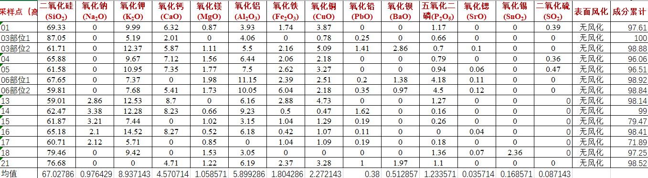

表 高钾无风化

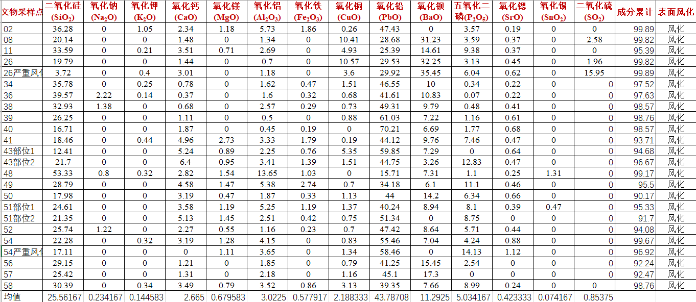

表 铅钡风化

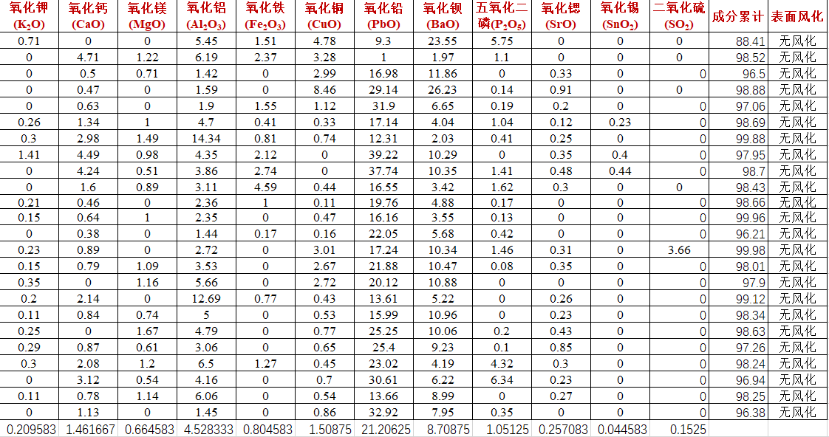

表 铅钡无风化

1. 总聚类分析

|  |  |  |  |  |  |  |
| --- | --- | --- | --- | --- | --- | --- |
| **集中计划** | | | | | | |
| 阶段 | 组合聚类 | | 系数 | 首次出现聚类的阶段 | | 下一个阶段 |
| 聚类 1 | 聚类 2 | 聚类 1 | 聚类 2 |
| 1 | 12 | 13 | 14.799 | 0 | 0 | 2 |
| 2 | 5 | 12 | 51.145 | 0 | 1 | 3 |
| 3 | 5 | 7 | 119.574 | 2 | 0 | 4 |
| 4 | 2 | 5 | 253.845 | 0 | 3 | 5 |
| 5 | 2 | 14 | 364.224 | 4 | 0 | 6 |
| 6 | 2 | 8 | 556.271 | 5 | 0 | 7 |
| 7 | 2 | 4 | 702.025 | 6 | 0 | 8 |
| 8 | 2 | 11 | 1089.945 | 7 | 0 | 9 |
| 9 | 2 | 3 | 1291.223 | 8 | 0 | 10 |
| 10 | 2 | 6 | 1451.353 | 9 | 0 | 11 |
| 11 | 2 | 10 | 7014.918 | 10 | 0 | 12 |
| 12 | 2 | 9 | 57408.052 | 11 | 0 | 13 |
| 13 | 1 | 2 | 199481.914 | 0 | 12 | 0 |

表 铅钡和高钾的分类依据表

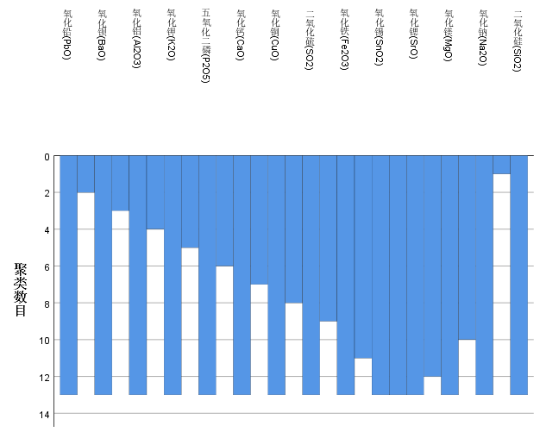

图 铅钡和高钾分类依据

1. 亚类聚类分析

|  |  |  |  |  |  |  |
| --- | --- | --- | --- | --- | --- | --- |
| **集中计划** | | | | | | |
| 阶段 | 组合聚类 | | 系数 | 首次出现聚类的阶段 | | 下一个阶段 |
| 聚类 1 | 聚类 2 | 聚类 1 | 聚类 2 |
| 1 | 5 | 7 | .327 | 0 | 0 | 2 |
| 2 | 3 | 5 | .609 | 0 | 1 | 3 |
| 3 | 1 | 3 | 2.063 | 0 | 2 | 4 |
| 4 | 1 | 2 | 3.300 | 3 | 0 | 6 |
| 5 | 4 | 6 | 11.321 | 0 | 0 | 6 |
| 6 | 1 | 4 | 15.680 | 4 | 5 | 0 |

表 高钾风化亚类分类依据

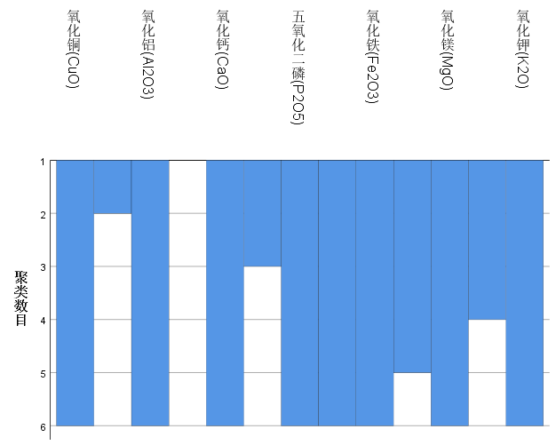

图 高钾风化亚类分类依据

|  |  |  |  |  |  |  |
| --- | --- | --- | --- | --- | --- | --- |
| **集中计划** | | | | | | |
| 阶段 | 组合聚类 | | 系数 | 首次出现聚类的阶段 | | 下一个阶段 |
| 聚类 1 | 聚类 2 | 聚类 1 | 聚类 2 |
| 1 | 11 | 13 | .493 | 0 | 0 | 2 |
| 2 | 11 | 12 | 5.679 | 1 | 0 | 4 |
| 3 | 8 | 9 | 7.591 | 0 | 0 | 4 |
| 4 | 8 | 11 | 12.199 | 3 | 2 | 5 |
| 5 | 4 | 8 | 17.608 | 0 | 4 | 7 |
| 6 | 6 | 10 | 20.598 | 0 | 0 | 8 |
| 7 | 1 | 4 | 41.697 | 0 | 5 | 9 |
| 8 | 6 | 7 | 48.816 | 6 | 0 | 9 |
| 9 | 1 | 6 | 65.907 | 7 | 8 | 12 |
| 10 | 3 | 5 | 189.624 | 0 | 0 | 11 |
| 11 | 2 | 3 | 395.275 | 0 | 10 | 12 |
| 12 | 1 | 2 | 653.047 | 9 | 11 | 0 |

表 高钾无风化亚类分类依据

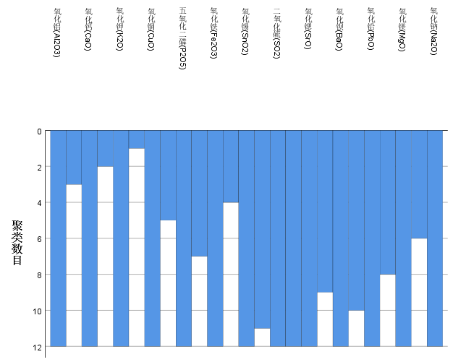

图 高钾无风化亚类分类依据

|  |  |  |  |  |  |  |
| --- | --- | --- | --- | --- | --- | --- |
| **集中计划** | | | | | | |
| 阶段 | 组合聚类 | | 系数 | 首次出现聚类的阶段 | | 下一个阶段 |
| 聚类 1 | 聚类 2 | 聚类 1 | 聚类 2 |
| 1 | 2 | 12 | 3.001 | 0 | 0 | 2 |
| 2 | 2 | 11 | 6.137 | 1 | 0 | 4 |
| 3 | 4 | 6 | 8.435 | 0 | 0 | 5 |
| 4 | 1 | 2 | 9.967 | 0 | 2 | 5 |
| 5 | 1 | 4 | 19.450 | 4 | 3 | 7 |
| 6 | 3 | 5 | 190.765 | 0 | 0 | 7 |
| 7 | 1 | 3 | 259.376 | 5 | 6 | 8 |
| 8 | 1 | 7 | 321.550 | 7 | 0 | 9 |
| 9 | 1 | 13 | 331.456 | 8 | 0 | 10 |
| 10 | 1 | 10 | 863.435 | 9 | 0 | 11 |
| 11 | 1 | 9 | 4531.518 | 10 | 0 | 12 |
| 12 | 1 | 8 | 45930.153 | 11 | 0 | 0 |

表 铅钡风化亚类分类依据

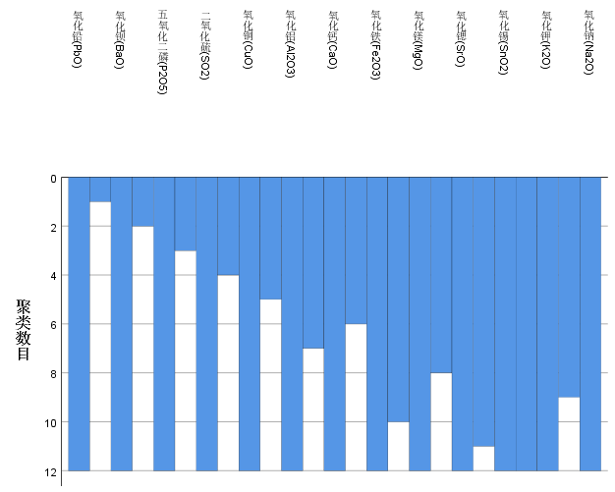

图 铅钡风化亚类分类依据

|  |  |  |  |  |  |  |
| --- | --- | --- | --- | --- | --- | --- |
| **集中计划** | | | | | | |
| 阶段 | 组合聚类 | | 系数 | 首次出现聚类的阶段 | | 下一个阶段 |
| 聚类 1 | 聚类 2 | 聚类 1 | 聚类 2 |
| 1 | 2 | 12 | 2.374 | 0 | 0 | 2 |
| 2 | 2 | 11 | 3.117 | 1 | 0 | 3 |
| 3 | 2 | 4 | 13.707 | 2 | 0 | 4 |
| 4 | 2 | 13 | 18.427 | 3 | 0 | 5 |
| 5 | 2 | 6 | 44.734 | 4 | 0 | 6 |
| 6 | 2 | 3 | 78.716 | 5 | 0 | 7 |
| 7 | 2 | 10 | 96.753 | 6 | 0 | 8 |
| 8 | 2 | 7 | 141.137 | 7 | 0 | 9 |
| 9 | 1 | 2 | 202.428 | 0 | 8 | 10 |
| 10 | 1 | 5 | 615.618 | 9 | 0 | 11 |
| 11 | 1 | 9 | 2260.688 | 10 | 0 | 12 |
| 12 | 1 | 8 | 11272.074 | 11 | 0 | 0 |

表 铅钡无风化亚类分类依据

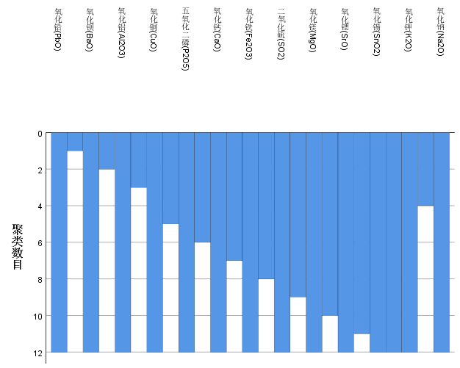

图 铅钡无风化亚类分类依据