* 1. 对数据进行预处理，首先对缺失值进行处理，将缺失值大于百分之五十的数据和age缺失的值删除。对剩下数据进行缺失值填充。通过主成分分析法，

进行缺失值填充时的图：

|  |  |  |  |  |  |  |  |
| --- | --- | --- | --- | --- | --- | --- | --- |
| **单变量统计** | | | | | | | |
|  | 个案数 | 平均值 | 标准 偏差 | 缺失 | | 极值数a | |
| 计数 | 百分比 | 低 | 高 |
| CDRSB_bl | 16213 | 1.219 | 1.5200 | 0 | .0 | 0 | 964 |
| ADAS11_bl | 16177 | 9.2724 | 5.78699 | 36 | .2 | 0 | 816 |
| ADAS13_bl | 16105 | 14.6371 | 8.60823 | 108 | .7 | 0 | 740 |
| APOE4 | 15898 |  |  | 315 | 1.9 |  |  |
| ADASQ4_bl | 16207 |  |  | 6 | .0 |  |  |
| a. 超出范围 (平均值 - 2*标准差, 平均值 + 2*标准差) 的个案数。 | | | | | | | |

|  |  |  |  |
| --- | --- | --- | --- |
| **估算平均值摘要** | | | |
|  | CDRSB_bl | ADAS11_bl | ADAS13_bl |
| 所有值 | 1.219 | 9.2724 | 14.6371 |
| EM | 1.219 | 9.2700 | 14.6696 |

|  |  |  |  |
| --- | --- | --- | --- |
| **估算标准差摘要** | | | |
|  | CDRSB_bl | ADAS11_bl | ADAS13_bl |
| 所有值 | 1.5200 | 5.78699 | 8.60823 |
| EM | 1.5160 | 5.78280 | 8.62755 |

|  |  |  |
| --- | --- | --- |
| **EM 平均值a** | | |
| CDRSB_bl | ADAS11_bl | ADAS13_bl |
| 1.219 | 9.2700 | 14.6696 |
| a. 利特尔 MCAR 检验：卡方 = 78.042，自由度 = 3，重要性 = .000 | | |

|  |  |  |  |
| --- | --- | --- | --- |
| **EM 协方差a** | | | |
|  | CDRSB_bl | ADAS11_bl | ADAS13_bl |
| CDRSB_bl | 2.2983 |  |  |
| ADAS11_bl | 6.1060 | 33.44073 |  |
| ADAS13_bl | 9.3496 | 48.46864 | 74.43455 |
| a. 利特尔 MCAR 检验：卡方 = 78.042，自由度 = 3，重要性 = .000 | | | |

|  |  |  |  |
| --- | --- | --- | --- |
| **EM 相关性a** | | | |
|  | CDRSB_bl | ADAS11_bl | ADAS13_bl |
| CDRSB_bl | 1 |  |  |
| ADAS11_bl | .696 | 1 |  |
| ADAS13_bl | .715 | .971 | 1 |
| a. 利特尔 MCAR 检验：卡方 = 78.042，自由度 = 3，重要性 = .000 | | | |

统计描述

|  |  |  |  |  |  |
| --- | --- | --- | --- | --- | --- |
| **描述统计** | | | | | |
|  | N | 最小值 | 最大值 | 均值 | 标准 偏差 |
| CDRSB_bl | 16213 | .0 | 10.0 | 1.219 | 1.5200 |
| ADAS11_bl | 16213 | .00 | 42.67 | 9.2742 | 5.78417 |
| ADAS13_bl | 16213 | .00 | 54.67 | 14.6741 | 8.62681 |
| 有效个案数（成列） | 16213 |  |  |  |  |

相关分析：Person相关分析

|  | **CDRSB_bl** | **ADAS11_bl** | **ADAS13_bl** | **ADASQ4_bl** |
| --- | --- | --- | --- | --- |
| CDRSB_bl | 1(0.000***) | 0.731(0.000***) | 0.75(0.000***) | 0.649(0.000***) |
| ADAS11_bl | 0.731(0.000***) | 1(0.000***) | 0.976(0.000***) | 0.771(0.000***) |
| ADAS13_bl | 0.75(0.000***) | 0.976(0.000***) | 1(0.000***) | 0.876(0.000***) |
| ADASQ4_bl | 0.649(0.000***) | 0.771(0.000***) | 0.876(0.000***) | 1(0.000***) |
| 注：***、**、*分别代表1%、5%、10%的显著性水平 | | | | |

热力图

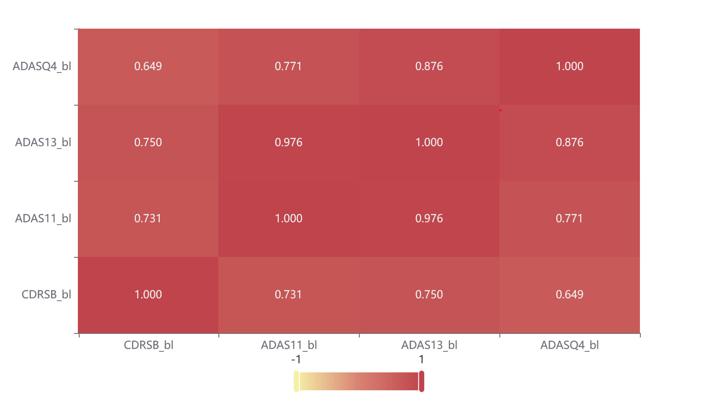

[1] Scientific Platform Serving for Statistics Professional 2021. SPSSPRO. (Version 1.0.11)[Online Application Software]. Retrieved from https://www.spsspro.com.

[2] 徐维超. 相关系数研究综述[J]. 广东工业大学学报,2012,29(3):12-17.