|  |  |  |
| --- | --- | --- |
| **Problem Chosen**  D | **2023**  **ShuWei Cup**  **Summary Sheet** | **Team Control Number**  2023091419462 |

**[Catalogue](https://fanyi.so.com/" \l "catalogue" \t "https://fanyi.so.com/_blank)**

1. Introduction 2

1.1 Background 2

1.2 Work 2

2.Problem analysis 3

2.1 Analysis of question one 3

2.2 Analysis of question two 3

2.3 Analysis of question three 3

2.4 Analysis of question four 4

3.Symbol and Assumptions 4

3. 1 Symbol Description 4

3.2 Fundamental assumptions 6

4.Model 6

4.1Model One 6

4.2 Model two 7

4.3 Model three 7

4.4 Model four 8

5. Test the Models 9

5.1 Test the Model One 9

5.2 Test the Model two 11

5.3Test the Model three 11

5.4Test the Model four 11

6. Strengths and Weakness 12

6.1Advantages 12

6.2Disadvantages 13

7.Conclusion 13

7.1Model One Conclusion 13

7.2Model two Conclusion 15

7.3Model three Conclusion 16

7.4Model four Conclusion 16

References 18

Appendix 19

Mathematical Modeling of Detergent Cleaning

**Summary**

This paper discusses the solubility, initial dirt quantity and target water availability with the optimal solution regarding the number of washes and the amount of water used per wash, and conducts the corresponding mathematical analyses using a linear programming model, which is derived using the arithmetic geometric mean inequality; and uses the equivalent substitution using a similar method in the model of the first question to obtain the most time-saving cleaning in the case that the dirt residue should be no more than one-thousandth of the initial dirt quantity program, analyze the effect of solubility and the initial amount of dirt on the optimal program; then, using the type and amount of dirt in Table 1 and the solubility of various detergents on dirt in Table 2, as well as the unit price of detergents using the optimization model method to find the decision variables, objective function, constraints, to get both cost savings and give a good cleaning program; for problem four viewed as a problem in graph theory to find the graph of a Maximum group division, NP-complete problem, use backtracking algorithm to find out all possible combinations, and then choose the optimal one.

In response to question 1,Put the clothes into m0 (kg) of water at a time, together with the clothes on the w (kg) of sewage, a total of V (kg) of water. The dirt is evenly distributed (where dirt has ak dissolved in water) in this w +V (kg) of water.

In response to question 2, The corresponding mathematical analysis was carried out using a linear programming model, which was derived using the arithmetic geometric mean inequality; and equivalent substitutions were carried out using a similar approach in the model of the first question.

In response to question 3, we define the number of contaminants in item i, item j, where i = 1,2, ... 36, j = 1,2, ... . 8.Summing the same pollutants in all clothes to get the total amount of different ,Let the amount of detergent k be added in washing,wk = 1,2...10. Let the decontamination effect of the k detergent on the j pollutant Be.The washing effect after n-turn washing can be achieved at most: given washing requirement $ε$ has $ε$ times of the original pollutant after washing.We do not have a definite one here, so we search for step size with $∆ε$ =0.0001, search value = $ε$ =0.0001 (One in a thousand)

In response to question 4，To wash these clothes in groups so that the clothes within each group can be mixed, we can think of this problem as a problem in graph theory. ，find the fewest combinations, we can try to find a maximal clique division of the graph. A cluster (clique) is a subgraph within which the vertices are all connected to each other. use a backtracking algorithm to find all possible combinations and then choose the optimal one. Here, we will create a function that recursively tries to place each item into an existing combination or create a new combination until all items are placed

**Keywords:detergent cleaning,linear programming model, optimization model, backtracking algorithm**

# Introduction

1.1 Background

Washing clothes is one of the most common events in our daily life. It is necessary to wash clothes with chemicals such as Surfactant, detergents, etc. , the mechanism of decontamination can be divided into four aspects: wetting, adsorption, solubilization and mechanical action. Under these actions, the dirt is separated from the fabric in suspension or emulsion state, and then after a number of rinsing, so as to achieve the role of cleaning. The cleanliness of clothing is related to the structure of surface active molecules, one end of which is hydrophilic, and the hydrophilic part of adsorbing water molecules repels oily substances, which weakens the intermolecular force that maintains the binding of water molecules, mechanical action or manual friction in the washing machine can result in the removal of Surfactant particles from the surface, which attach to the lipophilic parts of the Surfactant, the dirt particles still suspended on the surface of the object are removed during the rinsing stage. The removal of dirt is also related to the initial amount of dirt and the target amount of water available, the solubility of various detergents to dirt, the material of clothing, and the color of clothing.

Therefore, the solubility of detergent to dirt and the dirt of clothes of different materials are evaluated, which can be used to accurately establish the model of the influence of detergent on the solubility of dirt of different clothes, it is of great significance to the efficient use of solvents, and a good cleaning plan is given.

Due to the initial amount of dirt and the target amount of water available, the solubility of various detergents for dirt, different materials of clothing, and different types and amounts of dirt on each clothing. Based on the data from the contest and other relevant data, the paper discusses the solubility, the initial amount of dirt and the target amount of available water, the solubility of various detergents to dirt, as well as the unit price of detergents to obtain the best solution to related problems as well as the cleaning plan.

1.2 Work

The following problems will be solved in this paper:

1. given the amount of dirt and available water, the solubility of dirt in water is ak in the k times wash, and the best method of cleaning is given without considering other factors, the optimal solution for wash times and water consumption per wash is discussed, and the effects of ak, initial fouling, and target water availability are discussed.
2. under other conditions similar to question 1, the final fouling residue should not exceed one thousandth of the initial fouling amount, providing the most time-saving cleaning scheme, and analyzing the influence of a and the initial fouling amount on the optimal scheme.
3. according to the solubility of various detergents to dirt and the unit price of detergents, try to save cost and give a good cleaning plan.
4. several different materials of clothes, the type and quantity of dirt on each kind of clothes, some clothes can not be mixed and washed under the same conditions as question 2, providing an economical and efficient cleaning plan.

# 2.Problem analysis

2.1 Analysis of question one

For the first question, mainly considering the characteristics of commonly used detergent and various actual conditions, when the laundry is given, rinsing water for a total of V (kg), V (kg) water into n times to use, Each dose is v1,v2......vn (kg) , establish the relevant mathematical model, from the first case reasoning, n times in turn by analogy, get the residual amount of the formula, for the fixed n times, from v1,v2......vn =V , find the relation formula of the minimum amount of dirt left after n times of washing, and consider the relation between the amount of dirt and the amount of water, then draw the curves of ak, initial amount of dirt and the amount of water available

2.2 Analysis of question two

Because the second model assumes that each washing time is the same, the available water is not limited, and under other conditions similar to question 1, the analysis establishes the relevant model, so question 2 is similar to question 1, in Question 2, we know from Question 1 that Model two analysis is similar to the analysis of V/w in Model two, except that V/w is replaced by t to build the model.

Thus, the most time-saving cleaning scheme and the influence of ak and the initial amount of dirt on the optimal scheme are obtained.

2.3 Analysis of question three

The third question asked us to use the detergent in Table 2 of the annex to clean the clothes in Table 1 of the annex. There are 8 kinds of pollutants on each piece of clothing, the sum of the eight pollutants in the 36 pieces of clothing can be considered to be just one piece of clothing, which greatly simplifies the calculation. The next item mentioned in the title, water costs 3.8 yuan per ton, it does not specify how much water is required per gram of detergent. Here we assume that 1 gram of detergent requires 1 ton of water. Then we can take the amount of each detergent as the decision variable, get the total amount of each pollutant after washing and the cost function, for these two functions take the minimum value, that is to save costs and good cleaning program.

2.4 Analysis of question four

From the table provided in the information, the constraints of mixing different materials for washing clothes are analyzed and obtained, there are several different materials of clothes, various list relationships of type and amount of dirt on each type of clothes, matrix is used to represent the mixing relationship,a graph is formed. The backtracking algorithm is used to find out all the possible combinations and then the optimal one is selected to build the optimization model. A cost effective cleaning schedule is obtained under the same conditions as in problem 2.

# 3.Symbol and Assumptions

## 3. 1 Symbol Description

Then the symbolic definition of question one and two

|  |  |
| --- | --- |
| w (kg) | The amount of water that remains after the clothes are wrung out at the beginning of the wash. |
| m0 (kg) | Containing dirt |
| w (kg) | The amount of water remaining in clothes after each wash and full wringing. |

Then the symbolic definition of question three:

|  |  |
| --- | --- |
| $$x_{ij}$$ | Number of j pollutants in item i clothing |
| $$Z_{kj}$$ | The decontamination effect of the k-type detergent on the j-type pollutant |
| $$d_{j}$$ | The original total amount of class j pollutants |
| $$w_{k}$$ | The amount of detergent k added to a wash |
| $$D_{j}$$ | The amount of residual class j pollutants |
| $$P_{k}$$ | Unit Price of each detergent (g/Yuan) |
| P | The cost price of the whole laundry |

Problem 3 Symbol Definition:

|  |  |
| --- | --- |
| $x_{ij}$ of group n | Quantity of j pollutant in group(n) for the i garment |
| $$Z_{kj}$$ | Decontamination effect of the k detergent on the j pollutant |
| $d_{j }$ of group n | Total raw amount of pollutants in group (n) for category j |
| $w_{k}$ of group n | Amount of the kth laundry detergent added to the wash in group (n) |
| $D_{j}$ of group n | Amount of pollutant type j remaining in group (n) |
| $$P_{k}$$ | Unit price of each laundry detergent (g/yuan) |
| P of group n | Cost price of the entire laundry in group(n) |

## 3.2 Fundamental assumptions

**question one assumptions:**

Assumption 1: There is enough water

Assumption2:There are w(kg)stains left on the clothes after each washingquestion

**two assumptions:**

Assumption 1: The washing time is the same each time

Assumption 2: There is no limit to the amount of water and there is enough water

Assumption 3: There are w(kg)stains left on the clothes after each washing

**question three assumptions:**

Assumption 1: all clothes can be mixed washing

assumption 2: each gram of detergent needs a ton of water

**question four assumptions:**

Assumption 2: One ton of water is needed per g of laundry detergent

Summing similar pollutants from the same combination of clothes gives the total amount of different types of pollutants:

$$d_{j} =\sum_{i=1}^{36}{x_{ij}}$$

The kth laundry detergent is added in the amount of $w_{k}$,k=1,2...,10。

# 4.Model

4.1Model One

Establish a model:

Let the clothes be wrung dry at the beginning of the residual water is w (kg), which contains dirt: m0 (kg), and every time the clothes washed and fully wrung residual water : w (kg), The total amount of water used for rinsing is V (kg), divided into V (kg) of water for n times uses, each use is v1, v2 ... vn .

How much dirt is left on the clothes after n Rinses? How to use this V (kg) of water rationally, can wash clothes the cleanest? (The minimum amount of residual dirt)

For the first time, put the clothes with m0 (kg) of dirt w (kg) of water into v1(kg) of water, rub and wring thoroughly, and as m0 (kg) of dirt is evenly distributed in w + v1(kg)of water, so the residual amount of dirt m1 (kg) on the clothes is proportional to the residual amount of water w (kg)

That is:







Obtained from the above formula: mn (kg)



4.2 Model two

Because the second model assumes that each washing time is the same, the available water is not limited, and under other conditions similar to question 1, the analysis establishes the relevant model, so question 2 is similar to question 1, in Question 2, we know from Question 1 that Model two analysis is similar to the analysis of V/w in Model two, except that V/w is replaced by t to build the model.



4.3 Model three

we define the number of contaminants in item i, item j, where i = 1,2, ... 36, j = 1,2, ... . 8



Summing the same pollutants in all clothes to get the total amount of different pollutants:

$$d_{j}=\sum_{i=1}^{36}{x_{ij}}$$

Let the amount of detergent k be added in washing,wk = 1,2...10.

Let the decontamination effect of the k detergent on the j pollutant Be.



Set as the unit price of the k detergent, because each gram of detergent with 1 ton of water, so the amount of water can also be used instead of wk.

is the total amount remaining for each pollutant, P is the final washing cost. And we just find the minimum of P.

Min $D_{j}$ = $d_{j}−\sum_{k=1}^{10}{{}_{k}∗Z_{kj},j=1,2,3....8}$

minP= $\sum_{k=1}^{10}{(W_{k}∗P_{k}+3.8w_{k})}$

4.4 Model four

The following table shows the conditions for mixing and washing clothes

Table 1: Limitations of washing clothes mixed with different materials

|  |  |  |  |  |  |  |  |  |
| --- | --- | --- | --- | --- | --- | --- | --- | --- |
| Materia | 1 | 2 | 3 | 4 | 5 | 6 | 7 | 8 |
| 1 |  | × | √ | √ | √ | √ | × | × |
| 2 | × |  | × | × | × | × | × | √ |
| 3 | √ | × |  | × | × | √ | √ | √ |
| 4 | √ | × | × |  | × | √ | √ | √ |
| 5 | √ | × | × | × |  | × | √ | √ |
| 6 | √ | × | √ | √ | √ |  | √ | √ |
| 7 | × | × | √ | √ | √ | √ |  | √ |
| 8 | × | √ | √ | √ | √ | √ | √ |  |

Here we use the matrix A to represent the mixing relationship, where 1 means that it can be mixed and 0 means that it cannot be mixed.



To wash these clothes in groups so that the clothes within each group can be mixed, we can think of this problem as a problem in graph theory. A matrix can be thought of as an adjacency matrix, where the rows and columns of the matrix represent the vertices in the graph (in this case, the types of laundry), and the elements of the matrix represent whether these vertices (the laundry) are connected (i.e., whether they can be put together).

To find the fewest combinations, we can try to find a maximal clique division of the graph. A cluster (clique) is a subgraph within which the vertices are all connected to each other. Maximum clique partitioning is the process of dividing the vertices of a graph into as few clusters as possible, such that each vertex belongs to a clique and the vertices within each clique are interconnected.

This problem is NP-complete and there is no efficient algorithm that can be solved in polynomial time for large graphs. But since the graph here is small (only 8 vertices), we can try to compute it directly.

We can use a backtracking algorithm to find all possible combinations and then choose the optimal one. (i.e. least grouping, clothing stains are most even after grouping) Here, we will create a function that recursively tries to place each item into an existing combination or create a new combination until all items are placed.

The following optimal grouping can be obtained:

Table 2: Optimal washing grouping of clothes

|  |  |
| --- | --- |
| Grouping | Type of clothing |
| Combination 1 | 2,8 |
| Combination 2 | 3,1 |
| Combination 3 | 4,6 |
| Combination 4 | 5,7 |

# Test the Models

5.1 Test the Model One

From the above model:

1. It turns out that the more dirt m0 (kg) there is left on the clothes, the more dirt mn(kg) will be left in the end. (The dirtier the clothes, the harder they are to wash)
2. the smaller the original sewage w(kg) is, the smaller the mn (kg) will be, that is, the more“Dry” the wring each time, the less the residual sewage will be, which is consistent with our common sense.

For fixed n times, according to the arithmetic-geometric mean inequality, there are:





（when  ）

So：



This shows that when the water consumption is V/n, the residual amount of mn (kg) is the minimum, that is, the clothes are the cleanest.

If the minimum amount of residue after n times of washing is recorded as mn* (kg)

So: this shows that for a given amount of water, it is cleaner to divide the water into n + 1 times than to divide it into n times. Further, when the volume of Water V (kg) is a certain time, is it possible to wash the number n times enough, you can make the minimum amount of residual dirt arbitrarily small?



This shows that mn* (kg) is not an infinitesimal amount, that is, when the total amount of water V is constant, no matter how many times it is rinsed, it can not be done without any residue.

5.2 Test the Model two

The derivation process of the model test is similar to that of problem 1, which is derived from the arithmetic-geometric mean inequality



5.3Test the Model three

Through the analysis of Model 3 above, we can establish the optimization model

1. decision variables

|  |  |
| --- | --- |
| Zkj | The decontamination effect of the k-type detergent on the j-type pollutant |
|  | The amount of detergent k added to a wash |
|  | Unit Price of each detergent (g/Yuan) |
| P | The cost price of the whole laundry |

1. objective function

Min $D_{j}$ = $d_{j}−\sum_{k=1}^{10}{W_{k}∗Z_{kj},j=1,2,3....8}$

minP= $\sum_{k=1}^{10}{(W_{k}∗P_{k}+3.8w_{k})}$

1. $D_{j}$ constraints

$w_{k}≥0$*,k=1,2....10*

$w_{k}≤$ Stock of detergent K

$\sum_{k=1}^{10}{w_{k}}≤$ The total amount of water available

5.4Test the Model four

The data were first analyzed in Table 3：

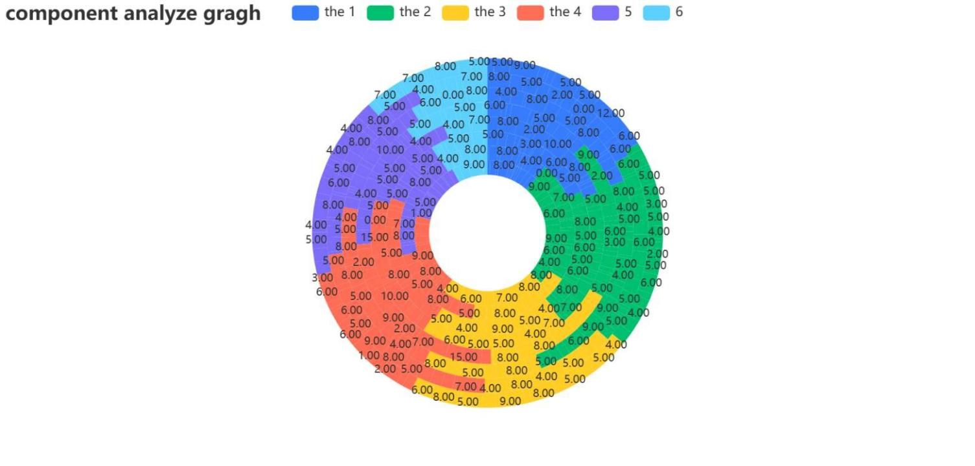

Figure 1

Let the decontamination effect of the kth detergent on the jth pollutant be $Z_{kj}$。



Let be the unit price of the kth detergent, and since 1 ton of water is used per gram of detergent, the amount of water used can also be replaced by $w_{k}$.

$D_{j}$ is the total amount of each pollutant remaining in group n, and P is the final cost of washing in group n. And we are finding the minimum value of P in group n.

# Strengths and Weakness

6.1Advantages

1. Relatively simple: The mathematical expression of the linear programming model is relatively simple, easy to understand and implement. It uses a linear function to describe the problem, making it relatively easy to solve the model.  
   (2) Feasibility: Linear programming problems usually have feasible solutions, that is, there are solutions that meet all constraints. This means that the linear programming model can find the optimal solution to the problem or a solution that is close to the optimal solution.  
   (3) High efficiency: The solution algorithm of linear programming model usually has high efficiency. For small and medium-scale problems, linear programming algorithms can find the optimal solution in a reasonable time.  
   (4) Flexibility: The linear programming model can be flexibly applied to various fields and problems, including production planning, resource allocation, transportation problems, etc. It can be used to optimize decision-making and resource utilization for optimal benefits and results.

6.2Disadvantages

(1) Only applicable to linear problems: Linear programming models are only suitable for problems with linear constraints and linear objective functions. For nonlinear problems, the application of linear programming models will lead to a loss of accuracy or cannot be effectively solved.  
(2) Hypothesis limitations: Linear programming models are usually based on some assumptions, such as the existence of feasible solutions, the establishment of linear relations, etc.These assumptions may not hold true in some practical problems, limiting the applicability of the model.  
(3) Sensitivity: The linear programming model has a high sensitivity to the problem parameters. Even if there is a slight change in the parameters, the optimal solution may change significantly. This makes the model need to consider the uncertainty and stability of the data in practical applications.  
(4) Dimension limitations: With the increase of the dimension of the problem, the difficulty of solving the linear programming model increases exponentially. In high-dimensional problems, solving linear programming models can become very difficult or even impossible.

# 7.Conclusion

7.1Model One Conclusion

Conclusion 1:

The discussion shows that if the total water volume V (kg) is large enough and washed enough times, the minimum residual amount of dirt can be arbitrarily small, which contradicts water saving and is not necessary in fact.

In fact, when V: w= 4:1, the minimum residue is:



As n times increases, it converges very quickly, so you can just divide the water into a few equal parts, and by calculation, you can usually divide the water: two to four parts, so there is very little left over from the booty, so the automatic washing machine set three rinses is not because of the trouble, but the stolen goods rinsing has reached the ideal requirements.

1. So we can conclude that the optimal number of washes is 3 and the amount of water used per wash is $\frac{V}{3}$

And from the following picture conclusion:

1. ak influence ：

Let k as the independent variable, the solubility curve of ak

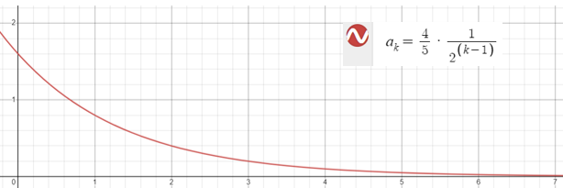

Figure 2

1. The influence of the initial amount of dirt:

When the optimal solution V/w = 4, n = 3, the effect of m0 on mn

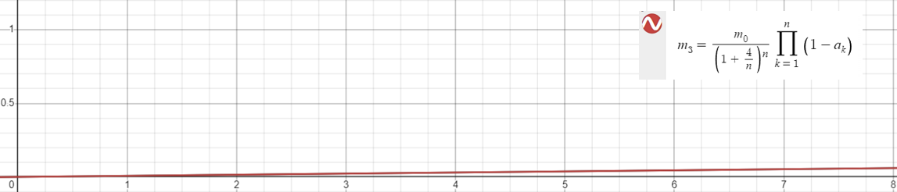

Figure 3

1. Impact of target water availability:

Target water availability V, because V/w = t affects mn(may also be analyzed)

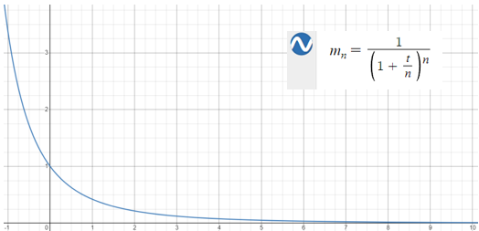

Figure 4

7.2Model two Conclusion

1. At the end of the dirt residue should not exceed the initial amount of dirt 1/1000, we can provide the most time-saving cleaning program graphic curve.

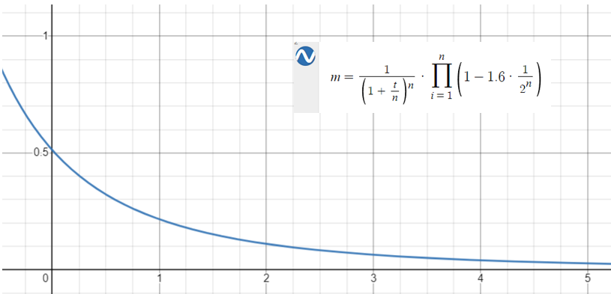

Figure 5

Get A/w and m (10-3) data relationship table, (accurate to the last six)

|  |  |  |  |  |  |  |  |  |
| --- | --- | --- | --- | --- | --- | --- | --- | --- |
| A/w | 170 | 180 | 190 | 199 | 200 | 210 | 220 | 230 |
| m（10-3） | 1.170 | 1.105 | 1.047 | 1.000 | 0.995 | 0.948 | 0.905 | 0.866 |

Get the data：

0.00116959064327

0.00110497237569

0.00104712041885

0.000995024875622

0.000947867298578

0.000904977375566

0.000865800865801

1. A graph of the effect of ak on the optimal solution:



Figure 6

1. A graph of the effect of the initial amount of dirt on the optimal scheme:

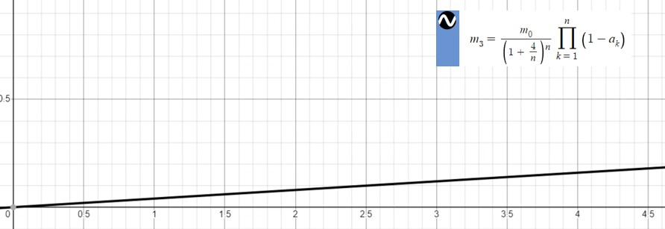

Figure 7

7.3Model three Conclusion

The washing effect after n-turn washing can be achieved at most: given washing requirement $ε$ has $ε$ times of the original pollutant after washing

$$D_{j}≤εd_{j}$$

We do not have a definite one here, so we search for step size with $∆ε$ =0.0001, search value = $ε$ =0.0001 (One in a thousand)

The solution can be found in the following figure:

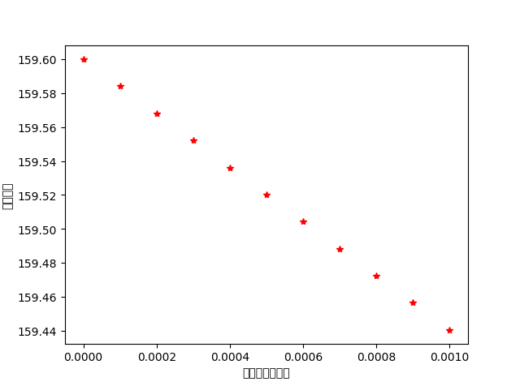

Figure 8

7.4Model four Conclusion

Through the analysis of Model 4 above, we can establish the optimization model

1. decision variables

|  |  |
| --- | --- |
| Zkj | The decontamination effect of the k-type detergent on the j-type pollutant |
|  | The amount of detergent k added to a wash |
|  | Unit Price of each detergent (g/Yuan) |
| P | The cost price of the whole laundry |

1. objective function

Min $D_{j}$ = $d_{j}−\sum_{k=1}^{10}{W_{k}∗Z_{kj},j=1,2,3....8}$

minP= $\sum_{k=1}^{10}{(W_{k}∗P_{k}+3.8w_{k})}$

1. $D_{j}$ constraints

$w_{k}≥0$*,k=1,2....10*

$w_{k}≤$ Stock of detergent K

$\sum_{k=1}^{10}{w_{k}}≤$ The total amount of water available

The washing effect after n-turn washing can be achieved at most: given washing requirement $ε$ has $ε$ times of the original pollutant after washing

$$D_{j}≤εd_{j}$$

Since the instructions in Problem 4 are the same as the conditions in Problem 2, then we will assign $ε$ value of 1/1000 here, and then add up the minimum P calculated for each group to get the final result.

The solution can be obtained into the following figure:

table 3:The amount of laundry detergent used in different combinations and the minimum cost

|  |  |  |  |  |  |  |  |  |  |  |  |
| --- | --- | --- | --- | --- | --- | --- | --- | --- | --- | --- | --- |
| assembly | Detergent 1 | Detergent 2 | Detergent 3 | Detergent 4 | Detergen  5 | Detergent 6 | Detergent 7 | Detergent 8 | Detergent  9 | Detergent 10 | cost |
| 1 | 8.77 | 1.99 | 1.69 | 2.48 | 1.95 | 2.18 | 3.76 | 2.45 | 2.16 | 3.31 | 1016.99 |
| 2 | 68.62 | 0 | 148.28 | 0 | 0 | 0 | 0 | 0 | 0 | 0 | 838.61 |
| 3 | 207.06 | 0 | 0 | 0 | 0 | 0 | 0 | 0 | 0 | 0 | 838.62 |
| 4 | 121.70 | 0 | 0 | 0 | 0 | 0 | 0 | 0 | 0 | 0 | 492.87 |
| total | 406.15 | 1.99 | 149.97 | 2.48 | 1.95 | 2.18 | 3.76 | 2.45 | 2.16 | 3.31 | 3187.09 |

( Keep two decimal places)

# References

[1] 洗衣服中蕴涵着学问

李树臣 - 中学数学研究, 2003 - cqvip.com