**Test project for a small weather application**

**Overview**

For the test project a small web app/mobile app should be created which utilizes a simple JSON rest API.

The test is aimed to last about 1-2 hours and should NOT exceed 2 hours as it is NOT expected that the complete scope will be finished as each developer has his own speed, coding style, approach and background knowledge. So it’s up to the developer to manage his own priorities for this test project.

The app itself can be developed either as a Vue web app, Angular web app, Ionic mobile app, native Android mobile app or native iOS mobile app depending on the developers preference and won’t have any influence on the test.

**Scope**

A small weather application should be created with following basic functionalities:

* Show three tabs with predefined cities (Rio de Janeiro, Beijing and Los Angeles)
* Connect to a backend to get the weather data
* Show for the selected city a forecast for the next hours and the next days should be presented
* The user should get the ability to refresh the data
* On the next page is a mockup for the small weather application
* Weather icons are available at <https://openweathermap.org/weather-conditions>
* Bonus: allow to search for a city

For the backend following JSON rest API will be used:

* The API documentation can be found here: <https://openweathermap.org/api>
* The used access key for the API is 9170e0e85794088df319259526c55afd
* Please use the API responsibly and keep in mind that excessive or misuse can lead to temporary blockages
* If your key gets temporarily blocked, please get in touch with us and you can get another key
* Under the link the usage and samples can be found
* Bonus: use the small city meta data <https://www.weatherbit.io/api/meta> (the one with ~20,000 cities) for the city search

**Mockups**

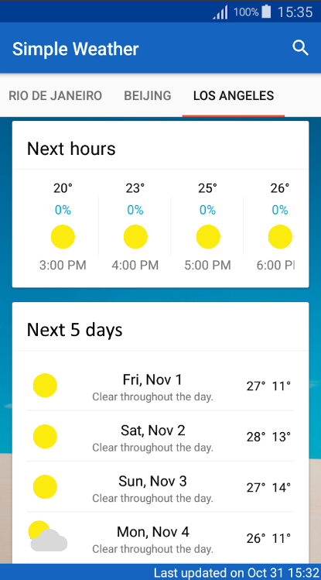

Next 5 days forecast

Next hours forecast

Tabs for different cities