Elaborative Rehearsal

: a technique to help the short-term memory store thoughts and ideas and pass them into the long-term memory

What is Bert?

Bert : Bidirectional Encoder Representations from Transformers

1. Input



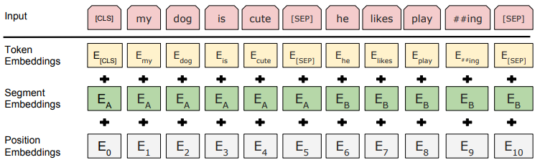

<Token Embedding>



Word2Vec)

: regard it as an independent word

Bert)

: 카페 + ##라떼, 초코 + ##라떼, 바닐라 + ##라떼



“난 오늘 카페라떼를 먹었고 초코라떼와 바닐라라떼를 포장했다”

* BPE)

1. Classifies sentences into spacing units.

-> 난/오늘/카페라떼를/먹었고/초코라떼와/바닐라라떼를/포장했다

1. Classifies spacing units into character units.

-> 난/오/늘/카/페/라/떼/를/먹/었/고/초/코/라/떼/와/바/닐/라/라/떼/를/포/장/했/다

1. 난/오/##늘/카/##페/##라/##떼/##를/먹/##었/##고/초/##코/##라/##떼/##와/바/##닐/##라/##라/##떼/##를/포/##장/##했/##다
2. 난/오/##늘/카/##페/##라떼/##를/먹/##었/##고/초/##코/##라떼/##와/바/##닐/##라/##라떼/##를/포/##장/##했/##다

* WordPiece)

1. Jet makers feud over seat width with big orders at stake
2. _J et _makers _fe ud _over _seat _width _with _big _orders _at _stake

2. Pre-training

* **Depend on the context**
* **Depend on the context** 
  + **unidirectional**

**I made a bank deposit**

* + **bidirectional (BERT)**

**I made a bank deposit**

* **MLM(Masked Language Model)**

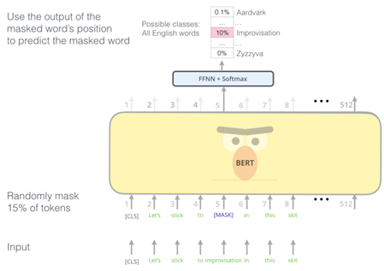

* **NSP(Next Sentence Prediction)**

