Home Automation with Firewall

***Mini*** ***Project*** ***Report*** ***submitted*** ***in*** ***partial*** ***fulfillment.***

***of*** ***the*** ***requirement*** ***for*** ***the*** ***degree*** ***of***

**T.** **E.** **(Information** **Technology)**

Submitted By

**Suhail Khan**

**Aakash Mahadik  
Nikhil Dhangada**

Under the Guidance of

Prof. Vinita Bhandiwad

Department of Information Technology





Vidyalankar Institute of Technology

Wadala(E), Mumbai 400 037

University of Mumbai

2021-22

CERTIFICATE OF APPROVAL

**For**

**Mini** **Project** **Report**

This is to Certify that

**Suhail Khan – 17101A0074**

**Aakash Mahadik – 19101A0011  
Nikhil Dhangada – 15101A0047**

Have successfully carried out Mini Project entitled

“**Home Automation with Firewall**”

In partial fulfillment of degree course in

Information Technology

As laid down by University of Mumbai during the academic year 2021-22

Under the Guidance of

“Prof. Vinita Bhandiwad”

Signature of Guide Head of Department

Examiner 1 Examiner 2 Principal

Dr. S. A. Patekar

**ACKNOWLEGEMENT**

We would like to express our deepest appreciation to all those who provided us the possibility to complete this report. We express our profound gratitude to our **Prof. Vinita** Ma’am, our respectable project guide, for her gigantic support and guidance. Without her counseling our project would not have seen the light of the day.

We extend our sincere thanks to **Dr. Vipul Dalal**, Head of the Department of

Information Technology for offering valuable advice at every stage of this undertaking.

We would like to thank all the staff members who willingly helped us. We are grateful to VIDYALANKAR INSTITUTE OF TECHNOLOGY for giving us this opportunity.

The days we have spent in the institute will always be remembered and also be

reckoned as guiding in our career.

1. **Suhail Khan – 17101A0074**
2. **Aakash Mahadik – 19101A0011**
3. **Nikhil Dhangada – 15101A0047**

**Table of Contents**

|  |  |  |
| --- | --- | --- |
| Sr. No. | Topic | Page No. |
| 1 | Introduction |  |
| 2 | Aim & Objectives |  |
| 3 | Problem Definition |  |
| 4 | Proposed System  4.1 Block Diagram  4.2 Flow Chart |  |
| 5 | Components  5.1 Hardware 5.2 Software |  |
| 6 | Project Architecture |  |
| 7 | Code |  |
| 8 | Implementation  8.1 Working  8.2 Circuit Diagram |  |
| 9 | Results |  |
| 10 | Conclusion & Future Scope |  |
|  | IEEE technical paper on project topic |  |
|  | Tinker cad experiment |  |
|  | Technical poster on Project topic |  |
|  | GitHub repository link |  |

**Abstract**

Home Automation is a iOT based project aimed towards securing your private network responsible for all your automations. To secure the network we use IDS technology of firewall and is currently able to detect attacks such as DoS.

The IDS uses ML based SVM algorithms which has already been feed with a huge dataset of TCP, UDP and ICMP dumps. Dataset was also created by us and every time system detects attack it stores new records and trains itself to block more sophisticated attacks.

We also implemented a PiR Motion detector system with our relay board and ESP 8266 module which gives out alert when a person passes within a certain distance.

**INTRODUCTION**

The fundamental purpose of monitoring electronics appliances in the modern world by using Internet of Things (IoT) is to control them based on situational demands. With the advancement of technology, the need for efficient controlling is more as it optimizes performance and saves unnecessary wastage of power. The basic home appliances are fan, light and water pump which consume maximum power. Unnecessary wastage of power and resources by turning on lights during daytime or high-speed fans in winter season or water pump during overflow of water from tank can be avoided in this way. A system has been proposed to control home appliances anytime from anywhere in the world and efficiently utilize power by controlling appliances properly. Blynk app has been used to read data from sensors located in home environment and user controls home appliances based on these data. Being busy in hectic schedule of daily life user may not be able to read sensor data continuously to take some action through app. So, the designed system sends an emergency notification in user’s mobile app

**AIM**

**The main object of this project is to protect your MQTT network which is responsible for all the automations throughout your Home**

**&**

**To automate the local Blynk server and Blynk client locally i.e., without using internet.**

**Proposed System**

Block Diagram:

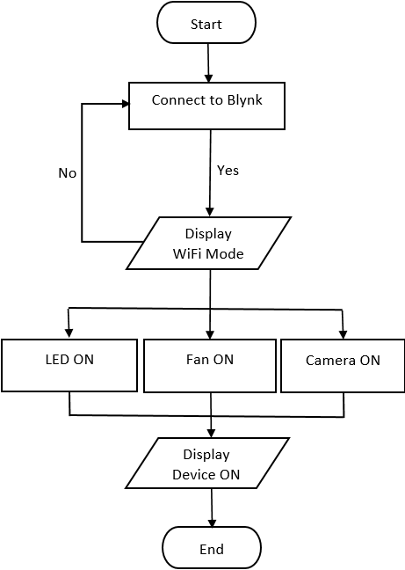

Flow Chart:

Components

Hardware:

1.ESP 8266

2.Relay Board

3.Jumper Wires

4.PiR Sensor

5. RaspberryPi

6.PowerSupply

7. LED Bulb and Switch Board

Software:

Blynk: Blynk server is installed in RaspberryPi and stored near router, getting powered via PoE.

ArduinoIDE: To write programs we used Arduino IDE

Code:

/*************************************************************

This example runs directly on NodeMCU.

Note: This requires ESP8266 support package:

https://github.com/esp8266/Arduino

Please be sure to select the right NodeMCU module

in the Tools -> Board menu!

For advanced settings please follow ESP examples :

- ESP8266_Standalone_Manual_IP.ino

- ESP8266_Standalone_SmartConfig.ino

- ESP8266_Standalone_SSL.ino

Change WiFi ssid, pass, and Blynk auth token to run :)

Feel free to apply it to any other example. It's simple!

*************************************************************/

/* Comment this out to disable prints and save space */

#define BLYNK_PRINT Serial

#include <ESP8266WiFi.h>

#include <BlynkSimpleEsp8266.h>

char auth[] = "dEx1q81ywSDmI_vCFhW9b7-_z0mvw6K0";

// Your WiFi credentials.

// Set password to "" for open networks.

char ssid[] = "Suhail's7";

char pass[] = "qwertyuiop";

char server[] = "172.20.10.6";

int port = 8080;

void setup()

{

WiFi.begin(ssid, pass);

Blynk.config(auth, server, port);

Blynk.connect();

}

void loop()

{

Blynk.run();

}

Implementation

Working:

Step 1: Upload the Code on ESP8266 and make the connection as per the below circuit diagram.

Step 2: Open Blynk Client and create the buttons and a gauge to display PiR Sensor reading.

Step 3: Make sure your program had proper Tokens, IP address of your Blynk Local Server and SSID/Pass of your WiFi.

Step 4: If all the steps are correct you should be able to have access of appliances

Circuit Diagram:

**Result:**

The Blynk application provides the facility to read sensor data and control appliances easily. For two appliances using 2 channel relay and controlling it using Blynk Client via switch and having a gauge for reading sensor reading. IDS Running in background gives alert when someone tries to perform attack on your server.

**Conclusion**

**&**

**Future Scope**

This project is a successful demonstration of how easy it is to safeguard your entire home automation system by just installing a RaspberryPI with some filtration technology (in this case it’s a IDS). Sensor reading is not stable on Gauge Meter on Blynk Client which can be improved and then the Firewall itself which was made by us could be improved a lot.

iOT Security is major issue and to tackle it supervised model might lack some skills compared to unsupervised model which works on clusters so changing the algorithm itself might get reflected soon.