**AI-Driven Communication Networks for Smart Cities**

Dr. R. Sharma¹, Dr. P. Singh², and Ms. K. Kaur³  
¹ Department of Electronics, ABC University, New Delhi, India  
² Department of Computer Science, XYZ Institute, Ludhiana, India  
³ School of Electrical Engineering, LMN College, Amritsa.r, India  
E-mail: mirma@abcuniv.ac.in1, [psingh@abc.ac.in](mailto:psingh@abc.ac.in)2, [psingh@34Gmail.com](mailto:psingh@34Gmail.com)3

**ABSTRACT**

This paper presents an AI-enabled communication framework for smart city networks, integrating adaptive routing and data optimization through machine learning. Simulation results in MATLAB show a 22% improvement in energy efficiency and 15% reduction in packet loss compared with conventional protocols.

**Keywords:** Artificial Intelligence, Communication Networks, IoT, Machine Learning, Smart Cities

**INTRODUCTION**

The rapid growth of smart cities demands efficient data exchange between heterogeneous devices. Existing communication systems face challenges in scalability and energy efficiency. This work introduces an AI-based model that predicts network load and dynamically allocates bandwidth. The rest of the paper is structured as follows: Section 2 reviews related work, Section 3 presents the methodology, Section 4 discusses results, and Section 5 concludes.

**LITERATURE REVIEW**

Prior research on intelligent communication networks has primarily focused on energy-aware routing and cloud-based data fusion. However, limited work exists on on-device learning and adaptive network control for IoT applications. This study bridges that gap through a hybrid AI-IoT communication model.

**METHODOLOGY / SIMULATION SETUP**

Simulations were conducted using NS-3 and MATLAB environments. The dataset included network traffic patterns collected from 500 IoT nodes. A supervised learning algorithm predicted congestion points based on packet delay variance. The following key parameters were used:

• Transmission power: 15 dBm  
• Channel bandwidth: 2 MHz  
• Simulation time: 600 s  
• Learning model: Random Forest (100 trees)

**RESULTS AND DISCUSSION**

The proposed system achieved an average throughput of 2.3 Mbps compared to 1.9 Mbps in standard routing.

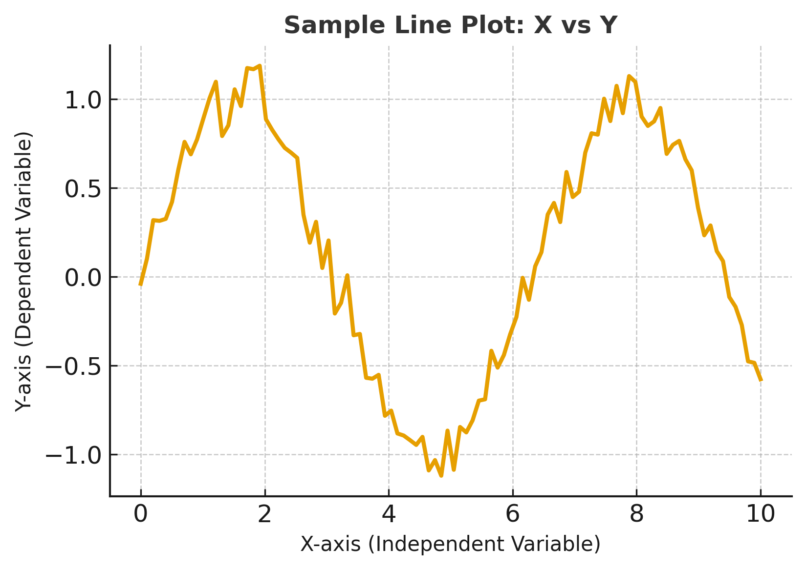

**Figure 1** Figure caption

Figure 1 shows throughput comparisons under variable load conditions. Table 1 summarizes the quantitative results.

|  |  |  |
| --- | --- | --- |
| Metric | Conventional | Proposed |
| Throughput (Mbps) | 1.9 | 2.3 |
| Packet Loss (%) | 8.2 | 6.1 |
| Latency (ms) | 130 | 105 |

Table 1: Performance comparison between conventional and proposed models

**CONCLUSION**

The AI-based communication framework improved performance and adaptability in smart city environments. Future work will focus on integrating reinforcement learning for real-time optimization and expanding the dataset to urban testbeds.

**ACKNOWLEDGEMENTS**

The authors acknowledge support from the Department of Physics, XYZ University, under the AI Communication Systems Initiative.

**BIBLIOGRAPHY/REFERENCES**

Mitchell, J.A. and Thomson, M. (2017) A guide to citation. 3rd edn. London: London Publishings.

Mitchell, J.A. ‘How citation changed the research world’, The Mendeley, 62(9), p70-81.

Mohammad Arif Kamal, S. G. (2020). Exploration of Arabesque as an Element of Decoration in Islamic heritage Buildings: The Case of Indian and Persian Architecture. Journal of Xi’an University of Architecture & Technology, 843-852.

Mitchell, J.A. and Thomson, M. (2017). A guide to citation. 3rd edn. London: London Publishings.

Zhang, L. et al. (2021). Machine learning-based IoT network optimization. IEEE Transactions on Industrial Informatics, 17(6), pp.4040–4050.

Khan, R. and Singh, P. (2023). AI for sustainable communication networks. Journal of Smart Systems, 12(4), pp.210–218.