All the code is tested on virtual machine with an image of linux ubuntu 64 bits system. In all the test cases, the screen shots of terminals on the server side and the client side are represented in this report. All the created test cases for this assignment is passed.

Connection:

Enter ./Server echos 5002 on the Server terminal

Enter ./Client echos osboxes 5002 on the client side terminal.

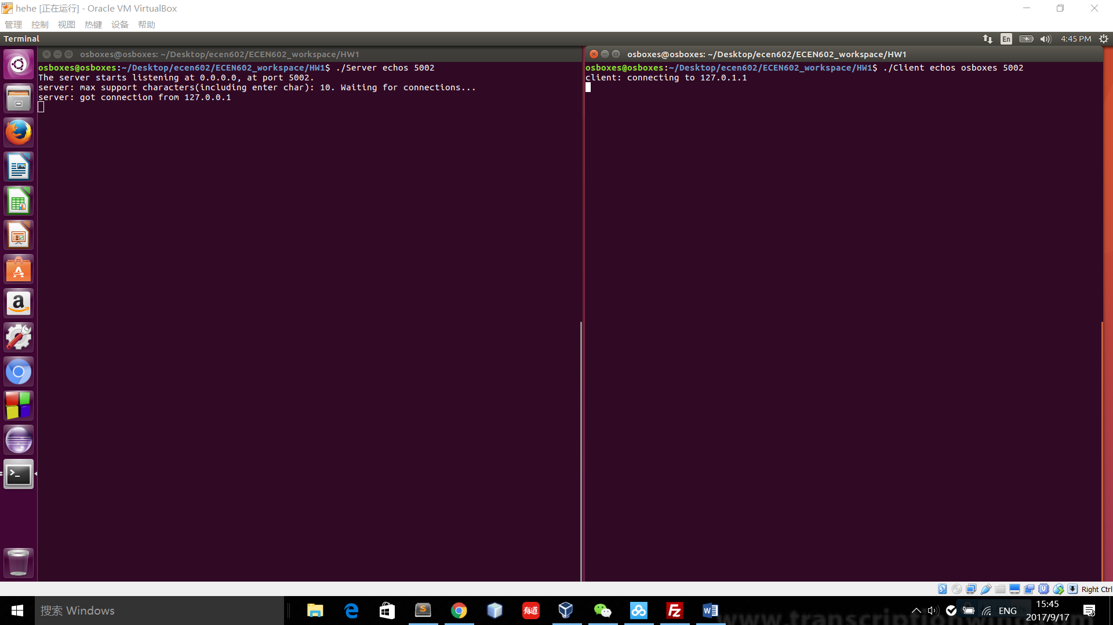

Figure 1: Server side interface when testing connection



Figure 2: Client side interface when testing connection

The server could be connected by the client and the client connects to the server successfully on the desired port.

Case one: enter a string terminated by a new line

The input on the client side is “abc”

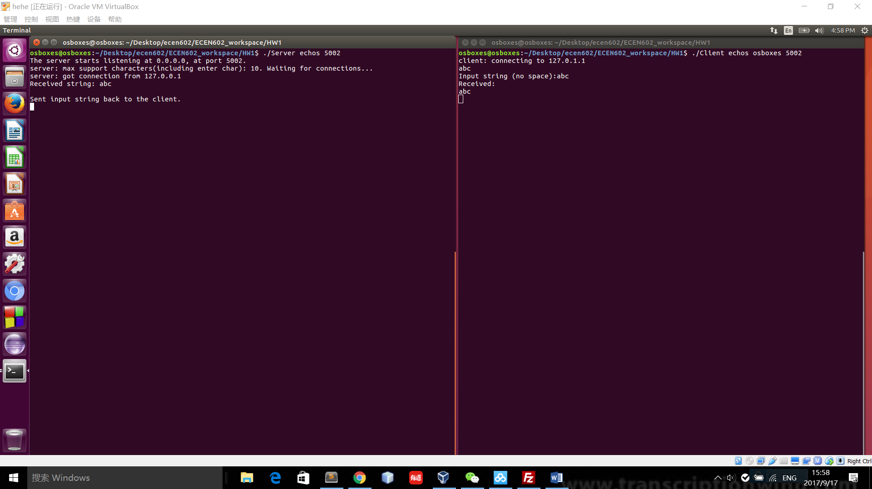

Figure 3: Server side interface for case one



Figure 4: Client side interface for case one

In this test case, the enter string is abc followed by a new line because enter key introduces a new line. The sent back string is the same as the input string.

Test case two: line of maximum line length

The maximum line length is set as ten. That means 9 characters can be sent in one line. Because the enter key would be taken as a char. “1234567898” is input on the client side. The size exceed the maximum line length because of the enter key. The connection between the client and server would be closed in this case.

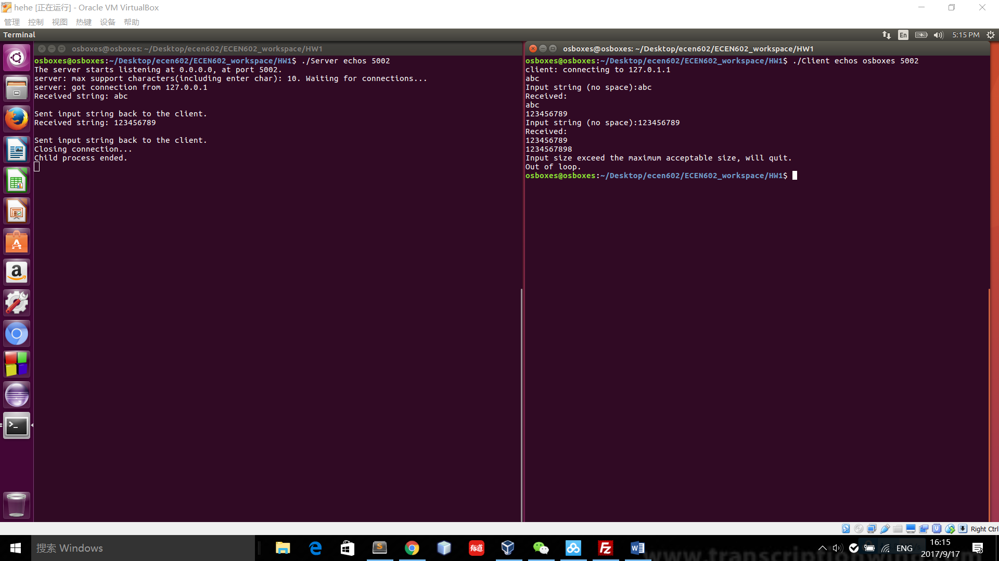

Figure 5: Server side interface for test case two



Figure 6: Client side interface for the test case two

Test case 3: line with no characters and EOF

Ctrl+D is entered to the client side terminal to test the responses in this case.

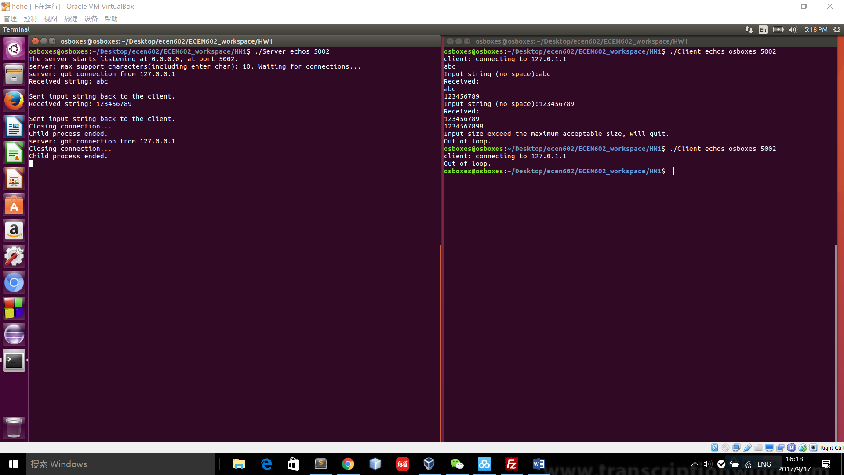

Figure 7: Server side interface for test case three



Figure 8: Client side interface for test case three

Test case 4:

abc is entered in the client terminal followed by ctrl+z to terminate the client. The entered line could be returned correctly while the client is stopped after the test.

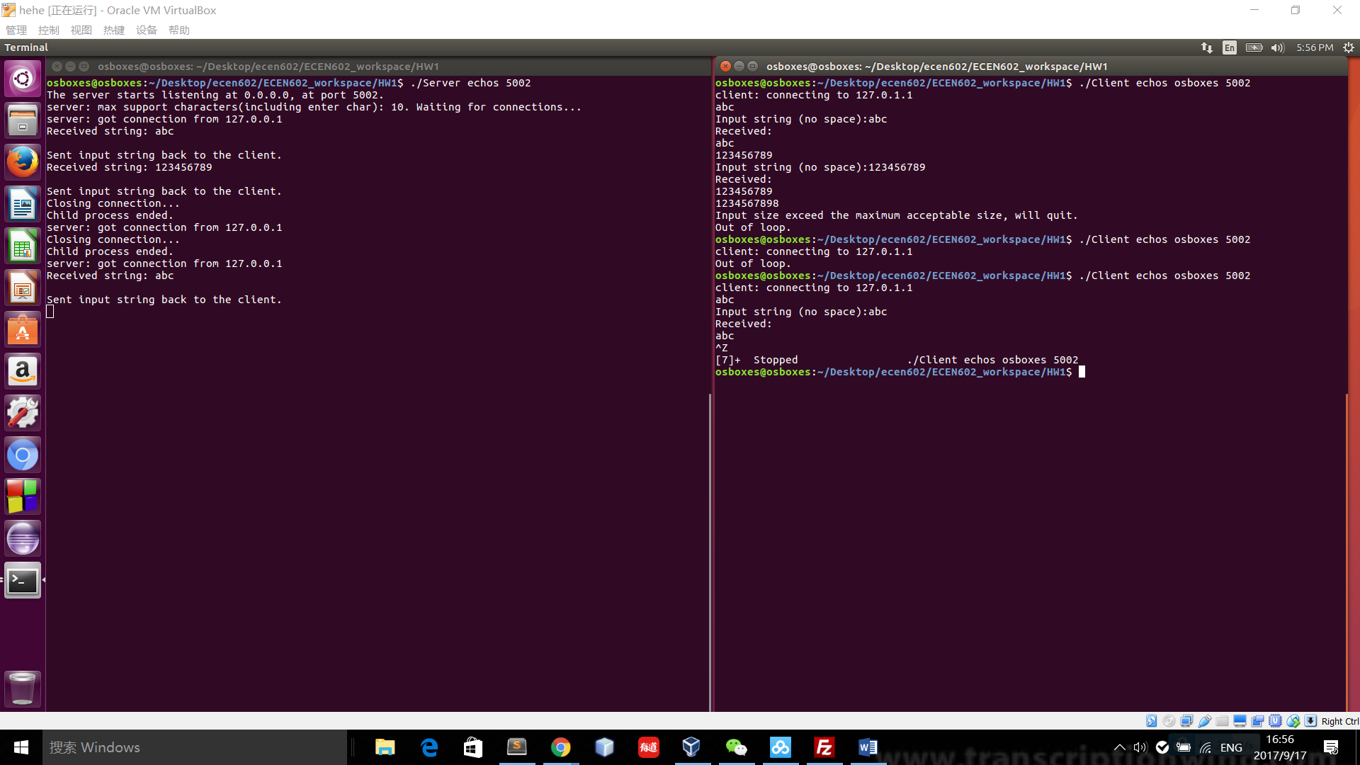

Figure 9: Server side interface for test case four



Figure 10: Server side interface for test case four

Test case 5: 3 clients connect to the server in the mean time

The server is restarted at port 5003 to test being connected by three clients. The server could be connected by three clients in the mean time.

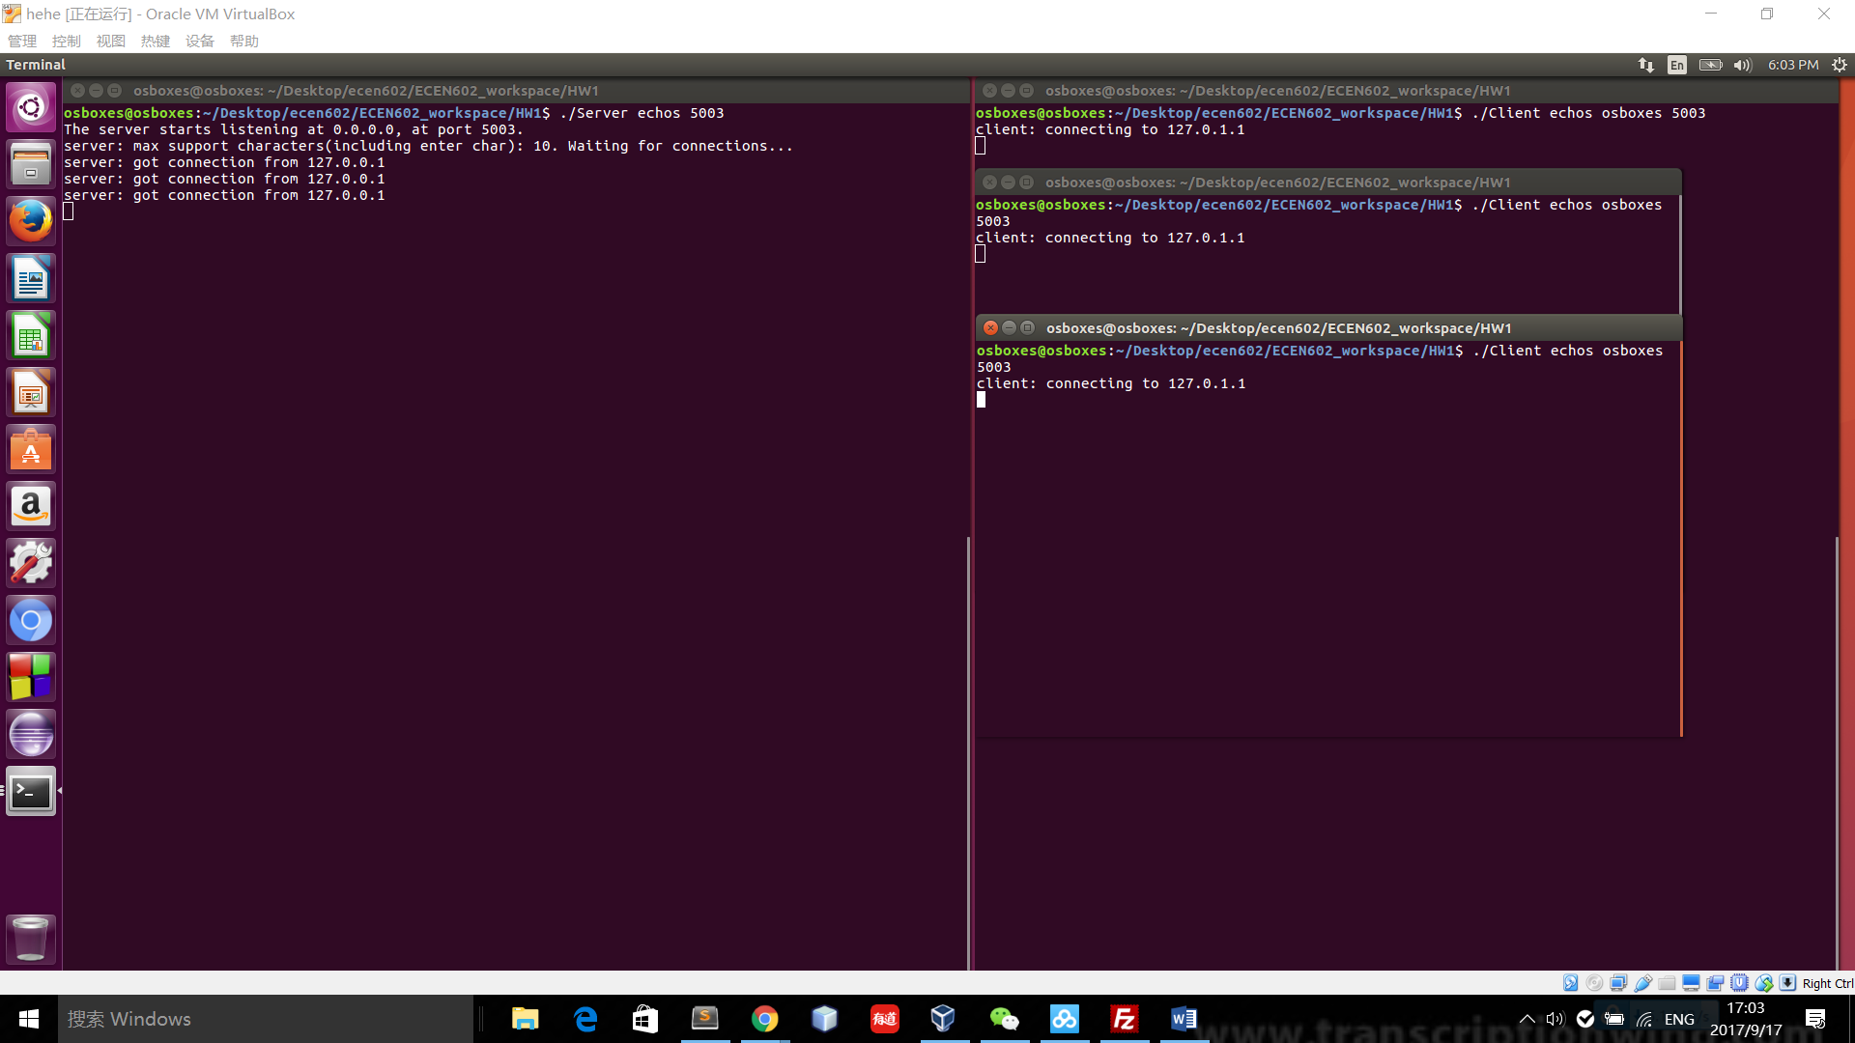

Figure 11: Server side interface for test case five

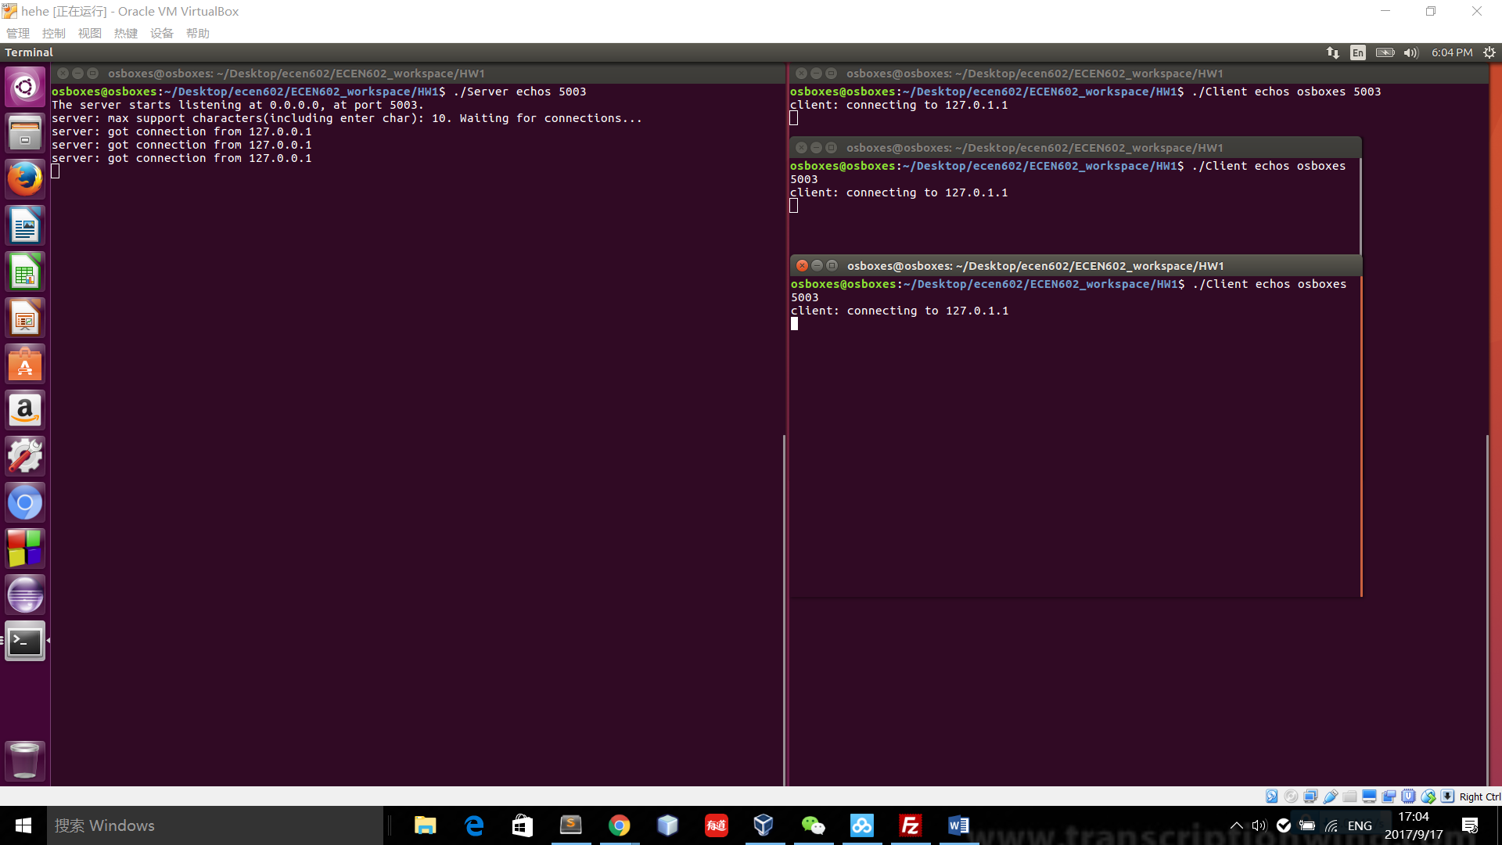

Figure 12: Three clients interface for connecting to the server