Diego Craveiro Chaves

20026893@tafe.wa.edu.au

Student ID: 20026893

CC – Portfolio part 1

Documentation and test evidence

Table of Contents

1. Read 2

1.1. Read all categories 2

2. Read one 3

2.1. Read a category with id = 3 3

2.2. Read a category with id = 999 4

2.3. Read a category without providing an id 5

3. Create 6

3.1. Create a category with code = SMPH, name = iPhoneX.png and description = iPhone X 6

3.2. Create a category with code = SMPH, name = AnotherPhone.png and description = Galaxy S999 7

3.3. Create a category with code = SMTH, name = something.png and no description 8

3.4. Create a category with code = SMTH, description = something and no name 9

3.5. Create a category with name = something.png, description = something and no code 10

4. Update 11

4.1. Update a category with id = 30, code = SMPH, name = galaxyS999.png and description = Galaxy S999 11

4.2. Update a category with id = 999, code = SMPH, name = galaxyS999.png and description = Galaxy S999 12

4.3. Update a category with code = SMPH, name = galaxyS999.png, description = Galaxy S999 and no id 13

4.4. Update a category with id = 30, code = SMPH, name = galaxyS999.png and no description 14

4.5. Update a category with id = 30, code = SMPH, description = Galaxy S999 and no name 15

4.6. Update a category with id = 30, name = galaxyS999.png, description = Galaxy S999 and no code 16

5. Delete 17

5.1. Delete a category with id = 22 17

5.2. Delete a category with id = 999 18

5.3. Delete a category without providing an id 19

5.4. Delete a category with a non-numeric id 20

6. Search 21

6.1. Search for a category with search = MOT 21

6.2. Search for a category with search = 22

6.3. Search for a category with search = nothing 23

# 1. Read

Reads all categories from the database.

Request endpoint: GET ***api/categories/read.php***

## 1.1. Read all categories

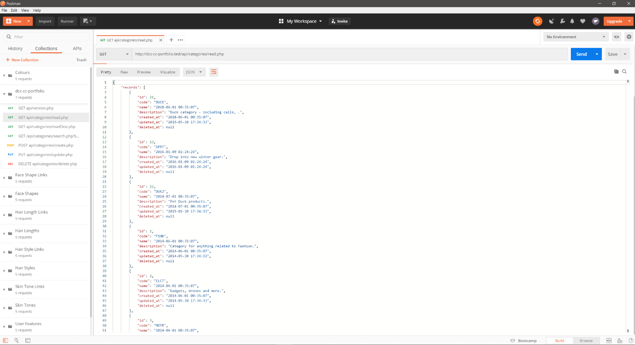

# 2. Read one

Reads a category from the database with a given ID (provided in the JSON request body).

Request endpoint: GET ***api/categories/readOne.php*** with {“id”: <id>}

## 2.1. Read a category with id = 3

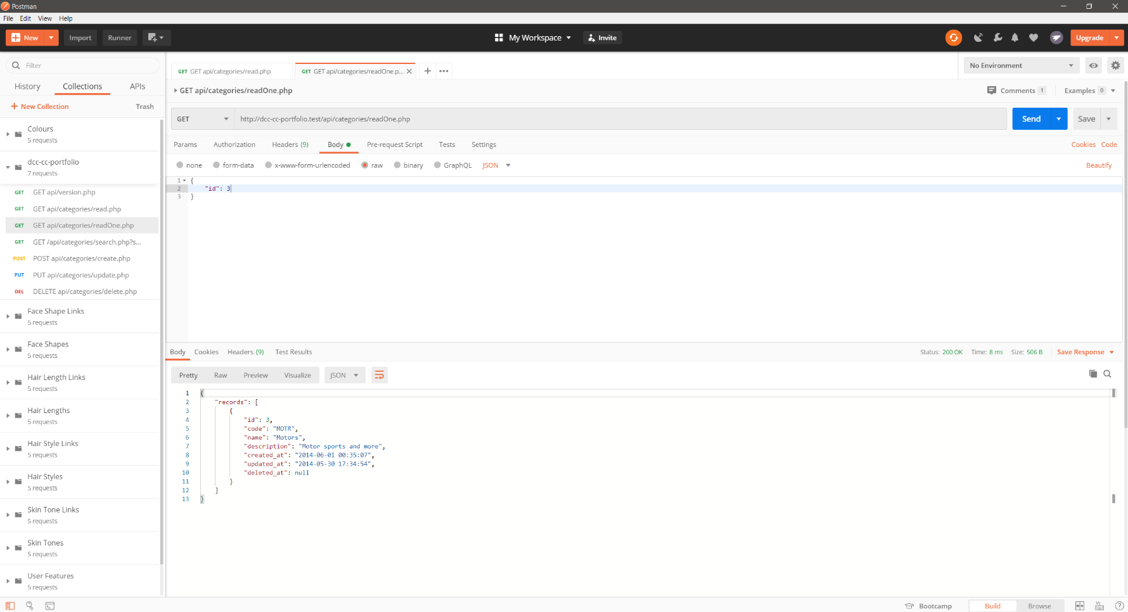

## 2.2. Read a category with id = 999

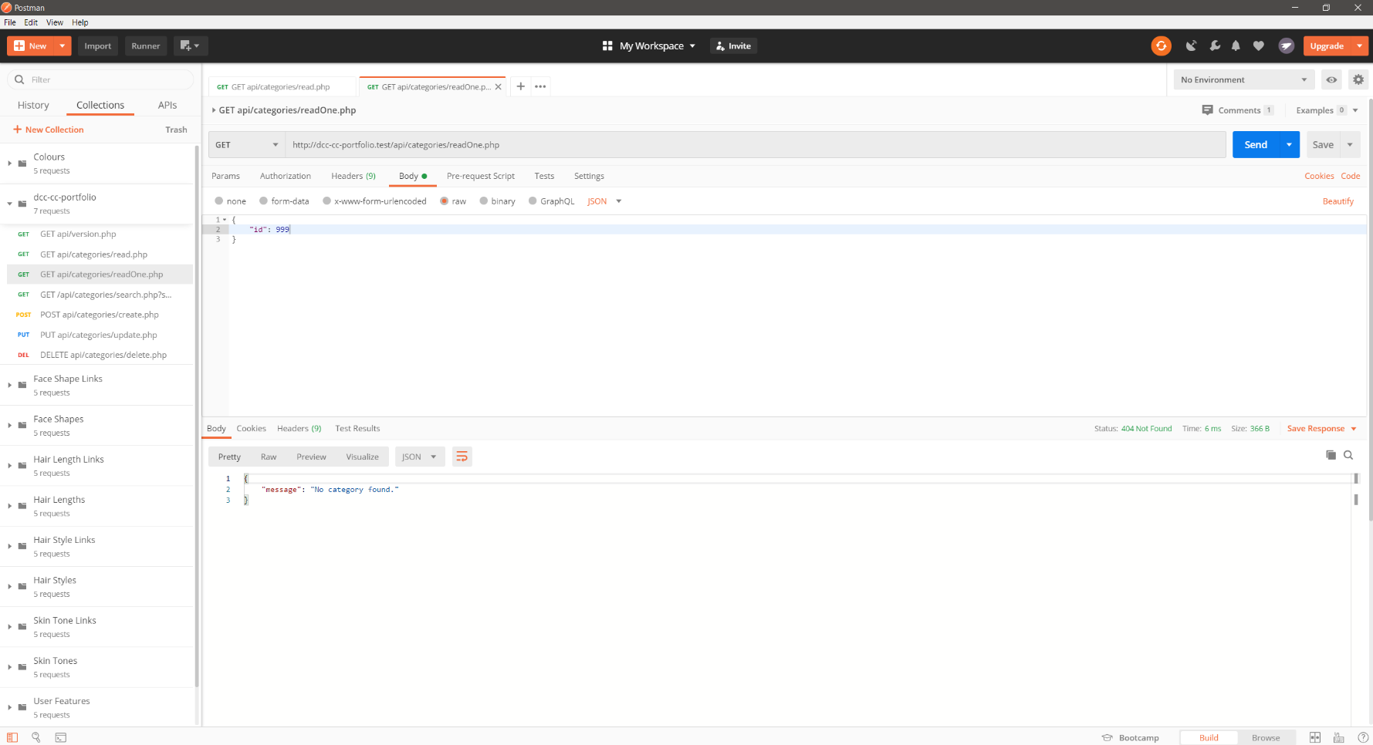

## 2.3. Read a category without providing an id

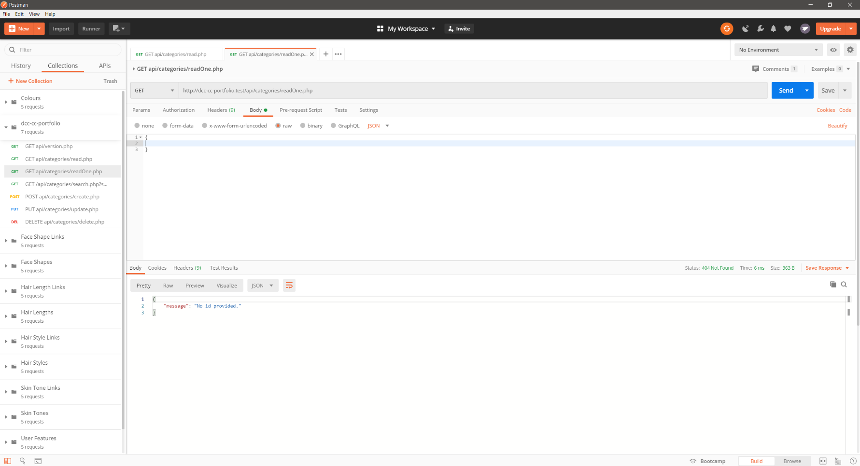

# 3. Create

Creates a category with a given code, name and description (provided in the JSON request body).

Request endpoint: POST ***api/categories/create.php*** with:

{“code”: <code>, “name”: <name>, “description”: <description>}

## 3.1. Create a category with code = SMPH, name = iPhoneX.png and description = iPhone X

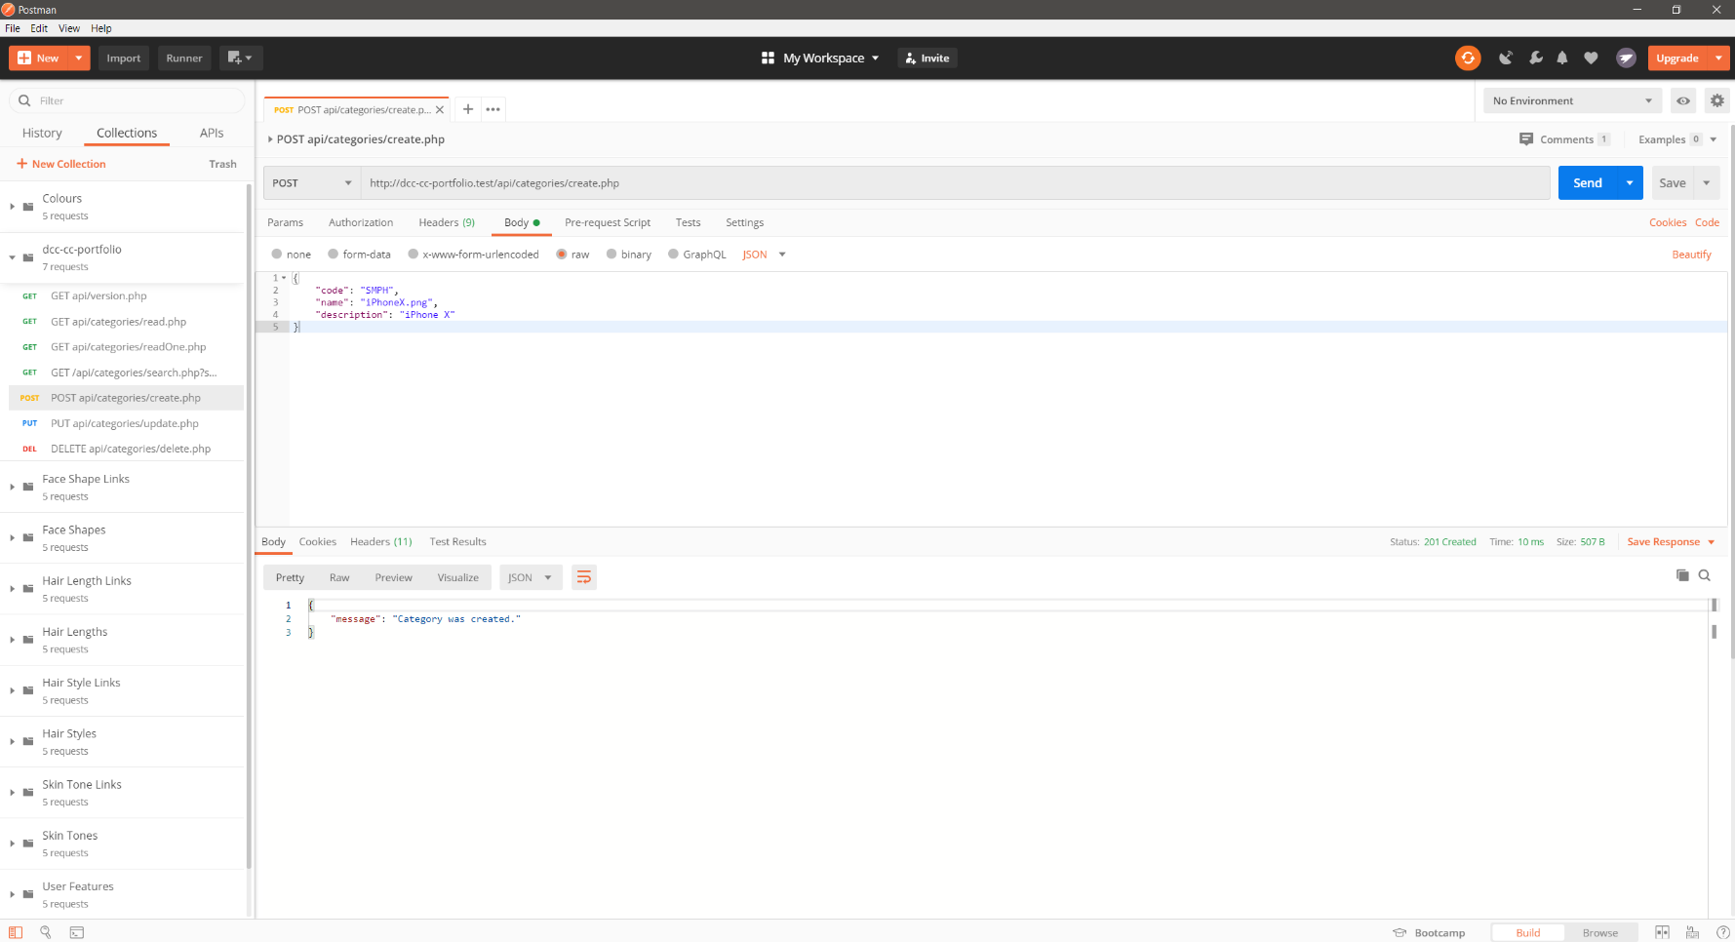

## 3.2. Create a category with code = SMPH, name = AnotherPhone.png and description = Galaxy S999

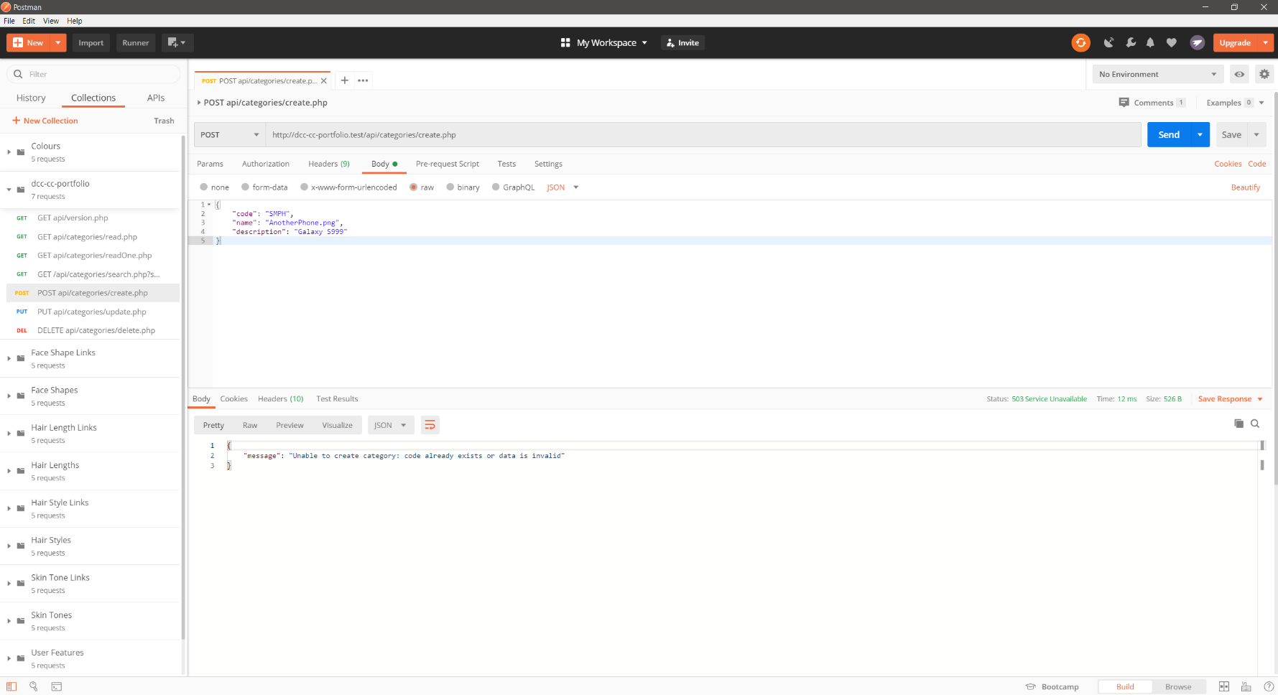

## 3.3. Create a category with code = SMTH, name = something.png and no description

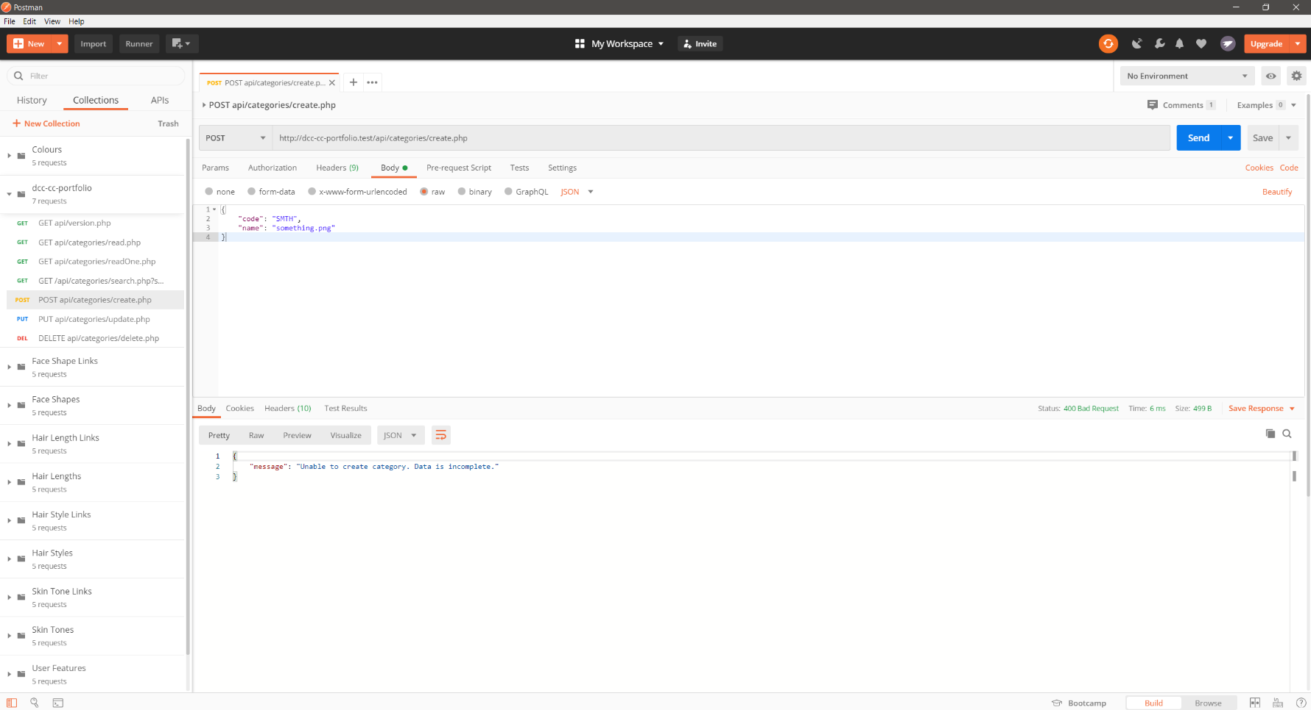

## 3.4. Create a category with code = SMTH, description = something and no name

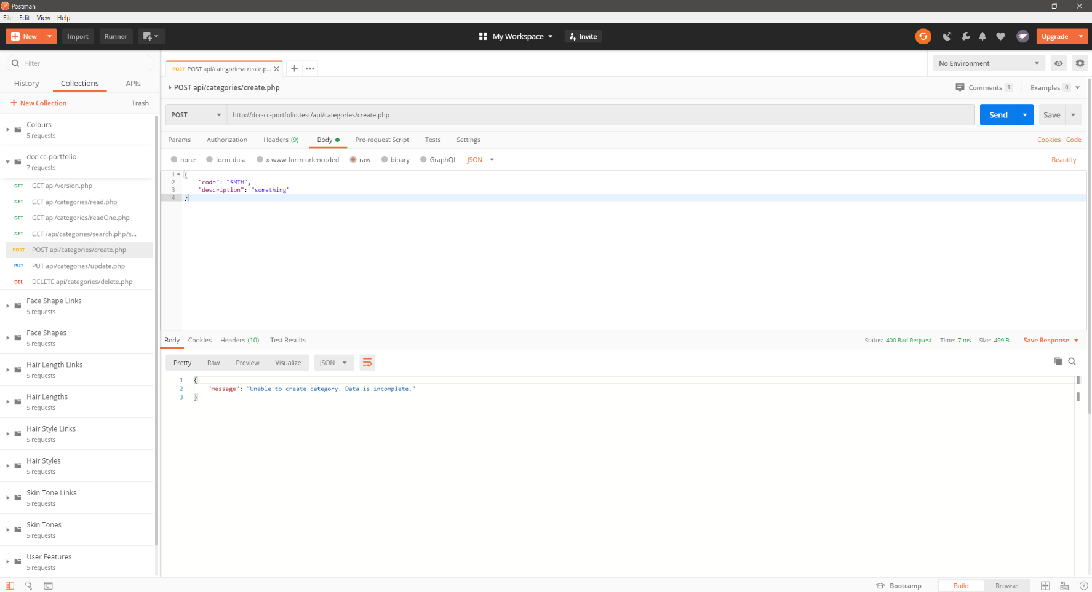

## 3.5. Create a category with name = something.png, description = something and no code

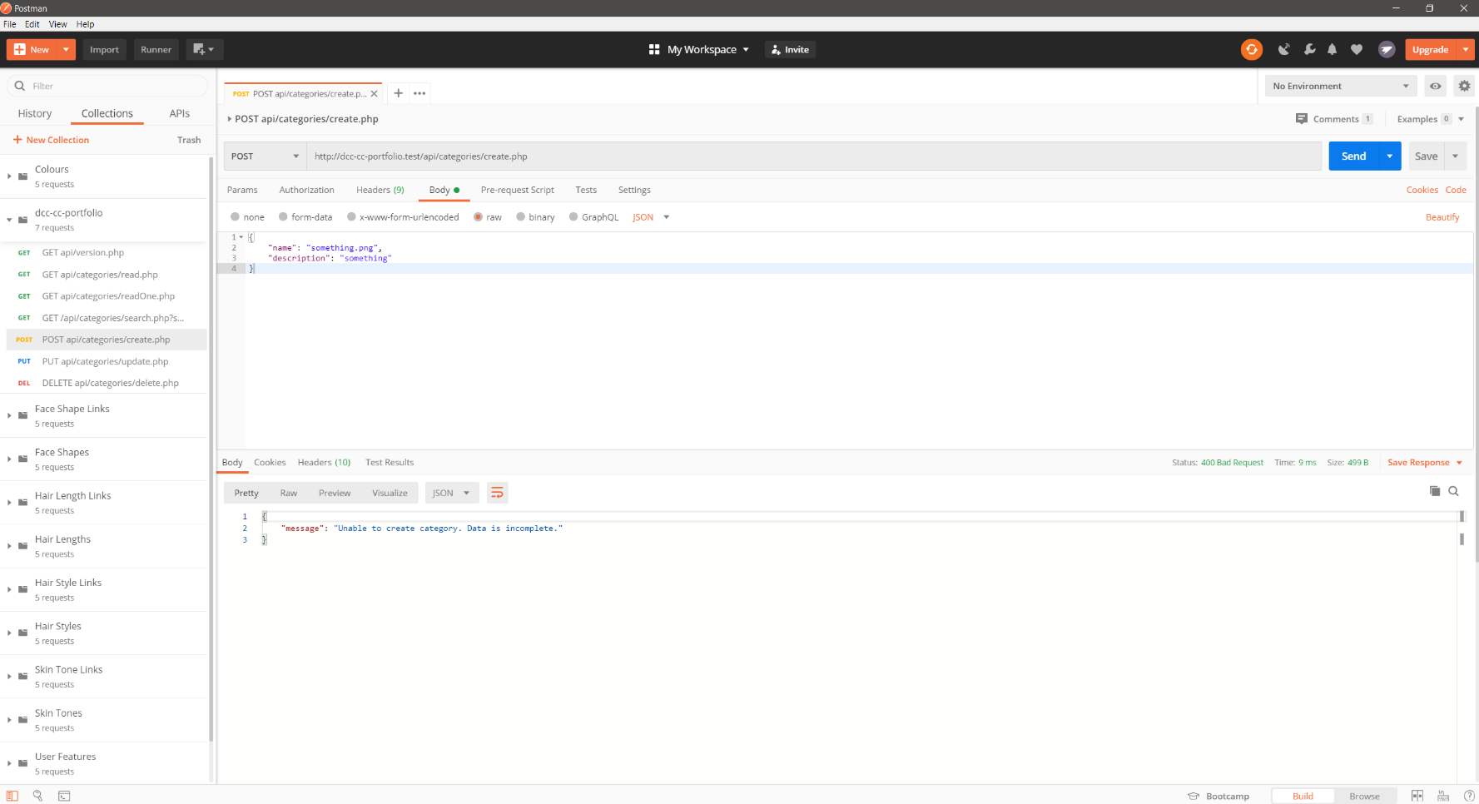

# 4. Update

Updates a category with a given id, with code, name and description also provided in the JSON request body.

Request endpoint: PUT ***api/categories/update.php*** with:

{“id”: <id>, “code”: <code>, “name”: <name>, “description”: <description>}

## 4.1. Update a category with id = 30, code = SMPH, name = galaxyS999.png and description = Galaxy S999

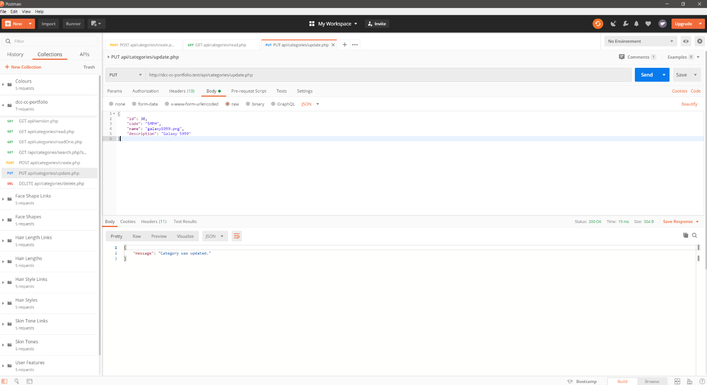

## 4.2. Update a category with id = 999, code = SMPH, name = galaxyS999.png and description = Galaxy S999

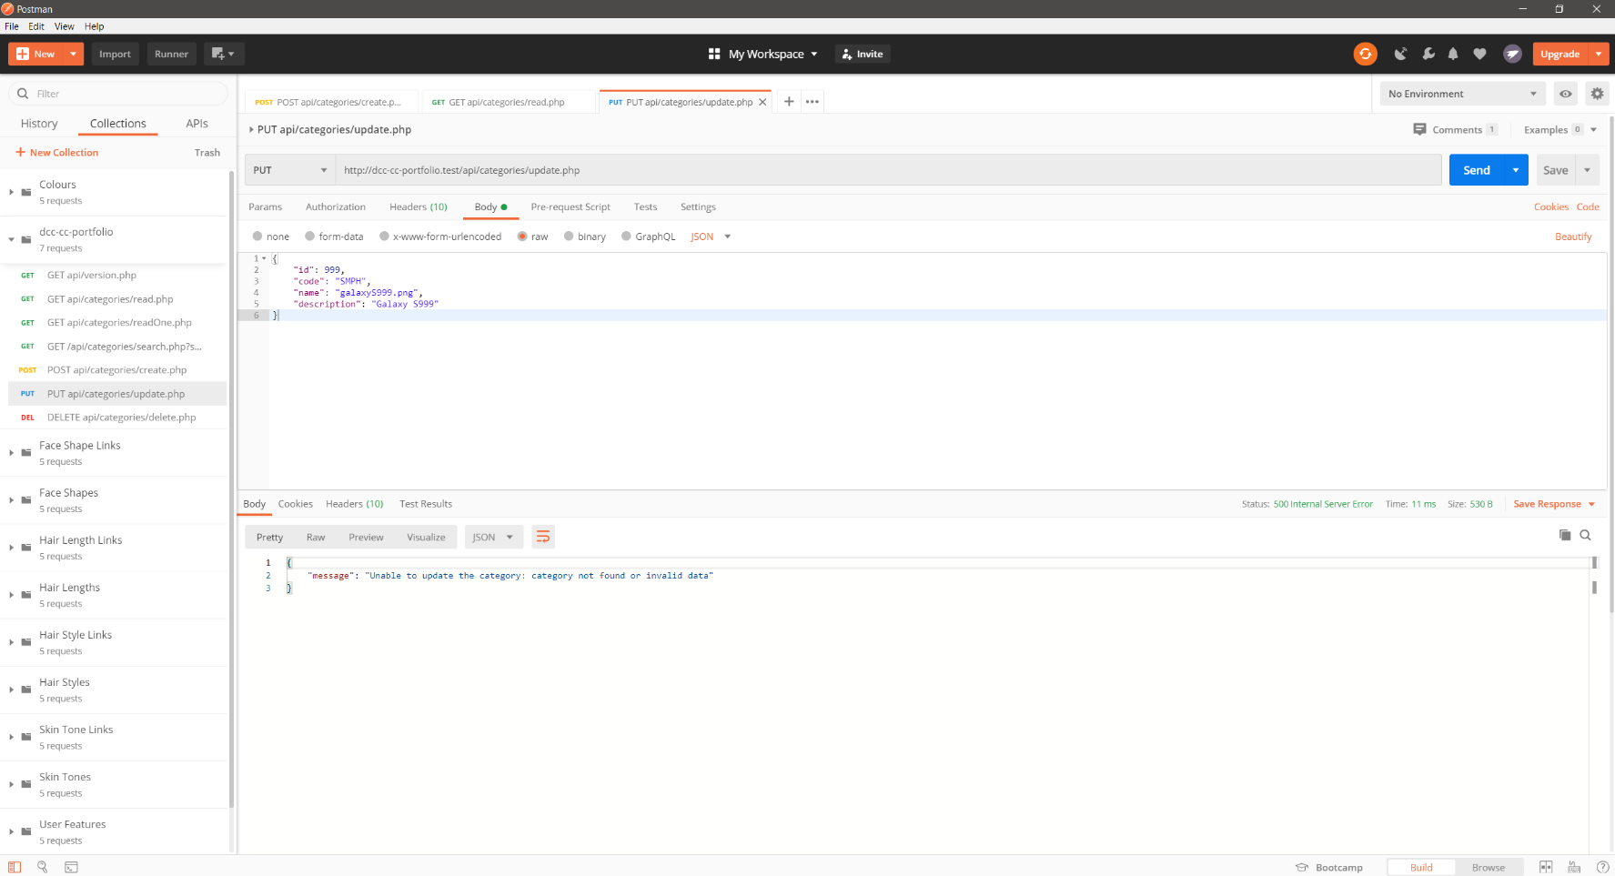

## 4.3. Update a category with code = SMPH, name = galaxyS999.png, description = Galaxy S999 and no id

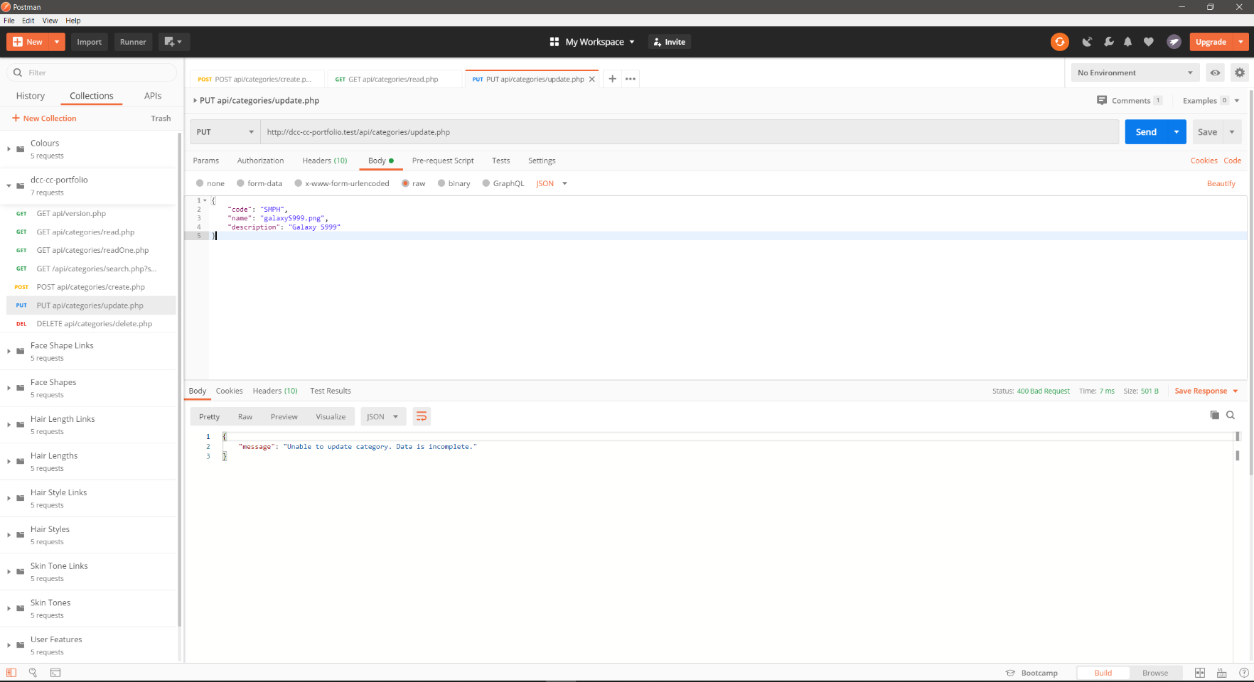

## 4.4. Update a category with id = 30, code = SMPH, name = galaxyS999.png and no description

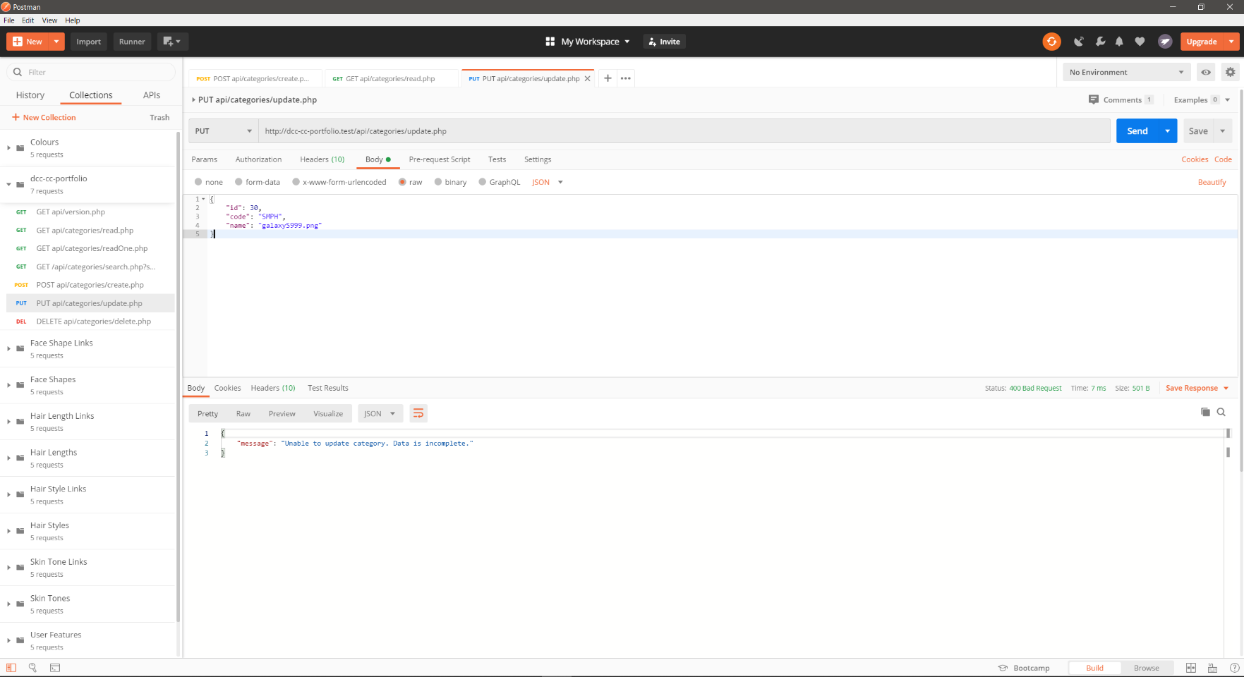

## 4.5. Update a category with id = 30, code = SMPH, description = Galaxy S999 and no name

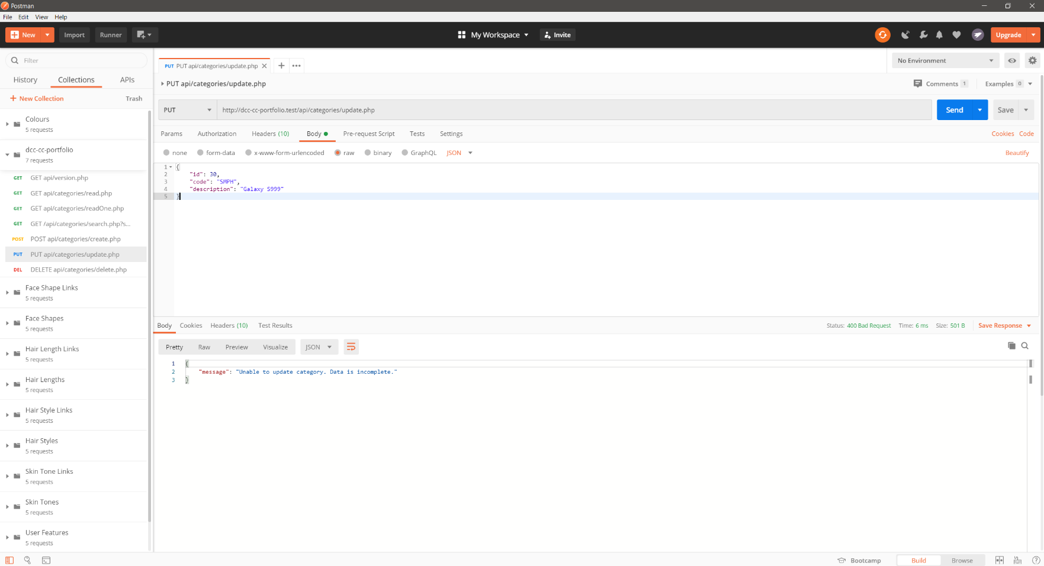

## 4.6. Update a category with id = 30, name = galaxyS999.png, description = Galaxy S999 and no code

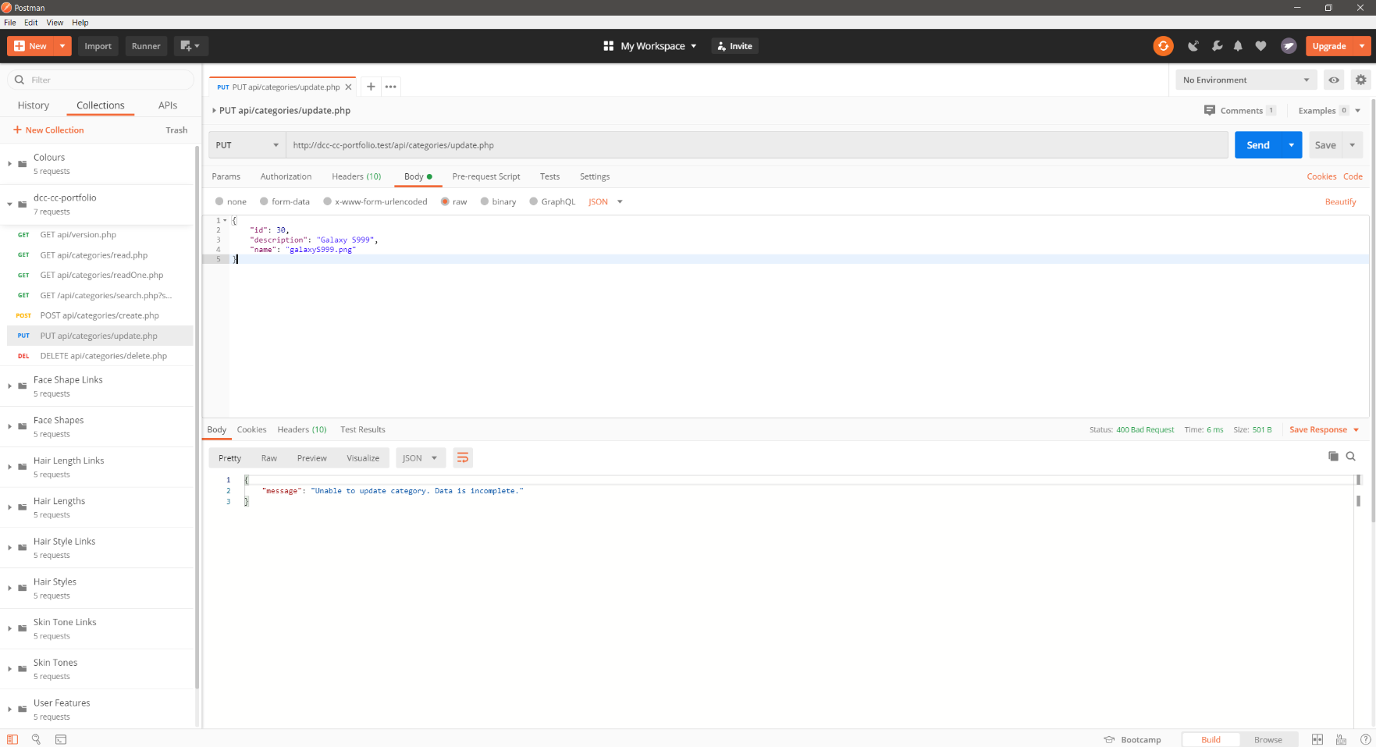

# 5. Delete

Deletes a category with a given id, provided in the JSON request body.

Request endpoint: DELETE ***api/categories/update.php*** with:

{“id”: <id>}

## 5.1. Delete a category with id = 22

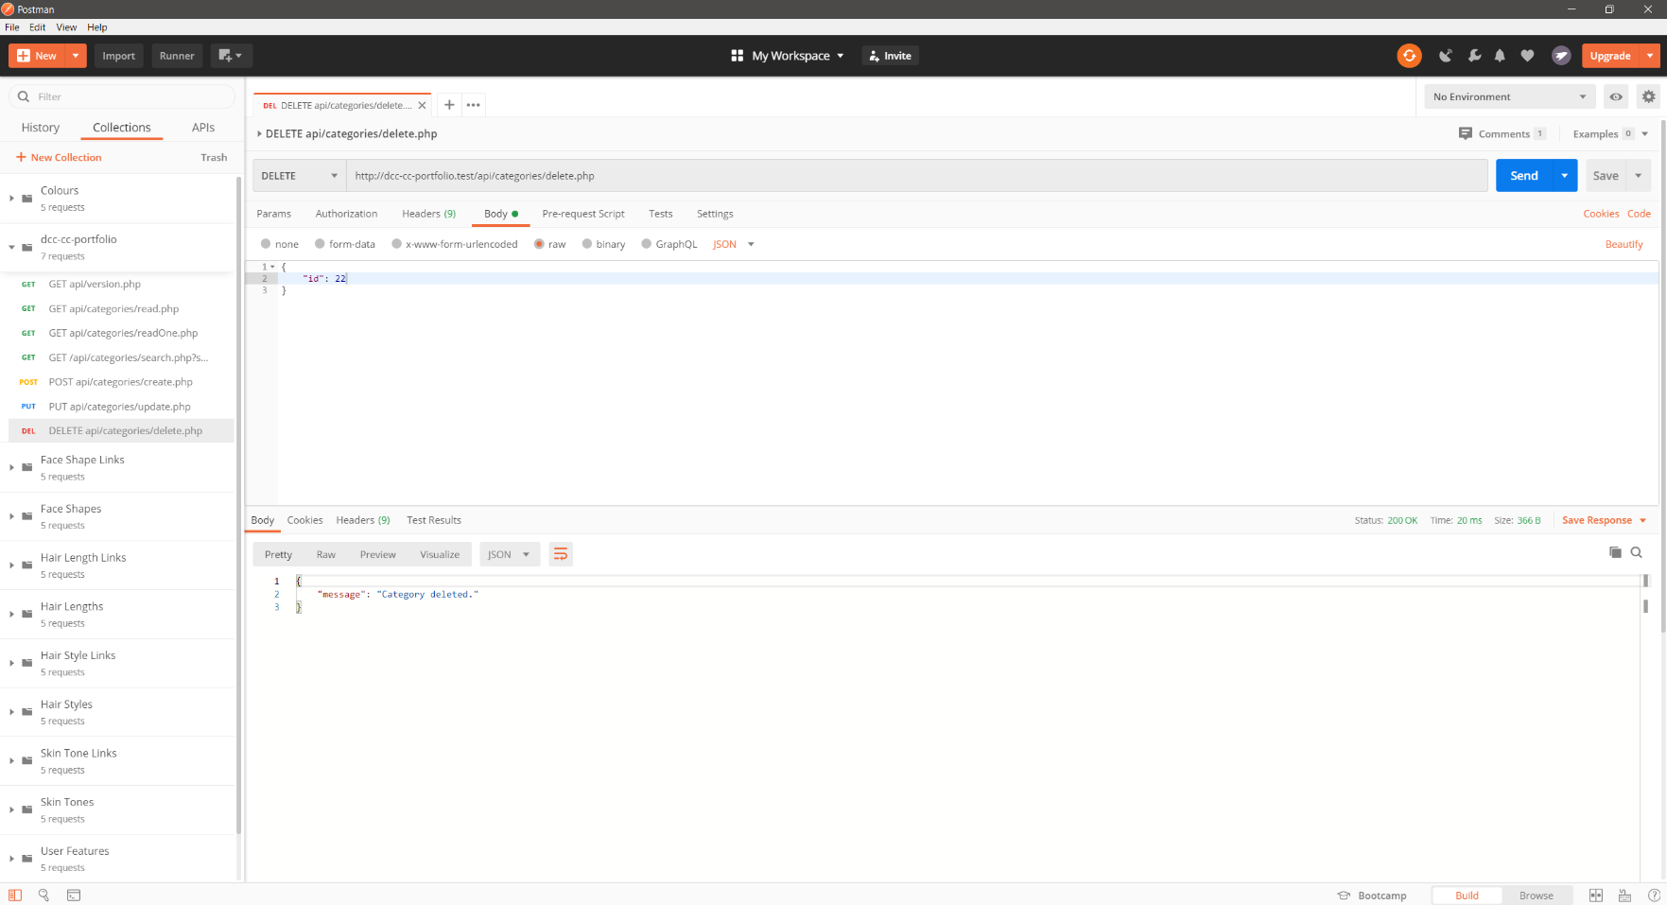

## 5.2. Delete a category with id = 999

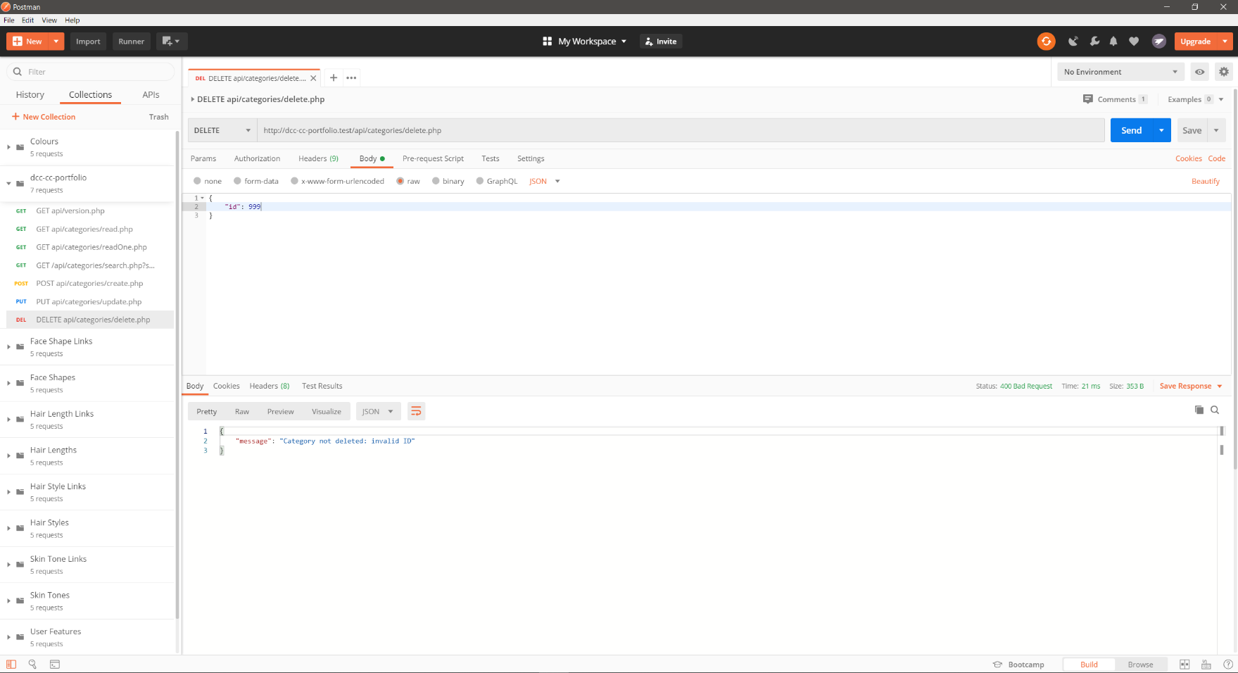

## 5.3. Delete a category without providing an id

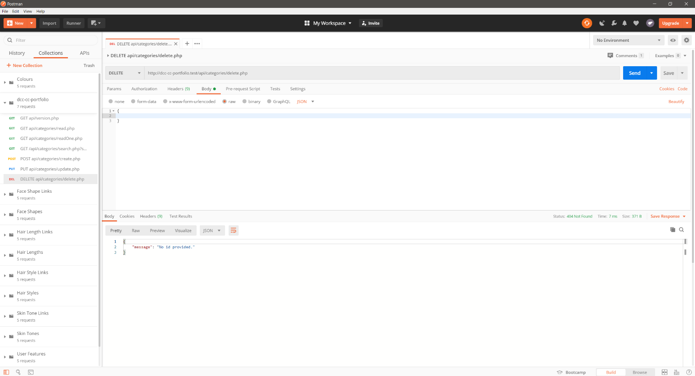

## 5.4. Delete a category with a non-numeric id

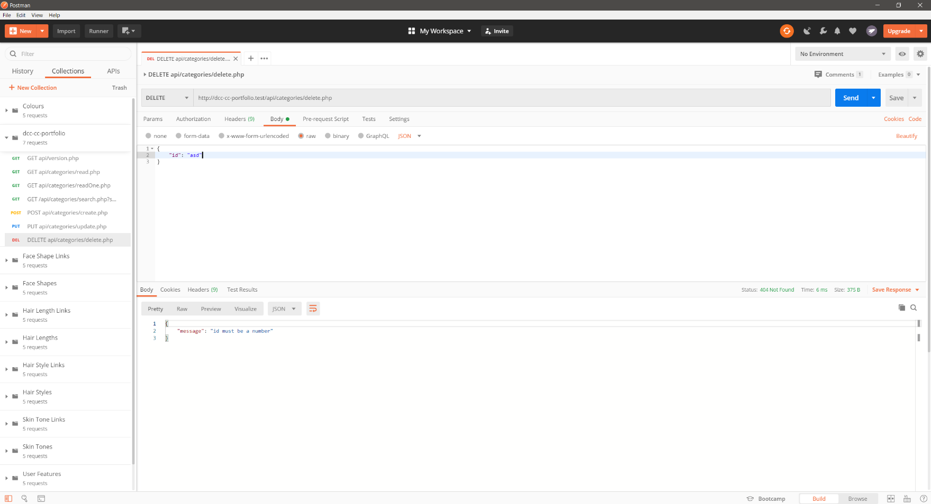

# 6. Search

Searches for a category by code or description, provided as a query string

Request endpoint: GET ***api/categories/search.php?search=<query>***

## 6.1. Search for a category with search = MOT

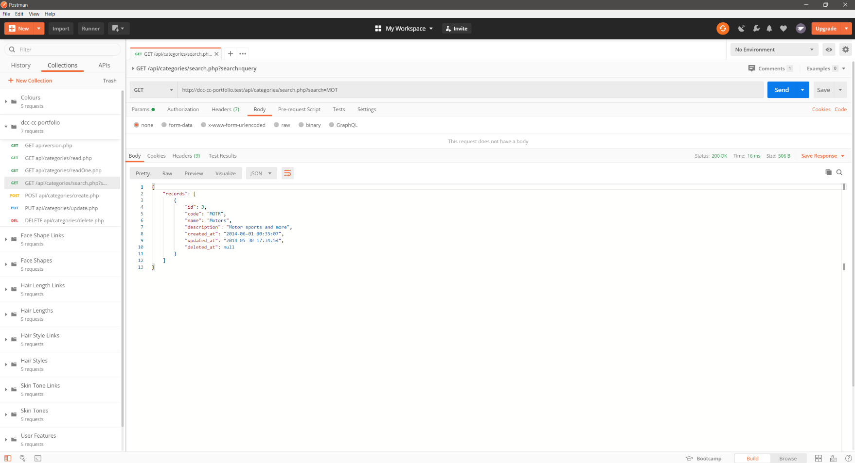

## 6.2. Search for a category with search =

Returns all categories, see comments in Category.php (from line 280) for more details.

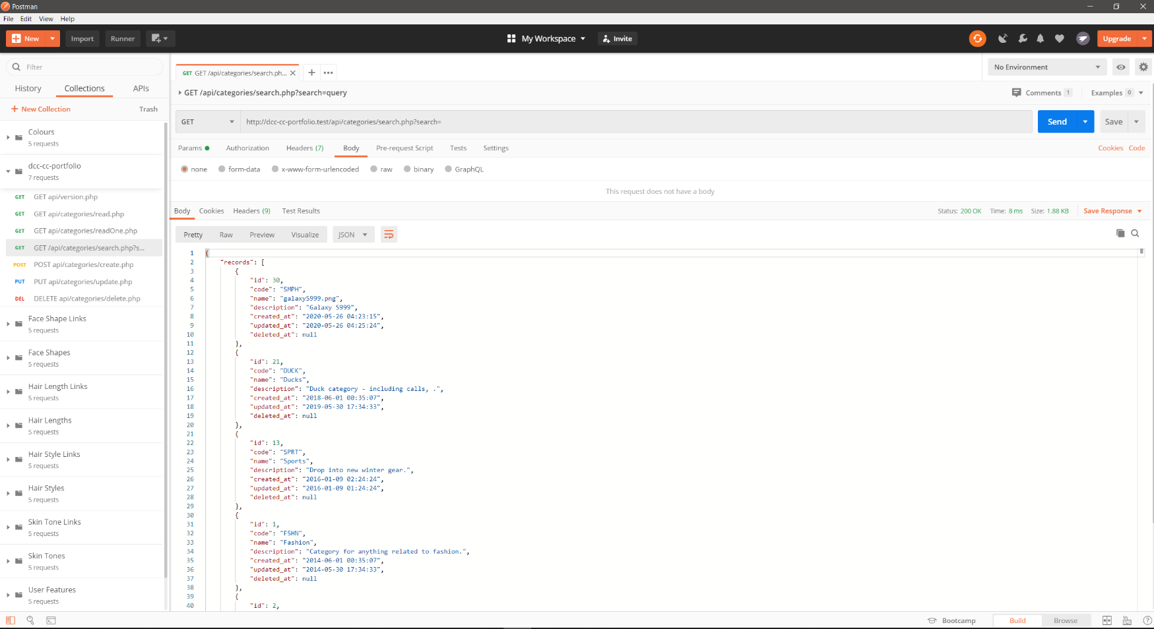

## 6.3. Search for a category with search = nothing