Debug Documentation

Diego C.

# Issue #1: BinarySearch.search_all_by_last_name() gets stuck in an infinite loop

As pictured below, this issue stems from the fact that whenever a match is found inside the while loop of that method, the list “l” remains the same. In other words, the method keeps adding the same player object to the list of results repeatedly.

In order to fix it, it was concluded through analysis of the variables being debugged that after the first result is found, the possible next ones will be found at the left of the first. Thus, the list should reduce in size up to and not including the “mid” index (the index position where the first result was found in the current iteration).

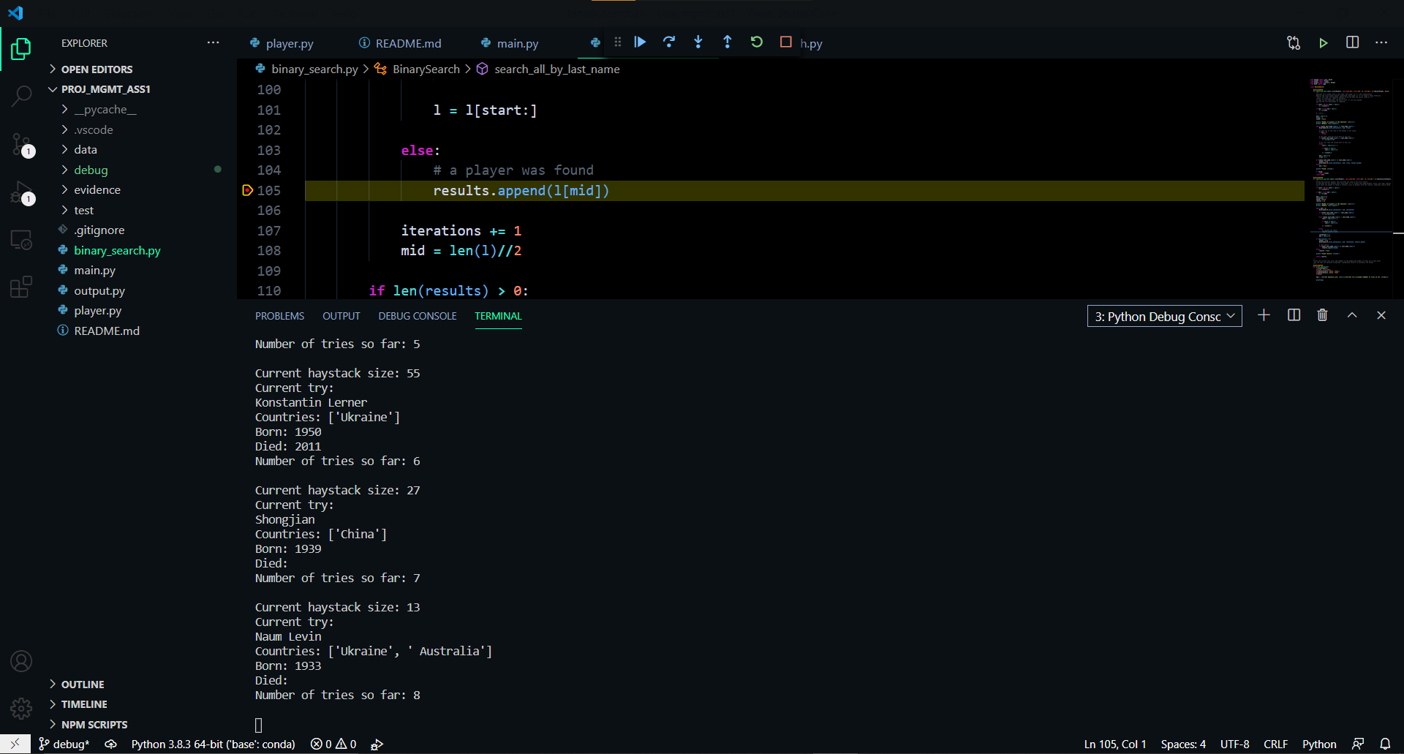

## Solution:

The following code was added to properly reduce the size of the list “l”.

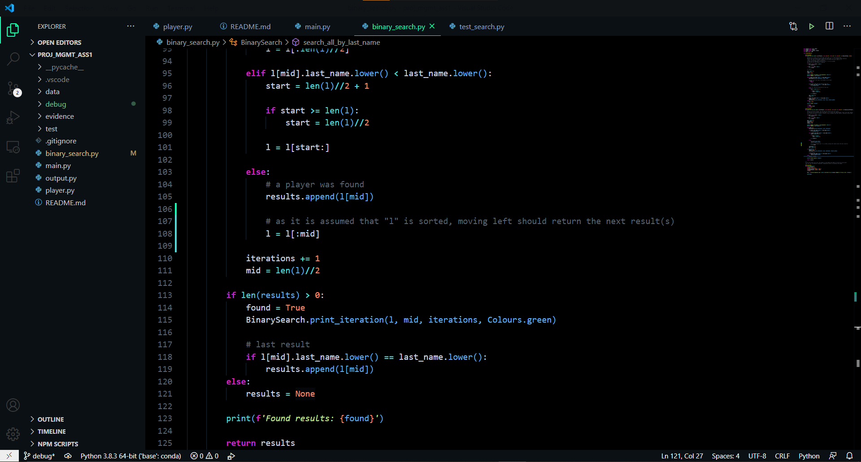

# Issue #2: BinarySearch.search_all_by_last_name() does not return any results even when the specified last_name is present in the list

The picture below illustrates the issue with the current implementation of this function. Since last_name is case sensitive, results may not be found.

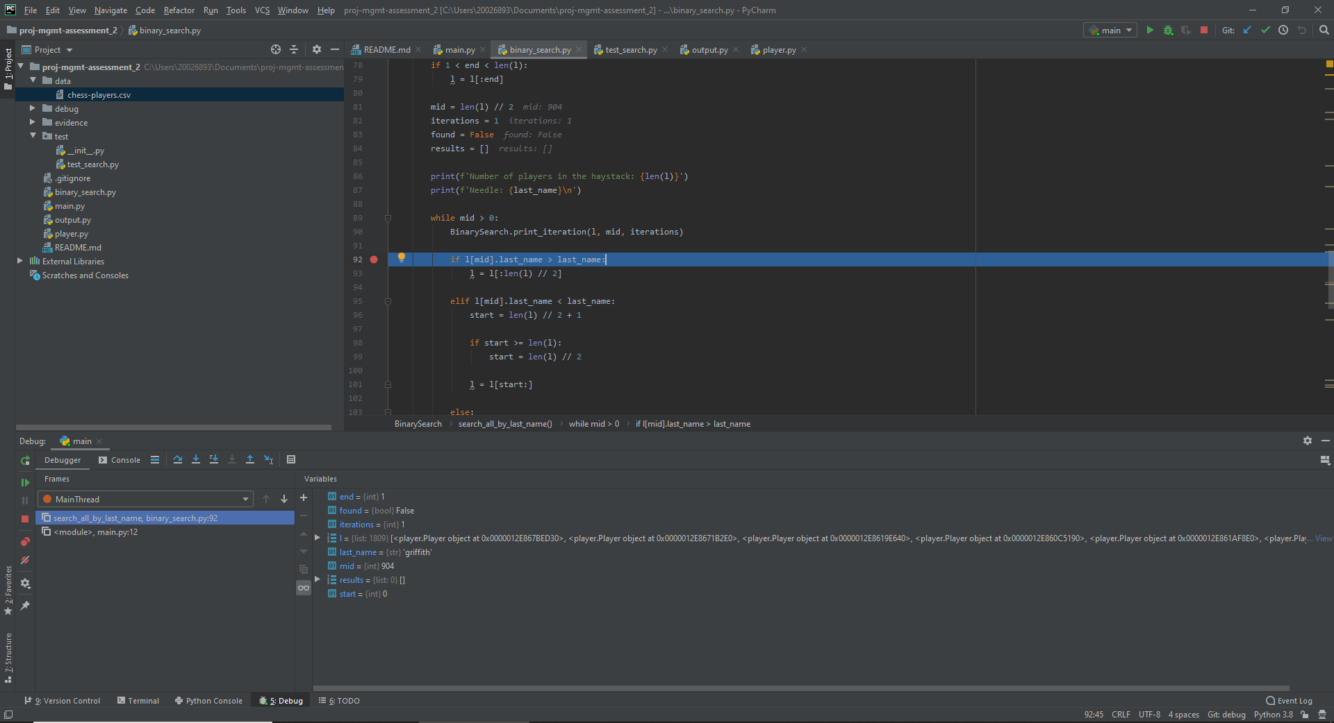

## Solution:

In order to make the function work in a case insensitive manner, the lower() method needs to be applied:

