Homework 1
Diego Escobar Salce
April 9th 2019

# Problem 1:

We can first observe in Table 1 that the most common crimes are associated with
different kinds of robbery such as theft, assault and burglary.

Table 1: Crime Type
THEFT | 127611
BATTERY | 98856
CRIMINAL DAMAGE | 56655
ASSAULT | 39594
DECEPTIVE PRACTICE | 35630
OTHER OFFENSE | 33935
BURGLARY | 24633
NARCOTICS | 24273
ROBBERY | 21548
MOTOR VEHICLE THEFT | 21331
CRIMINAL TRESPASS | 13680
WEAPONS VIOLATION | 10126
OFFENSE INVOLVING CHILDREN | 4318
CRIM SEXUAL ASSAULT | 3131
PUBLIC PEACE VIOLATION | 2858
INTERFERENCE WITH PUBLIC OFFICER | 2388
SEX OFFENSE | 2000
PROSTITUTION | 1451
HOMICIDE | 1262
ARSON | 816
LIQUOR LAW VIOLATION | 456
GAMBLING | 392
STALKING | 385
KIDNAPPING | 359
INTIMIDATION | 316
CONCEALED CARRY LICENSE VIOLATION | 217
OBSCENITY | 166
NON-CRIMINAL | 74
PUBLIC INDECENCY | 24
HUMAN TRAFFICKING | 22
OTHER NARCOTIC VIOLATION | 12
NON-CRIMINAL (SUBJECT SPECIFIED) | 5

Table 2 then shows this dis-aggregated by year. Some categories show large differences from one year to another but in my opinion comparing crime data from one year to another does not make sense, specially when the data is so dis-aggregated. We cannot reliably distinguish this changes from simple random noise without formal testing.

Table 2: Crime Type by Year
year | 2017 | 2018
ARSON | 444 | 372
ASSAULT | 19252 | 20342
BATTERY | 49137 | 49719
BURGLARY | 12946 | 11687
CONCEALED CARRY LICENSE VIOLATION | 69 | 148
CRIM SEXUAL ASSAULT | 1541 | 1590
CRIMINAL DAMAGE | 28955 | 27700
CRIMINAL TRESPASS | 6799 | 6881
DECEPTIVE PRACTICE | 17768 | 17862
GAMBLING | 191 | 201
HOMICIDE | 676 | 586
HUMAN TRAFFICKING | 8 | 14
INTERFERENCE WITH PUBLIC OFFICER | 1083 | 1305
INTIMIDATION | 150 | 166
KIDNAPPING | 190 | 169
LIQUOR LAW VIOLATION | 191 | 265
MOTOR VEHICLE THEFT | 11367 | 9964
NARCOTICS | 11475 | 12798
NON-CRIMINAL | 37 | 37
NON-CRIMINAL (SUBJECT SPECIFIED) | 2 | 3
OBSCENITY | 80 | 86
OFFENSE INVOLVING CHILDREN | 2144 | 2174
OTHER NARCOTIC VIOLATION | 11 | 1
OTHER OFFENSE | 16965 | 16970
PROSTITUTION | 734 | 717
PUBLIC INDECENCY | 10 | 14
PUBLIC PEACE VIOLATION | 1496 | 1362
ROBBERY | 11869 | 9679
SEX OFFENSE | 939 | 1061
STALKING | 184 | 201
THEFT | 63586 | 64025
WEAPONS VIOLATION | 4682 | 5444

Finally, Figure 1 shows the relative frequency of each type of crime in each neighborhood, summing up to 100 percent on each column. The most common crimes are mostly the same across areas, but the relative predominance of each one has a long of variation (measured by the intensity of the color in the graph).

Figure 2 then shows the absolute amount of crimes on each neighborhood. We can observe that there is a high degree of concentration in the neighborhoods where crimes are committed (lighter colors in the graph), while some others seem relatively safe.

Figure 1: Relative Crime Frequency

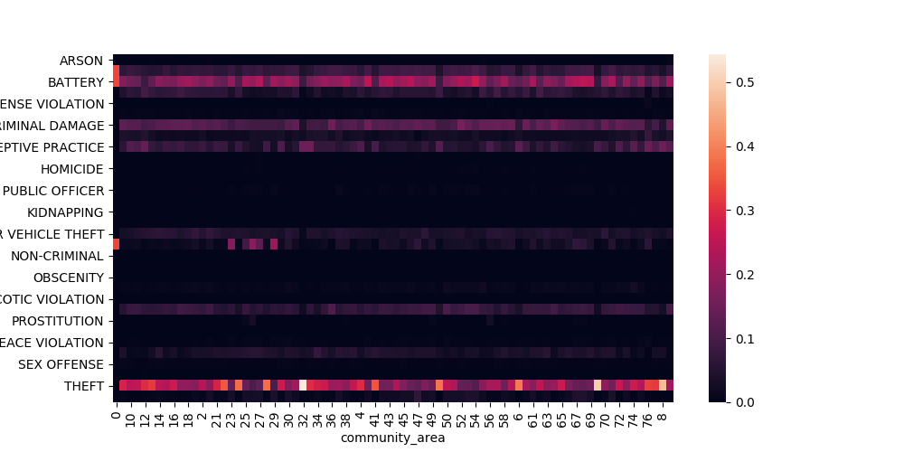

Figure 2: Absolute Crime Frequency
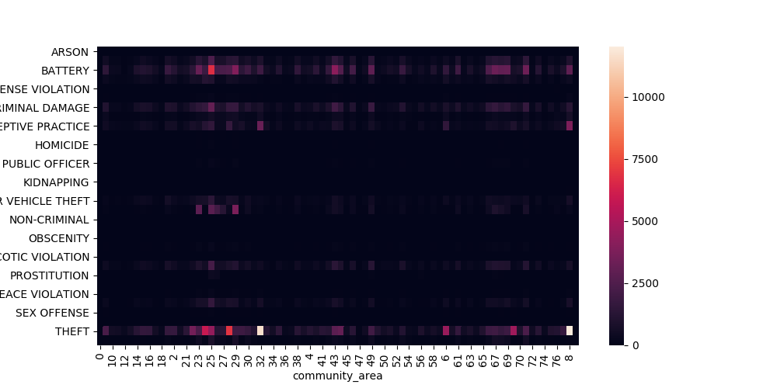
# Problem 2:

Table 3: Correlations

 | battery | homicide | sex_offense | deceptive_practice | prop_hisp | prop_black | prop_male | income
battery | 1 | -0.023497 | -0.029586 | -0.128928 | -0.001945 | 0.093408 | -0.051975 | -0.055013
homicide | -0.023497 | 1 | -0.003021 | -0.013166 | -0.003811 | 0.026081 | -0.01209 | -0.013613
sex_offense | -0.029586 | -0.003021 | 1 | -0.016578 | 0.012162 | -0.01399 | 0.007031 | 0.001601
Deceptive_practice | -0.128928 | -0.013166 | -0.016578 | 1 | -0.017558 | -0.093966 | 0.039462 | 0.085278
prop_hisp | -0.001945 | -0.003811 | 0.012162 | -0.017558 | 1 | -0.577885 | 0.338214 | -0.092616
prop_black | 0.093408 | 0.026081 | -0.01399 | -0.093966 | -0.577885 | 1 | -0.526033 | -0.324412
prop_male | -0.051975 | -0.01209 | 0.007031 | 0.039462 | 0.338214 | -0.526033 | 1 | 0.089631
income | -0.055013 | -0.013613 | 0.001601 | 0.085278 | -0.092616 | -0.324412 | 0.089631 | 1

Table 3 shows the correlation of the occurrence of different kinds of crimes and the characteristics of the neighborhoods where the crimes where committed.

- Batteries where committed more of often in areas with a higher proportion of black population. They also occurred more often in neighborhoods with lower income and a lower proportion of males.
- Homicides show similar patterns than battery, but the correlations with each one of the determinants is less strong.
- I collected the data for a single year so I cannot asses this. However, I would expect the variables that I included to evolve slowly over time, as the average racial composition or income in a neighborhood changes over larger spans of time.
- Deceptive practice occurred more often in higher income neighborhoods, as indicated by the larger correlation. On the other hand, sex offenses occurred more frequently in neighborhoods with a larger proportion of female inhabitants.

# Problem 3:

# A: Table 4 shows the frequency of each kind of crime in the 28 days leading to June 26th in 2017 and 2018 (i.e. June 28th to July 26th). The data does not coincide with what the candidate showed in his campaign.

Table 4: Candidate Statistics
 | 2018 | 2017
ARSON | 35 | 34
ASSAULT | 1893 | 1774
BATTERY | 4752 | 4429
BURGLARY | 1103 | 1185
CONCEALED CARRY LICENSE VIOLATION | 12 | 5
CRIM SEXUAL ASSAULT | 143 | 132
CRIMINAL DAMAGE | 2611 | 2613
CRIMINAL TRESPASS | 556 | 601
DECEPTIVE PRACTICE | 1574 | 1466
GAMBLING | 43 | 18
HOMICIDE | 56 | 77
INTERFERENCE WITH PUBLIC OFFICER | 132 | 107
INTIMIDATION | 23 | 15
KIDNAPPING | 12 | 21
LIQUOR LAW VIOLATION | 35 | 25
MOTOR VEHICLE THEFT | 821 | 962
NARCOTICS | 1093 | 964
NON-CRIMINAL | 3 | 3
NON-CRIMINAL (SUBJECT SPECIFIED) | 1 | 0
OBSCENITY | 10 | 7
OFFENSE INVOLVING CHILDREN | 175 | 147
OTHER NARCOTIC VIOLATION | 0 | 2
OTHER OFFENSE | 1504 | 1456
PROSTITUTION | 51 | 68
PUBLIC INDECENCY | 1 | 0
PUBLIC PEACE VIOLATION | 118 | 139
ROBBERY | 872 | 977
SEX OFFENSE | 81 | 93
STALKING | 22 | 20
THEFT | 5885 | 5795
WEAPONS VIOLATION | 527 | 494

# B: The statistics are completely misleading. When we use time series data we cannot take conclusions from two observations over time to perform our inference. In particular, the alderman is not taking into account the possibility of random noise affecting these numbers. Even if the increase is relatively large (e.g. 22 percent since 2016), more evidence needs to be shown to address whether this is due to the inherent randomness of the data or if it reflects fundamental changes in patterns.

Also, the choice of that particular time for the analysis seems very subject to manipulation and could lead to biased results.

Moreover, focusing on particular types of crimes may be neglecting drastic changes in other crimes. On the other hand, the comparison between years seem more reasonable but it could be hiding large heterogeneity in the type of crimes committed, and major crimes such as homicides would not matter much for the overall total crimes as their quantity is relatively more reduced.

# C: 5 Findings

1) A large proportion of the crimes are related to different kinds of robbery, so more police street surveillance could prove effective controlling it.

2) Although smaller in quantity, the number of major crimes such as homicides and sexual assaults is relatively high.

3) The main crime categories seem to repeat across neighborhoods, but there's clearly variation in the distribution of them across areas. This implies that different kind of policies are required in different neighborhoods.

4) There is a high degree of concentration of the crimes. Some neighborhood have a very limited amount of crimes, while some others concentrate a large amount of crimes.

5) Given the high degree of concentration of some types of crimes in certain neighborhoods, it would be useful to evaluate the geographical dispersion of these places to check the patterns in the location of crime.

# D: A big caveat is the lack of statistical comparisons. Although informative, simply comparing averages is not enough to produce strong policy recommendations. Moreover, when analyzing crime, the proper level at which the analysis should be done is probably larger than a neighborhood. In particular, if policies were implemented at the neighborhood level it could probably simply displace crime to a different neighborhood instead of eliminating it as intended.

# Problem 4:

# a:
Types of crimes in the community area where the address is located:

Table 5: Crimes around S Michigan Ave
THEFT | 1127
BATTERY | 577
DECEPTIVE PRACTICE | 530
CRIMINAL DAMAGE | 341
OTHER OFFENSE | 221
ASSAULT | 216
MOTOR VEHICLE THEFT | 160
ROBBERY | 142
CRIMINAL TRESPASS | 134
BURGLARY | 92
NARCOTICS | 36
SEX OFFENSE | 23
CRIM SEXUAL ASSAULT | 21
WEAPONS VIOLATION | 19
OFFENSE INVOLVING CHILDREN | 17
PUBLIC PEACE VIOLATION | 12
PROSTITUTION | 6
INTERFERENCE WITH PUBLIC OFFICER | 5
LIQUOR LAW VIOLATION | 5
HOMICIDE | 3
ARSON | 3
STALKING | 3
OBSCENITY | 3
NON-CRIMINAL | 2
INTIMIDATION | 2
CONCEALED CARRY LICENSE VIOLATION | 1
KIDNAPPING | 1

# b:
The most common type in Garfield is battery while in Uptown theft is more common (considering Garfield as East Garfield community area and Uptown as part of Lakeview community area). Moreover, both areas have a similar amount of crime overall, so P(Uptown)~P(Garfield).

Table 6: Crimes in Garfield Park and Uptown
community_area | Garfield | Uptown
ARSON | 18 | 4
ASSAULT | 811 | 466
BATTERY | 2313 | 1551
BURGLARY | 257 | 641
CONCEALED CARRY LICENSE VIOLATION | 3 | 3
CRIM SEXUAL ASSAULT | 47 | 103
CRIMINAL DAMAGE | 905 | 822
CRIMINAL TRESPASS | 306 | 382
DECEPTIVE PRACTICE | 269 | 1433
GAMBLING | 48 | 0
HOMICIDE | 43 | 1
INTERFERENCE WITH PUBLIC OFFICER | 81 | 10
INTIMIDATION | 7 | 7
KIDNAPPING | 7 | 1
LIQUOR LAW VIOLATION | 9 | 20
MOTOR VEHICLE THEFT | 370 | 416
NARCOTICS | 1240 | 78
NON-CRIMINAL | 0 | 4
NON-CRIMINAL (SUBJECT SPECIFIED) | 1 | 0
OBSCENITY | 3 | 3
OFFENSE INVOLVING CHILDREN | 77 | 23
OTHER OFFENSE | 593 | 431
PROSTITUTION | 8 | 2
PUBLIC PEACE VIOLATION | 72 | 58
ROBBERY | 538 | 428
SEX OFFENSE | 26 | 52
STALKING | 5 | 9
THEFT | 1267 | 4489
WEAPONS VIOLATION | 268 | 23

# c:
Using Bayes rule we can solve:
P(G|B)=P(B|G)*P(G)/(P(B|G)*P(G)+P(B|U)*P(U))

So the probability that a Battery call comes from Garfield (assuming in this case that these two are the only options) would be 38.46, so it is 60 percent more likely that the call comes from Uptown (P(U|B)/P(G|B)).

