# Problem 1:

We can first observe in Table 1 that the most common crimes are associated with
different kinds of robbery such as theft, assault and burglary.

Table 1: Crime Type

Table 2 then shows this dis-aggregated by year. Some categories show large differences from one year to another but in my opinion comparing crime data from one year to another does not make sense, specially when the data is so dis-aggregated. We cannot reliably distinguish this changes from simple random noise without formal testing.

Table 2: Crime Type by Year

Finally, Figure 1 shows the relative frequency of each type of crime in each neighborhood, summing up to 100 percent on each column. The most common crimes are mostly the same across areas, but the relative predominance of each one has a long of variation (measured by the intensity of the color in the graph).

Figure 2 then shows the absolute amount of crimes on each neighborhood. We can observe that there is a high degree of concentration in the neighborhoods where crimes are committed (lighter colors in the graph), while some others seem relatively safe.

Figure 1: Relative Crime Frequency

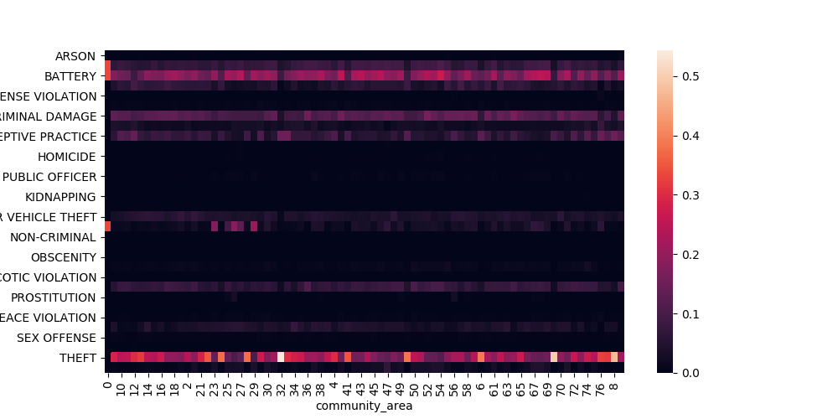
Figure 2: Absolute Crime Frequency
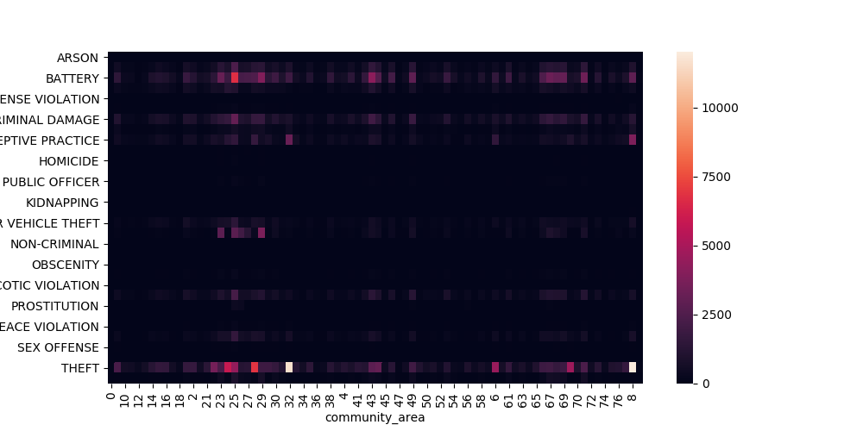

# Problem 2:

I downloaded the data but I could not merge the data, so comparison of different areas is not presented.

# Problem 3:

# A: Table 3 shows the frequency of each kind of crime in the 28 days leading to June 26th in 2017 and 2018 (i.e. June 28th to July 26th). The data does not coincide with what the candidate showed in his campaign.

Table 3: Candidate Statistics

# B: The statistics are completely misleading. When we use time series data we cannot take conclusions from two observations over time to perform our inference. In particular, the alderman is not taking into account the possibility of random noise affecting these numbers. Even if the increase is relatively large (e.g. 22 percent since 2016), more evidence needs to be shown to address whether this is due to the inherent randomness of the data or if it reflects fundamental changes in patterns.

Also, the choice of that particular time for the analysis seems very subject to manipulation and could lead to biased results.

Moreover, focusing on particular types of crimes may be neglecting drastic changes in other crimes. On the other hand, the comparison between years seem more reasonable but it could be hiding large heterogeneity in the type of crimes committed, and major crimes such as homicides would not matter much for the overall total crimes as their quantity is relatively more reduced.

# C: 5 Findings

1) A large proportion of the crimes are related to different kinds of robbery, so more police street surveillance could prove effective controlling it.

2) Although smaller in quantity, the number of major crimes such as homicides and sexual assaults is relatively high.

3) The main crime categories seem to repeat across neighborhoods, but there's clearly variation in the distribution of them across areas. This implies that different kind of policies are required in different neighborhoods.

4) There is a high degree of concentration of the crimes. Some neighborhood have a very limited amount of crimes, while some others concentrate a large amount of crimes.

5) Given the high degree of concentration of some types of crimes in certain neighborhoods, it would be useful to evaluate the geographical dispersion of these places to check the patterns in the location of crime.

# D: A big caveat is the lack of statistical comparisons. Although informative, simply comparing averages is not enough to produce strong policy recommendations. Moreover, when analyzing crime the proper level at which the analysis should be done is probably larger than a neighborhood. In particular, if policies were implemented at the neighborhood level it could probably simply displace crime to a different neighborhood instead of eliminating it as intended.

# Problem 4:

# a:

# b:

# c:
Using Bayes rule we can solve:
P(G|B)=P(B|G)*P(G)/(P(B|G)*P(G)+P(B|U)*P(U))

So the probability that a Battery call comes from Garfield (assuming in this case that these two are the only options) would be 38.46, so it is 60 percent more likely that the call comes from Uptown (P(U|B)/P(G|B)).

