UPDATED ‘AIDOPTION’ PLATFORM

USER EXPERIENCE DESIGN PROJECT WORK
Diego Rossi

In the updated version for the AIdoption platform, results are evidenced in a clearer way for users to understand. OOD score is reported, as well as uncertainty (not very informative in this specific case).
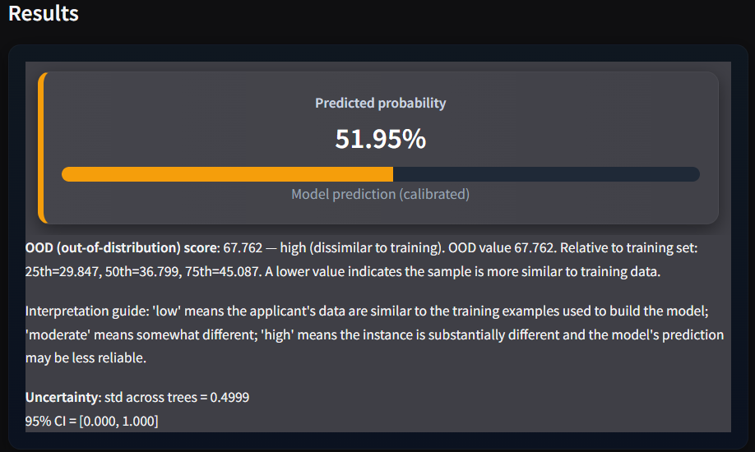
Here I reported another case in which the uncertainty and the associated range assume more significance (even if the OOD score signals it is highly out-of-distribution):
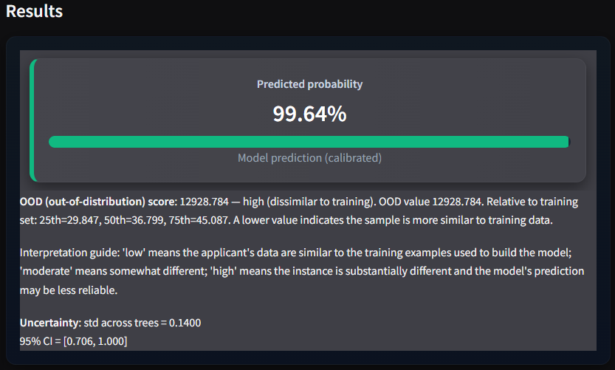
Moreover, a graphic representation for SHAP explanation is provided. Diagnostics for the model are presented as well to the users.
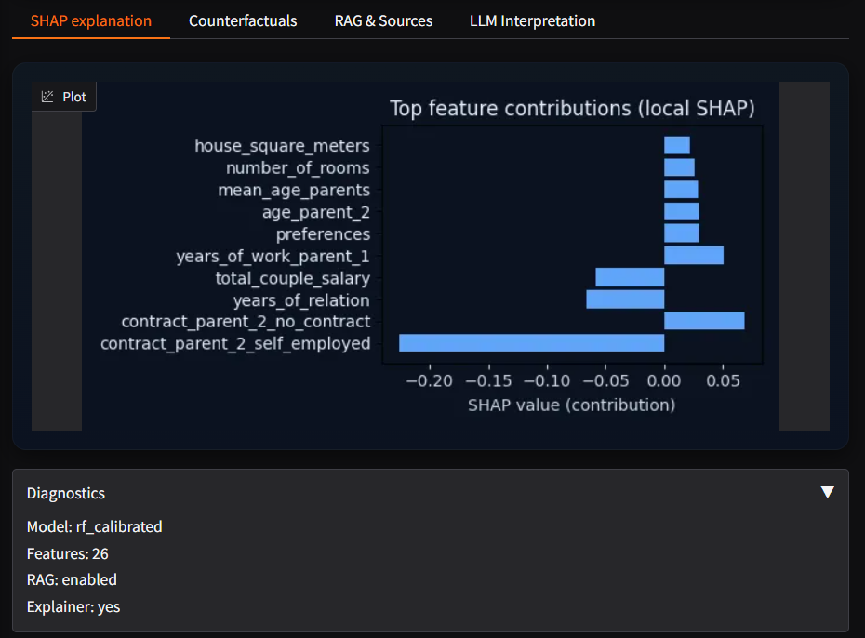

A counterfactual analysis is available for the couple to understand how different choices/situations would’ve impacted on their probability score. A disclaimer is present as well as not every variable can be arbitrarily determined by the users.
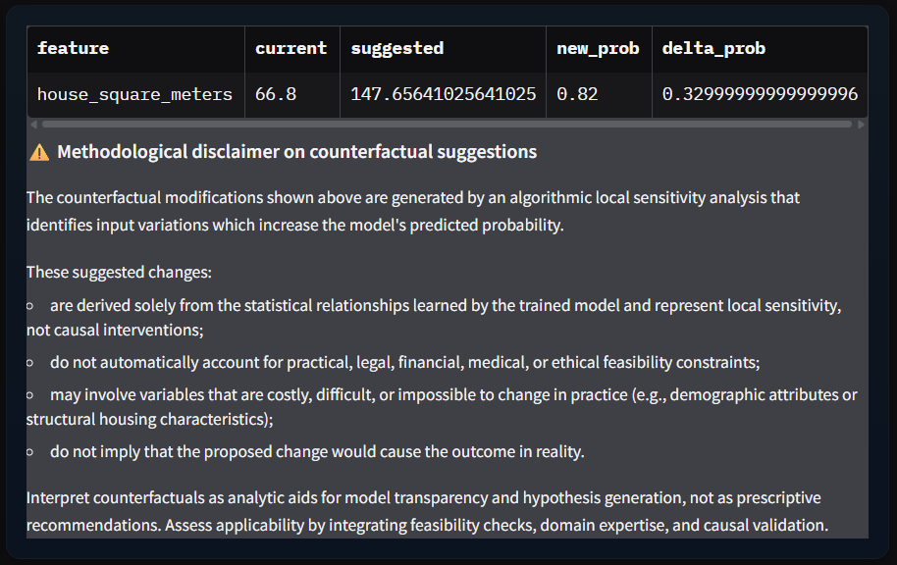

A contextualized RAG justification, based on legal information coming from official Italian channels (Presidenza del Consiglio dei Ministri – “NORMATTIVA: il portale della legge vigente”) and enriched by a LLM is presented to the couple to have a better understanding on the mandatory constraints that they have to respect and also on how the validation process works.
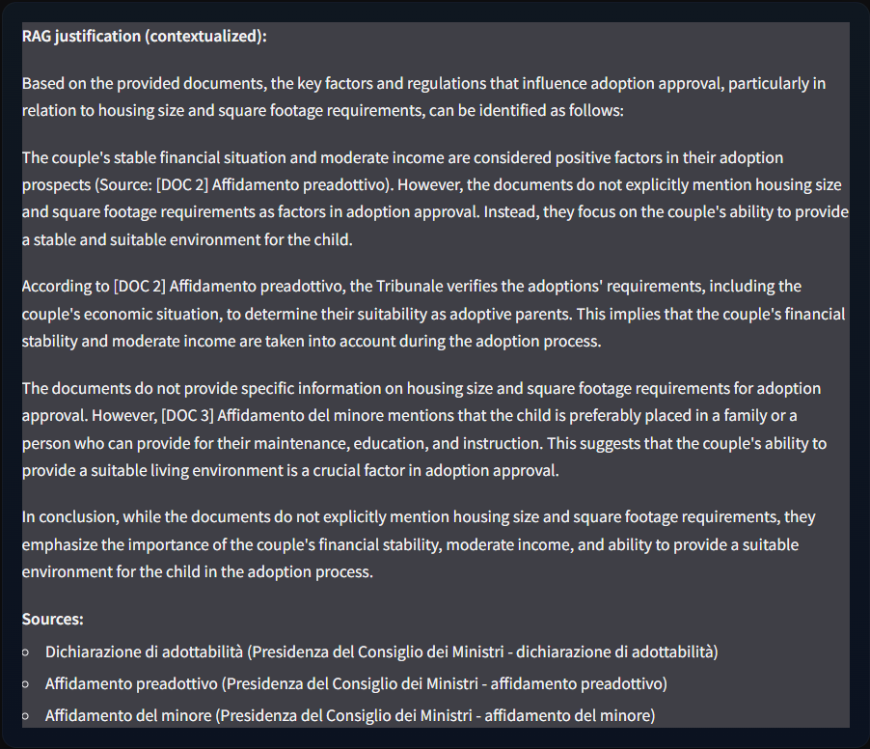

In the end, the LLM that was already provided in the first version of the platform is improved by making it possible for the users to decide the level of expertise for the generated analysis between ‘basic’, ‘intermediate’ and ‘advanced’.
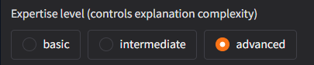
In the following case, advanced level was chosen:
