- You must have successfully created a VM running RHEL 7 before proceeding with these instructions.

- For Oracle Virtual Box users, ensure port forwarding using port 5022 (external) -> 22 (internal) is setup for the VM image. See image below for an example of this:
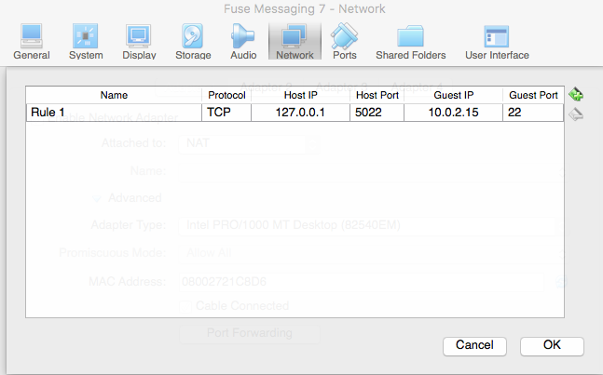

- Generate your SSH public and private keys, that will be used by you - at your local workstation - to establish an SSH connection with the VM.

- Copy the ssh public key into the VM, using any of these means:
  - ssh-copy-id -i ~/.ssh/id_rsa.pub <remote-host-ip-address>
  - cat ~/.ssh/id_rsa.pub | ssh root@ <remote-host-ip-address> "mkdir ~/.ssh; cat >> ~/.ssh/
  - (For Oracle Virtual Box users) => cat ~/.ssh/id_rsa.pub | ssh root@ <remote-host-ip-address> -p 5022 "mkdir ~/.ssh; cat >> ~/.ssh/

- Connect to the VM using SSH, through a command line console on your workstation.

- Follow these instructions - https://access.redhat.com/solutions/253273 - in order to set up RHN subscriptions for the RHEL VM Image user.

- Ensure that user account of RHEL VM Image is subscribed to RHN, attaching these pools:
  - subscription-manager attach --pool=8a85f9815bd4351c015bd4a6b1694bd6
  - subscription-manager attach –pool=8a85f9843e3d687a013e3ddd46dd07f1

- Clear the history of the command to subscribe to RHN, using history -d <line number of command>

- Ensure the following RHN Subscription channels are enabled:
  - rhel-7-server-rpms
  - rhel-7-server-extras-rpm
  - rhel-7-server-supplementary-rpm
  - a-mq-interconnect-1-for-rhel-7-server-beta-rpms

- Enable searching of yum repos, by setting 'notify_only=0' in /etc/yum/pluginconf.d/search-disabled-repos.conf

- Ensure that there yum -y update is successful. In case of an unsuccessful update, execute this command first, before retrying the update: yum -y install yum-skip-broken

- If performing an upgrade of the software installed, check for new Yum repos using yum repolist all

- For Oracle Virtual Box users, set up the Ansible inventory file (hosts) with this entry :
  - 127.0.0.1 ansible_ssh_port=5022 ansible_ssh_user=jboss ansible_become_pass=jboss
For KVM users, set up the inventory file (hosts) with this entry :
  - 127.0.0.1 ansible_ssh_port=22 ansible_ssh_user=root

- For Oracle Virtual Box users, change port number in ~/OPEN_virtual/<course_category>/<course_name>/ansible/roles/reboot/tasks/main.yml to 5022

- Assign the the file name of the AMQ 7 broker archive, without the -bin.zip suffix (eg: amq-broker-7.0.1.redhat-1) as the value for the amq_base_name variable in /OPEN_virtual/<course_category>/<course_name>/ansible/group_vars/all/vars.yml

- Execute Ansible playbook. The following messages (shown below) indicate a successful execution:

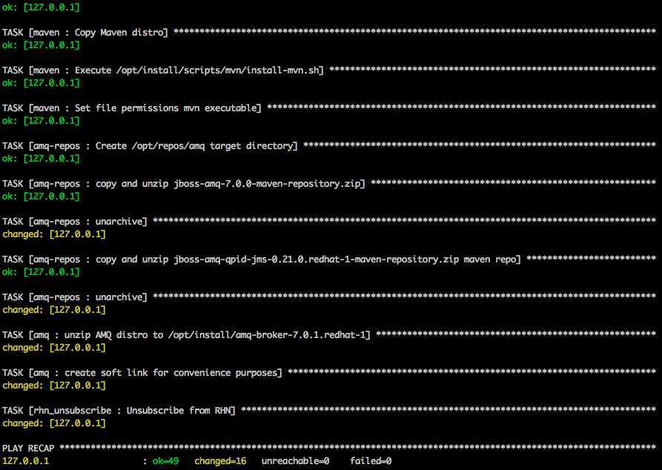

- Once installation of software in OPEN VIRTUAL VM Image is complete, unregister the user from RHN, with these three commands in succession:
  - subscription-manager unsubscribe --all
  - subscription-manager remove --all
  - subscription-manager unregister
  - subscription-manager clean

