**Application**

# Main page Enterpise CRUD

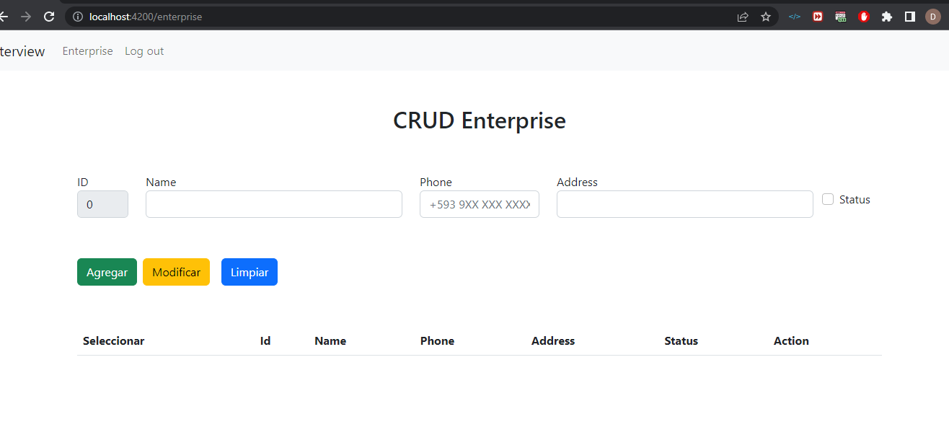

# Department CRUD

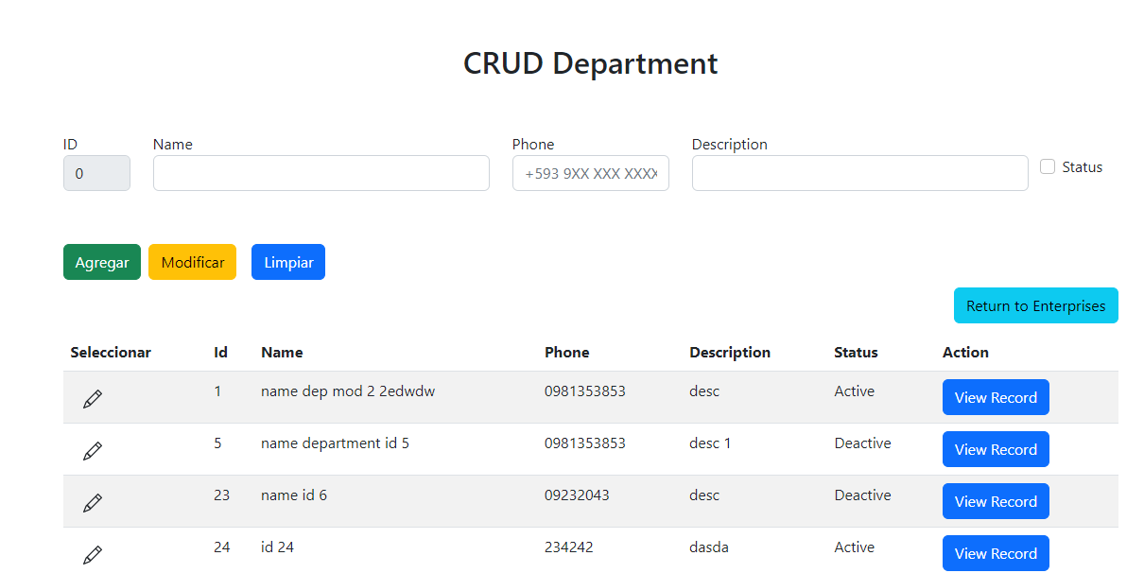

# Employee CRUD

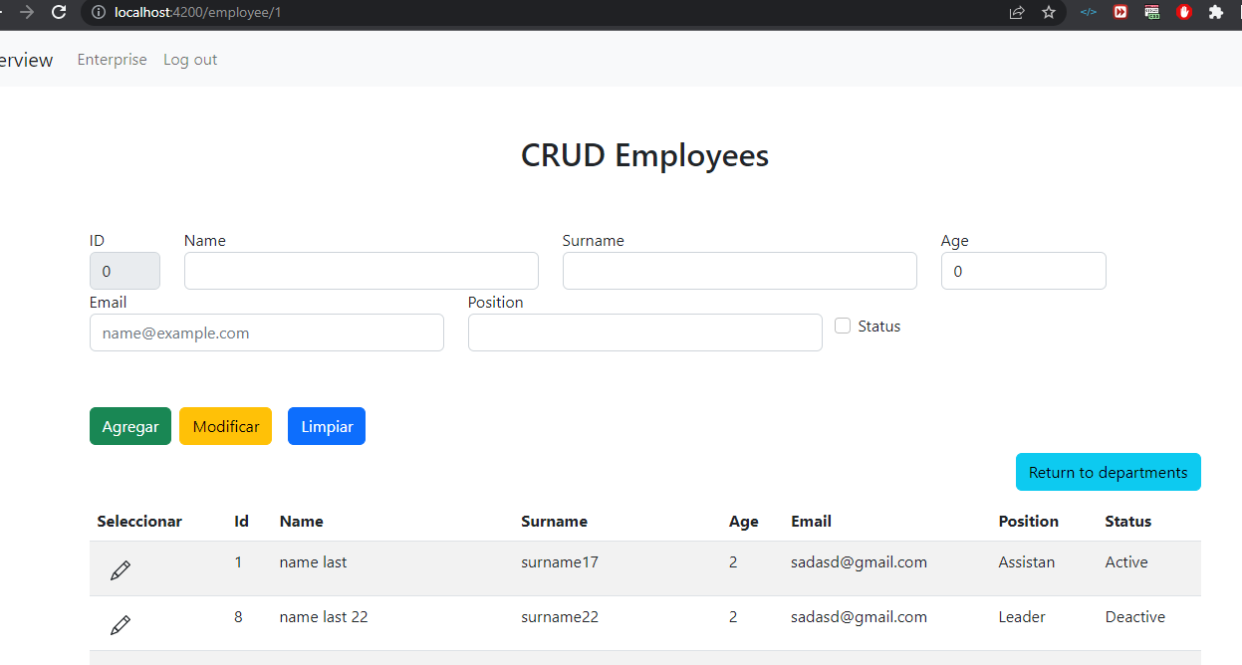

# Tools used

**Database**

A Microsoft option very used in the enterprise world

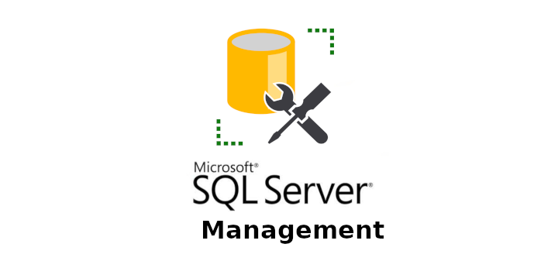

**BackEnd**

**Visual Studio:** Visual Studio IDE created by Microsoft. It provides a comprehensive set of tools and features for developing software applications.

.NET is a software development platform created by Microsoft

**Postman:** for API (developed in .NET) testing





**FrontEnd (Angular, Visual Studio Code)**

**Visual Studio Code:** is a code editor with multiple and useful plugins

**Angular:** is an open-source front-end web application framework



**Code versioning**

Git using the Github Desktop tool



**Methodology**

**Scrum** is an agile project management framework that is widely used in software development. It is a flexible and iterative approach to project management that focuses on delivering value to the customer in short, time-boxed iterations known as sprints.

|  |  |
| --- | --- |
| **Sprint** | **Task** |
| Sprint 1 | * Database model * Database script * Setup |
| Sprint 2 | * Back End Development:   + Models creation   + Management code to connect to databse   + Controllers definitions   + Postman tests |
| Sprint 3 | * Front End Development:   + Angular code (components, Services, modules)   + Interface design * Documentation:   + Installation Guide   + Application Document |