CNC Digital Twin: Team Guide
MFG 598 Industrial IoT, ASU · how to open the digital twin online
Our digital twin reads live MTConnect data from the Metalogi demo agent and moves the Mazak and OKUMA machines in 3D. You can open it online with GitHub Codespaces, so you do not need to install anything. You only need a GitHub account.
Repository: https://github.com/diegobethancourth/digital_twin_diego

First time (only one time)
- Open this link and sign in to GitHub if it asks: https://codespaces.new/diegobethancourth/digital_twin_diego. The link is also in the README.
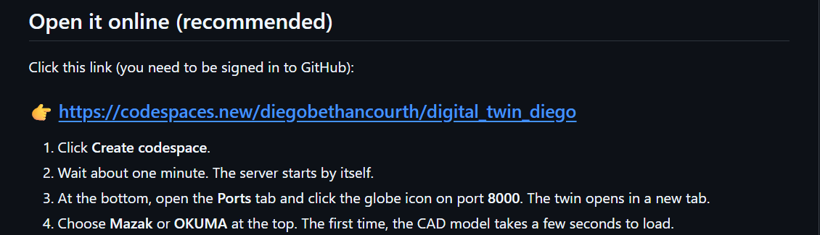
- Click Create codespace. Keep the default options (branch main, 2-core).
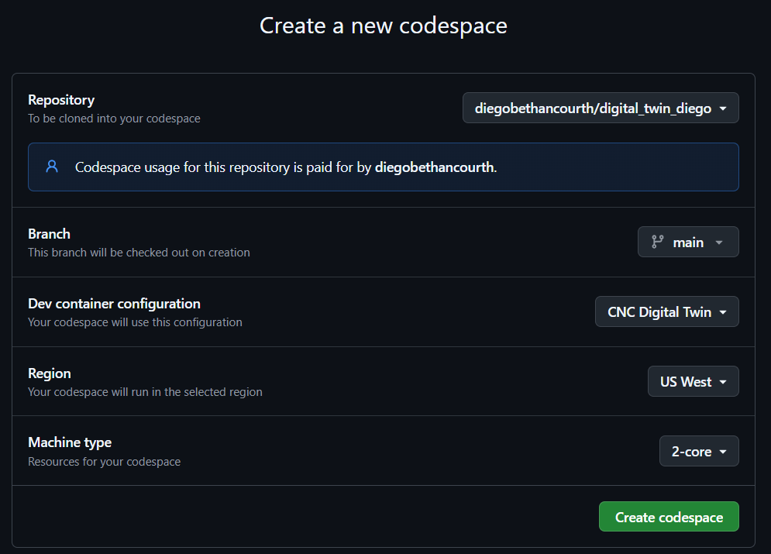
- Wait about one minute. VS Code opens in the browser and the server starts by itself. Do not type anything in the terminal.
- At the bottom, click the Ports tab. On the line for port 8000, click the globe icon (Open in Browser).
If the Ports tab is empty: click Forward a Port, type 8000 and press Enter.
- The twin opens in a new tab. Choose Mazak or OKUMA at the top. The first time, the CAD model takes a few seconds to load.
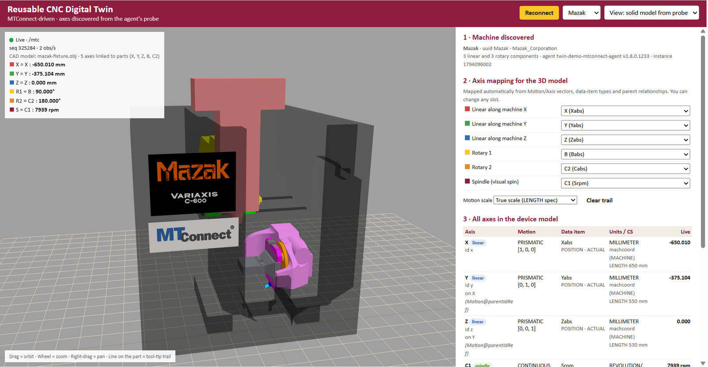
- Save this tab as a bookmark. The address stays the same for your codespace.

Next times
- Go to the repository, click Code → Codespaces and click the name of your codespace (or go to github.com/codespaces).
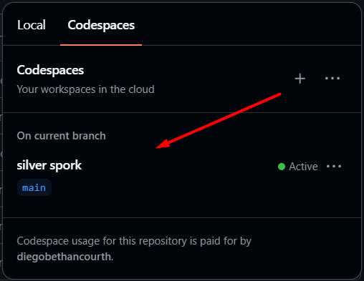
- Wait about one minute, then open your bookmark (or use the globe icon again).

Good to know
- The codespace stops by itself after 30 minutes without use. When it is stopped, the bookmark does not open: open the codespace first.
- Your link is personal. It does not work for other people, so each one of us creates our own codespace.
- GitHub deletes a codespace after 30 days without use. Then just create a new one with the same link.
- If you type python serve.py and get "port already in use", it is fine: the server was already running.
- Codespaces is free for personal accounts up to a monthly limit, which is enough for this project.

Optional: run it on your computer
Download the repo (Code → Download ZIP), unzip it and double-click start_twin.bat (Windows). On Mac, open a terminal in the folder and type python3 serve.py. Then open http://localhost:8000/?device=Mazak. You need Python 3.

