**Communication Lab Homework 3 Report**

B10901061陳冠穎

**Part 1. OFDM signal generation and reception**

1. Generate 1 OFDM symbol with the cyclic prefix. Plot the generated signal in the time domain right before upsampling (a in Fig. 1) with the x-axis in 𝜇𝑆. Mark the cyclic prefix part.

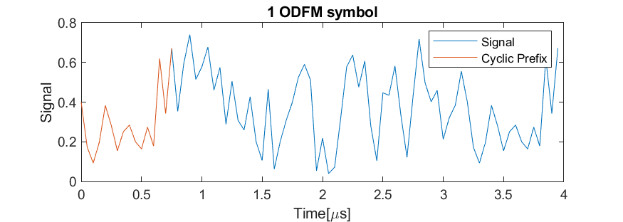

Figure 1. 1 ODFM symbol with marked Cyclic Prefix

It can be observed that the cyclic prefix (orange part) is copied from the last quarter of the original signal (blue part).

1. Plot the OFDM signal in the frequency domain after upconversion (b in Fig. 1). The x-axis is in GHz. Briefly describe the figure.

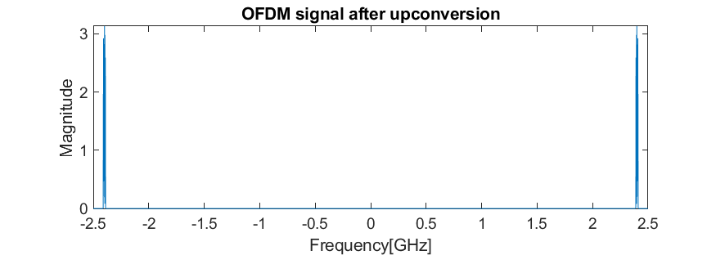

Figure 2. OFDM signal after upconversion in frequency domain

Since the signal has been upconverted with 2.4GHz, we can see two different peaks at around ±2.4GHz. Since the signal has also been filtered by interpolation filter, noises are also filtered out and the signal becomes cleaner.

1. Plot the received signal in the frequency domain after the cyclic prefix is removed (c in Fig.1). The x-axis is in KHz. Briefly describe the figure.

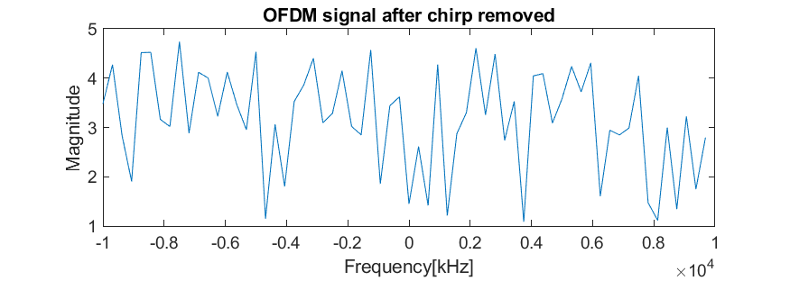

Figure 3. Received OFDM signal after the CP is removed in frequency domain

Since there exists signal in every frequency subcarrier, all frequencies have similar magnitude, and there isn’t any peak exists.

1. Transmit and receive 1000 OFDM symbols with SNR = {0dB, 5dB, 10dB, 15dB, 20dB}. Plot the BER vs SNR. Briefly describe the figure.

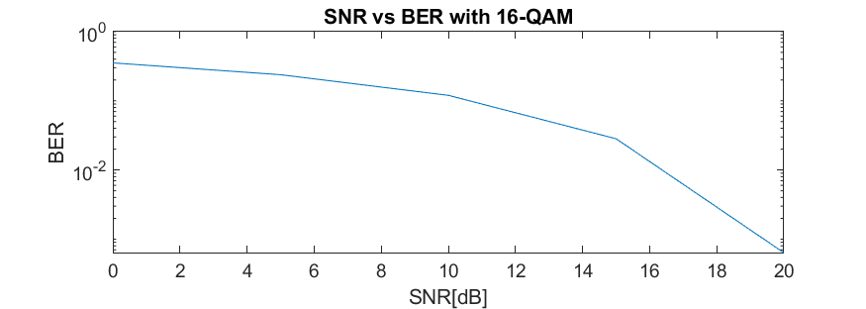

Figure 4. SER vs. BER with 16-QAM

Just as the intuition, the bit error rate decreases while SNR increases. Under 16-QAM, the BER is around 100~10-2.

1. Repeat D using a modulation order of 64-QAM. Plot the BER vs SNR of 16-QAM and 64-QAM on the same figure. Briefly describe the figure.

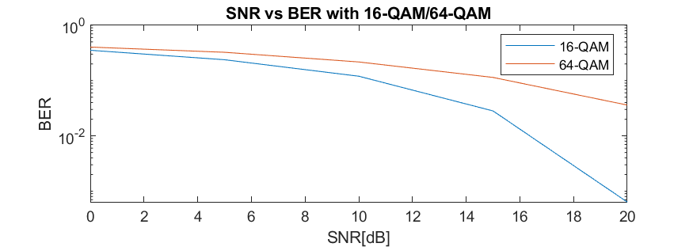

Figure 5. SER vs. BER with 16-QAM and 64-QAM

Compare to 16-QAM, 64-QAM has worse BER under same SNR. However, the BER in both decrease with the increasing SNR.

**Part 2. STS & LTS generation and frame synchronization**

1. Generate the short training sequence (STS). Please refer to 𝑆'­-26,26 (in the course slide for STS generation. Plot the STS (10 repeated symbols) in the time domain with the x-axis in 𝜇𝑆.

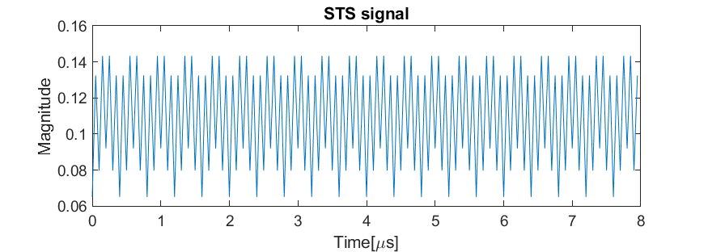

Figure 6. Short training sequence (STS) signal

1. Generate the long training sequence (LTS). Please refer to 𝐿'­-26,26 (in the course slide for LTS generation. Plot the LTS (2 long training symbols + cyclic prefix as in the course slide) in the time domain with the x-axis in 𝜇𝑆.

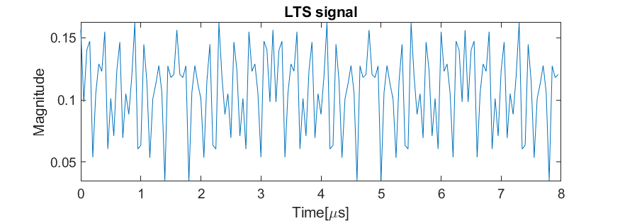

Figure 7. Long training sequence (LTS) signal

1. Create a frame starting with STS, LTS, followed by 3 OFDM symbols (using the same procedure in part 1 with 16-QAM). Normalize the signal if needed so that the whole frame has consistent power. Plot the whole frame in the time domain with the x-axis in 𝜇𝑆. Mark STS, LTS, and data portion in the frame.

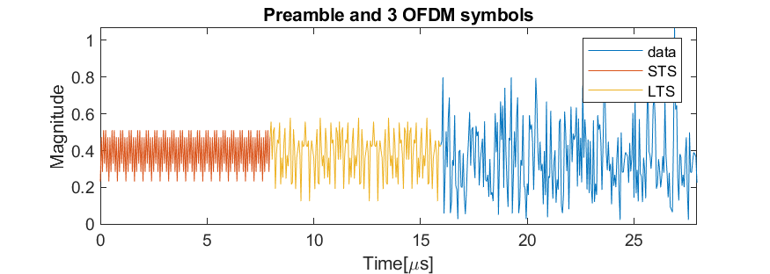

Figure 8. Preamble and 3 OFDM symbols

1. Create a frame similar to the one in C but now with 100 OFDM symbols. Before upsampling, add 30 zeros before and after the created frame (that is, the frame starts with 30 zeros, followed by STS, LTS, OFDM data, then 30 zeros). Add white Gaussian noise with 20 dB SNR. For the received signals (after downsampling), create your own matched filter based procedure to correctly determine the start of the OFDM data symbols. Plot the match filter result and briefly explain the figure.

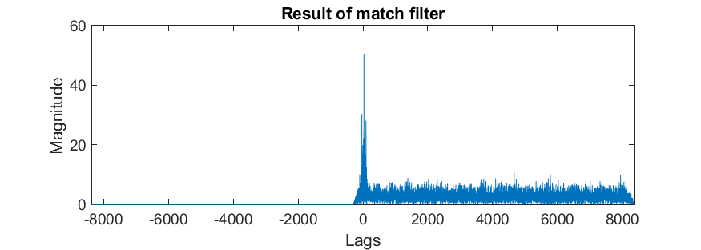

Figure 9. Performance of match filter. *Lags* means the position of premable

1. Explain your synchronization algorithm.

The match filter in D calculates the correlation between preamble and received data after filtered by decimator filter. Since ideally, the first 320 bits of the data shall be the same as the preamble data, we can find the peak of correlation magnitude and mark that position as the beginning of the data. Since the length of preamble is fixed as 320 elements, we are able to mark the real starting point of data for further processing.

1. Process the OFDM data signals obtained in D. What is the bit error rate?

*Bit error rate: 0.000820*

1. Use the frame created in D and vary the SNR = {0dB, 5dB, 10dB, 15dB, 20dB} (by adding white Gaussian noise with different power). For each SNR, repeat the frame transmission 100 times and calculate the probability of successful frame synchronization at the receiver (i.e., correctly determine the start of OFDM data symbols). Plot the probability of successful frame synchronization with SNR. Briefly describe the figure.

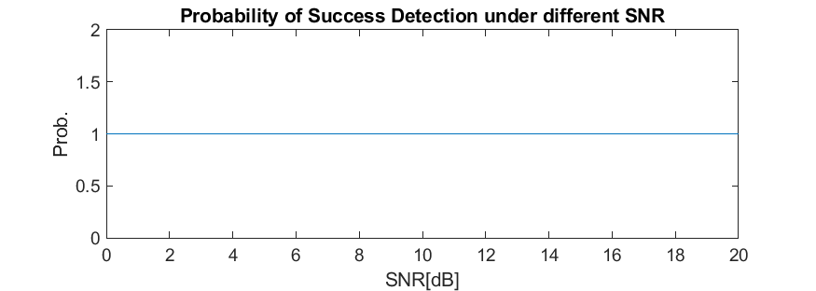

Figure 10. Probability of successfully detecting the preamble position after different SNR

It is surprised to notice that under all cases of SNR, the algorithm could successfully detect all the preamble signal. Since adding white noise will make no effect on correlation, the correlation is still available to distinguish preamble signal from noise.