|  |  |
| --- | --- |
| Name: | Diego Roberto Cuéllar |
| Class: | Interchange 2 |

http://www.misteraidan. com

**Part A: Read.**

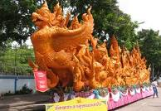

Every year in July, people in Ubon Ratchathani Thailand celebrate the Candle Festival. Tourists from all over the country come to Ubon to look at huge wax candles that are paraded through the streets. There is music, dancers, a huge market and even a competition for artists to design the best candle.

In other countries, they have different festivals. Some are really strange. One of the weirdest festivals in the world is Day of the Dead.

Day of the Dead is celebrated on November 1st in Mexico, Ecuador, Guatemala and other parts of Central and South America. Families gather to pray to dead relatives and ask them to return for just one night.

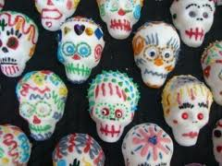

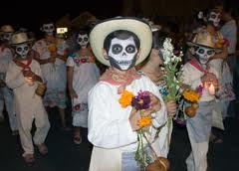

People decorate their homes and gravesites with food, candles, candy skulls and flowers to welcome the dead back to earth. People dress up as skeletons and parade through the streets.

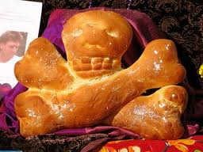

Pan de los muertos (bread of the dead) is baked in the shape of skulls and crossbones, and a toy is hidden inside each loaf. The person who bites into the toy is said to have good luck.

Day of the Dead sounds like a scary event, but it’s a happy time to celebrate and remember the lives of dead family members.

**Part B: Answer True or False.**

|  |
| --- |
| F |

1. Day of the Dead is celebrated in July.

|  |
| --- |
| T |

2. Families ask dead people to come back for one night.

|  |
| --- |
| T |

3. Pan de los Muertos is a type of bread.

|  |
| --- |
| F |

4. It is unlucky to bite the toy in Pan de los Muertos.

|  |
| --- |
| T |

5. Day of the Dead is a happy festival.

|  |
| --- |
| F |

6. Day of the Dead is celebrated in Africa.

**Part C: Answer the questions. (Write full sentences please.)**

1. Why do people celebrate Day of the Dead?

|  |
| --- |
| it’s a happy time to celebrate and remember the lives of dead family members |

2. What do people in South America put in Pan de los Muertos?

|  |
| --- |
| Pan de los muertos (bread of the dead) is baked in the shape of skulls and crossbones, and a toy is hidden inside each loaf. |

3. How often do South Americans celebrate Day of the Dead?

|  |
| --- |
| They are held once a year and this date is November 1 |

**Part D: Answer the questions. Use google or wikipedia.org to find the answers.**

1. What does “Pan de los Muertos” mean?

|  |
| --- |
| Pan de muerto also called pan de los muertos in Mexico, is a type of pan dulce traditionally baked in Mexico during the weeks leading up to the Día de Muertos, which is celebrated from October 31st to November 2nd |

2. Can you name five other countries in South America?

|  |
| --- |
| Peru, Venezuela, Ecuador, Colombia. |

3. What else is a skull and crossbones symbol used for?

|  |
| --- |
| For when something can be toxic like same poison |

**Part E: Write a few sentences about a festival in your country**

**(What’s it called? When is it? What do you do? Etc.)**

In El Salvador this holiday is called “día de los difuntos” and and it is celebrated on November 2.

what is done this day is:

1.Bloom

This is the main tradition of the Salvadorans, crowns and arrangements are sold, natural and artificial flowers, in addition to other materials that serve to decorate the graves, with this activity the cemeteries end up full of a lot of color.

2. Clean the graves

The family brings paint, brushes, brooms, among other items, to clean and renovate the graves and niches of their loved ones. Even individuals are observed who work that day cleaning and decorating the tombstones.

5. Religious activities

In most cemeteries, special masses or cults are held to remember loved ones on this date.