Outputs:

|  |  |  |
| --- | --- | --- |
| **Function** | **GPIO / PIN** | **Comments** |
| **Front** | | |
| Led – Heartbeat | 73 / 7 |  |
| Encoder button | 75 / 12 (isr) | Internal pullup is used (4.7K ohms) |
| Encoder A | 72 / 15 (isr) | Internal pullup is used (4.7K ohms) |
| Encoder B | 231 / 19 (isr) | Internal pullup is used (4.7K ohms) |
| Conn - 485-A | none (UART.5) |  |
| Conn - 485-B | none (UART.5) |  |
| WiFi-antenna | none |  |
| **Back** | | |
| Power + | none |  |
| Power - | none |  |
| SSR1 + Common | none (PCF8574) |  |
| SSR2 + Common | none (PCF8574) |  |
| SSR3 + Common | none (PCF8574) |  |
| SSR4 + Common | none (PCF8574) |  |
| 0-20-1 + Common | none (ADS1115-1) |  |
| 0-20-2 + Common | none (ADS1115-1) |  |
| 0-20-3 + Common | none (ADS1115-1) |  |
| 0-20-4 + Common | none (ADS1115-1) |  |
| AN1 + Common | none (ADS1115-2) |  |
| AN2 + Common | none (ADS1115-2) |  |
| AN3 + Common | none (ADS1115-2) |  |
| AN4 + Common | none (ADS1115-2) |  |
| DI1 + Common | 74 / 26 (isr) | Internal pullup is used (4.7K ohms) |
| DI2 + Common | 233 / 24 (isr) | Internal pullup is used (4.7K ohms) |
| DI3 + Common | 230 / 23 (isr) | Internal pullup is used (4.7K ohms) |
| DI4 + Common | 232 / 21 (isr) | Internal pullup is used (4.7K ohms) |

Connectors – Front

SMA (Wi-Fi)

Connectors – Back

Power + 485 (2x3)

TOP: VCC, 485A, 485B

Bottom: GND, GND, GND

0-20mA (2x 4)

TOP: AA1, AA2, AA3, AA4

Bottom: GND, GND, GND, GND

0-10V (2x 4)

TOP: AV1, AV2, AV3, AV4

Bottom: GND, GND, GND, GND

DIGITAL IN (2x 4)

TOP: DI1+, DI2+, DI3+, DI4+

Bottom: DI1-, DI2-, DI3-, DI4-

DIGITAL OUT (2x 4)

TOP: DO1A, DO2A, DO3A, DO4A

Bottom: DO1B, DO2B, DO3B, DO4B

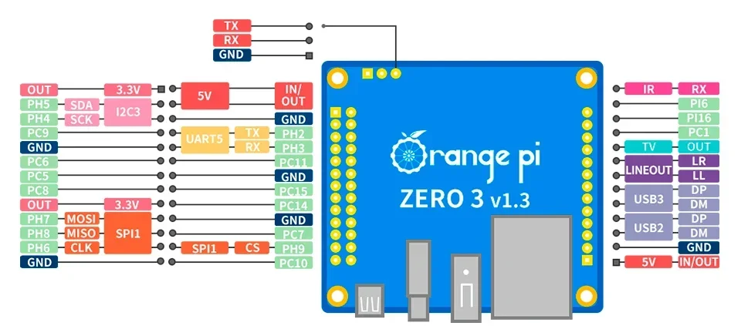

+------+-----+----------+--------+---+ H616 +---+--------+----------+-----+------+

| GPIO | wPi | Name | Mode | V | Physical | V | Mode | Name | wPi | GPIO |

+------+-----+----------+--------+---+----++----+---+--------+----------+-----+------+

| | | 3.3V | | | 1 || 2 | | | 5V | | |

| 229 | 0 | SDA.3 | ALT5 | 0 | 3 || 4 | | | 5V | | |

| 228 | 1 | SCL.3 | ALT5 | 0 | 5 || 6 | | | GND | | |

| 73 | 2 | PC9 | OUT | 0 | 7 || 8 | 0 | OFF | TXD.5 | 3 | 226 |

| | | GND | | | 9 || 10 | 0 | OFF | RXD.5 | 4 | 227 |

| 70 | 5 | PC6 | OUT | 0 | 11 || 12 | 0 | OFF | PC11 | 6 | 75 |

| 69 | 7 | PC5 | ALT5 | 0 | 13 || 14 | | | GND | | |

| 72 | 8 | PC8 | OFF | 0 | 15 || 16 | 0 | OFF | PC15 | 9 | 79 |

| | | 3.3V | | | 17 || 18 | 0 | OFF | PC14 | 10 | 78 |

| 231 | 11 | MOSI.1 | OFF | 0 | 19 || 20 | | | GND | | |

| 232 | 12 | MISO.1 | OFF | 0 | 21 || 22 | 0 | OFF | PC7 | 13 | 71 |

| 230 | 14 | SCLK.1 | OFF | 0 | 23 || 24 | 0 | OFF | CE.1 | 15 | 233 |

| | | GND | | | 25 || 26 | 0 | OFF | PC10 | 16 | 74 |

| 65 | 17 | PC1 | OFF | 0 | 27 || 28 | | | | | |

| 272 | 18 | PI16 | ALT2 | 0 | 29 || 30 | | | | | |

| 262 | 19 | PI6 | OFF | 0 | 31 || 32 | | | | | |

| 234 | 20 | PH10 | ALT3 | 0 | 33 || 34 | | | | | |

+------+-----+----------+--------+---+----++----+---+--------+----------+-----+------+

| GPIO | wPi | Name | Mode | V | Physical | V | Mode | Name | wPi | GPIO |

+------+-----+----------+--------+---+ H616 +---+--------+----------+-----+------+

Display screens

123456789012345678901

0 STATUS

1 ---------------------

2 Date 2024-07-23 23:59

3 WiFi 192.192.192.192

4 Eth 192.192.192.192

5 Temp 44ºC/92ºF

6 CPU (1 min) 1.8%

7 Firmware 1.0.0.0

123456789012345678901

0 D-IO IN OUT

1 ---------------------

2

3 1 (--) (--)

4 2 (--) (--)

5 3 (--) (--)

6 4 (--) (--)

7

123456789012345678901

0 A-IN V mA

1 ---------------------

2

3 1 0.00 0.00

4 2 0.00 0.00

5 3 0.00 0.00

6 4 0.00 0.00

7

123456789012345678901

0 Wi-Fi

1 ---------------------

2 Status

3 SSID Los De Marco

4 IP 192.192.192.192

5 Band 8153 MHz

6 RSSI -58 dBm

7

123456789012345678901

0 Ethernet

1 ---------------------

2 IP 192.192.192.192

3

4

5

6

7