CIS7 Documentation

1. Team: Gardenhead

Diego Duenas Hernandez

1. In this project I’m creating the Vigenere Cipher.

The solutions implemented in the project is the ability to successfully encrypt and decrypt a word with a key provided by the user. It has three functions one that creates the key, another that encrypt, and then one that decrypts. I was originally working on trying to get the algorithms to work through multidimensional arrays but I couldn’t figure out a way to get it working successfully. I found these functions online just to get the program working but I commented out what I was working on originally in the code.

The objective of the program is to decrypt a word inputted by the user and then display it after encryption and then decrypt it. The program first gives the user a menu to choose from options 1, 2 or 3. If the user picks 1, encryption, it’ll take the user through a series of questions asking first what word it is they are trying to encrypt, then it’ll ask them to input a key they’d like to use for encryption. After the encryption takes place the program will output the word after encryption and after decryption. Option 2 doesn’t really use the decryption algorithm but just displays the inputted word before encryption. The program is limited because there’s really no use to the word it’s just a decrypted word that’ll get erased after the user decides to quit the program.

1. **Pseudocode:**

Displays menu that asks user to choose from 3 options.

1 to encrypt a word.

2 to decrypt a word that’s already been encrypted.

Or 3 exit the program.

If 1

Ask user to input a word that they’d like the have encrypted. The input by the user will be saved in the input variable.

Ask user to input a key to use for the cipher. Input is saved in key variable.

The program calls the key_gen function and passes the variables input and key to generate the key and assigns it to the keygen string.

Then it calls the cipher function and passes the input and the keygen strings and assigns it to the encrypt string.

Displays the word after encryption.

Displays the encrypted word after decryption.

If 3

Exits the program

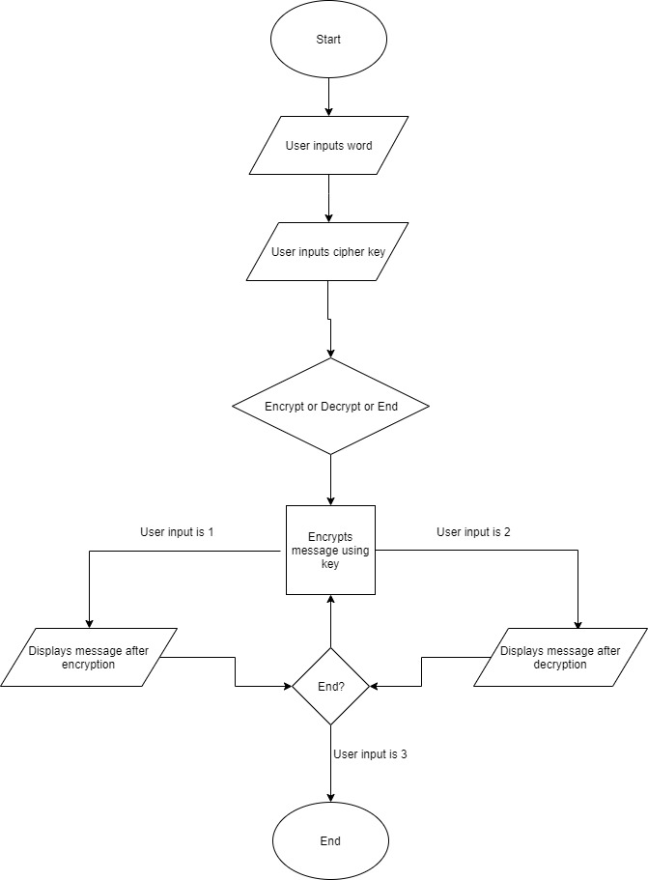**Flowchart:**