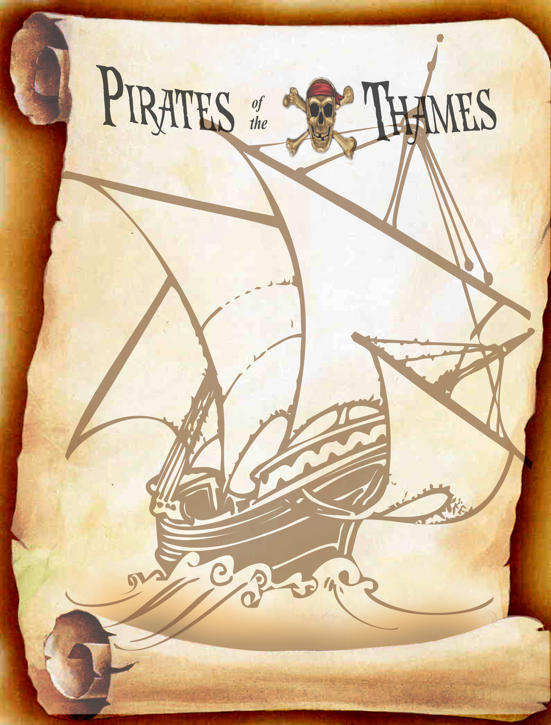

Ahoy Matey!!!
You are hereby invited to
WALK THE GANGPLANK
Captain <BIRTHDAY CHILDS NAME> will be in harbour on <DATE AND TIME OF PARTY> in search of a fresh crew and will find his way to <PARTY VENUE> to meet suitable candidates.
Bold buccaneers wishing to set sail for a London RIB Adventure should come suitably attired for an exciting journey.
Signed
Captain
RSVP

Ahoy Matey!!!
You are hereby invited to
WALK THE GANGPLANK
Captain <BIRTHDAY CHILDS NAME> will be in harbour on <DATE AND TIME OF PARTY> in search of a fresh crew and will find his way to <PARTY VENUE> to meet suitable candidates.
Bold buccaneers wishing to set sail for a London RIB Adventure should come suitably attired for an exciting journey.
Signed
Captain
RSVP

