SOC ANALYST — CYBERSECURITY PORTFOLIO
Phase 1 — Network Fundamentals
Lab 02 — HTTP Deep Dive: Headers, Redirects & HTTP Stream

File | SOC_Phase1_Lab02_HTTP_Headers_Redirects_Stream.docx
Category | Phase 1 — Network Fundamentals
Tool | Wireshark 4.4.6
Environment | Kali Linux (VirtualBox)
Date | April 2026
Difficulty | Beginner
Status | Completed

1. Objective
Perform a deep analysis of HTTP traffic using Wireshark. Apply display filters, inspect complete HTTP request and response headers, understand HTTP redirect behavior (301), identify server information disclosure, and use Follow HTTP Stream to view the full client-server conversation.

2. Background — What Happens When You Load a Web Page
Loading a single web page involves multiple HTTP exchanges. Each one reveals information about both the client and the server. This lab focuses on reading and understanding that information — the same skill used by SOC analysts to detect anomalies and attackers to identify targets.

HTTP Element | What It Reveals | Security Risk
User-Agent header | OS, browser, version of the client | Attacker identifies exploitable software versions
Server header | Web server software and version | Attacker searches CVEs for that specific version
301 Redirect | Resource has moved — new location provided | Redirect hijacking — attacker intercepts and redirects to malicious site
HTTP Stream | Full conversation in plain text | Anyone on the network can read credentials, sessions, content

3. Environment & Tools
- Operating System: Kali Linux (VirtualBox)
- Tool: Wireshark 4.4.6
- Network Interface: eth0
- Target URL: http://neverssl.com (HTTP only — no TLS encryption)

4. Lab Steps

Step 1 — New Capture on eth0
Started a fresh capture on the eth0 interface, navigated to http://neverssl.com, then stopped the capture after the page loaded.
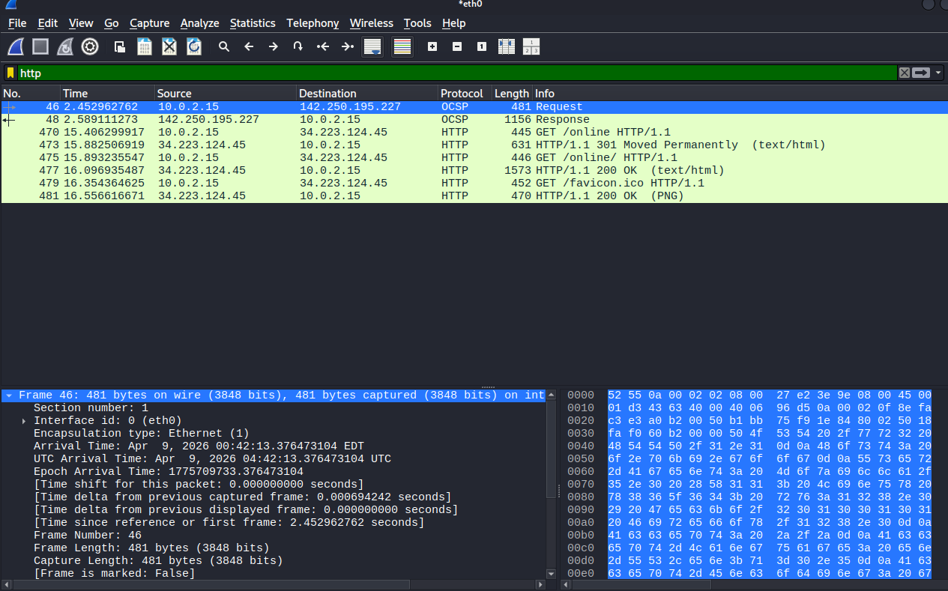
Figure 1 — HTTP traffic captured after browsing to neverssl.com

Step 2 — Analyzing the HTTP Filter Results
Applied the http display filter. The following sequence was immediately visible:
GET /online HTTP/1.1 → Kali requesting the page
HTTP/1.1 301 Moved Permanently → Server redirecting to new path
GET /online/ HTTP/1.1 → Kali following the redirect
HTTP/1.1 200 OK (text/html) → Server delivering the page
HTTP/1.1 200 OK (PNG) → Server delivering an image

Understanding 301 — Moved Permanently:
- The server replied 301 to indicate the resource had moved to a new URL
- Kali automatically followed the redirect and sent a second GET request
- This entire exchange happened in plain text — fully visible to anyone on the network

⚠ Security Risk — Redirect Hijacking
A 301 redirect over HTTP can be intercepted by an attacker on the same network. They can modify the Location header to redirect the user to a malicious site instead of the real destination — without the user noticing.

Step 3 — Inspecting Request Headers
Clicked on the GET /online/ HTTP/1.1 packet and expanded the Hypertext Transfer Protocol section to view the full request headers:
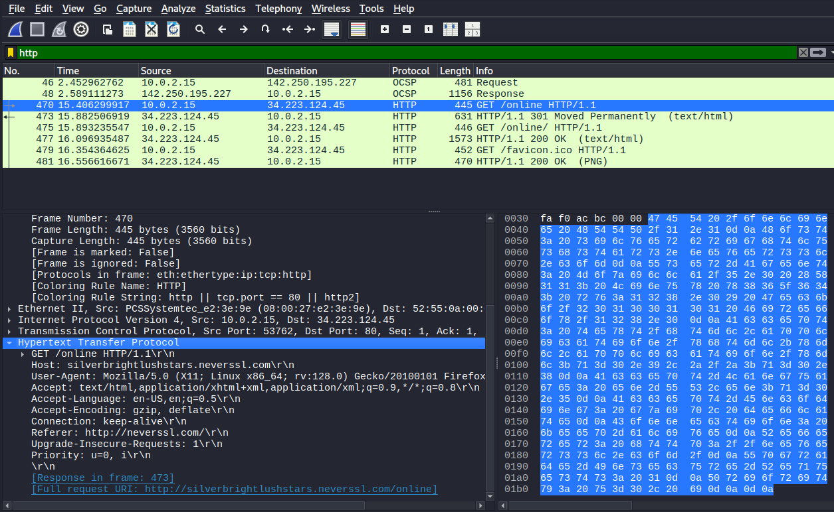
Figure 2 — Full HTTP request headers expanded in Wireshark

Header | Value Captured | Security Implication
Host | silverbrightlushstars.neverssl.com | Destination server — visible in plain text
User-Agent | Mozilla/5.0 (X11; Linux x86_64) Firefox/128.0 | Reveals OS (Kali Linux), architecture (64-bit), browser version
Accept-Language | en-US | Reveals user locale/region
Connection | keep-alive | Connection reuse — multiple requests in one TCP session
Referer | http://neverssl.com/ | Reveals navigation path — where user came from

⚠ Security Risk — User-Agent Disclosure
The User-Agent header reveals the exact OS and browser version in plain text. On a public WiFi network, any attacker running Wireshark can read this and look up specific exploits for that OS/browser combination without any interaction with the target.

Step 4 — Inspecting Response Headers
Clicked on the HTTP/1.1 200 OK packet and expanded the response headers:
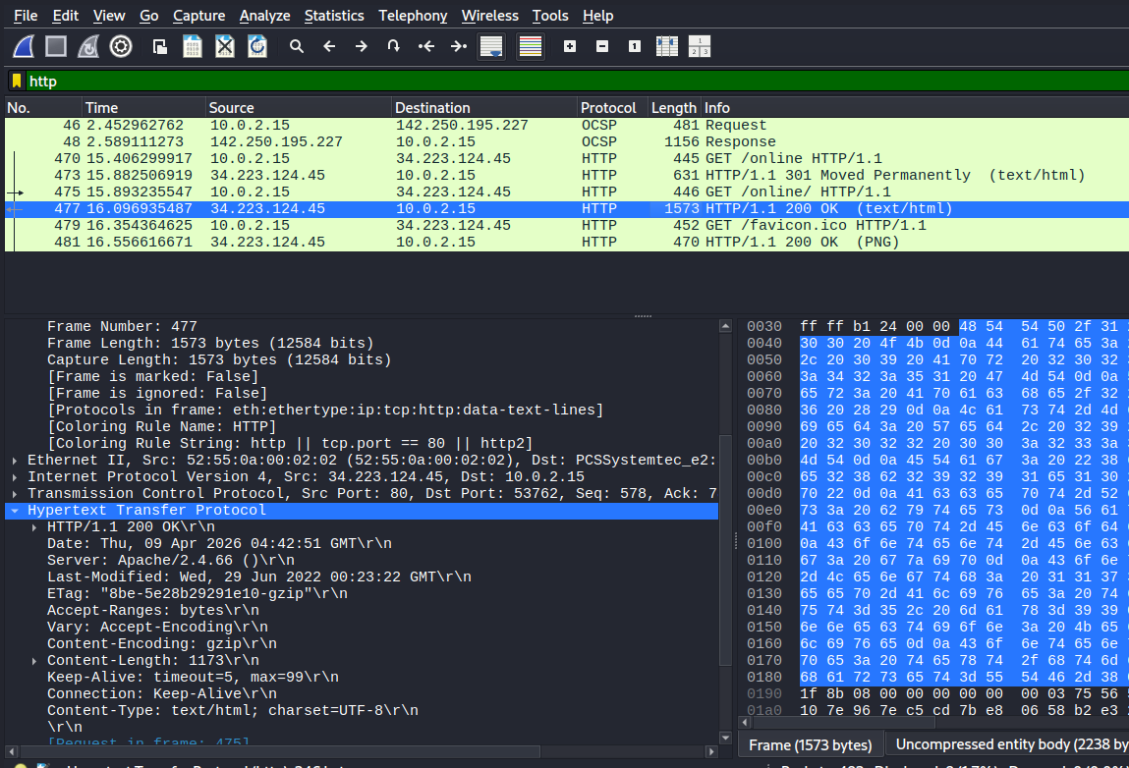
Figure 3 — Full HTTP response headers showing server information

Header | Value Captured | Security Implication
Server | Apache/2.4.66 | Reveals exact web server software and version
Date | Thu, 09 Apr 2026 | Server timestamp — confirms server is live
Last-Modified | Wed, 29 Jun 2022 | Reveals when content was last updated
Content-Type | text/html; charset=UTF-8 | Content format confirmed
Keep-Alive | timeout=5, max=99 | Connection persistence settings

⚠ Critical Finding — Server Version Disclosure
The Server header exposes Apache/2.4.66. An attacker uses this to search CVE databases for known vulnerabilities affecting that version. Fix: add ServerTokens Prod and ServerSignature Off to the Apache configuration to hide this header.

Step 5 — Follow HTTP Stream
Right-clicked on the GET /online/ packet and selected Analyze → Follow → HTTP Stream to view the complete client-server conversation in one window:
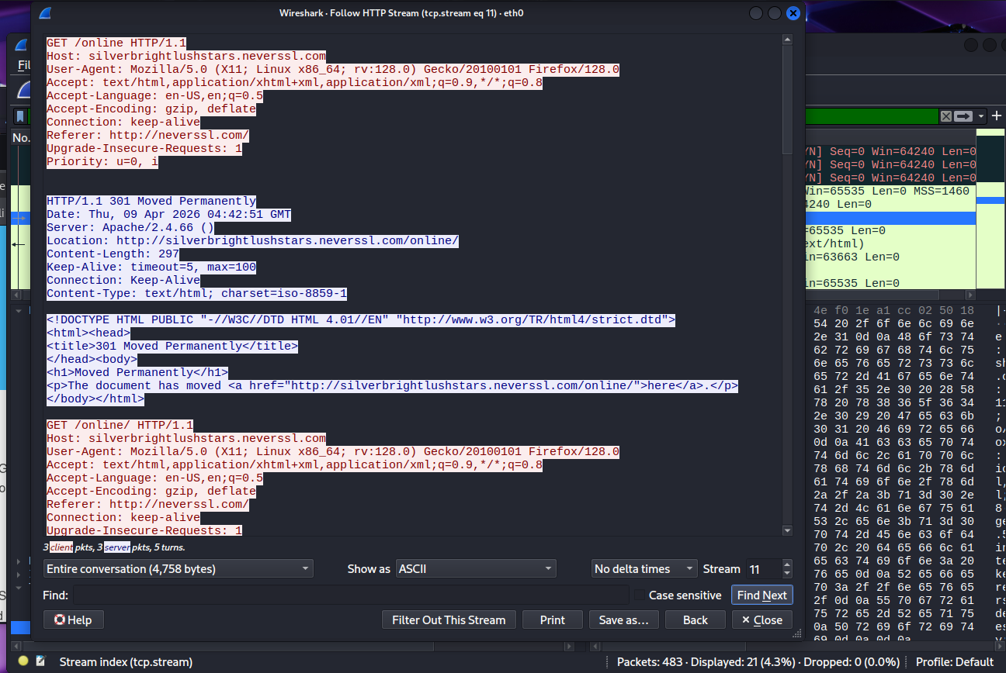
Figure 4 — HTTP Stream showing full conversation (red = client, blue = server)

The stream showed the complete exchange in sequence:
RED → GET /online HTTP/1.1 + all request headers (Kali → Server)
BLUE → HTTP/1.1 301 + Location header (Server → Kali)
RED → GET /online/ HTTP/1.1 (Kali follows redirect)
BLUE → HTTP/1.1 200 OK + full HTML page content (Server → Kali)

Everything — headers, content, redirect path — was visible in plain text. This is what any attacker on the same network would see with zero effort.

5. Findings
Finding 01: HTTP 301 Redirect Observed
The server responded with a 301 redirect before delivering the page. The full redirect chain (GET → 301 → GET → 200) was visible in plain text. This redirect is vulnerable to interception and hijacking on unsecured networks.

Finding 02: Client OS and Browser Disclosed via User-Agent
The User-Agent header revealed: OS = Linux (Kali), Architecture = x86_64, Browser = Firefox 128.0. This information was transmitted in plain text and is immediately visible to any attacker on the same network running Wireshark.

Finding 03: Server Version Disclosed via Server Header
The response header Server: Apache/2.4.66 was visible in plain text. Versions prior to 2.4.66 were affected by CVE-2025-58098 (SSI injection), CVE-2025-59775 (SSRF/NTLM leak), and CVE-2025-66200 (CGI bypass). Mitigation: ServerTokens Prod + ServerSignature Off.

Finding 04: Full HTTP Stream Readable in Plain Text
Using Follow HTTP Stream, the entire client-server conversation was readable in one view — including all headers, redirect paths, and page content. On HTTP (no TLS), there is no encryption — credentials, session tokens, or any data sent over this connection would be fully exposed.

6. Key Concepts Learned
Concept | Definition | Attack to Know
HTTP 301 | Permanent redirect — server tells client to go to new URL | Redirect Hijacking
Request Headers | Metadata sent by client: User-Agent, Host, Referer, etc. | OS/browser fingerprinting
Response Headers | Metadata sent by server: Server version, Content-Type, etc. | Server version disclosure → CVE lookup
HTTP Stream | Full plain-text conversation between client and server | Credential sniffing, session hijacking
ServerTokens Prod | Apache config to hide server version from response headers | Mitigation for version disclosure

7. Commands & Filters Reference
Command / Filter | Purpose
http | Show only HTTP traffic
Analyze → Follow → HTTP Stream | View full client-server HTTP conversation
http.request.method == GET | Show only GET requests
http.response.code == 301 | Show only 301 redirects
http.response.code == 200 | Show only successful responses
http.server | Filter by server header value

8. Conclusion
This lab demonstrated how much information is exposed in a standard HTTP exchange. By applying Wireshark filters and reading headers, the following was confirmed:
- HTTP redirects (301) expose the full navigation path and are vulnerable to hijacking
- Request headers reveal the client OS, browser, and version — enabling targeted attacks
- Response headers reveal the server software and version — enabling CVE-based attacks
- HTTP Stream shows the entire conversation in plain text — zero effort required for an attacker on the same network

From a SOC perspective, these are the exact indicators analysts look for when investigating suspicious HTTP traffic. From a defensive perspective, hiding server headers and enforcing HTTPS eliminates most of this exposure.

GitHub Repository Naming Convention
soc-portfolio/
phase1-network-fundamentals/
lab01-wireshark-traffic-analysis/
lab02-http-headers-redirects-stream/
SOC_Phase1_Lab02_HTTP_Headers_Redirects_Stream.docx
screenshots/

