SOC ANALYST — CYBERSECURITY PORTFOLIO
Phase 1 — Network Fundamentals
Lab 01 — Network Traffic Analysis with Wireshark

File | SOC_Phase1_Lab01_Wireshark_Traffic_Analysis.docx
Category | Phase 1 — Network Fundamentals
Tool | Wireshark 4.4.6
Environment | Kali Linux (VirtualBox)
Date | April 2026
Difficulty | Beginner
Status | Completed

1. Objective
Capture and analyze live network traffic generated from Kali Linux using Wireshark. Identify and understand three core protocol types: DNS, HTTP, and TCP — and observe how they work together every time a browser loads a web page.

2. Background — Why This Matters for SOC
Every time a device accesses a website, three things happen in sequence:

Step | Protocol | What Happens | SOC Relevance
1 | DNS | Device asks: What is the IP of neverssl.com? | DNS Poisoning — attacker redirects to malicious IP
2 | TCP | Three-way handshake establishes the connection | SYN Flood — attacker crashes server with fake SYNs
3 | HTTP | Browser requests the page, server sends it back | MITM / Sniffing — credentials visible in plain text

Understanding this flow is foundational for a SOC Analyst. Most network-based attacks exploit one of these three layers.

3. Environment & Tools
- Operating System: Kali Linux (VirtualBox)
- Tool: Wireshark 4.4.6
- Network Interface: eth0
- Target URL: http://neverssl.com (HTTP only — no TLS, ideal for learning)

4. Lab Steps

Step 1 — Verify Wireshark Installation
Opened a terminal in Kali Linux and confirmed Wireshark was installed:
wireshark --version
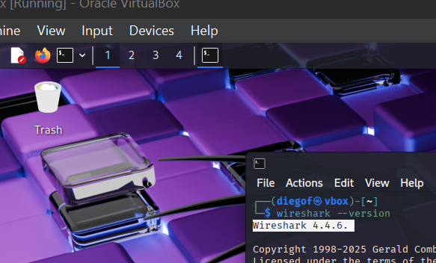
Figure 1 — Wireshark version confirmation in terminal

Step 2 — Launch Wireshark
Launched Wireshark with root privileges to allow interface capture:
sudo wireshark
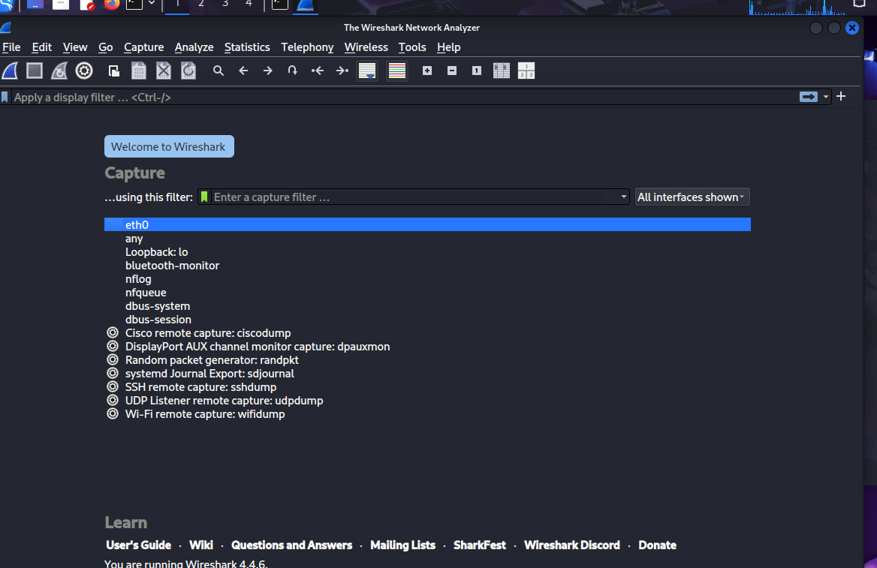
Figure 2 — Wireshark main interface with network interfaces listed

Step 3 — Start Capture on eth0
Selected the eth0 interface (active network adapter) and double-clicked to start the capture. Then navigated to http://neverssl.com in the browser to generate HTTP traffic.
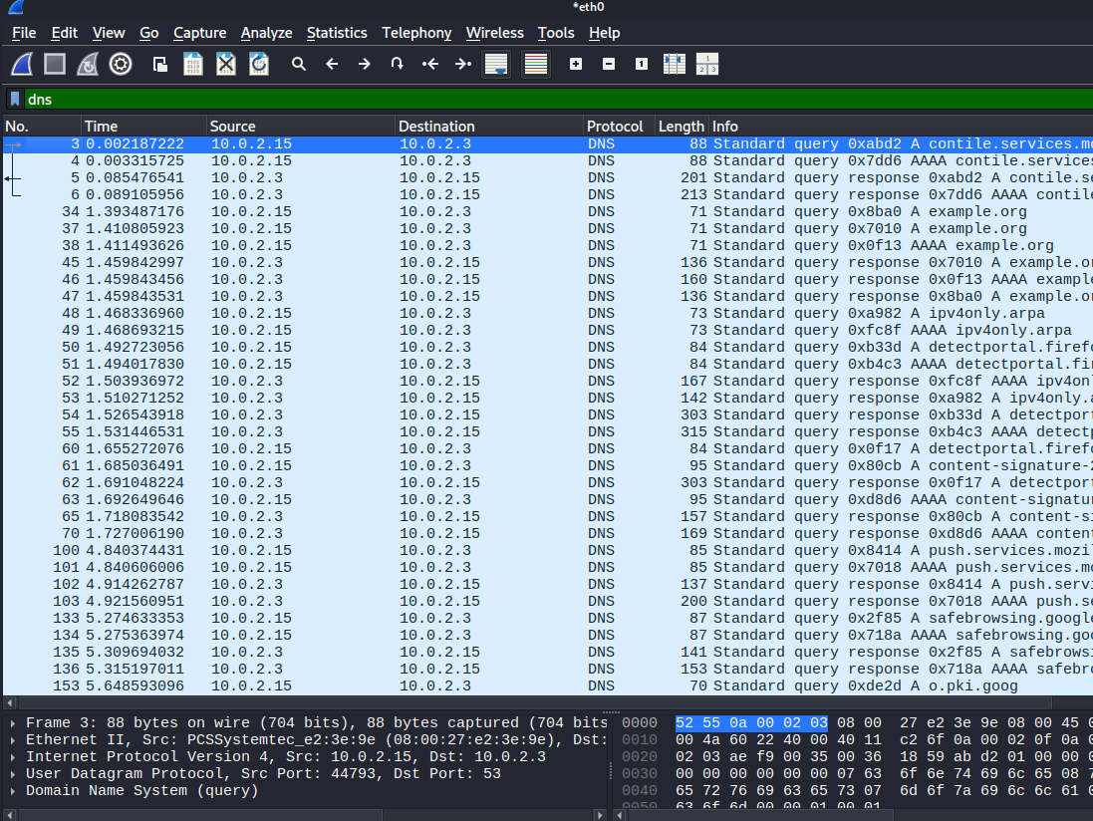
Figure 3 — Live packet capture on eth0 interface

Step 4 — Filter by DNS
Stopped the capture and applied the DNS display filter to isolate name resolution traffic:
dns
Located the two key packets related to neverssl.com:
- Standard query — Kali asking: Where is neverssl.com?
- Standard query response — DNS server answering with IP 34.223.124.x
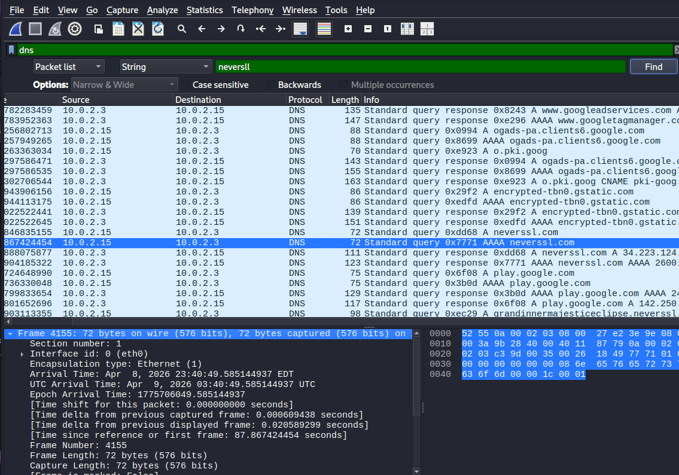
Figure 4 — DNS query and response for neverssl.com

Step 5 — Filter by HTTP
Applied the HTTP display filter to observe the web request:
http
- GET / HTTP/1.1 — Kali requesting the page from 34.223.124.45
- HTTP/1.1 200 OK — Server confirming and sending the HTML content
Note: The destination IP 34.223.124.45 matches exactly the IP returned by DNS in Step 4 — confirming the full DNS → HTTP chain.
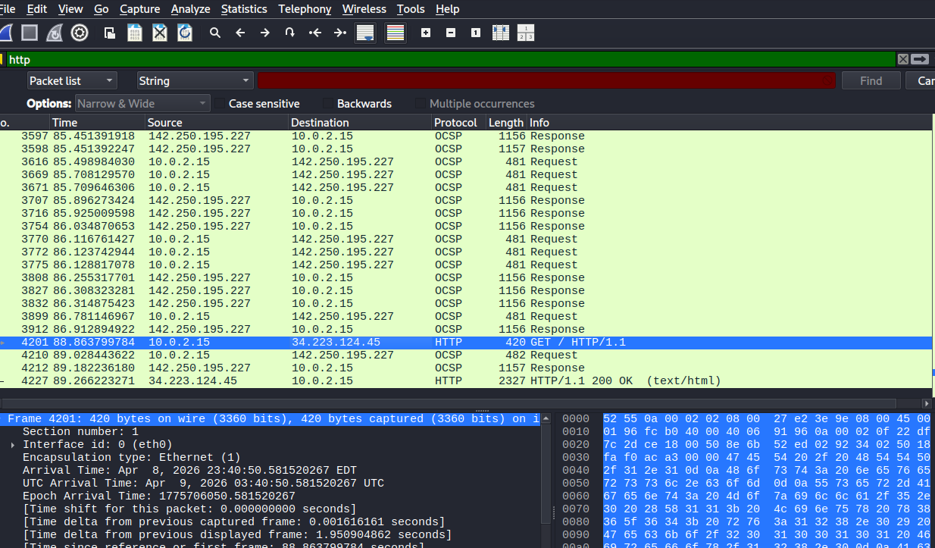
Figure 5 — HTTP GET request and 200 OK response

Step 6 — Filter by TCP
Applied the TCP display filter to observe the connection layer:
tcp
- SYN — Kali initiating the connection
- SYN, ACK — Server acknowledging
- ACK — Kali confirming — handshake complete
- [TCP Retransmission] — A packet was lost; TCP automatically resent it
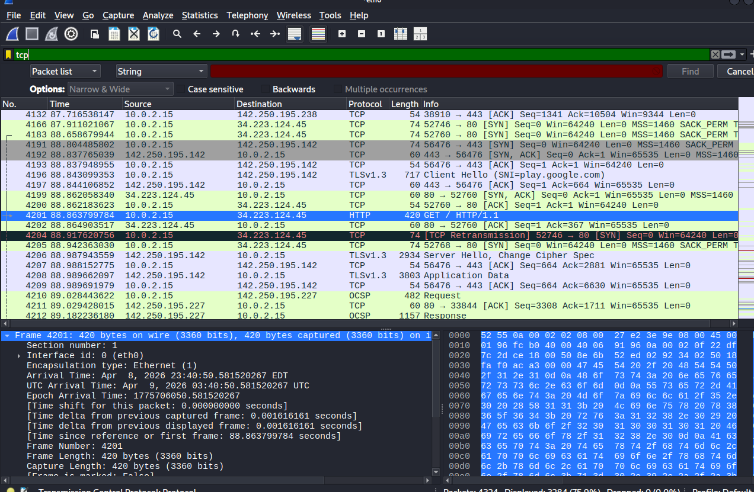
Figure 6 — TCP three-way handshake and retransmission

5. Findings
Finding 01: DNS Resolution Captured
Wireshark captured the complete DNS query/response cycle for neverssl.com. The device sent a query to 10.0.2.3 (DNS server) and received IP 34.223.124.45 in response.

Finding 02: HTTP Traffic Visible in Plain Text
Because neverssl.com uses HTTP (not HTTPS), the full GET request and 200 OK response were readable in Wireshark. In a real attack scenario, credentials or session data sent over HTTP could be intercepted.

Finding 03: TCP Three-Way Handshake Observed
The SYN → SYN-ACK → ACK sequence was clearly visible before the HTTP request. A TCP Retransmission was also observed, demonstrating TCP's built-in reliability mechanism.

Finding 04: DNS-to-HTTP IP Correlation Confirmed
The IP returned by DNS (34.223.124.45) was the exact same destination used in the HTTP GET request — confirming that DNS resolution is always the first step before any web connection.

6. Key Concepts Learned
Concept | Definition | Attack to Know
DNS | Translates domain names to IP addresses | DNS Poisoning — fake IP response
HTTP | Plain-text web protocol — readable by anyone on the network | MITM / Credential sniffing
HTTPS | Encrypted HTTP using TLS — neverssl.com does NOT use this | SSL Stripping
TCP Handshake | SYN → SYN-ACK → ACK — establishes reliable connection | SYN Flood (DoS attack)
TCP Retransmission | Lost packet automatically resent — TCP guarantees delivery | N/A — reliability feature

7. Commands Reference
Command / Filter | Purpose
wireshark --version | Verify Wireshark is installed and check version
sudo wireshark | Launch Wireshark with capture permissions
dns | Wireshark filter — show only DNS traffic
http | Wireshark filter — show only HTTP traffic
tcp | Wireshark filter — show only TCP traffic

8. Conclusion
This lab demonstrated the complete network flow that occurs every time a device accesses a website. Using Wireshark on Kali Linux, the following was confirmed:
- DNS is always the first step — it resolves the domain to an IP before any connection is made
- TCP establishes the reliable connection before any data is transferred
- HTTP sends the actual request and response — in plain text, making it vulnerable to interception
- All three protocols are visible in real-time to anyone with access to the network — reinforcing why HTTPS is mandatory in production environments

From a SOC perspective, this exercise builds the foundation for understanding DNS poisoning, MITM attacks, SYN floods, and basic packet analysis — all skills used daily in Tier 1 SOC operations.

GitHub Repository Naming Convention
soc-portfolio/
phase1-network-fundamentals/
lab01-wireshark-traffic-analysis/
SOC_Phase1_Lab01_Wireshark_Traffic_Analysis.docx
screenshots/
phase2-...

This naming structure allows recruiters and hiring managers to navigate your portfolio clearly and understand your progression through each phase.

