https://code.claude.com/docs/en/overview
APP NAME: MOVES
SUBTITLE: ›
DESCRIPTION: Accessible chess for blind players
PITCH: "The greatest strategic minds don't need to see the board"

https://github.com/jaredcassoutt/chess_swiftui/blob/main/Chess/OpponentChessEngine.swift

al dar jaque mate ganar o perder o tablas poner otro tipo de menu mas bonito de que felicidades o no se

Moves.swiftpm/
├── Package.swift ✅ (Hoy)
├── Sources/
│ ├── MovesApp.swift ✅ (Hoy)
│ ├── Models/
│ │ ├── ChessGame.swift (Mañana)
│ │ └── Position.swift (Mañana)
│ ├── Views/
│ │ ├── WelcomeView.swift (Miércoles)
│ │ └── GameplayView.swift (Miércoles)
│ └── Services/
│ ├── AudioService.swift (Viernes)
│ └── HapticService.swift (Próxima semana)

INSPO DISEÑO: https://dribbble.com/shots/15912179-3D-Chess-Pieces

https://dribbble.com/tags
/chess-app
https://www.behance.net/gallery/175144257/Chess-UX-UI?tracking_source=search_projects%7Cchess+app+mobile+ux&l=3

https://www.behance.net/gallery/166245419/Chess-Mobile-App?tracking_source=search_projects%7Cchess+app+mobile+ux&l=6

https://dribbble.com/shots/20617958-Chess-Mobile-App

https://dribbble.com/shots/13984300-Chess-Game-Mobile-App-UI-UX-Design-and-Animation

https://dribbble.com/shots/26755958-Chess-Platform

LOGO: https://stock.adobe.com/es/images/games-icon-with-chess-pieces-on-isolated-white-background-3d-illustration-app/444348478?as_channel=adobe_com&as_campclass=brand&as_campaign=srp-raill&as_source=behance_net&as_camptype=acquisition&as_audience=users&as_content=thumbnail-click&promoid=J7XBWPPS&mv=other

Hear the Game. Master the Mind.
Hear the Game. Master the Mind.
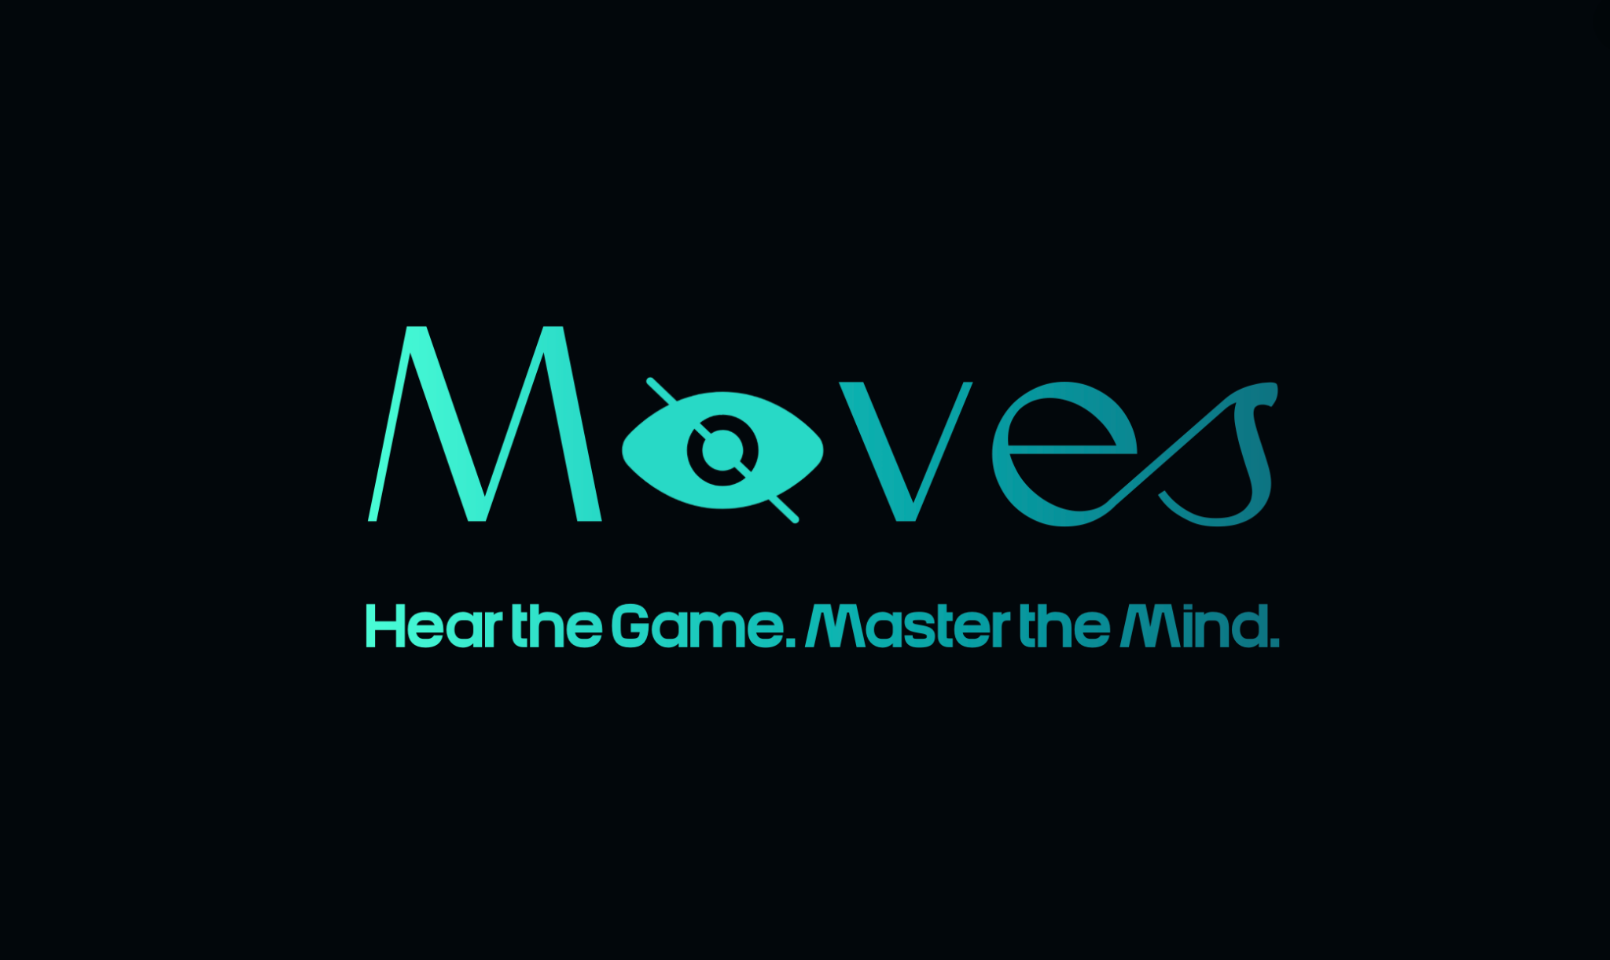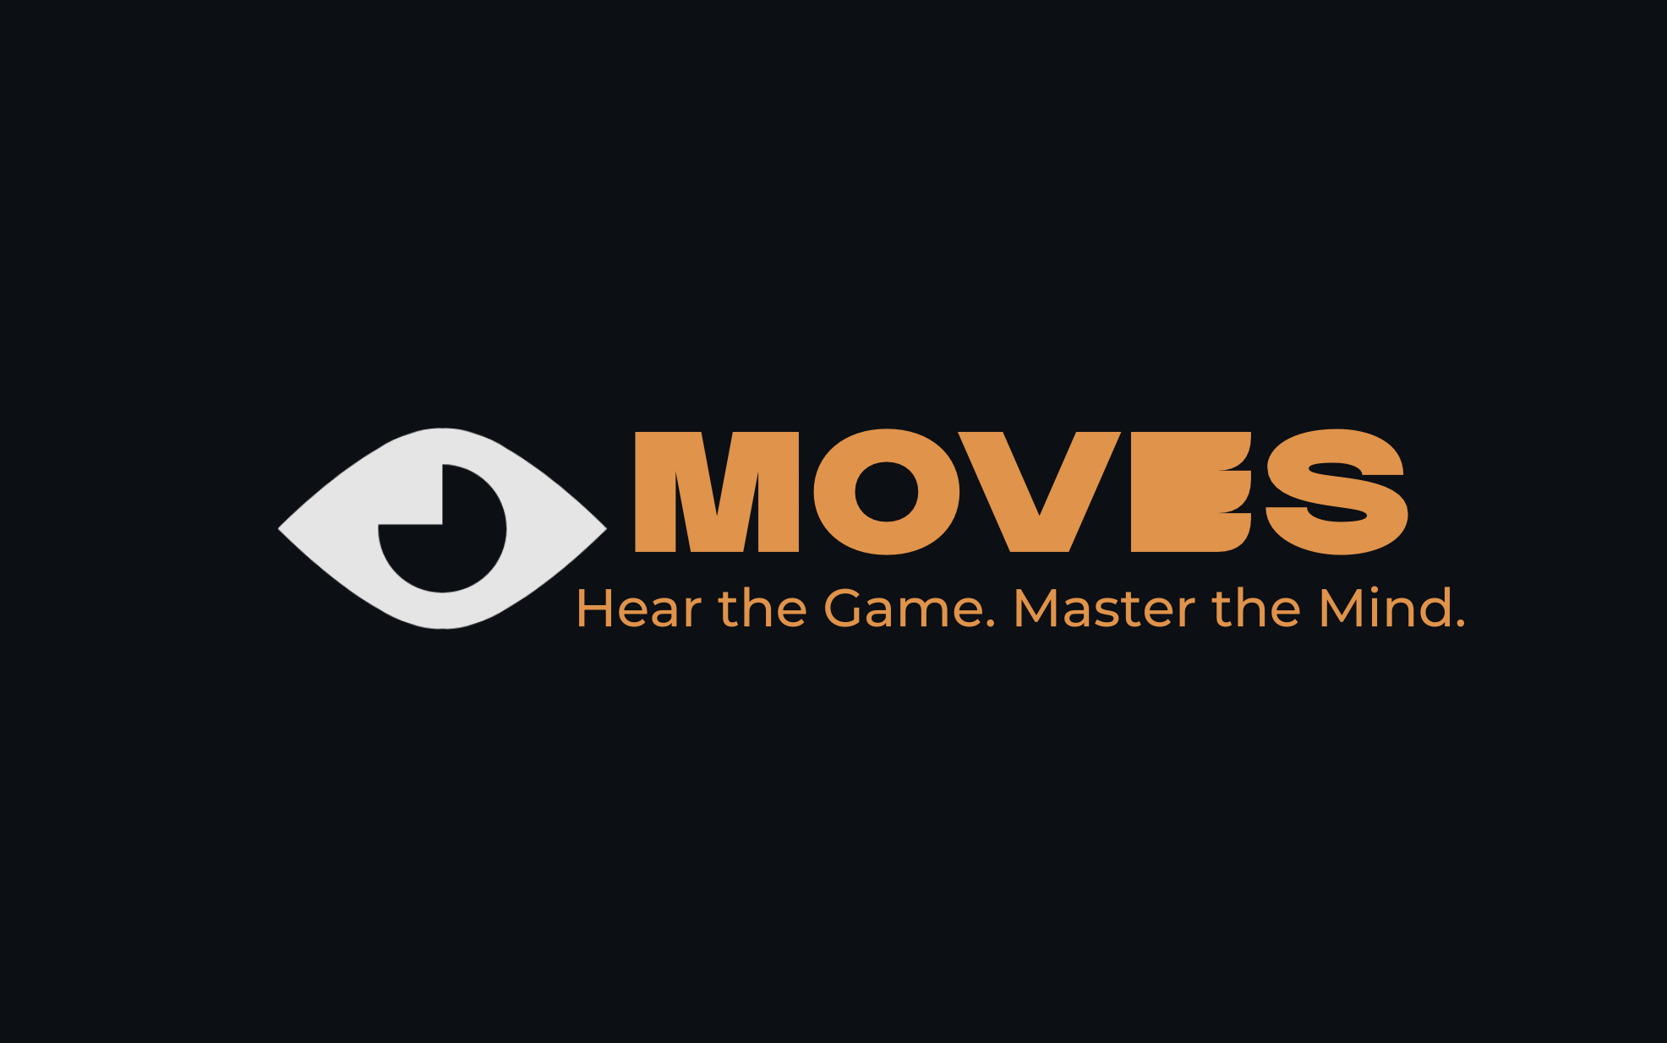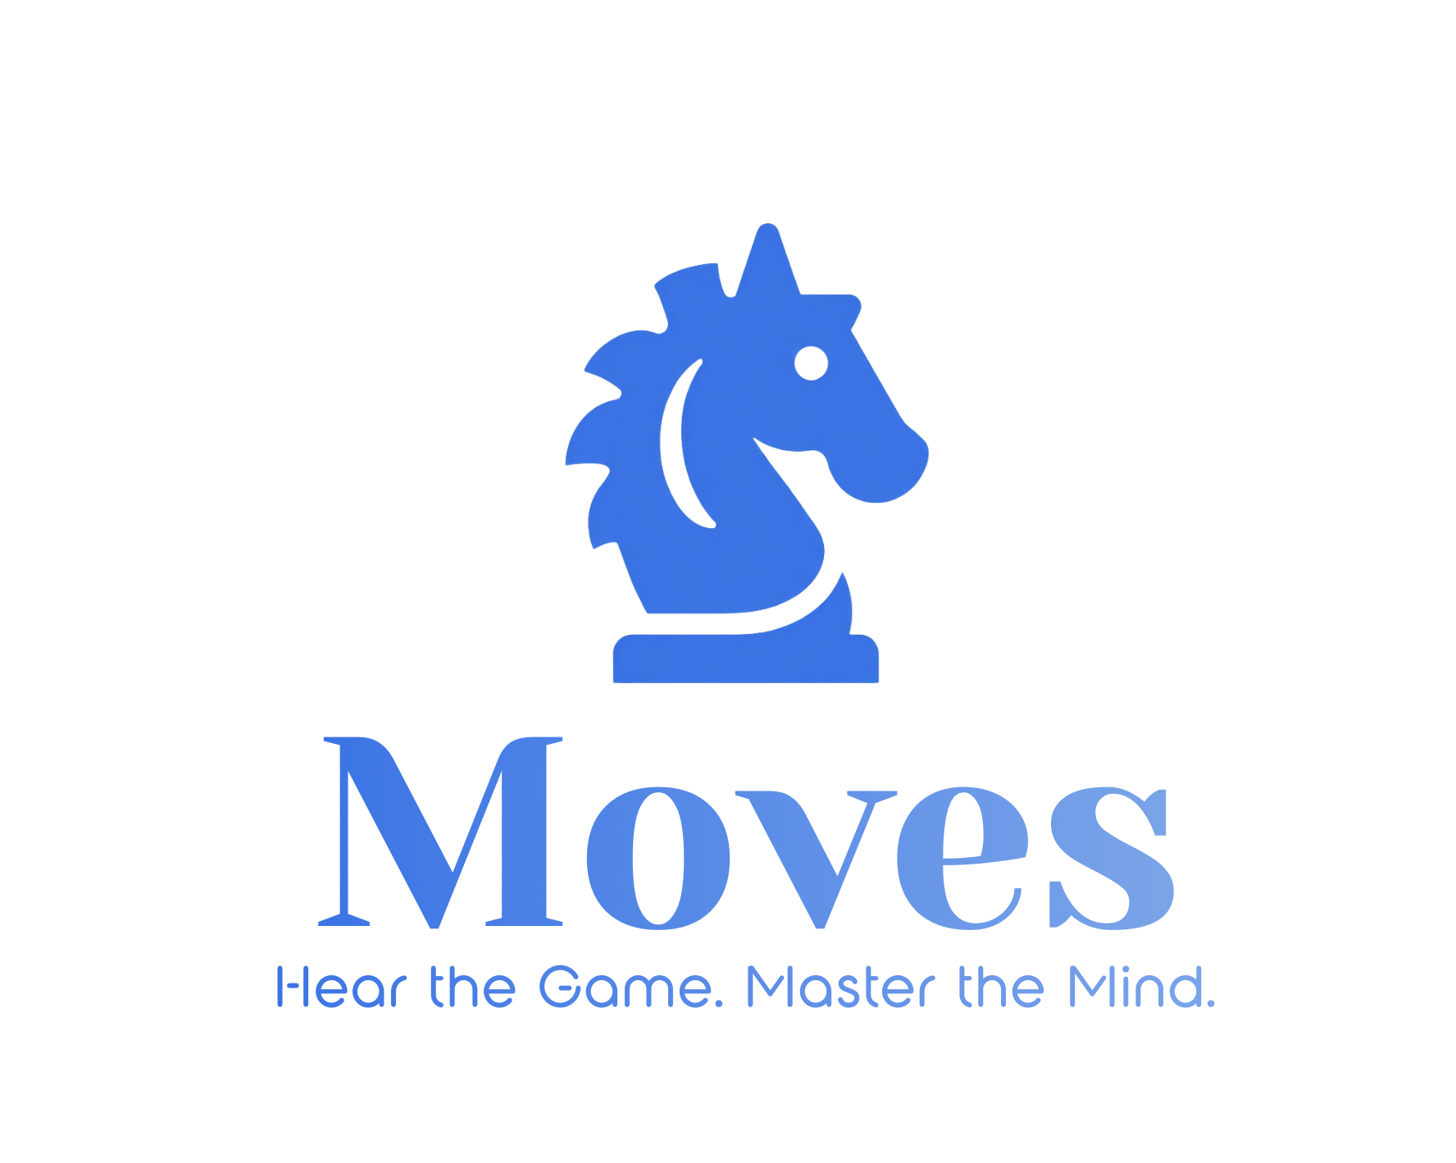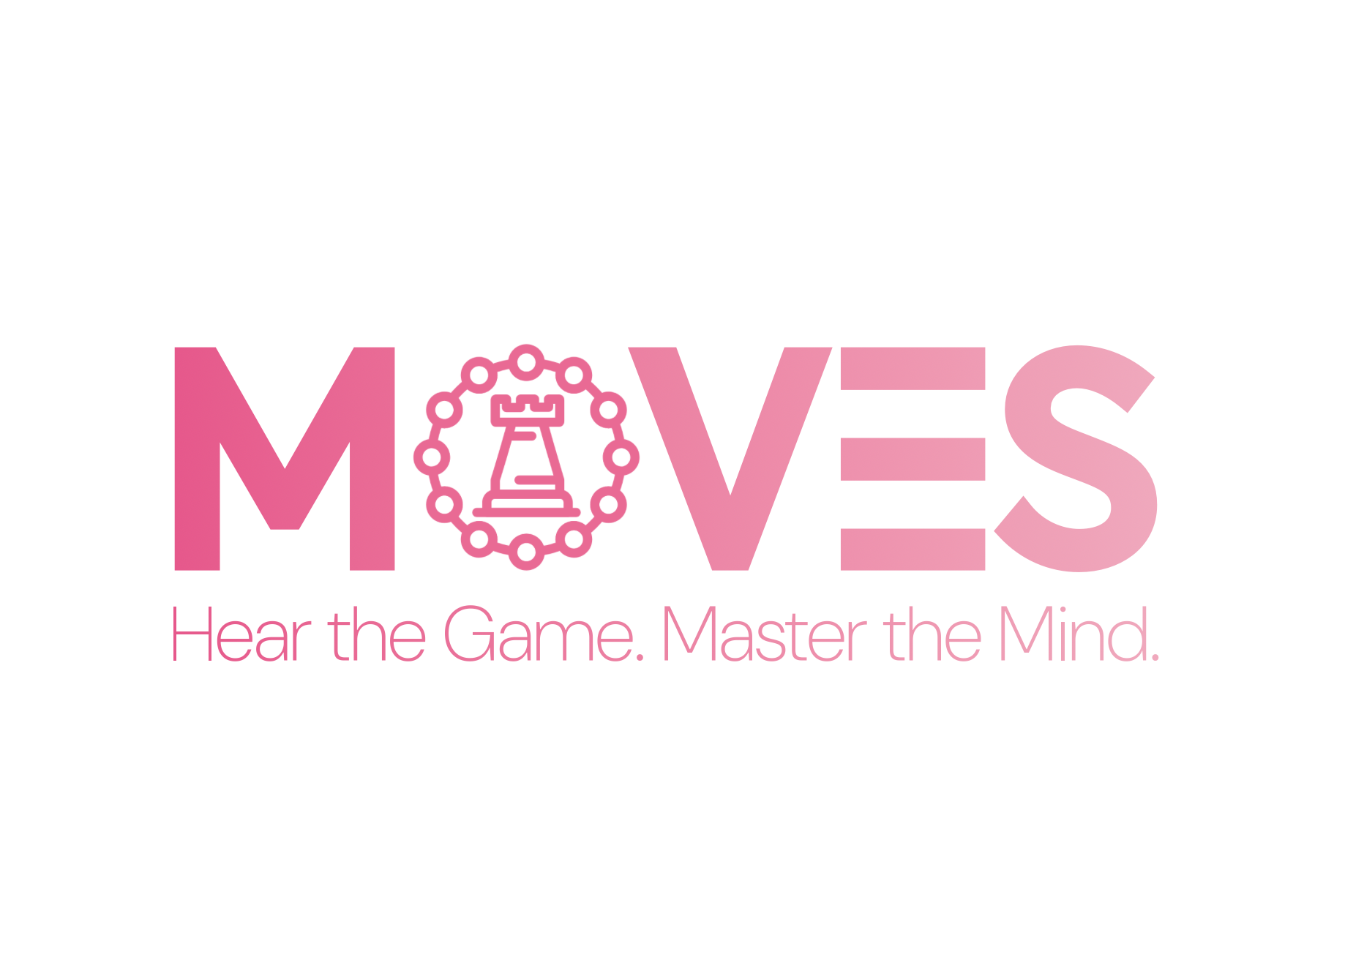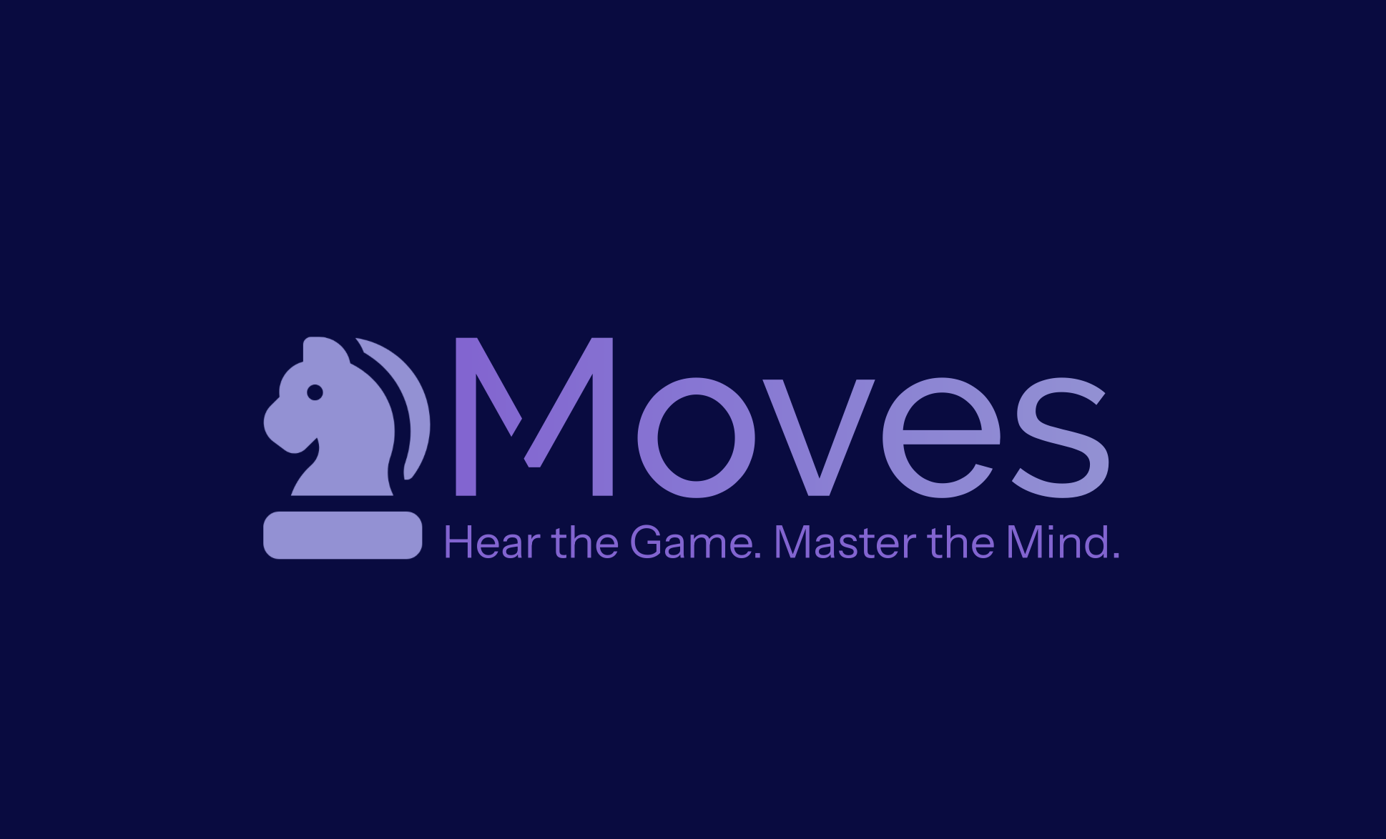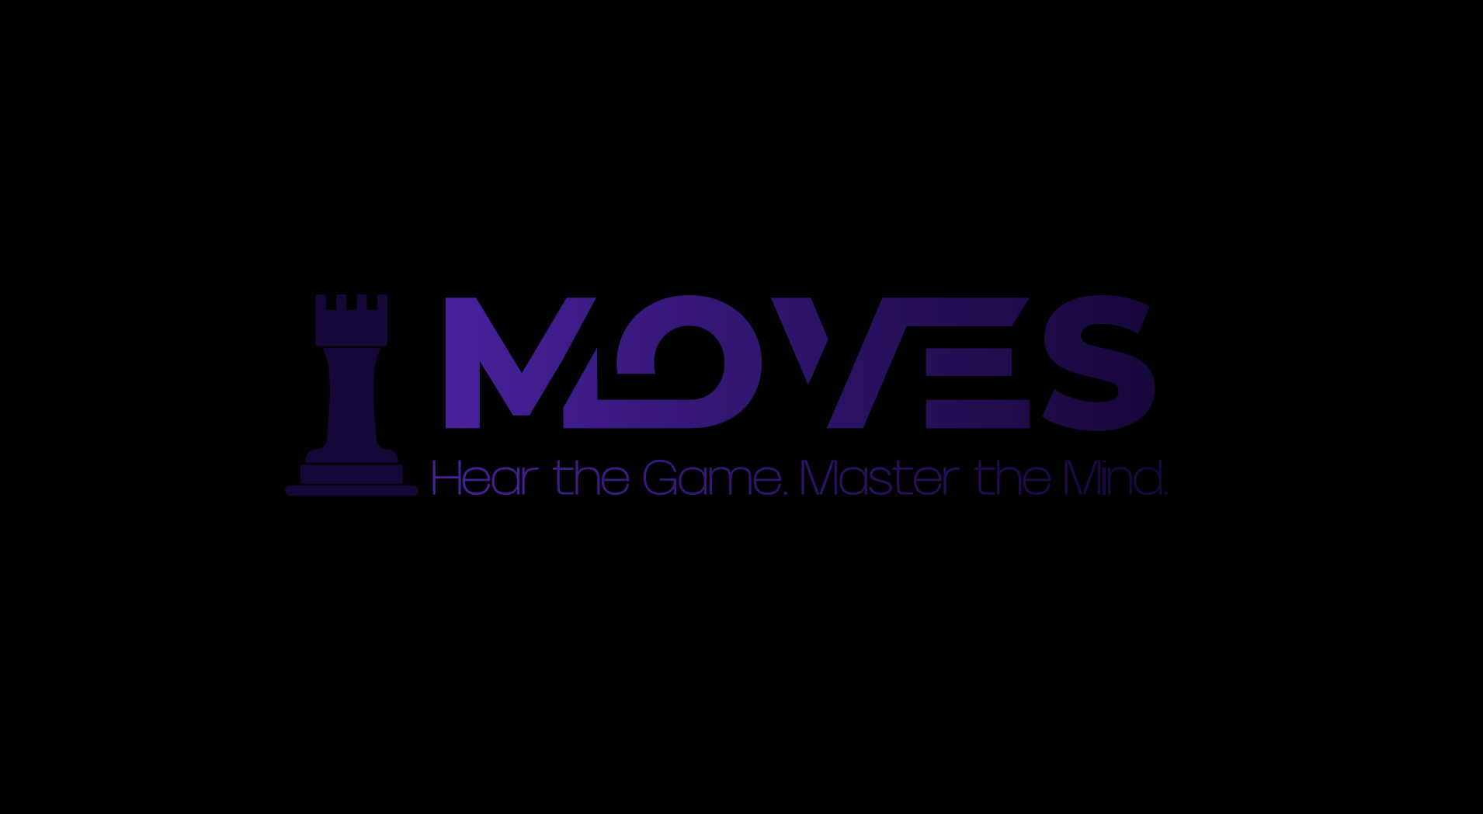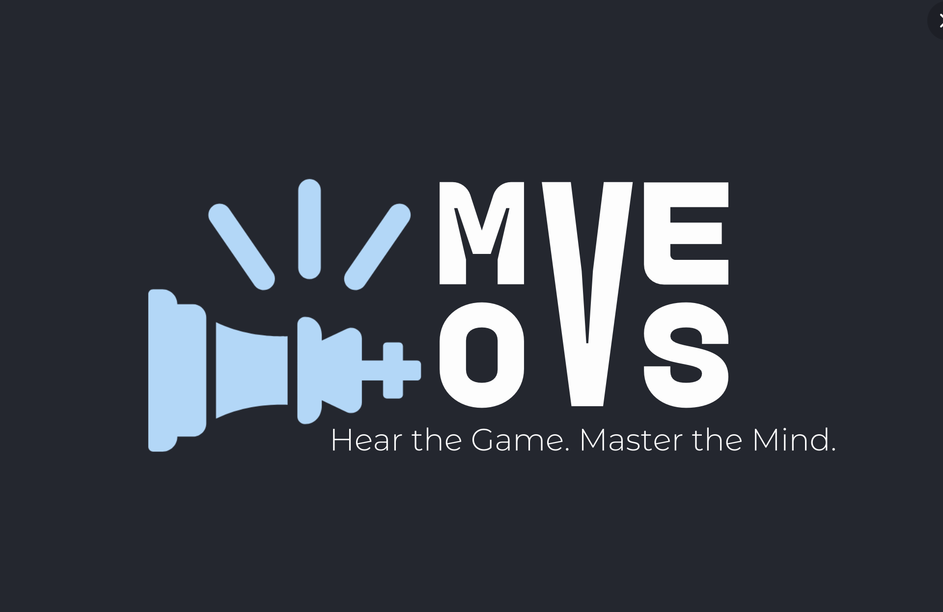

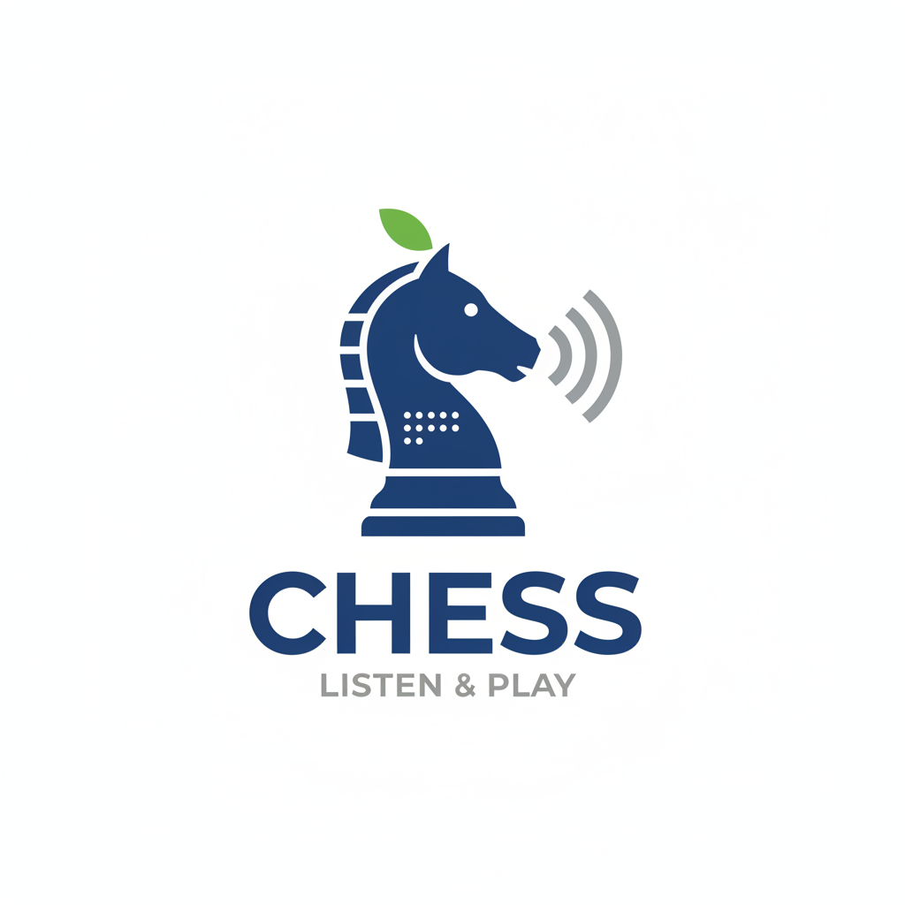
the

import AVFoundation
import Combine

enum RecordingState: String, Sendable {
case idle
case recording
case playing
}

@MainActor
final class AudioRecorder: ObservableObject {
static let shared = AudioRecorder()

// MARK: - Published State

@Published var state: RecordingState = .idle
@Published var currentTime: TimeInterval = 0
@Published var duration: TimeInterval = 0
@Published var hasRecording: Bool = false

// Permission state
@Published var hasMicrophonePermission: Bool = false
@Published var permissionDenied: Bool = false

// MARK: - Private

private var audioRecorder: AVAudioRecorder?
private var audioPlayer: AVAudioPlayer?
private var updateTimer: Timer?

private var recordingURL: URL {
let dir = FileManager.default.temporaryDirectory
return dir.appendingPathComponent("SonicLab_TapeRecording.m4a")
}

// MARK: - Init

private init() {
checkMicrophonePermission()
}

// MARK: - Permission Handling

func checkMicrophonePermission() {
switch AVAudioApplication.shared.recordPermission {
case .granted:
hasMicrophonePermission = true
permissionDenied = false
case .denied:
hasMicrophonePermission = false
permissionDenied = true
case .undetermined:
hasMicrophonePermission = false
permissionDenied = false
@unknown default:
hasMicrophonePermission = false
}
}

func requestMicrophonePermission() async -> Bool {
let granted = await AVAudioApplication.requestRecordPermission()
await MainActor.run {
hasMicrophonePermission = granted
permissionDenied = !granted
}
return granted
}

// MARK: - Audio Session

private func configureSessionForRecording() -> Bool {
let session = AVAudioSession.sharedInstance()
do {
try session.setCategory(.playAndRecord, mode: .default, options: [.defaultToSpeaker])
try session.setActive(true)
return true
} catch {
print("[AudioRecorder] Session config error: \(error)")
return false
}
}

private func configureSessionForPlayback() -> Bool {
let session = AVAudioSession.sharedInstance()
do {
try session.setCategory(.playback, mode: .default)
try session.setActive(true)
return true
} catch {
print("[AudioRecorder] Session config error: \(error)")
return false
}
}

// MARK: - Recording

func startRecording() {
guard hasMicrophonePermission else {
Task {
let granted = await requestMicrophonePermission()
if granted {
self.startRecording()
}
}
return
}

// Stop anything currently running
stopEverything()

guard configureSessionForRecording() else { return }

let settings: [String: Any] = [
AVFormatIDKey: kAudioFormatMPEG4AAC,
AVSampleRateKey: 44100.0,
AVNumberOfChannelsKey: 1,
AVEncoderAudioQualityKey: AVAudioQuality.high.rawValue
]

do {
audioRecorder = try AVAudioRecorder(url: recordingURL, settings: settings)
audioRecorder?.record()
state = .recording
currentTime = 0
duration = 0
startUpdateTimer()
} catch {
print("[AudioRecorder] Failed to start recording: \(error)")
}
}

func stopRecording() {
guard state == .recording else { return }

audioRecorder?.stop()

duration = audioRecorder?.currentTime ?? 0
currentTime = 0
audioRecorder = nil

hasRecording = FileManager.default.fileExists(atPath: recordingURL.path)
stopUpdateTimer()
state = .idle
}

// MARK: - Playback

func startPlayback() {
guard hasRecording, state != .recording else { return }

// Stop any current playback first
if state == .playing {
stopPlayback()
}

guard configureSessionForPlayback() else { return }

do {
audioPlayer = try AVAudioPlayer(contentsOf: recordingURL)
audioPlayer?.delegate = PlaybackDelegate.shared
PlaybackDelegate.shared.onFinish = { [weak self] in
Task { @MainActor in
self?.playbackDidFinish()
}
}
audioPlayer?.play()
state = .playing
startUpdateTimer()
} catch {
print("[AudioRecorder] Failed to start playback: \(error)")
}
}

func stopPlayback() {
audioPlayer?.stop()
audioPlayer = nil
stopUpdateTimer()
currentTime = 0
state = .idle
}

private func playbackDidFinish() {
audioPlayer = nil
stopUpdateTimer()
currentTime = 0
state = .idle
}

// MARK: - Stop All

func stopEverything() {
if state == .recording {
audioRecorder?.stop()
audioRecorder = nil
}
if state == .playing {
audioPlayer?.stop()
audioPlayer = nil
}
stopUpdateTimer()
currentTime = 0
state = .idle
}

// MARK: - Clear

func clearRecording() {
stopEverything()
try? FileManager.default.removeItem(at: recordingURL)
hasRecording = false
duration = 0
currentTime = 0
}

// MARK: - Timer

private func startUpdateTimer() {
stopUpdateTimer()
updateTimer = Timer.scheduledTimer(withTimeInterval: 0.1, repeats: true) { [weak self] _ in
Task { @MainActor in
self?.updateTime()
}
}
}

private func stopUpdateTimer() {
updateTimer?.invalidate()
updateTimer = nil
}

private func updateTime() {
switch state {
case .recording:
currentTime = audioRecorder?.currentTime ?? 0
duration = currentTime
case .playing:
currentTime = audioPlayer?.currentTime ?? 0
case .idle:
stopUpdateTimer()
}
}

// MARK: - Formatting

var formattedCurrentTime: String { formatTime(currentTime) }
var formattedDuration: String { formatTime(duration) }

private func formatTime(_ time: TimeInterval) -> String {
let minutes = Int(time) / 60
let seconds = Int(time) % 60
return String(format: "%02d:%02d", minutes, seconds)
}
}

// MARK: - Playback Delegate (needed because AVAudioPlayerDelegate is @objc)

private final class PlaybackDelegate: NSObject, AVAudioPlayerDelegate, @unchecked Sendable {
static let shared = PlaybackDelegate()
var onFinish: (() -> Void)?

func audioPlayerDidFinishPlaying(_ player: AVAudioPlayer, successfully flag: Bool) {
onFinish?()
}
}

