
Robin Bird

experimental, small and flexible C++ machine learning
library for embedded systems

Abstract

Robin Bird is a small and flexible machine learning library, written in C++, that aims to provide simple and extensible implementations of machine learning algorithms for solving real world problems on embedded systems. Robin Bird provides these algorithms as simple command-line programs, Python bindings, and C++ classes which can be used and integrated into low to medium-scale machine learning solutions.

- Introduction

  - Artificial Intelligence and Machine Learning

    - Overview

Machine Learning make our minds probably deliberate about robots and talking machines, some of us might even related Machine Learning to advanced robots bent on destroying the world. Although this could actually happens in the future, for the time being this technology is more about building intelligent systems with decision making abilities.

Think about Machine Learning as a sub-field of Artificial Intelligence that can analyze large amounts of data and automate analytical model buildings. This branch of AI was born from pattern recognition and the theory that computer can learn, and having the ability to independently draw knowledge from experience.

    - Historically

All the programs related to AI typically excelled at just on feature, like the Deep Blue computer, that could play chess in a high level championship but that's all it could do. Presently, large data centers and huge storage capacities make things, that were believed for years to be distant concepts, possible.

To write a program to play the Tic-Ta-Toe would required all the instructions, even this is not impossible, the problem starts when it goes from a few possibilities from TTT game to for example chess that has an average of 35 possible possibilities for each move, the rules gets bigger, and as deeper it dives into the problem, more messy it gets and the written rules starts to break down.

The program and all its covers for each possibility becomes, almost impossible, or worse, impracticable. The rules does not need to be written by an human, with the right instructions the computer can learn and create its own programs.

1
    - Presently

Even ML existing solely as software, most cases requires the use of hardware components to build intelligent machines. Having a basic form, ML combined with embedded systems can reach significant improvements in image and video recognition, and the reason is due a certain level of smartness that embedded systems reach over the last years.

This also explains the cause it has been gaining space and moment in several types of industrial processes nowadays. Driving cars were made only by humans at least until a few years ago. The computer learning and its advance are making improvements over the last decade, where autonomous car and talking driver assistants are already in test.

    - Coding

This field boils down on spending time to write many lines of code, that eventually solve a problem by applying some type of intelligent algorithm. For instance, some smart houses have lighting systems which automatically turn on and off based on whether anyone is present in the room. This idea does not amuse, but thinking about this, it realizes that the system is actually making decision on its own.

    - Algorithm

The much-needed algorithms required for real-time image and video recognition are being developed and will get it all quickly. Not just that, several types of algorithms for different issues are being created every day and embedded systems is fully prepared to completely embrace this technology replacing the work of an human being.

- Robin Bird

  - Overview

Machine Learning is the study of algorithms that learn from examples and experiences instead of relying on hard-coded rules. Robin Bird comes for solving real world problems using only math and object-oriented programming language, including an easy extensible implementation of its oriented classes for enthusiast developers.

For instance, think about the following situation where is required to write a code to recognizer two types of fruit, or cars, or animals. This is absolutely impossible without Machine Learning. Robin Bird can make predictions based on a huge amount of data, just by recognizing aspects and relations.

  - Classification

Problems like image, speech and character recognition belongs to a category that is called Classification problems, which a certain given input, the machine should be able to select a category where it belongs and labeled.

  - Robin Bird Release

This Robin Bird release includes algorithms for recognition problems, it can be integrated with machine learning solutions from low to medium-scale.

    - Getting Started with Robin Bird Library

      - Compiling from Source Code

Get the Robin Bird released source code:

$ git clone
$ git checkout imx-robin-bird_2019-25-06_version-1.0.0

Cross-compile the RB using the latest 4.19 Yocto Release:

$ source /opt/toolchain
$ cd imx-robin-bird/
$ mkdir build64 && cd build64/
$ cmake ..
$ make

Deploy the build folder to the i.MX target:

$ scp -r build64 root@<imx_board_ip>:/home/root

In the board, install the Robin Bird:

root@root:/home/root/build/# make install

      - Compiling from Yocto

$ bit-bake imx-robin-bird

Flash the image:

$ dd if=imx-robin-bird.sd card of=/dev/sd<x> status=progress bs=1M && sync

    - Examples

      - Training

Download this data set that contains one thousand number pictures to generate the Robin Bird model.

$ robin-bird-training -d dataset -n <model_name>.rb

      - Sample

# sample -m <model_name>.rb

      - Handwritten Digit Test

# handwritten-digit -m <model_name>.rb

      - Handwritten Digit from File

# handwritten-digit-file -m <model_name>.rb -f number.png

- Robin Bird Experimental Implementation

The algorithms used in Robin Bird are able to find patterns itself, then it only requires to an object and the Robin Bird find the patterns. The Robin Bird learn from examples we are passing to it, and it returns for a data it was never compute before if it is or not the object that was sent it.

The next steps describes only classification problems, they are very similar with the ones other machine learning libraries used, they all have the same math base. This document allows the developer to apply the knowledge on other Machine Learning solutions.

NOTE: "This is an object, find the pattern!".

To find the pattern itself, the codes implements a neural network. The NN is used in the core of most machine learning implementations nowadays. Every human has a visual cortex in the brain, the model described is inspired on it. Our brain has millions of year of natural evolution, the model itself is not even comparable, it can not be compared with the way our brain actually works.

  - ARTIFICIAL NEURON

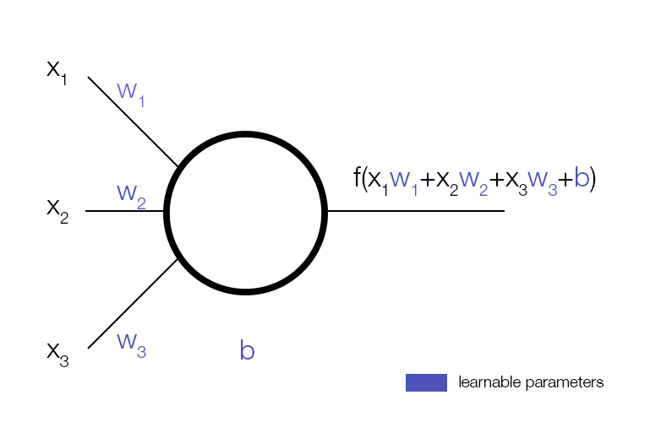

In computer science this above image represents an artificial neuron, similar to our brain but remotely powerful. This neuron by its own is completely ineffective, you can only start to learn things when it is add a bunch of it.

- A neuron can have one or infinite inputs.
- A neuron usually has only one output.
- X_i are inputs of the neuron (which can be image pixels)
- W_i, b stands, respectively, weight and bias. These are parameters of the neuron (the values that needs to be found).
- The output is quantified by the weight entry.
- Bias works as an offset, weights multiplies the inputs, helping the training to be faster.
- Output is equal a sum of weighted plus bias function.

This output is an activation function and it adds non-linearity to the output. Without this part, all the connected neurons would be equivalent to one neuron with the weights specified, therefore a simple weighted sum as an output. The NN needs a non-linear to work properly, the output being linear a simple

f(x) = ax+b

equation would be enough, the NN must find a function that fits a given set of points. Sigmoid function is the one used in this library as activation function:

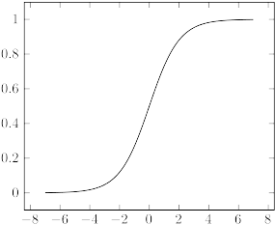

The important part is the graph, this function is asymptotic (0 and 1) and is differentiate. This is required to find the right values for the weights and bias, then the output of the neuron can match with the expect output. If randomly changing the values for W_i and b is possible to see the neuron behavior. However, if the network is dense due the endless possibilities it would take a long time.

To match the expect and actual outputs, a loss function was written and it is derivative with the respect parameters. This calculation explains how to change the error if the parameter would be modify.

The changing is required for decreasing the error, the function derivatives
(in math, one variable function = derivative) is positive if have an incremental,
and negative if have a decrement. Therefore, to decrease the loss function, which means:

- expected - actual = 0

hence:

- expected = actual

it would need to follow the derivative to the lowest, which is a gradient descent (multiple variables functions). Gradient is a vector pointing towards to the direction that increase the function quickly. Besides that, Sigmoid function lies between 0 and 1, so the neuron can be handle as a statistical probability.

  - MATRIX
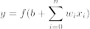
The output of a neuron:

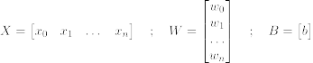
Matrix is a very powerful mathematical trick for handling these neurons:

Then:

f(M) means f is applied in each element of M. A and B are two matrices, the dot product AB can only be calculated if A width is equal to B height. If A size is a*b, and B size is b*c, then the dot product AB is a*c size.

  - NEURAL NETWORK

A single neuron does not compute enough results, adding others neurons can solve many different problems. Then, presenting a multi-layer neural network:

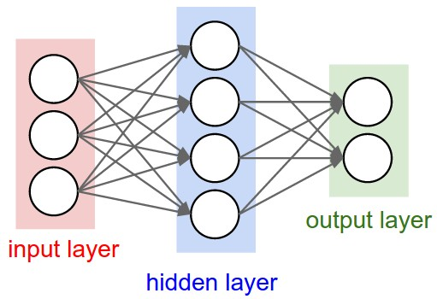

This fully-connected neurons are as the name, connected to every neurons of the previous and next layer.

- Input layer takes all the input data, for example: image pixels. Being for each pixel an input, hence this layer contains as many neurons as there as input.

- Hidden layer is among input and output layers, depending on the problem it can have 1 to infinite layers.

- Output layer is the result of the network. The number of categories contains as many neurons as there are output.

  - FORWARD PROPAGATION

Input, hidden and output layers are respectively X, H and Y. The weights between input and the hidden are W_1, and weights between hidden and output are W_2. Hidden and output bias are B_1 and B_2.
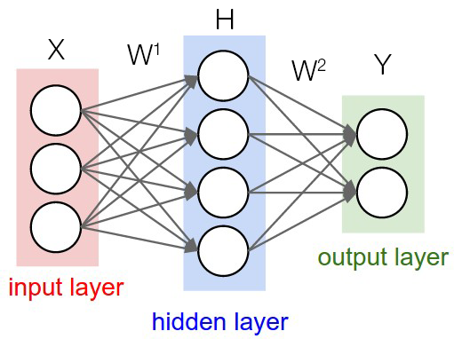

 | size
X | 1 * input neuron count
W_1 | Input neuron count * hidden neuron count
H | 1 * hidden neuron count
W_2 | Hidden neuron count * output neuron count
Y | 1 * output neuron count

The forward propagation is calculate, which means the output.

  - BACK PROPAGATION

The back propagation is actually the reverse, this is required when the parameters are updated, otherwise the values does not change and the output network remains the same. Writing the loss function is possible to derivative of it with respect weight and bias:

Above, the squared error loss function has Y^* that is the expect output. To derivative this function requires the ½ and the 2 power, so it can be find the minimum loss, which means

- expect = actual

without these values the result is a local minimum, actually the result must be a global minimum. The following random function shows that the second minimum is the global minimum, to get this is add the power 2 to the loss function, where x^2 is a convex function, which means one minimum.

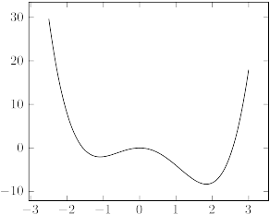

To cancel the power when is differentiate the loss, it adds the ½ fraction. Calculating the derivative of the loss function with the respect parameters, starting with the second bias:

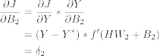

with:

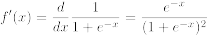

The derivative of the loss function with respect to each element of B_2, must have the same dimension as B_2.The product result is a scalar multiplication, element to element. Calculating the second matrix weight:

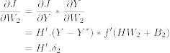

As the previous differentiate, it must have the same dimension as W_2. Therefore, taking the transposed matrix of H it must compute a doc product. This transposed step is similar to a flip operation, where each element of coordinates IJ turns JI. Thus, it reverses a matrix of size a*b into a matrix of size b*a.

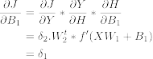

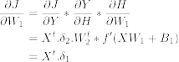

The final equations for back propagation:

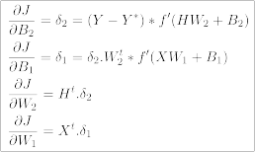

  - UPDATE PARAMETERS

The network output calculation is calculated, likewise the derivative loss function with the respect parameters enabling the loss reduction. The final step is to change the parameters:

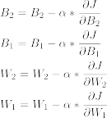

To apply a learning rate it adds an arbitrary constant Alpha. Follows a graph to understand the derivative subtraction:
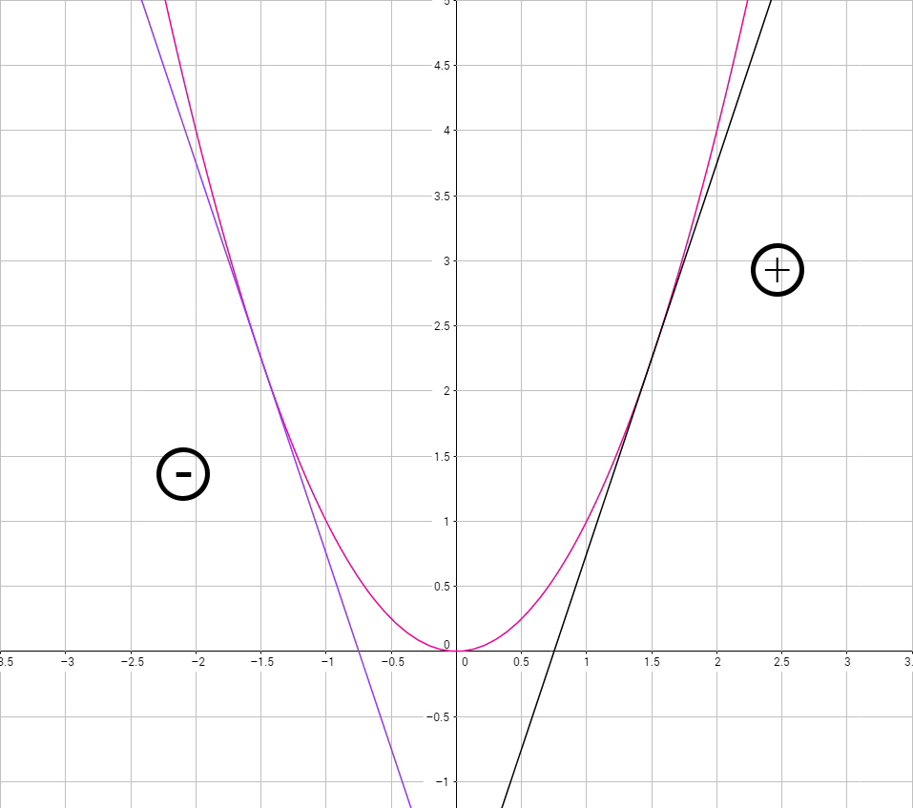

The loss function is a convex x^2, analogously with the above graph where x < 0 = df / dx < 0, and when x > 0 = df / dx > 0, then:

- if (x < 0) then (df / dx > 0) resulting in pushing x value to the right of the graph
- if (x > 0) then (df / dx < 0) resulting in pushing x value to the left of the graph

I and II cases applied a change to x value that f(x) goes toward to zero. Iterating through this process the error decreases.

- IMPLEMENTATION CODE

The network architecture Robin Bird is implemented using a oriented-object programming language. This experimental release provides a training set of hand written digits within 0 to 9, which basically can be 28x28, 32x32, NxN arrays of data. The releases includes 32x32 arrays of data, where it must defined first what is the input neurons and what is the number of output neurons.

- 32 x 32 = 1024 neurons, one for each pixel (binary images).

It can not have one single value as output which can assumes numbers between 0 and 9, the final result goes through a sigmoid function which outputs a number between 0 and 1. The network solution must output 10 output neurons, if the network predicts the 8 number when given an image as input, then it must results the vector as follows:

- [0,0,0,0,0,0,0,0,1,0]

which represents a probability with one maximum at index number eight, and zero minimum probability for the other numbers.

  - MATRIX

The programming classes must have a few implementations to easily handle the matrix calculations. These features are as follow:

        - Dot product function
        - Transpose function
        - Addition function
        - Subtraction function
        - Hadamard product (element to element) function
        - Multiplication with a scalar function
        - Apply a function to every element of a matrix function

The calc-matrix header file implementation:

<CODE>

These functions are looping through the matrix addition, subtraction or multiplication it, invoking them depending on the function.

  - NEURAL NETWORK

The neural network implementation consists into a few fundamental steps:

- Load the training examples into the network
- Train the network
        - Compute output
        - Compute gradients
        - Update parameters
        - Loop through steps 1,2,3
- Use the network to make new prediction

The loop are in the steps in the training network.

  - LOAD DATA
to be continued

The first step is to load a training example : give data to the network so it can learn from it. I found a training set of hand written digits (0 to 9) on the internet. You can download the file here.

If you open the file you will see a lot of things like this :

<IMAGE>

Basically it's a 32x32 array that represents a number between 0 and 9. The line that follows the array tells what number is represented. The training set contains 946 examples like this one. We will train the network on 936 samples and keep the last 10 to test the network on data it never saw. Ultimately, you could make a program that read pixels from a png file and convert the white pixels to 0 and the black ones to 1 so that the network takes directly images as input.

Create a new file called main.cpp. We will start by writing the function that will load the data from the file into two vectors : input and output.

  - Training
================

Now we need to train the network. We will create two functions : one that computes the output, and one that computes the gradient and then update the parameters. The first thing we are going to do is to define global variables (just for the sake of simplicity) :

<CODE>

Nothing has changed since part 1, you should recognize every parameter. We are also going to create the initilization function which sets the size of each matrix and sets random weights and bias :
void init(int inputNeuron, int hiddenNeuron, int outputNeuron, double rate)

<CODE>

Indeed, we cannot set the parameters to zero because the derivative of the loss function with respect to the parameters will be all the same and the program will never start to learn. That said, we need to implement the random function :

<CODE>

  - COMPUTE OUTPUT
======================

Here are the equations of part 1 :

<EQUATION>

This is very easy now that we have the Matrix class :

<CODE>

We also need to define the sigmoid function :

<CODE>

  - COMPUTE GRADIENT
========================

Again, here are the equations of part 1 :

<EQUATIONS>

We just need to copy these formulas :

<CODE>

Of course we also have to declare sigmoidPrime which is the derivative of the sigmoid function :

<CODE>

  - ITERATE THROUGHT THE PROCESS AND TEST
=============================================

Finally we can create the main() function which is going to make all these functions work together :

<CODE>

As the sigmoid function never reaches 0.0 nor 1.0, it can be a good idea to consider values greater than 0.9 as 1.0 and values smaller than 0.1 as 0.0, hence the step function :

<CODE>

  - SUMMARIZE
===============

The main.cpp file should contain this final code now :

<CODE>

All you need to do is compile and run !

<CODE>

What happens when you run the code :

<CODE RUNNING IMAGE>

(Of course your result can be different since we initialize random parameters)

As you can see the program did pretty well on the last 10 examples ! (which are not all the numbers from 0 to 9 but just whatever happened to be the last 10 training examples)

Here is a compressed file that contains the project we made : Neural-Network.rar

And there is the full project with extras features : https://github.com/omaflak/Neural-Network

You reached the end of this tutorial, congratulation ! I hope you liked it. Let me know if everything went right in the comments ! Peace.

