# EDAV Project 2: Regression with Principal Components

## Aim: Visualize and analyze relationship between flood characteristics and number of people displaced

### 1. Visualize distribution of variables

* Magnitude:

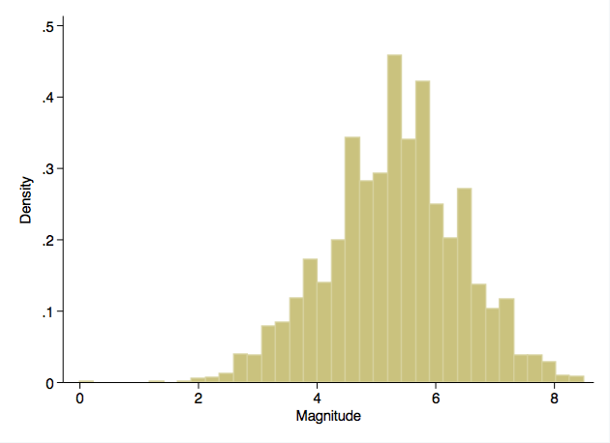

* Duration:

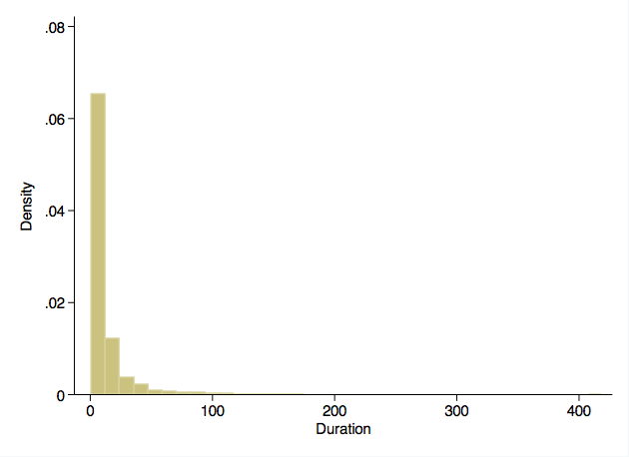

* Affected area:

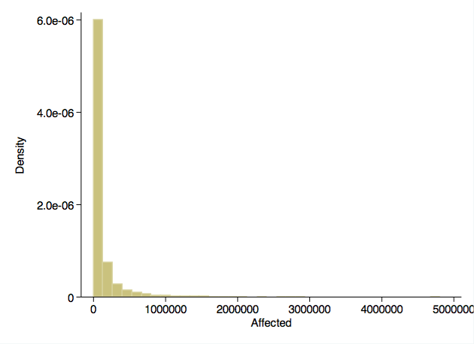

* Number displaced:

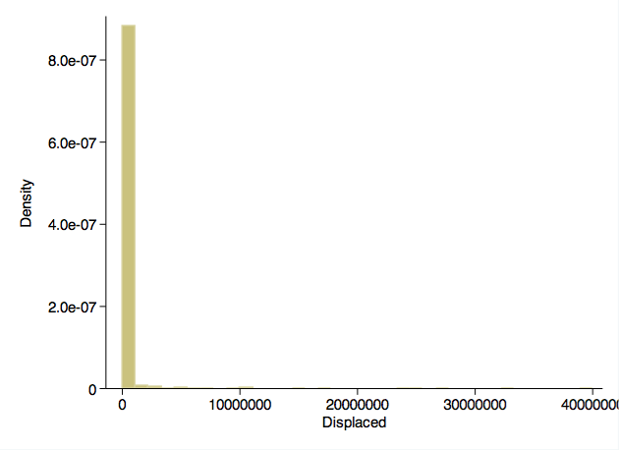

### 2. Center and scale

Except for magnitude, other variables are not normally distributed, so log-transform them and then center and scale all variables.

### 3. Linear regression

Perform multiple linear regression with “displaced” as dependent variable and other three variables (“magnitude”, “duration”, “affected”) as independent variables.

This model seems to explain ~20% of number of people displaced (model R2 = 0.19).

* **Model 1**. regress std_log_displaced std_magnitude std_log_duration std_log_affected  
     
   Source | SS df MS Number of obs = 3034  
   -------------+------------------------------ F( 3, 3030) = 238.20  
   Model | 578.799987 3 192.933329 Prob > F = 0.0000  
   Residual | 2454.19999 3030 .809966995 R-squared = 0.1908  
   -------------+------------------------------ Adj R-squared = 0.1900  
   Total | 3032.99998 3033 .999999994 Root MSE = .89998  
     
   ----------------------------------------------------------------------------------  
   std_log_displa~d | Coef. Std. Err. t P>|t| [95% Conf. Interval]  
   -----------------+----------------------------------------------------------------  
   std_magnitude | .2641184 .1101812 2.40 0.017 .0480809 .4801559  
   std_log_duration | .2125168 .0464031 4.58 0.000 .1215321 .3035015  
   std_log_affected | -.0117362 .0844968 -0.14 0.890 -.1774131 .1539406  
   _cons | -.0675865 .0165535 -4.08 0.000 -.1000437 -.0351292  
   ----------------------------------------------------------------------------------

Remove “affected” since not significantly associated with dependent variable. R2 remains unchanged.

* **Model 2**. regress std_log_displaced std_magnitude std_log_duration  
     
   Source | SS df MS Number of obs = 3034  
   -------------+------------------------------ F( 2, 3031) = 357.40  
   Model | 578.784361 2 289.39218 Prob > F = 0.0000  
   Residual | 2454.21562 3031 .809704922 R-squared = 0.1908  
   -------------+------------------------------ Adj R-squared = 0.1903  
   Total | 3032.99998 3033 .999999994 Root MSE = .89984  
     
   ----------------------------------------------------------------------------------  
   std_log_displa~d | Coef. Std. Err. t P>|t| [95% Conf. Interval]  
   -----------------+----------------------------------------------------------------  
   std_magnitude | .2491953 .0244173 10.21 0.000 .2013191 .2970716  
   std_log_duration | .2180322 .0240046 9.08 0.000 .1709653 .2650992  
   _cons | -.0675127 .0165423 -4.08 0.000 -.0999479 -.0350774  
   ----------------------------------------------------------------------------------

Check assumptions of linear regression:

* Assumption of normality of residuals appears satisfied.

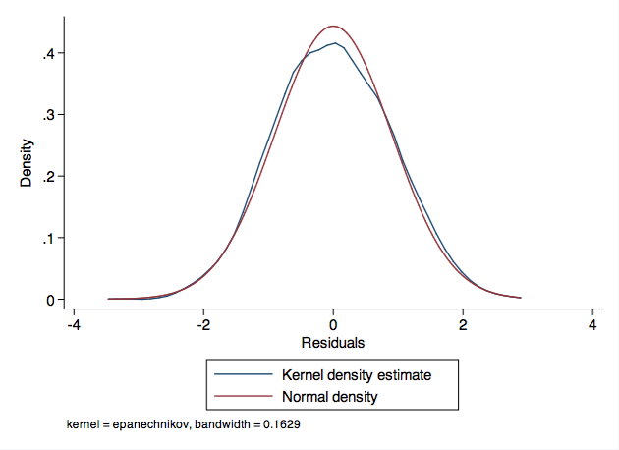

* Assumption of homoscedasticity of residuals appears satisfied.

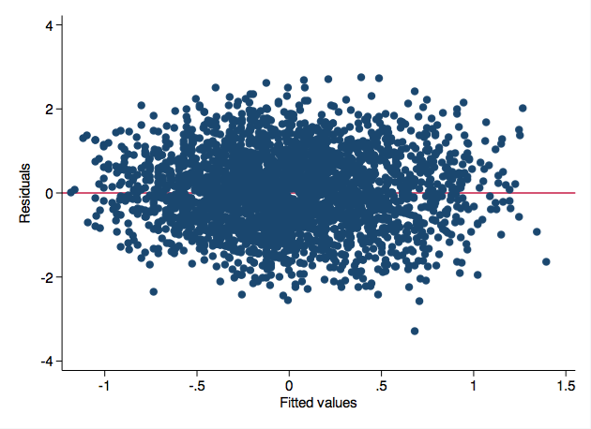

* No evidence of significant collinearity (VIF <10).
* Variable | VIF 1/VIF   
   -------------+----------------------  
   std_log_du~n | 2.21 0.452957  
   std_magnit~e | 2.21 0.452957  
   -------------+----------------------  
   Mean VIF | 2.21
* Assumption of linearity appears satisfied.

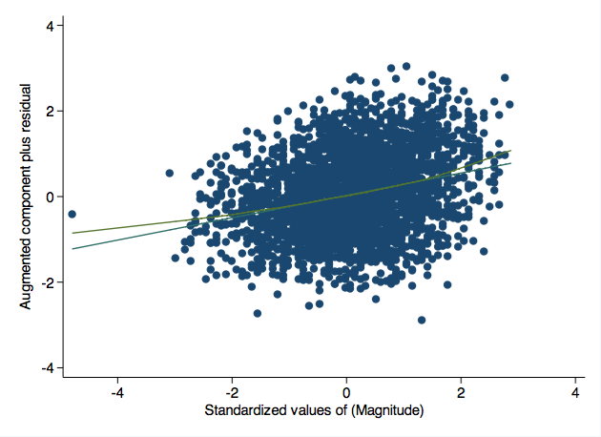

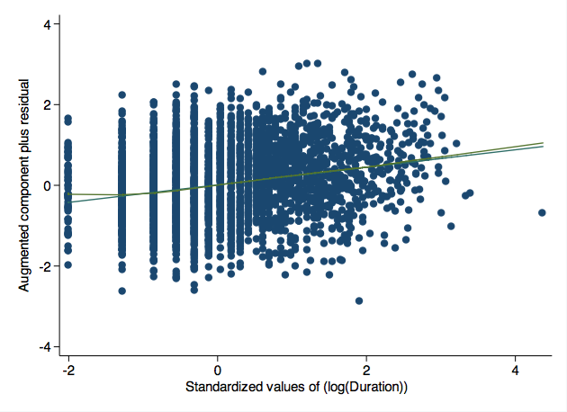

### 4. Perform principal components analysis on “magnitude” and “duration”

Estimate principal components.

* pca std_magnitude std_log_duration  
     
   Principal components/correlation Number of obs = 4312  
   Number of comp. = 2  
   Trace = 2  
   Rotation: (unrotated = principal) Rho = 1.0000  
     
   --------------------------------------------------------------------------  
   Component | Eigenvalue Difference Proportion Cumulative  
   -------------+------------------------------------------------------------  
   Comp1 | 1.73842 1.47684 0.8692 0.8692  
   Comp2 | .261578 . 0.1308 1.0000  
   --------------------------------------------------------------------------  
     
   Principal components (eigenvectors)   
     
   ------------------------------------------------  
   Variable | Comp1 Comp2 | Unexplained   
   -------------+--------------------+-------------  
   std_magnit~e | 0.7071 0.7071 | 0   
   std_log_du~n | 0.7071 -0.7071 | 0   
   ------------------------------------------------

Component 1 explains ~87% of variance, so compute score of that component (pc1) and regress on that alone. R2 of Model 3 is similar to the earlier Model 2 with separate terms for “magnitude” and “duration”.

* **Model 3**. regress std_log_displaced pc1  
     
   Source | SS df MS Number of obs = 3034  
   -------------+------------------------------ F( 1, 3032) = 714.48  
   Model | 578.41338 1 578.41338 Prob > F = 0.0000  
   Residual | 2454.5866 3032 .809560224 R-squared = 0.1907  
   -------------+------------------------------ Adj R-squared = 0.1904  
   Total | 3032.99998 3033 .999999994 Root MSE = .89976  
     
   ------------------------------------------------------------------------------  
   std_log_di~d | Coef. Std. Err. t P>|t| [95% Conf. Interval]  
   -------------+----------------------------------------------------------------  
   pc1 | .3297514 .0123365 26.73 0.000 .3055626 .3539401  
   _cons | -.0676347 .0165297 -4.09 0.000 -.1000453 -.0352241  
   ------------------------------------------------------------------------------

Regression model with “pc1” (Model 3 above) appears to have superior R2 (0.19) than regression models with “duration” alone (0.16) (Model 4 below) or “magnitude” alone (0.17) (Model 5 below).

* **Model 4**. regress std_log_displaced std_log_duration  
     
   Source | SS df MS Number of obs = 3034  
   -------------+------------------------------ F( 1, 3032) = 590.56  
   Model | 494.448928 1 494.448928 Prob > F = 0.0000  
   Residual | 2538.55105 3032 .837252986 R-squared = 0.1630  
   -------------+------------------------------ Adj R-squared = 0.1627  
   Total | 3032.99998 3033 .999999994 Root MSE = .91502  
     
   ----------------------------------------------------------------------------------  
   std_log_displa~d | Coef. Std. Err. t P>|t| [95% Conf. Interval]  
   -----------------+----------------------------------------------------------------  
   std_log_duration | .3992275 .0164281 24.30 0.000 .3670161 .4314389  
   _cons | -.063597 .0168168 -3.78 0.000 -.0965705 -.0306235  
   ----------------------------------------------------------------------------------  
     
     
   **Model 5**. regress std_log_displaced std_magnitude  
     
   Source | SS df MS Number of obs = 3034  
   -------------+------------------------------ F( 1, 3032) = 615.76  
   Model | 511.983959 1 511.983959 Prob > F = 0.0000  
   Residual | 2521.01602 3032 .831469664 R-squared = 0.1688  
   -------------+------------------------------ Adj R-squared = 0.1685  
   Total | 3032.99998 3033 .999999994 Root MSE = .91185  
     
   -------------------------------------------------------------------------------  
   std_log_dis~d | Coef. Std. Err. t P>|t| [95% Conf. Interval]  
   --------------+----------------------------------------------------------------  
   std_magnitude | .4132298 .0166528 24.81 0.000 .3805779 .4458817  
   _cons | -.0543578 .0166988 -3.26 0.001 -.0870999 -.0216158  
   -------------------------------------------------------------------------------

Check assumptions of linear regression for model with principal component alone (Model 3):

* Assumption of normality of residuals appears satisfied.

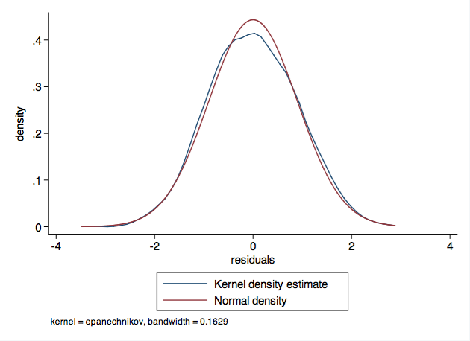

* Assumption of homoscedasticity of residuals appears satisfied.

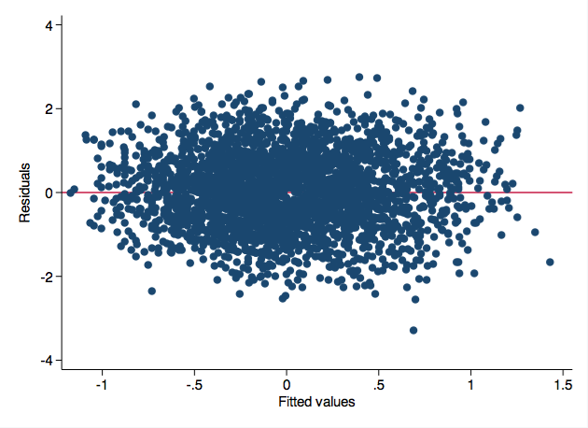

* No evidence of significant collinearity (VIF <10).
* Variable | VIF 1/VIF   
   -------------+----------------------  
   pc1 | 1.00 1.000000  
   -------------+----------------------  
   Mean VIF | 1.00
* Assumption of linearity appears satisfied.

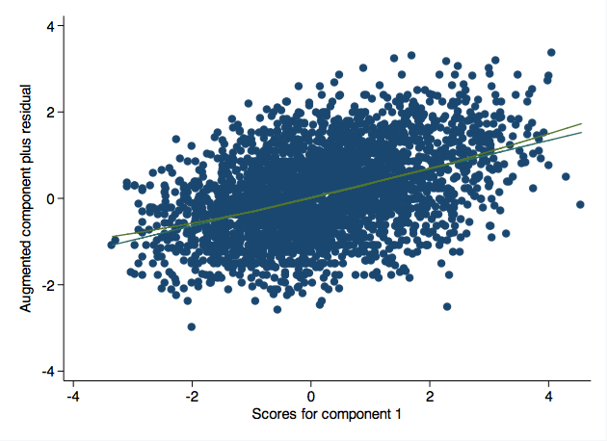

### 5. Visually assess relationship between multiple flood characteristics and the number of people displaced

Such a visualization would be difficult to perform with traditional linear regression in the presence of multiple independent variables.

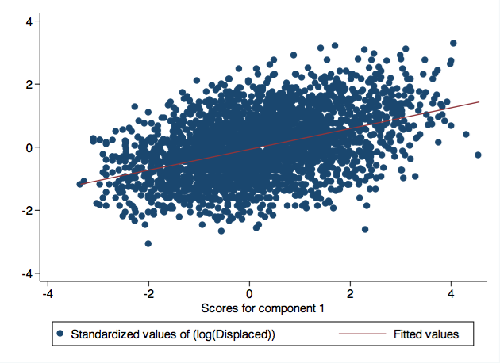

### 6. Summmary

Principal components analysis allowed dimension reduction to one dimension, thereby allowing direct visualization between predictor and outcome.

Regression using one principal component was superior to regression limited to one traditional independent variable.