**Task One**: Referencing this image, create a low-fidelity wireframe.

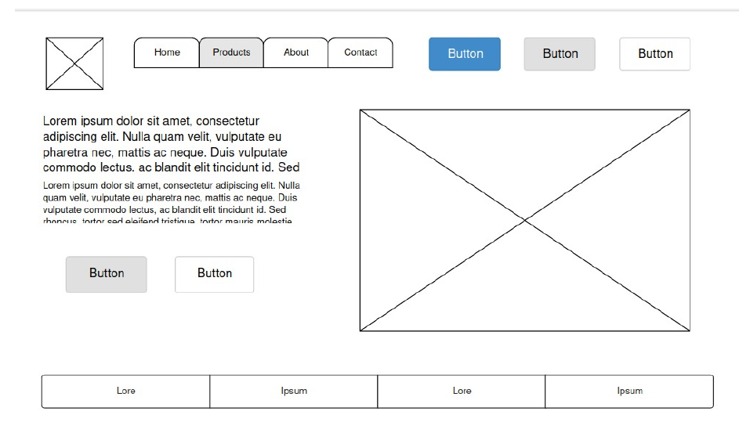

**Task Two**: Use one of the following websites and the inspect tool to identify 2-3 colors used

repeatedly as part of the site’s color scheme. Remember that different shades of gray and black

can be included as a color.

<https://timmyomahony.com/> colors #ffe8dc #ffffff

**Task Three**: Create a user story by referencing one of these websites

Youtube:

David is a young teacher who enjoys explaining topics about maths. To do that, he uploads periodically videos on Youtube. He creates list , responds comments, chats with followers. He is interested in video edition, how to improve visits to his videos, and get feedback from his followers. David also put links in his videos to recommend material to other maths sources. Sometimes he responds to followers with explained questions related to his videos.

**Task Four:** Identify the prime objective of Facebook, Twitter, Google, and Youtube.

The main goal is to make money with advertisements. They don’t generate content ,  the content is created by their “clients”

* **Facebook**: They generate money sending specific advertisements to their clients, knowing their interests. They need a great knowledge of big data
* **Twitter**: They make the possibility of to be updated in one specific field. To do that they suggest other followers, or other recommendable content
* **Google**: Provides relevant information on the searches performed by the user. They get money from advertisements and uses the word rank to “sell” a position in the google search list to sellers.
* **Youtube**: Get money from sellers who pay advertisements. To do that the followers produce content and Youtube offers this content to sellers to put their advertisements in the video.