Amazing Printer Controller
Technical Documentation
GRBL-based Control Software

Table of Contents
Table of Contents 2
Overview 4
Core Functionality 4
Installation and Build Guide 5
Prerequisites 5
Setting Up vcpkg 5
vcpkg.json Manifest 5
Project Structure 6
Development with VS Code 6
Running the Application 6
Serial Port Permissions 6
Class Hierarchy and System Architecture 7
Application Core 7
Presentation Layer (GUI) 7
Control and Hardware Layer 7
Technical Stack 8
Dependency Management with vcpkg 8
Core Libraries 8
Boost (Communication and Logic) 8
wxWidgets (Graphical User Interface) 8
Glaze (JSON Serialisation) 8
GRBL Firmware 8
GRBL Commands 9
System Commands 9
Realtime Commands 9
Soft Reset (Ctrl+X) 9
Status Report Query (?) 9
Cycle Start / Resume (~) 9
Feed Hold (!) 9
G-Code Commands 9
Class Documentation 11
SerialPortManager 11
Hardware Discovery and Initialisation 11
Handling the GRBL Reset Cycle 11
Asynchronous Data Processing 11
Thread Safety and Resource Management 11
GrblController 12
Connecting to the Target 12
The Polling Mechanism 12
State and Position Parsing 12
Motion Control Strategies 12
Machine Configuration 12
ScanHandler 14
Scan Line Generation 14
Point-by-Point Scan Cycle (StartScanCycle) 14
Continuous Scan Cycle (StartContinuousScanCycle) 14
CoordinatePanel 15
Coordinate Transformation System 15
Rendering Pipeline 15
Click-to-Move Interaction 15
GrblScanWindow 16
Form Construction and Validation 16
Scan Execution and Threading 16
GrblConfigDialog 17
Grid Construction and Setting Definitions 17
Reading Settings from Hardware 17
Writing Settings to Hardware 17
MainFrame 18
Layout Architecture 18
Connection Management 18
Manual Control Tab 18
Callback Wiring 18
Console and Command Input 19
MyApp (Application Entry Point) 20
JsonHandler 20
File Path Resolution 20
Templated Save and Load 20
AppSettings and GridPatternSettings 20
wxHelpers 21
Available Methods 21
GrblTypes 22
GrblState Enumeration 22
GrblStatus Structure 22
Grbl Command Constants 22

List of Figures
Figure 1: Main application window after launch
Figure 2: Connection panel showing port dropdown and Connect button
Figure 3: Output Panel after Connecting
Figure 4: Manual Control tab with jog pad and motion controls
Figure 5: Move To Panel
Figure 6: Coordinate panel showing machine position as a blue dot
Figure 7: Coordinate panel with scan preview rectangle visible
Figure 8: Scanner tab showing all configuration fields
Figure 9: GRBL Configuration dialog with settings grid

Introduction
The development of this application arose from the practical requirements within another bigger project within the HTW Dresden which necessitated the use of a GRBL motion system to precisely position a sensor across a defined grid of points, triggering a measurement at each location.

While there are multiple GRBL open source projects over the internet, with vastly more features, none of them were a proper fit for our basic requirements, which were that it must be able to run on Linux Mint, it must be written in C++ and must be easily extendable in order to accommodate the universities requirements and ensure long term maintainability.

Overview
This tool is primarily used for the direct motion control of hardware running under GRBL firmware via a USB serial connection. The main target platform is a VEVOR laser engraver. The provided graphical user interface (GUI) is the primary means for the user to operate and monitor the state of the machine. The application targets Linux as its primary platform and is written in C++. However, it is designed to run on other platforms (such as Windows or macOS) with little to no modification, as all code uses standard C++ with cross-platform libraries.

Core Functionality
The tool facilitates communication with the machine to send commands and provide real-time updates from the controller. Its primary responsibilities include:
- G-Code Streaming: All motion commands are sent as G-Code and handled automatically by the tool. A terminal is also provided for direct manual input of custom G-Code commands.
- Status Monitoring: Real-time tracking of the machine position coordinates (X and Y) displayed both numerically and as a graphical plot in the GUI.
- Automated Scanning: A configurable grid-based scanning system that moves the machine through a pattern of points, supporting horizontal/vertical direction and zigzag (snake) traversal.
- Machine Configuration: Direct read/write access to the GRBL controller’s internal EEPROM settings through a dedicated configuration dialog.
- Persistent Settings: User preferences and scan parameters are automatically saved to disk as JSON and restored on the next launch.

Installation and Build Guide
This section describes how to obtain, build, and run the application from source on a Linux system. The project was developed and tested on Linux Mint distribution using GCC and CMake. The build system uses vcpkg for dependency management, so all third-party libraries are fetched and compiled automatically.

Prerequisites
The following tools must be installed on the system before building the project:
- Git: Required for cloning the project repository and vcpkg.
- CMake: Version 3.10 or later. The build system uses CMake to configure and generate build files.
- GCC / G++: A C++ compiler supporting the C++20 standard (GCC 10 or later recommended).
- Ninja: Required for the provided build presets
- pkg-config and GTK3 development headers: Required by wxWidgets when building from source on Linux.
On Ubuntu/Debian/Mint, these can be installed with:
sudo apt update
sudo apt install git cmake build-essential pkg-config libgtk-3-dev

Setting Up vcpkg
vcpkg is used to download and build all project dependencies (Boost.Asio, wxWidgets, and Glaze) from source. If vcpkg is not already installed on the system, it can be set up as follows:
cd /opt
git clone https://github.com/microsoft/vcpkg.git
cd vcpkg
./bootstrap-vcpkg.sh
Then we need to set the VCPKG_ROOT environment variable so that CMake can locate the vcpkg toolchain file automatically. This can be added to the shell profile:
export VCPKG_ROOT=$HOME/vcpkg
export PATH=$VCPKG_ROOT:$PATH
There is no need to manually run vcpkg install for individual libraries. The project includes a vcpkg.json manifest file that declares all required dependencies. CMake will invoke vcpkg automatically during the configure step to resolve and build them.

vcpkg.json Manifest
The project’s vcpkg.json file declares the following dependencies:
- boost-asio: Asynchronous I/O library for serial communication.
- wxwidgets: Cross-platform GUI framework.
- glaze: High-performance JSON serialisation library.
When CMake is configured with the vcpkg toolchain file, it reads this manifest and ensures all three libraries are built and available before the project itself is compiled.

Project Structure
The source code is organised as follows:
- src/: All .cpp source files (main.cpp, MainFrame.cpp, GrblController.cpp, etc.).
- include/: All .hpp header files.
- bin/: Output directory for the compiled executable (created automatically by CMake).
- vcpkg.json: Dependency manifest for vcpkg.
- CmakeLists.txt: Build configuration file.

Development with VS Code
The project was developed using Visual Studio Code with the CMake Tools extension (ms-vscode.cmake-tools). When this extension is installed and the project is opened in VS Code, it automatically detects the CMakeLists.txt and provides build, debug, and IntelliSense integration. The included c_cpp_properties.json configures the C++ IntelliSense engine to use GCC with the C++20 standard and includes the vcpkg header paths.
To build within VS Code, use the CMake Tools commands from the command palette (Ctrl+Shift+P):
- CMake: Configure: Runs the CMake configure step with vcpkg integration.
- CMake: Build: Compiles the project.
- CMake: Debug: Launches the application under GDB for debugging.

Running the Application
The application can be launched directly from the project root:
./bin/AmazingPrinterConverter
On first launch, the application creates its configuration directory at ~/.config/AmazingPrinterController/ and writes a default settings.json file. The GRBL machine should be connected via USB before attempting to connect through the GUI.

Serial Port Permissions
On most Linux distributions, access to serial ports (e.g., /dev/ttyUSB0) requires the user to be a member of the dialout group. If the application fails to open a port, the user can add themselves to this group with:
sudo usermod -aG dialout $USER
A logout and login (or system reboot) is required for the group change to take effect.

Class Hierarchy and System Architecture
The application follows an object-oriented architecture that separates the GUI from the hardware communication and control logic. The system is built upon the wxWidgets framework for cross-platform UI rendering and Boost.Asio for asynchronous serial communication. The system’s classes can be categorised into three primary layers: the Application Core, the Presentation Layer, and the Control/Hardware Layer. A full class relationship diagram is available in the accompanying Mermaid diagram file (MermaidDiagram.txt).

Application Core
- MyApp: Entry point. Inherits from wxApp. Owns JsonHandler and AppSettings.
- JsonHandler: Handles loading and saving of application settings as JSON via the Glaze library.
- AppSettings / GridPatternSettings: Plain data structures holding user preferences and last-used scan parameters.

Presentation Layer (GUI)
- MainFrame: Inherits from wxFrame. Central UI orchestrator. Owns the GrblController shared instance and all UI panels.
- CoordinatePanel: Inherits from wxPanel. Custom double-buffered rendering surface for the machine coordinate plot.
- GrblScanWindow: Inherits from wxPanel. Scan configuration form and execution control.
- GrblConfigDialog: Inherits from wxDialog. Modal dialog for reading/writing GRBL EEPROM settings.
- wxHelpers: Static utility class providing factory methods for validated input controls.

Control and Hardware Layer
- GrblController: State machine and primary logic controller. Owns a SerialPortManager instance.
- ScanHandler: Scan cycle execution engine. Uses a shared GrblController to perform grid-based scanning operations.
- SerialPortManager: Lowest-level class handling direct OS-level serial port I/O via Boost.Asio.

Technical Stack

Dependency Management with vcpkg
vcpkg is a free, open-source, cross-platform C/C++ package manager maintained by Microsoft and the open-source community. It handles the downloading and building from source for all the dependencies and libraries mentioned in this section. As it is cross-platform (supporting Windows, Linux, and macOS), it ensures that the exact same library versions and build configurations are used across all development environments.

Core Libraries

Boost (Communication and Logic)
Boost is a collection of open-source, cross-platform, and highly robust C++ libraries. In this project, Boost.Asio provides the asynchronous I/O model required for the high-speed serial data stream to and from the GRBL controller.

wxWidgets (Graphical User Interface)
wxWidgets is an open-source, cross-platform C++ GUI library. It was used to create all user interface elements in this project, from the main window layout and control panels to custom-painted coordinate displays.

Glaze (JSON Serialisation)
Glaze is a high-performance, header-only C++ JSON library used for serialising and deserialising the application settings. It provides compile-time reflection to map C++ structs directly to JSON without requiring manual parsing code.

GRBL Firmware
GRBL is free, open-source firmware for controlling CNC motion on Arduino-class microcontrollers. All motion is handled using G-Code and GRBL’s own system commands. Key configurable parameters include:
- Acceleration: Ensures motors speed up and slow down gradually.
- Hard Limits: Automatically monitors physical limit switches to stop the machine from crashing into its own frame.
- Soft Limits: Software-imposed travel boundaries. The target machine’s limits are set at X: 400 mm, Y: 380 mm.

GRBL Commands

System Commands
The system commands provided by GRBL add additional controls beyond G-Code motion:
- $H (Homing Cycle): Initiates the machine’s search for physical limit switches to establish a known zero point.
- $X (Kill Alarm Lock): Overrides the Alarm state often triggered by hitting a limit switch or after a power-on.
- $$ (View/Write Settings): Used by the GrblConfigDialog to fetch or modify the internal non-volatile parameters of the machine.

Realtime Commands
A realtime command executes within tens of milliseconds, is a single character sent at any time, does not require a line feed, and is never placed in the parser buffer. The four primary realtime commands are:

Soft Reset (Ctrl+X)
Immediately halts and safely resets GRBL without a power cycle. If reset while in motion, GRBL throws an alarm to indicate position may be lost. If reset while stationary, position is retained and re-homing is not required.

Status Report Query (?)
Immediately generates and sends back runtime data with a status report. This command is automatically and periodically sent by the application’s polling mechanism to keep the GUI updated with the current machine position.

Cycle Start / Resume (~)
Resumes a feed hold, a safety door state (when the door is closed), and M0 program pause states. The command is otherwise ignored.

Feed Hold (!)
Places GRBL into a suspend or HOLD state. If the machine is in motion, it will decelerate to a stop and then be suspended. If jogging, a feed hold cancels the jog motion and flushes all remaining jog commands from the planner buffer.

G-Code Commands
The application uses the following G-Code commands for motion control:
- G0: Rapid positioning (maximum speed). Used for non-cutting travel moves via the GoTo function.
- G1: Linear interpolation at a specified feed rate. Used during scan cycles for controlled-speed movement.
- G21: Set units to millimetres. Sent as a prefix to ensure the machine is in the correct mode.
- G90: Absolute positioning mode. Used for GoTo and scan movements.
- G91: Incremental (relative) positioning mode. Used exclusively for jog commands ($J).
- $J: GRBL’s dedicated jog command. Safer for manual overrides as it does not affect the main G-Code parser state and can be cancelled by a feed hold.
There are more G-Code Commands that can be used but for the purposes of this project only these were used

Class Documentation

SerialPortManager
SerialPortManager is the class responsible for the communication between the control software and a GRBL-based controller over a USB-serial connection. It uses the Boost.Asio library to provide a non-blocking, event-driven architecture, ensuring that the main application thread remains responsive while waiting for status reports or command acknowledgements.

Hardware Discovery and Initialisation
The manager implements a scanning mechanism to identify available hardware. In Linux, serial devices are represented as files in the /dev directory.
- Port Scanning: The ScanPorts() method iterates through the /dev filesystem to find device nodes matching ttyS, ttyUSB, or ttyACM patterns.
- Port Configuration: Upon opening a port, the class enforces the GRBL standard communication parameters: 115200 baud, 8 data bits, no parity, 1 stop bit, no flow control.

Handling the GRBL Reset Cycle
A critical aspect of connecting to an Arduino-based GRBL controller is managing the auto-reset feature. When the serial port is opened, the DTR (Data Terminal Ready) signal typically triggers a hardware reset.
- DTR/RTS Manipulation: The code uses ioctl() to manually set the DTR flag and clear the RTS flag to stabilise the connection.
- Synchronisation Delay: A 2000 ms blocking sleep is implemented immediately after opening the port. This allows the GRBL firmware to finish its boot sequence and clear the serial buffer before the software sends any commands.

Asynchronous Data Processing
To handle the continuous stream of data from GRBL, the manager uses a recursive asynchronous read pattern:
- StartAsyncRead: Launches a dedicated worker thread (ioThread_) to run the Boost.Asio io_context.
- DoRead: Initiates an async_read_some operation for a single character at a time.
- Buffer Management: Characters are appended to an internal m_inputBuffer. When a newline or carriage return is detected, the complete line is dispatched via the m_onLineRead callback to the higher-level parser, and the buffer is cleared.

Thread Safety and Resource Management
- Work Guard: A boost::asio::executor_work_guard prevents the io_context from exiting when there are no pending asynchronous tasks, keeping the read loop alive.
- Graceful Shutdown: The destructor ensures the serial port is closed, the io_context is stopped, and the background thread is joined correctly, preventing memory leaks or hung processes.

GrblController
This class handles the higher-level logic for parsing and sending GRBL-compliant messages. It uses an internal SerialPortManager instance to handle the lower-level serial communication.

Connecting to the Target
A connection to a GRBL machine is started using the Connect() method by specifying the port name (e.g., /dev/ttyUSB0). Upon success, the method initialises the asynchronous read loop and spawns the polling thread.

The Polling Mechanism
A critical requirement for GRBL control is knowing the machine’s position at all times. GRBL does not push position updates automatically; it must be queried.
- Background Polling: Upon connection, a dedicated thread (PollingThreadLoop) is spawned.
- Query Frequency: At a configurable interval (default 100 ms), the thread sends the ? character (Status Query) to the machine.
- Real-time Feedback: This creates a continuous loop ensuring the UI always has access to the most recent Machine Position (MPos).

State and Position Parsing
The controller interprets raw string data from the serial port:
- Regex Parsing: The ParseStatus() method uses a regular expression to extract X, Y, and Z coordinates from status strings in the format <Idle|MPos:100.000,200.000,0.000|...>.
- State Management: It extracts the machine’s current state (Idle, Run, Hold, Jog, Alarm, etc.) to ensure commands are only sent when the machine is ready.
- Settings Parsing: The ParseSetting() method detects and stores key-value pairs from $$ responses (e.g., $100=250.000) into an internal map for use by the GrblConfigDialog.

Motion Control Strategies
The class distinguishes between different types of movement:
- Linear Movement (MoveTo): Used for absolute positioning. It prefixes commands with G21 (metric) and G90 (absolute). If a feed rate is provided, it uses G1 (linear interpolation); otherwise it uses G0 (rapid).
- Jogging (JogTo): Used for manual positioning via GRBL’s $J command with G91 (relative mode). This is safer for manual overrides as it does not affect the main G-Code parser state.
- Arrival Synchronisation: The WaitForArrival() function provides a blocking mechanism that monitors the current position vs. the target position within a tolerance of 0.5 mm. It also monitors for Alarm or Unknown states and supports a configurable timeout (default 10 seconds).

Machine Configuration
The SetupMachineAndHome() method provides an initialisation sequence for the hardware:
- Homing ($22=1): Enables the homing cycle so the machine can find its physical limits.
- Soft Limits ($20=1, $130=400, $131=380): Configures software boundaries to prevent the machine from exceeding 400 mm on X and 380 mm on Y.
- Homing Direction ($23=3): Sets homing to seek in the negative X and negative Y directions.

ScanHandler
ScanHandler is the scan cycle execution engine. It operates independently of the GUI and is responsible for generating scan paths and orchestrating the machine’s movement through them. It holds a shared pointer to the GrblController to issue motion commands.

Scan Line Generation
The CreateScanLines() method generates the complete set of scan lines for a given grid configuration. It accepts the grid dimensions (rows, columns), a start position, step sizes, scan direction (horizontal or vertical), and a zigzag flag.
- Direction Handling: When set to horizontal, the outer loop iterates over rows and the inner loop over columns. For vertical scanning, this is reversed, so the machine traverses column-by-column instead.
- Zigzag (Snake) Mode: When enabled, every odd-numbered line is traversed in reverse order. This eliminates the need for the machine to return to the start of each row, reducing total travel time significantly for large grids.
- ScanLine Structure: Each generated ScanLine contains the physical start and end coordinates as well as a vector of ScanPoint objects, each storing its row index, column index, and absolute X/Y coordinates.

Point-by-Point Scan Cycle (StartScanCycle)
This is the primary scan mode. The method moves the machine to each individual point in the scan grid and waits for arrival before proceeding.
- Initial Positioning: The machine first moves to the start position of the first scan line and blocks until arrival.
- Sequential Traversal: For each point in each line, MoveTo() is called followed by WaitForArrival(). Upon arrival, the onPointReached callback is invoked with the row, column, and coordinates.
- Cancellation: The m_shouldCancel atomic flag is checked before every point. If CancelScan() has been called, the method returns immediately.

Continuous Scan Cycle (StartContinuousScanCycle)
This alternative mode is optimised for time-critical applications where the machine should not stop at each measurement point.
- Line-Based Motion: Instead of stopping at each point, the machine moves continuously from the start to the end of each scan line at the specified feed rate.
- Time-Based Triggering: The method calculates when the machine should be passing over each point based on the expected travel time (distance divided by feed rate). It polls the elapsed time and fires the onPointReached callback at the calculated moment.
- Line Synchronisation: Between lines, the machine moves to the start of the next line and blocks with WaitForArrival() before beginning the continuous pass.

CoordinatePanel
CoordinatePanel is a custom wxPanel subclass that provides a real-time 2D visualisation of the machine’s coordinate space. It inherits from wxPanel and uses wxAutoBufferedPaintDC to eliminate screen flickering during frequent redraws.

Coordinate Transformation System
The panel maintains a mapping between the physical machine coordinate space (in millimetres) and screen pixel coordinates. Two complementary methods handle this:
- CoordToScreen(): Transforms a physical (X, Y) coordinate to a screen pixel position. It accounts for margins, calculates the aspect ratio of both the data range and available screen area, and centres the plot within the panel to maintain correct proportions regardless of window size.
- ScreenToCoord(): Performs the inverse transformation, converting a pixel position back to physical coordinates. It includes clamping logic to prevent out-of-bounds values when the user clicks outside the plotted area.

Rendering Pipeline
The OnPaint() handler draws the following layers in order:
- Grid Lines: Light grey lines drawn every 50 units across the full coordinate range, providing spatial reference.
- Axes: Bold black lines along X = 0 and Y = 0, with numeric labels at every 50-unit interval.
- Data Points: Each point in the internal collection is drawn as a small coloured circle with a coordinate label. The current machine position is typically shown in blue, updated in real time by the status polling.
- Preview Region: If a scan preview is active, a dashed red rectangle is drawn to indicate the bounding box of the configured scan area.

Click-to-Move Interaction
The panel supports interactive click-to-move functionality. When the user clicks on the panel, the OnMouseClick() handler converts the pixel position to machine coordinates using ScreenToCoord() and invokes the registered m_onClick callback. In the MainFrame, this callback is wired to call GrblController::MoveTo(), allowing the user to command the machine to any position by clicking directly on the coordinate plot.

GrblScanWindow
GrblScanWindow is a wxPanel subclass embedded as a tab in the MainFrame sidebar. It provides the user interface for configuring and executing automated scan cycles. It owns a shared pointer to a ScanHandler and operates on a GridPatternSettings struct provided by the application’s persistent settings.

Form Construction and Validation
The panel uses the wxHelpers utility class to construct its input form. Each input field is bound to a member of the GridPatternSettings struct via wxWidgets validators:
- Numeric Fields: Start X, Start Y, Step X, Step Y (doubles) and Rows, Cols, Speed (integers) are created via AddInputDouble() and AddInputInt(), which attach wxFloatingPointValidator or wxIntegerValidator respectively. Each field has a minimum value constraint.
- Direction: A wxRadioBox allows selection between Horizontal and Vertical scan direction, bound to the settings struct via wxGenericValidator.
- Zigzag Mode: A wxCheckBox toggles snake-scan traversal.
- Live Preview: Every input change triggers OnUIChange(), which calls TransferDataFromWindow() to pull validated values from the form into the settings struct, then invokes the PreviewCallback to update the coordinate panel’s preview rectangle.

Scan Execution and Threading
When the user presses Start Scan, the OnStart() handler launches the scan on a separate worker thread to keep the GUI responsive:
- Thread Launch: A std::thread is created that calls ScanHandler::CreateScanLines() followed by ScanHandler::StartScanCycle() with the current settings.
- UI State Management: All input controls are disabled during the scan via ToggleControls(). The Start button is relabelled to "STOP SCAN" and remains enabled so the user can cancel.
- Cancellation: Pressing the button while scanning calls ScanHandler::CancelScan(), which sets the atomic cancel flag. The button is disabled and relabelled to "Stopping..." to provide feedback.
- Completion: When the worker thread finishes (whether by completion or cancellation), CallAfter() is used to safely update the UI back on the main thread: controls are re-enabled, the button label is restored, and an informational message is shown.

GrblConfigDialog
GrblConfigDialog is a modal wxDialog that provides direct read/write access to the GRBL controller’s internal EEPROM settings. It presents all known GRBL parameters in an editable grid, allowing the user to inspect and modify the machine’s configuration.

Grid Construction and Setting Definitions
The dialog constructs a wxGrid with five columns: ID, Setting Name, Value, Units, and Description. The rows are populated from a static vector of GrblSetting definitions that encodes all standard GRBL v1.1 parameters:
- Data Types: Each setting is tagged with a GrblDataType (Integer, Float, Boolean, or Mask). Boolean fields use a wxGridCellChoiceEditor (True/False), numeric fields use wxGridCellNumberEditor or wxGridCellFloatEditor, ensuring type-safe input.
- Read-Only Metadata: The ID, Name, Units, and Description columns are set to read-only. Only the Value column is editable.
- ID-to-Row Map: An internal std::map<int, int> maps each GRBL setting ID to its grid row index, enabling efficient lookup when incoming settings data needs to be written to the correct row.

Reading Settings from Hardware
Upon opening, the dialog automatically sends the $$ command to the GRBL controller. As the controller responds with lines like $100=250.000, the GrblController::ParseSetting() method stores each key-value pair. The MainFrame’s message callback detects these settings lines and calls ReloadGrid(), which iterates over the stored settings map and writes each value to the correct grid cell using the ID-to-row map.

Writing Settings to Hardware
When the user clicks Write Changes, the OnSave() handler iterates over all grid rows, reads the ID and Value columns, constructs commands in the format $ID=VALUE (e.g., $100=250.000), and sends each to the GrblController. A confirmation message is displayed upon completion.

MainFrame
MainFrame is the central orchestrator of the user interface. It inherits from wxFrame and is responsible for constructing the application’s primary window layout, routing user actions to the GrblController, and updating visual elements in response to hardware state changes.

Layout Architecture
The frame uses a wxSplitterWindow to divide the interface into two resizable columns:
- Left Panel: Contains the connection controls at the top, a wxNotebook with two tabs (Manual Control and Scanner), and the console log area with command input at the bottom.
- Right Panel: Contains the CoordinatePanel, which fills the available space and provides the real-time coordinate plot.
- Toolbar: A wxToolBar at the top of the frame provides quick access to the GRBL Configuration dialog via a toolbar button.

Connection Management
The connection flow is managed through the OnConnect() handler:
- Port Selection: A wxComboBox is populated by scanning available serial ports via GrblController::GetAvailablePorts(). The user selects the desired port and clicks Connect.
- Asynchronous Connection: The connection process (which involves the 2-second Arduino reset delay) is launched on a detached std::thread to prevent the GUI from freezing. The Connect button is disabled and relabelled to "Connecting..." during this period.
- UI Update: Upon completion, CallAfter() is used to safely update the button label and enable/disable the port selector from the main thread.
- Disconnection: If already connected, clicking the button calls Disconnect(), re-enables the port selector, and restores the button label.

Manual Control Tab
The Manual Control tab contains two functional areas:
- Machine Control Box: Features a 3×3 directional jog pad (eight directions plus a centre Home button), configurable step size (wxSpinCtrlDouble, 0.01–100 mm) and feed rate (wxSpinCtrl, 1–5000 mm/min) controls, plus Unlock ($X), Hold (!), Resume (~), and Soft Reset (Ctrl+X) buttons. All jog buttons route to a single OnJog() handler that determines direction from the button ID and calls GrblController::JogTo().
- Go To Position Box: Two text inputs for absolute X and Y coordinates and a Go To button that calls GrblController::MoveTo() with the entered values.

Callback Wiring
The SetupGrblCallbacks() method registers two callbacks on the GrblController:
- OnMessageReceived: Every non-status message received from the hardware is logged to the console. If the message is a settings line (detected by ParseSetting()), and the GrblConfigDialog is currently open, ReloadGrid() is called to update the dialog in real time.
- OnStatusUpdate: Every status report updates the CoordinatePanel by clearing existing points and adding the new machine position as a blue dot. This provides continuous real-time position tracking.

Console and Command Input
The bottom of the left panel contains a rich-text console (dark background with green text) that displays all incoming and outgoing serial messages prefixed with RX: and TX: respectively. wxLog output is redirected to this control via wxLogTextCtrl. Below the console, a text input field with a Send button allows the user to type and transmit arbitrary G-Code or GRBL commands directly.

MyApp (Application Entry Point)
MyApp inherits from wxApp and serves as the application’s entry point. It overrides two key lifecycle methods:
- OnInit(): Loads persisted settings from disk via JsonHandler::load(), creates and shows the MainFrame, passing a pointer to the AppSettings struct so all UI components share the same settings instance.
- OnExit(): Saves the current settings back to disk via JsonHandler::save(), ensuring that user preferences and the last-used scan configuration survive across application restarts.
The wxIMPLEMENT_APP(MyApp) macro generates the platform-appropriate main() function.

JsonHandler
JsonHandler is a lightweight wrapper around the Glaze JSON library that manages loading and saving of typed settings objects to a JSON file on disk.

File Path Resolution
The constructor resolves the settings file path using the HOME environment variable. On Linux, this results in a path like ~/.config/AmazingPrinterController/settings.json. If HOME is not available, it falls back to a settings.json file in the current working directory.

Templated Save and Load
Both save() and load() are template methods that accept any serialisable struct:
- save(): Creates the parent directory structure if it does not exist (using std::filesystem::create_directories), then delegates to glz::write_file_json to serialise the object and write it to disk.
- load(): Checks if the file exists, then delegates to glz::read_file_json to deserialise the JSON back into the struct. If the file does not exist or parsing fails, the method returns false and the application continues with default values.

AppSettings and GridPatternSettings
These are plain data structures with no logic, used to hold the application’s configurable state:
- AppSettings: Contains global preferences: showPreview (bool), autoHomeOnConnect (bool), statusUpdateRefreshRateHz (int, default 10), and a nested GridPatternSettings for the last-used scan configuration.
- GridPatternSettings: Contains all parameters for a scan grid: startX, startY, rows, cols, stepX, stepY, speed, direction (Horizontal or Vertical), and isZigzag. Default values are provided so the application has a valid configuration on first launch.

wxHelpers
wxHelpers is a static utility class that provides factory methods for creating commonly used, validated wxWidgets input controls. It reduces boilerplate in form construction by combining label creation, validator attachment, sizer placement, and change-event binding into single method calls.

Available Methods
- AddInputDouble(): Creates a labelled wxTextCtrl with a wxFloatingPointValidator bound to a double pointer. Accepts a minimum value constraint and an optional onChange callback that fires on every keystroke.
- AddInputInt(): Creates a labelled wxTextCtrl with a wxIntegerValidator bound to an int pointer. Same interface as AddInputDouble but for integer values.
- AddCheckBox(): Creates a wxCheckBox with a wxGenericValidator bound to a bool pointer. The checkbox is placed in the second column of the sizer with an empty label cell for alignment.
All three methods place their controls into a wxFlexGridSizer with two columns (label in column 0, control in column 1) and wire the provided callback to the appropriate wxWidgets event (wxEVT_TEXT for text controls, wxEVT_CHECKBOX for checkboxes). Each callback calls event.Skip() after execution to allow normal event propagation.

GrblTypes
GrblTypes.hpp defines the core data types and constants used throughout the application for representing GRBL machine state.

GrblState Enumeration
An enumeration of all possible GRBL machine states: Unknown, Idle, Run, Hold, Jog, Alarm, Door, Check, Home, and Sleep. The ParseStateString() inline function converts the text representation from a status report (e.g., "Idle") to the corresponding enum value.

GrblStatus Structure
A simple struct containing the machine’s current state (GrblState) and its X, Y, Z position coordinates as doubles. This is the primary data type passed through the StatusCallback from GrblController to the UI.

Grbl Command Constants
The Grbl namespace defines string constants for the five most commonly used commands: SoftReset (0x18), StatusQuery (?), FeedHold (!), CycleStart (~), and Unlock ($X), and Home ($H). These are used throughout the codebase instead of raw string literals to prevent typographical errors and improve readability.

User Guide
This part of the documentation explains in basic terms how to use the basic features of the application via the UI

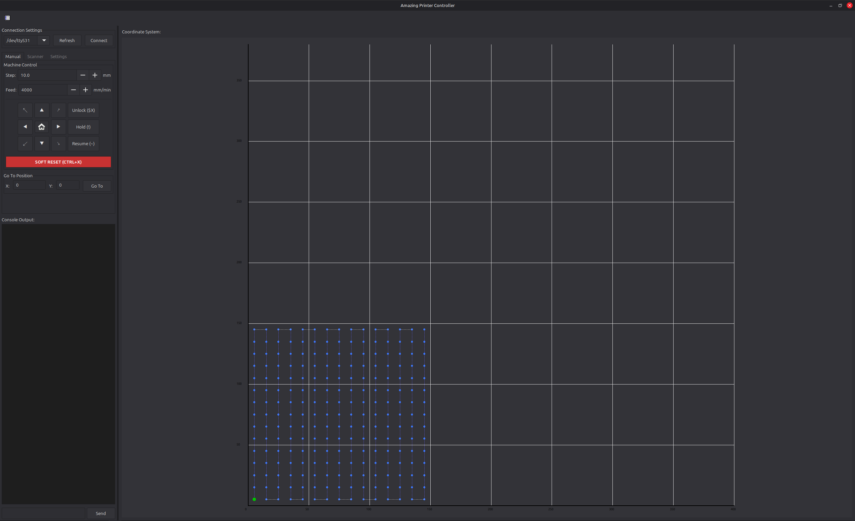
Figure 1: Main application window after launch

Connecting to the Machine
Before using any controls, the machine must be connected via USB. The connection panel is located at the top-left of the main window.

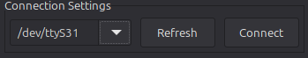
Figure 2: Connection panel showing port dropdown and Connect button

Steps to Connect
- Plug the GRBL machine into the computer via USB.
- Click Refresh to scan for available serial ports. The dropdown will populate with detected devices (e.g., /dev/ttyUSB0).
- Select the correct port from the dropdown.
- Click Connect. The button will show "Connecting..." for approximately 2 seconds while the Arduino resets.
- Once connected, the button changes to Disconnect and the console begins showing status messages.

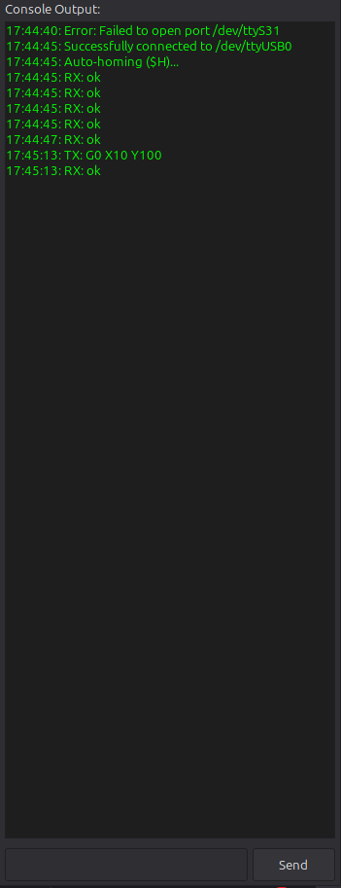
Figure 3: Output Panel after Connecting

Disconnecting
Click Disconnect to close the serial connection. The port selector will be re-enabled for a new connection.

Manual Control
The Manual Control tab provides direct control over the machine’s movement. It is located in the left sidebar under the "Manual" tab.

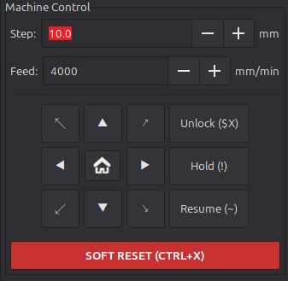
Figure 4: Manual Control tab with jog pad and motion controls

Jog Controls
The directional pad allows jogging the machine in 8 directions (up, down, left, right, and all four diagonals). The centre button triggers a homing cycle ($H).
- Step Size: Controls how far the machine moves per jog click (0.01 to 100 mm).
- Feed Rate: Controls the speed of jog movements (1 to 5000 mm/min).

Go To Position
Below the jog controls, enter absolute X and Y coordinates and click Go To to move the machine directly to that position using a rapid (G0) move.

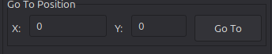
Figure 5: Move To Panel

Machine Control Buttons
- Unlock ($X): Clears the alarm state after a limit switch trigger or power-on.
- Hold (!): Pauses the machine mid-motion. It decelerates to a stop.
- Resume (~): Resumes motion after a Hold.
- Soft Reset (Ctrl+X): Emergency stop. Immediately halts all motion and resets the controller.

Coordinate Panel
The right side of the application displays a real-time coordinate plot showing the machine’s current position. The panel maps the full machine workspace (0–400 mm on X, 0–380 mm on Y) with a grid and axis labels.

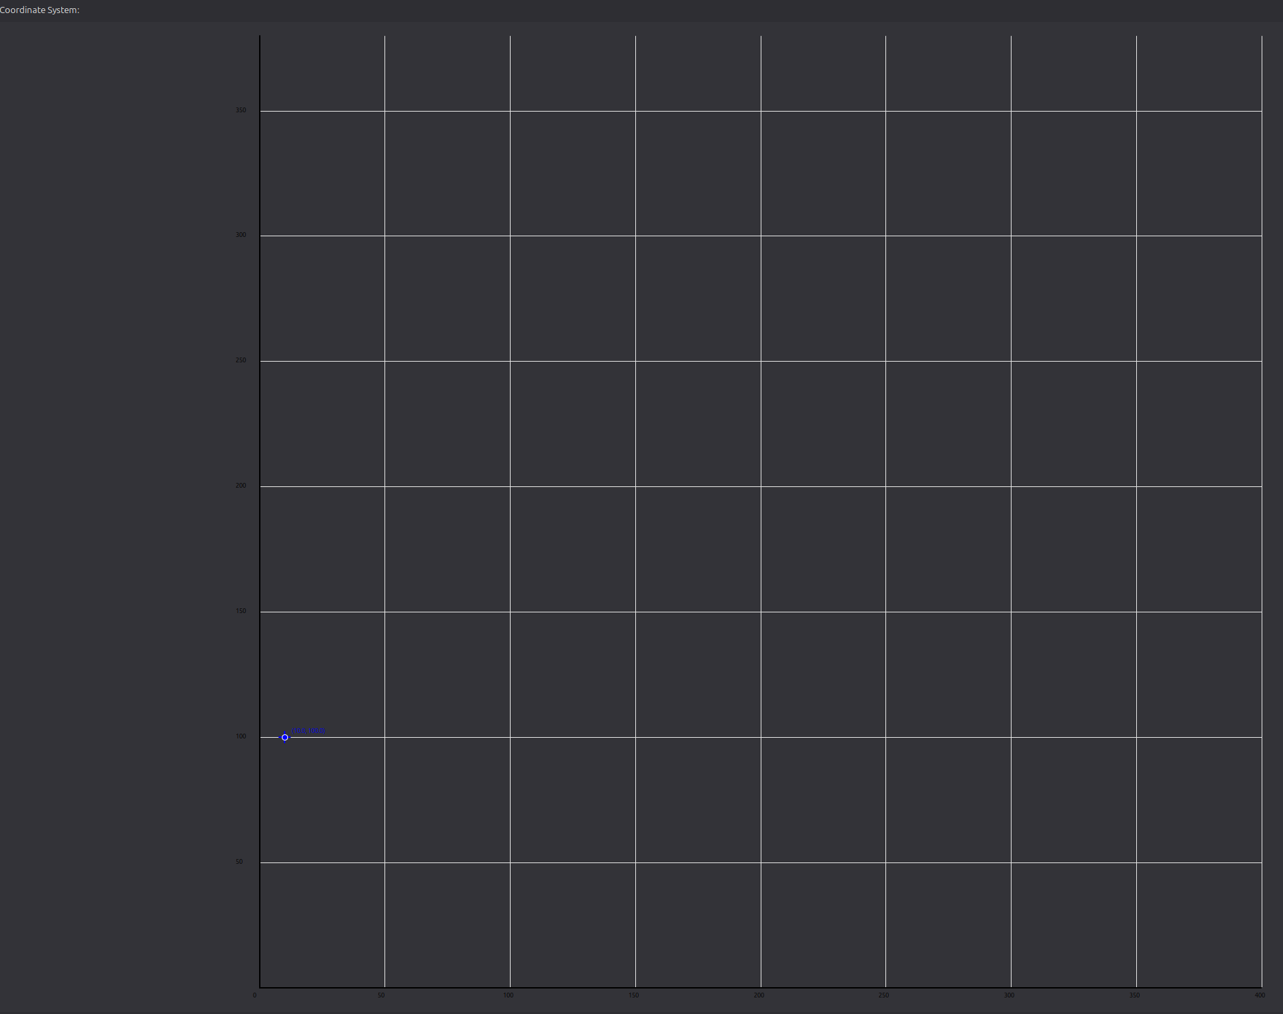
Figure 6: Coordinate panel showing machine position as a blue dot

Click-to-Move
Clicking anywhere on the coordinate panel commands the machine to move to that position. The clicked location is shown as a red dot, and the machine travels there using a rapid (G0) move.

Scan Preview
When scan parameters are configured in the Scanner tab, a dashed red rectangle appears on the coordinate panel showing the bounding box of the scan area. This updates live as scan parameters are changed.

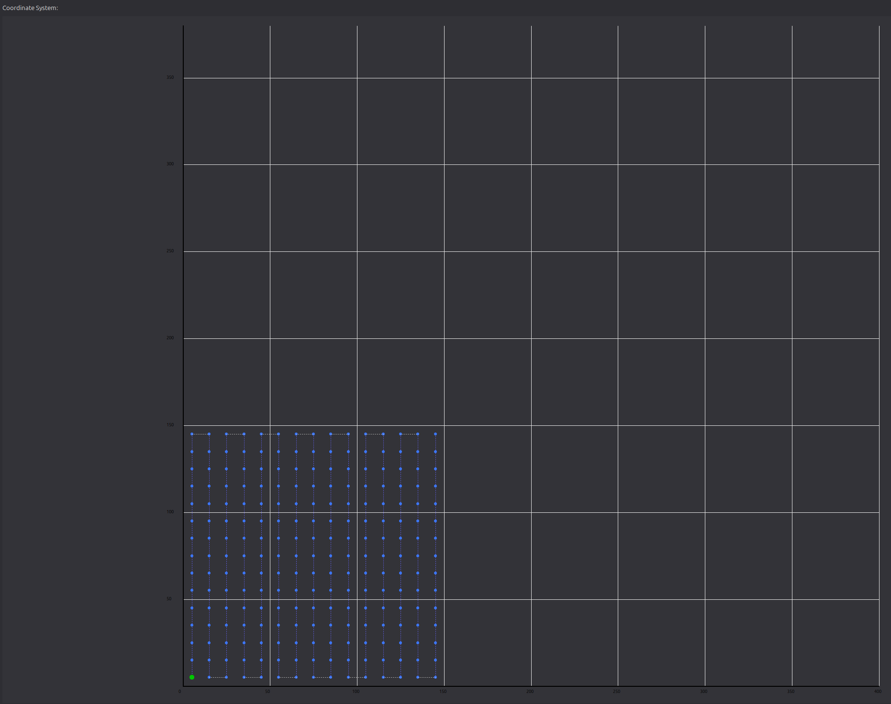
Figure 7: Coordinate panel with scan preview rectangle visible

Automated Scanning
The Scanner tab allows configuring and executing automated grid scan cycles. The machine moves through a grid of points defined by the scan parameters.

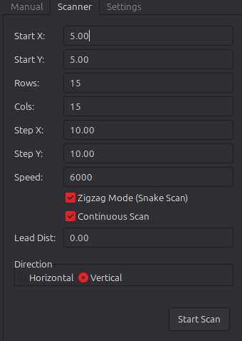
Figure 8: Scanner tab showing all configuration fields

Scan Parameters
- Start X / Start Y: The origin point of the scan grid in machine coordinates.
- Rows / Cols: The number of rows and columns in the grid.
- Step X / Step Y: The distance between adjacent points (in mm).
- Speed: The feed rate used during the scan (mm/min).
- Direction: Horizontal (row-by-row) or Vertical (column-by-column) traversal.
- Zigzag Mode: When enabled, alternating rows/columns are traversed in reverse order (snake pattern), reducing total travel distance.

Running a Scan
- Configure the desired parameters. The preview rectangle on the coordinate panel updates in real time.
- Click Start Scan. All input fields are disabled and the button changes to STOP SCAN.
- The machine moves to each grid point sequentially, waiting for arrival at each one.
- To cancel, click STOP SCAN. The machine stops at its current position.
- When complete (or cancelled), a message is displayed and controls are re-enabled.

GRBL Configuration
The GRBL Configuration dialog provides direct access to the machine’s internal EEPROM settings. It is opened from the toolbar button at the top of the main window.

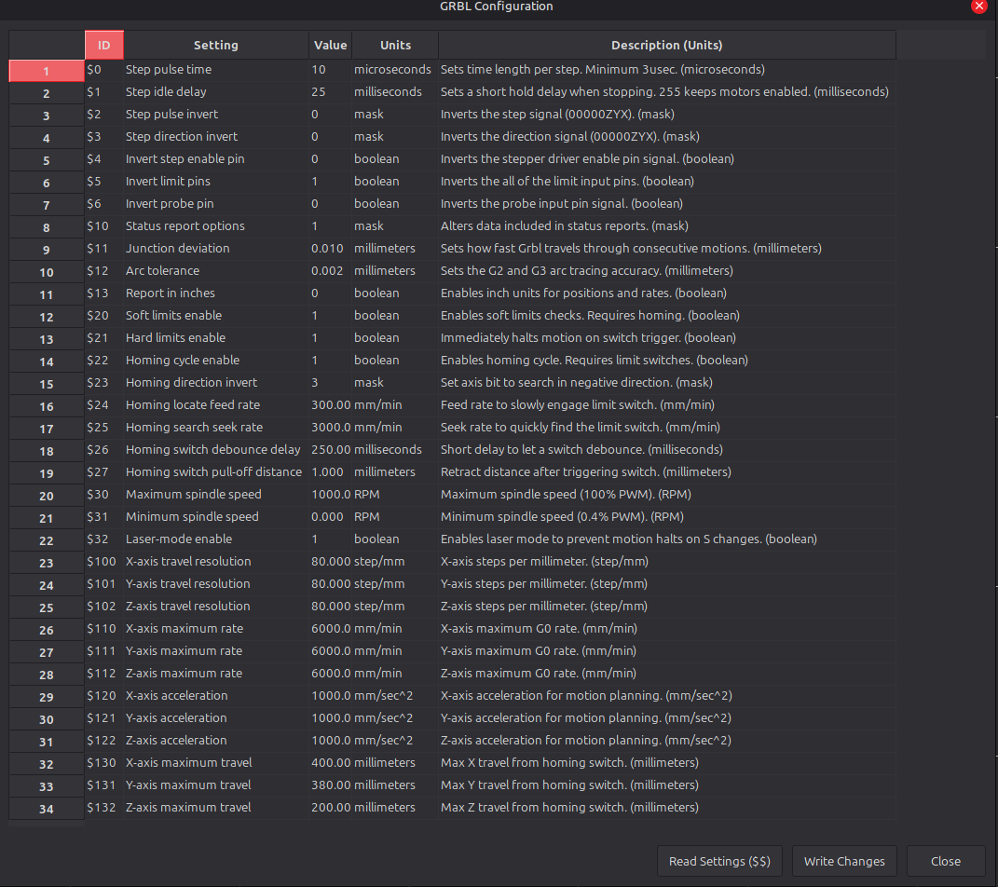
Figure 9: GRBL Configuration dialog with settings grid

Reading Settings
The dialog automatically sends the $$ command when opened, populating the grid with the current values stored on the machine. Click Read Settings ($$) to refresh at any time.

Modifying Settings
Edit any value in the Value column and click Write Changes to send all values to the machine. Each setting is sent as a $ID=VALUE command (e.g., $100=250.000). A confirmation message appears when complete.

Console and Manual Commands
The console at the bottom of the left panel shows all serial communication between the application and the machine. Incoming messages are prefixed with RX: and outgoing commands with TX:.

Sending Custom Commands
The text input below the console allows sending any G-Code or GRBL command directly. Type the command and press Enter or click Send. Examples:
- G0 X100 Y50 — Rapid move to position (100, 50).
- $H — Run the homing cycle.
- $$ — Display all GRBL settings in the console.
- $X — Clear alarm state.

References

[1] gnea, “GRBL: Open source, high performance g-code-parser and CNC milling controller,” GitHub, 2019. [Online]. Available: https://github.com/gnea/grbl
[2] gnea, “GRBL Wiki: Understanding GRBL v1.1 configuration and commands,” GitHub, 2019. [Online]. Available: https://github.com/gnea/grbl/wiki
[3] C. Kohlhoff, “Boost.Asio: Asynchronous I/O,” Boost C++ Libraries, 2024. [Online]. Available: https://www.boost.org/doc/libs/release/libs/asio/
[4] wxWidgets Team, “wxWidgets: Cross-Platform GUI Library,” wxWidgets.org, 2024. [Online]. Available: https://www.wxwidgets.org/
[5] S. Berry, “Glaze: Extremely fast, in memory, JSON and interface library for modern C++,” GitHub, 2024. [Online]. Available: https://github.com/stephenberry/glaze
[6] Microsoft, “vcpkg: A C/C++ package manager for Windows, Linux, and macOS,” Microsoft Learn, 2024. [Online]. Available: https://learn.microsoft.com/en-us/vcpkg/
[7] Kitware Inc., “CMake: A cross-platform build system generator,” cmake.org, 2024. [Online]. Available: https://cmake.org/documentation/
[8] T. Kramer, F. Proctor, E. Messina, “The NIST RS274NGC Interpreter — Version 3,” National Institute of Standards and Technology, NISTIR 6556, 2000. [Online]. Available: https://www.nist.gov/publications/nist-rs274ngc-interpreter-version-3

