## 3. Parameter Identification

### Level 1.)

Applying a step response from *0 V* to *24 V* to both the real system and the simulation model in MATLAB/Simulink, it can be observed in Figure (1) that the step response of the simulation model is not sufficiently coinciding with the real motor. The reason is the deviation of the real motor’s inertia and friction from the datasheet’s theoretical values.

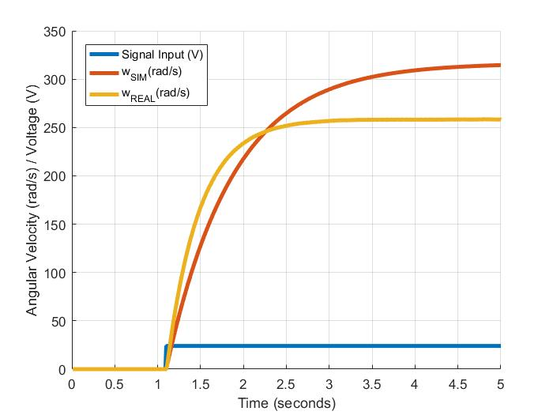

Figure : Step Response from 0 to 24 volts for the simulink model (orange) and the real motor (yellow).

Since the dynamics of the motor’s inductance is very fast with respect to the slow (dominant) dynamics of the mechanical elements, we can expect a second order model, as illustrated subsequently in Figure 2, to sufficiently model the real motor.  
Regarding the deviation between the model and the real motor, we can extend the model with two parameters ‘*eps_Jeq’* (εJeq) and ‘*eps_dm’* (εdm), illustrated with yellow colour in Figure 2. By doing so we can scale these two parameters in a way such that the theoretical values of the inertia *Jeq* and the viscous friction *dm*, given from the datasheet of the motor coincide with the actual values of the motor within an acceptable margin of deviation.

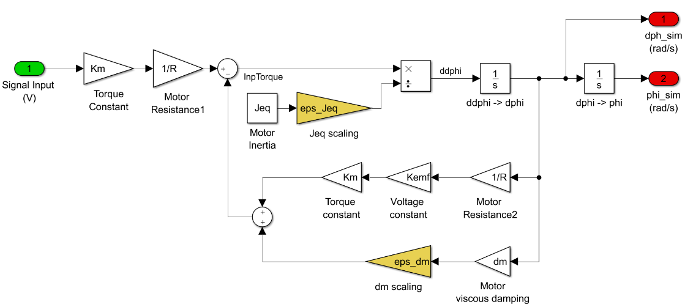

Figure : The MATLAB/Simulink block diagram of the motor model with extended parameters.

The theoretical values used in the beginning are given by *Jeq =* *2.2048e-05 kgm²* and *dm = 3.8e-6 Nms/rad*. After investigation of appropriate scaling, the scaling parameters *εJeq = 0.6* and *εdm = 3.56* are found to ensure a step response that coincides within an appropriate margin of deviation.   
Hence the final value for the motor’s inertia *Jeq* and the motor’s viscous damping *dm* are

*Jeq =* *2.2048e-05* kgm²,

*dm = 1.3528e-05 Nms/rad*.

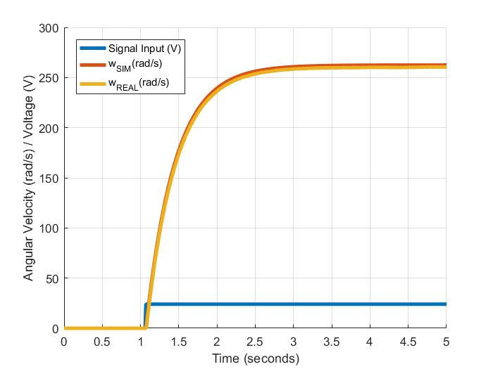

Figure : Step response with tuned parameters in the MATLAB/Simulink model for intertia Jeq and viscous damping dm.

### Level 2.)

In order to adapt the MATLAB/Simulink model to the motor’s nonlinear friction, the nonlinear friction model

$$M_{f}=d_{V}\dot{φ}+T_{C}sgn\left(\dot{φ}\right),$$

Where dv is the viscous damping and Tc the Coloumb friction torque, is applied.

The MATLAB/Simulink motor model is extended by the ‘Nonlinear Friction Model’-Subsystem as illustrated subsequently in Figure 4

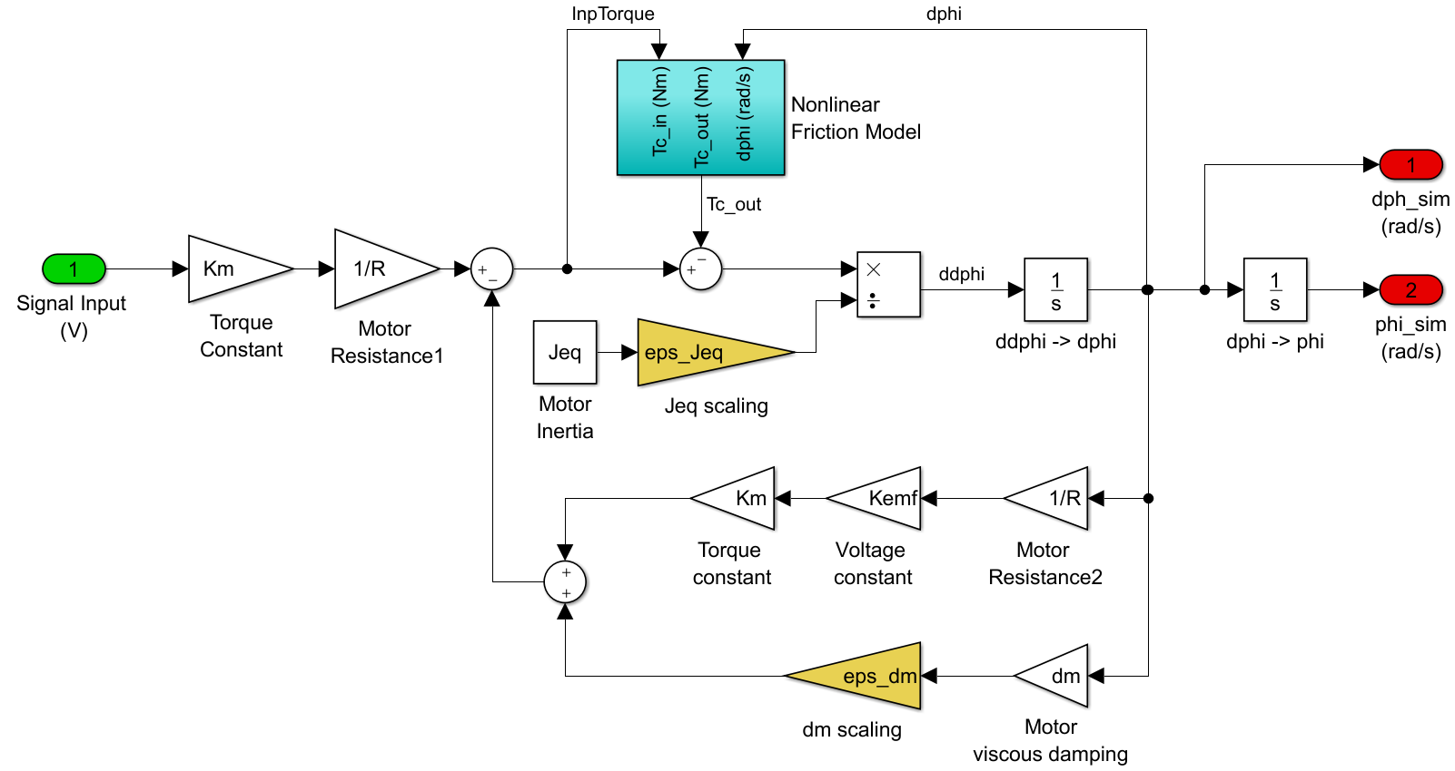

Figure : The MATLAB/Simulink motor model with nonlinear friction subsystem.

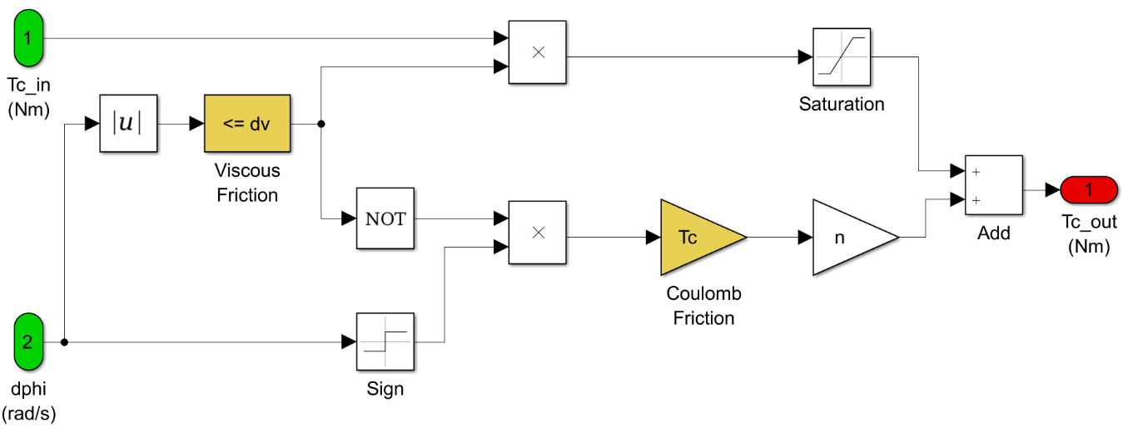

Figure : The MATLAB/SIMULINK motor model's nonlinear subsystem.

As illustrated in Figure 6, the identification of *dv* and *Tc* shows that the model represents the motor’s friction characteristic with sufficient precision. Hence the parameters values are found to be

*dv = 1e-2 Nms/rad*,

*Tc = 0.0013 Nm.*

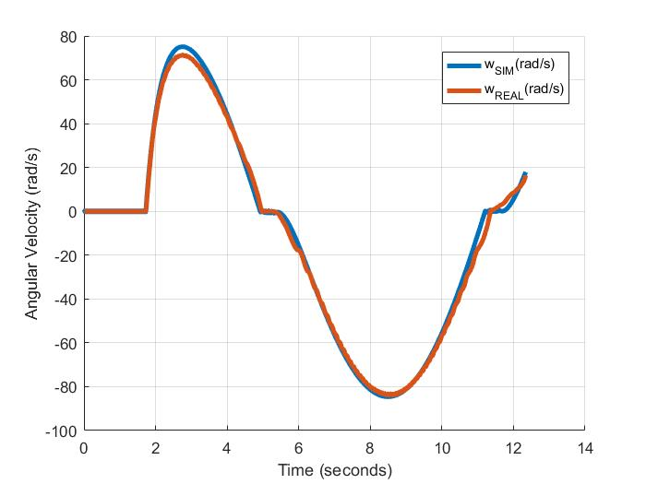

Figure : Motor and model trajectory for sinusoidal input signal with frequency = 100mHz.