PROJETO

**I.HELP**

**Modelo Conceitual**

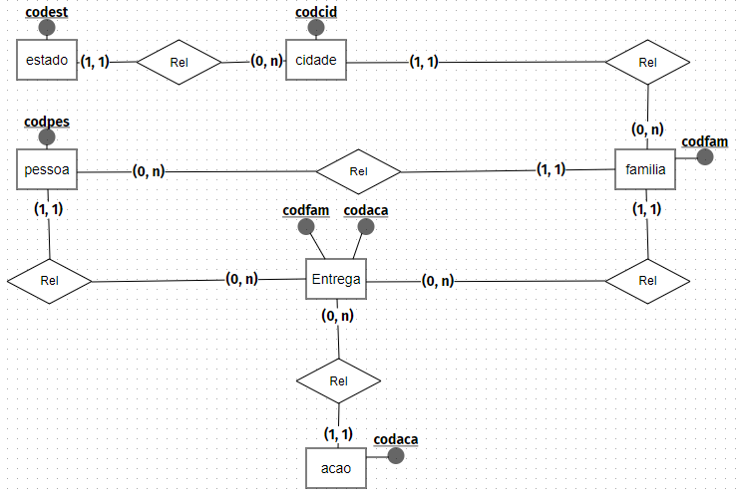

**Modelo Lógico**

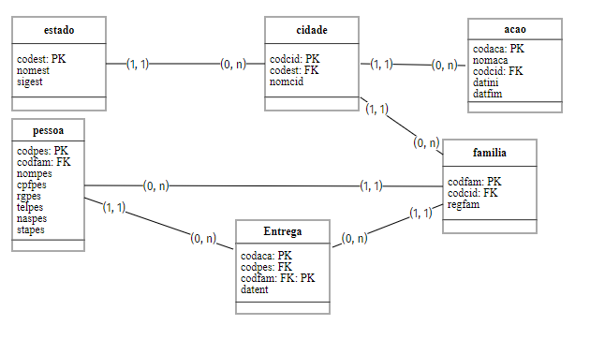

**SCRIPT**

create table estado(

codest int identity(0,1) primary key,

nomest varchar(150) not null,

sigest varchar(2) not null

);

--------------------

create cidade(

codcid int identity(0,1) primary key,

nomcid varchar(150) not null,

codest int references estado (codest)

);

--------------------

create table familia(

codfam int identity(0,1) primary key,

regfam varchar(5) not null,

codcid int references cidade (codcid),

);

--------------------

create table pessoa(

codpes int identity(0,1) primary key ,

nompes varchar(100) not null,

cpfpes varchar(14) not null,

rgpes varchar(20) not null,

telpes varchar(11) not null,

naspes date not null,

stapes numeric(1) not null default 1 constraint pessoa_ativa_0_1 check (stapes in (1,0)),

codfam int references familia (codfam)

);

--------------------

create table acao(

codaca int identity(0,1) primary key,

nomaca varchar(50) not null,

codcid int references cidade(codcid),

datini date not null,

datfim date not null

);

--------------------

create table entrega(

codaca int references acao(codaca),

codfam int references familia(codfam),

codpes int references pessoa(codpes),

datent datetime not null,

primary key (codaca, codfam)

);