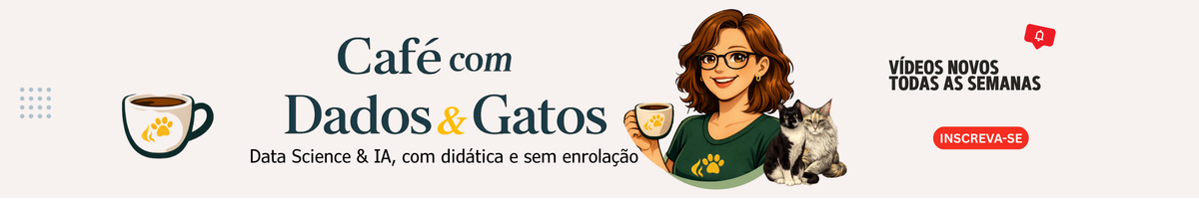
 | @CafecomDadoseGatos

Sumário
OpenClaw FULL in Docker + LM Studio (LOCAL) 2
✅ Prerequisites (what must be installed) 2
✅ Verification commands (before running) 2
0. CLEAN EVERYTHING (clean reinstall) 3
1. DOWNLOAD OFFICIAL OPENCLAW FULL 4
2. START FULL STACK 4
3. OPEN OPENCLAW 5
4. FIX ERROR 1008 5
5. ENABLE LM STUDIO ON WINDOWS 6
6. OPEN WINDOWS FIREWALL (ESSENTIAL) 6
7. TEST OPENCLAW → LOCAL LM STUDIO 6
8. ADD LM STUDIO TO OPENCLAW (NO CLOUD) 7

OpenClaw FULL in Docker + LM Studio (LOCAL)

✅ Prerequisites (what must be installed)
- Windows 10/11 (64-bit)
- WSL2 enabled
- Ubuntu on WSL2 (e.g., Ubuntu 22.04 or 24.04)
- Docker Desktop installed and using WSL2 backend
- LM Studio installed on Windows
  - Local server/API enabled (OpenAI-compatible mode)
  - At least 1 model downloaded in LM Studio (or download later)

✅ Machine requirements (recommended minimum)
- CPU-only works (no GPU required) (but it’s slow — GPU is strongly recommended; ideally an NVIDIA RTX for best performance)Recommended RAM: 16 GB (8 GB works but is tight)
- Disk space: at least 15 GB free
  - OpenClaw FULL image may take ~6–8 GB (varies by version)
- Internet: required to download Docker images and/or models in LM Studio (after setup it can run offline)

✅ Ports and network (basic requirements)
- 18789 → OpenClaw Gateway/UI (localhost)
- LM Studio server port (localhost) (example: 1234 — depends on your LM Studio config)
- From WSL/container, it must be possible to access:
  - http://host.docker.internal:<LM_STUDIO_PORT>/v1

✅ Verification commands (before running)
In PowerShell (Windows)
Check if LM Studio server is responding:
curl http://localhost:<LM_STUDIO_PORT>/v1/models
Example (if port is 1234):
curl http://localhost:1234/v1/models

In WSL (Ubuntu)
Check if Docker is OK:
docker info
Optional (good to confirm Windows → Docker route):
docker run --rm curlimages/curl:8.5.0 http://host.docker.internal:<LM_STUDIO_PORT>/v1/models

✅ Security / quick warning (for docs)
- Do NOT expose the LM Studio port to the internet — keep it local only (localhost).
- If you use docker system prune -a -f, understand this cleans the entire Docker environment (images, cache, and unused resources).
If you use:
docker system prune -a -f
it will clean the entire Docker system.

0. CLEAN EVERYTHING (clean reinstall)
In WSL:
cd ~
docker compose down -v
docker system prune -a -f
rm -rf ~/openclaw
⚠️ Attention:
docker system prune -a -f performs a global Docker cleanup, not just OpenClaw.
It removes stopped containers, unused images, unused networks, and build cache.
If you have other Docker projects, this may affect them too (you may need to recreate or re-download things later).
Use this command only if you really want to clean the entire Docker environment.
👉 If you want to clean only OpenClaw, prefer:
docker compose down -v

(from the project folder, e.g. ~/openclaw) + delete ~/openclaw.

1. DOWNLOAD OFFICIAL OPENCLAW FULL
cd ~
git clone https://github.com/openclaw/openclaw.git
cd openclaw
chmod +x ./docker-setup.sh

./docker-setup.sh
This generates:
- .env
- token
- base openclaw.json
If you need to run onboard again:
cd ~/openclaw
docker compose run --rm openclaw-cli onboard

2. START FULL STACK
cd ~/openclaw
docker compose up -d
docker compose ps

You should see:
- openclaw-gateway Running
- openclaw-cli Created

3. OPEN OPENCLAW
In browser:
http://localhost:18789/#token=YOUR_TOKEN

4. FIX ERROR 1008
Run in WSL (all one command):
docker compose exec -T openclaw-gateway sh -lc '
node - << "NODE"
const fs = require("fs");
const p = "/home/node/.openclaw/openclaw.json";
const j = JSON.parse(fs.readFileSync(p, "utf8"));
j.gateway = j.gateway || {};
j.gateway.controlUi = j.gateway.controlUi || {};
j.gateway.controlUi.enabled = true;
j.gateway.controlUi.allowInsecureAuth = true;
const add = ["192.168.65.0/24","172.17.0.0/16","172.18.0.0/16"];
const cur = Array.isArray(j.gateway.trustedProxies) ? j.gateway.trustedProxies : [];
j.gateway.trustedProxies = Array.from(new Set([...cur, ...add]));
fs.writeFileSync(p, JSON.stringify(j, null, 2));
console.log("patched gateway.controlUi + trustedProxies");
NODE
'

Then restart:
docker compose restart openclaw-gateway

Open again:
http://localhost:18789/#token=YOUR_TOKEN

5. ENABLE LM STUDIO ON WINDOWS
Open LM Studio on Windows.
Enable Local Server / API (OpenAI-compatible).
Test in PowerShell (change port if needed):
curl http://localhost:<LM_STUDIO_PORT>/v1/models

If it returns a list of models → OK.

6. OPEN WINDOWS FIREWALL (ESSENTIAL)
PowerShell as Admin:
New-NetFirewallRule -DisplayName "LM Studio API" -Direction Inbound -Action Allow -Protocol TCP -LocalPort <LM_STUDIO_PORT>

Example (port 1234):
New-NetFirewallRule -DisplayName "LM Studio 1234" -Direction Inbound -Action Allow -Protocol TCP -LocalPort 1234

7. TEST OPENCLAW → LOCAL LM STUDIO
In WSL:
docker compose exec -T openclaw-gateway sh -lc \
'curl -sS http://host.docker.internal:<LM_STUDIO_PORT>/v1/models && echo'

If JSON appears with "data" and models →
💚 CONNECTED.

8. ADD LM STUDIO TO OPENCLAW (NO CLOUD)
This setup is 100% local, so there is no login.
If the test above worked, LM Studio is ready to be used by OpenClaw.
You can integrate LM Studio directly during OpenClaw installation (onboard).
In the video, the manual method via openclaw.json (RAW editor) did not work.
So onboard was redone and configured in two steps.
✅ Recommendation: configure directly via onboard — most stable method.
1) Choose provider
When prompted for Model/Auth Provider:
- Select Custom Provider
2) Configure LM Studio URL
In API Base URL, enter your LM Studio IP + port:
Example:
http://192.168.10.107:1234/v1
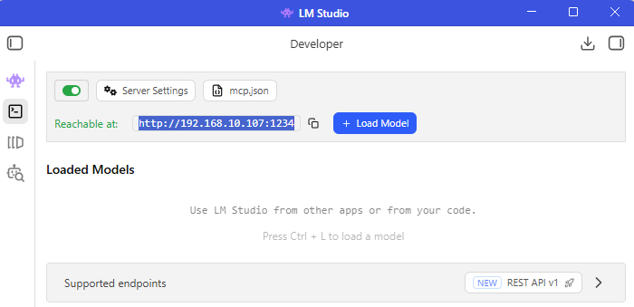

⚠️ Use the IP shown inside LM Studio (“Reachable at…”).
3) Endpoint compatibility
Select:
- OpenAI-compatible
4) Find correct Model ID
To list available models:
http://YOUR_IP:1234/v1/models
Example:
http://192.168.10.107:1234/v1/models
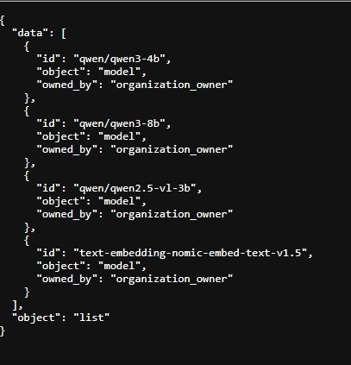
You will see installed model IDs.
Example active model:
- qwen/qwen3-4b
5) Fill Model ID and Alias
- Model ID: qwen/qwen3-4b
- Model Alias: short name for OpenClaw (e.g., qwen3-4b)
✅ Done!
From this point, OpenClaw can use LM Studio as a provider.

Document translated by AI from Portuguese to English.

