1. Calender main screen
There are 4 modules on this screen:
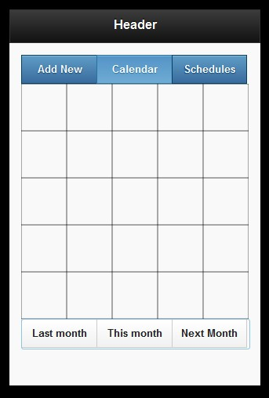
- Header
- Main Nav bar with 3 buttons
- The calendar
- Month switcher

Schedule for m/d/yyyy

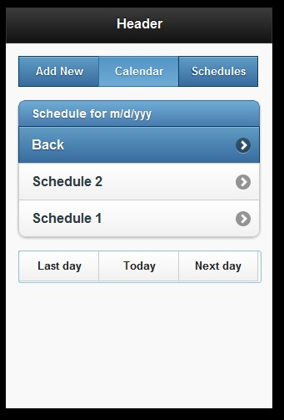

- When clicked on one date on calendar, can view the schedule for this day.
- Click the "Back" can return to calendar.
- Click the Day switcher can change day.

Add new screen
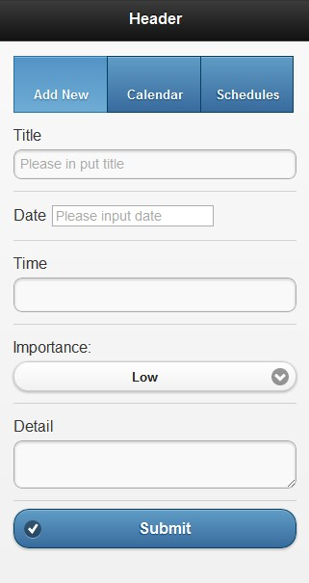
- Input the information and click the submit will save this schedule.
- If nothing was input, will not save the schedule.
- If has title or detail, but doesn't have date, please set the date to today.

4. Schedules screen
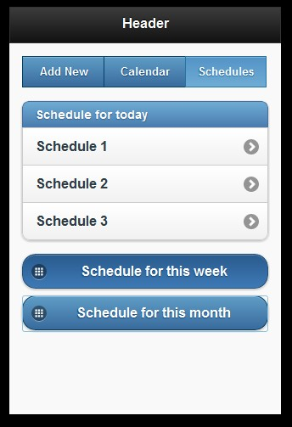

- When clicked on the schedules, can view the schedule for today.
- Can view the schedule for this week and this month.

Schedule detail screen

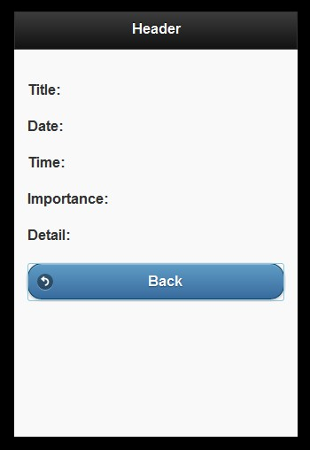

- When clicked on the schedule in schedule list, will show the schedule detail.
- When clicked on the "Back" button, will back to the last history screen.

