SOFTWARE:

Software is a set of instructions or data used to perform a specific task.

HARDWARE:

Hardware consists of physical components of a computer. It is tangible.

TYPES OF SOFTWARE:

1. System software
2. Programming software
3. Application software
4. Open-source software (OSS)
5. Proprietary software

System Software:

It includes OS and all the utilities that enables the computer to function. It is a program designed to run a computer’s hardware and applications.

Programming Software:

It enables software developers to write programs and debug them.

Application Software:

It includes programs that do real work for a user. That means, it performs a specific task to meet user needs.

Open-Source Software (OSS):

OSS is freely available software unlike Microsoft products. And we can make changes freely.

Example: LibreOffice

It is a computer software that is released under a license in which the copyright holder grants users the rights to use, study, change and distribute the software and its source code to anyone and for any purpose.

Proprietary Software:

These are non-free software. We can use this only after buying the proper license. It is owned by an individual or an organization.

Example: Microsoft, Auto CAD

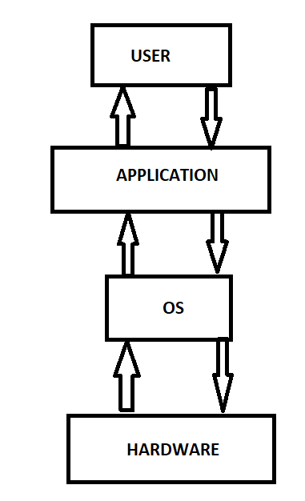

DIFFERENT ROLES IN SOFTWARE DEVELOPMENT

* Marketing Managers: work at product marketing and sales.
* Project Managers: responsible for overall management and controlling throughout the development life cycle.
* Team Leader: Managing a team and make sure that team members are doing their assigned duties properly. If any work is not done due to some reasons, team leader will be responsible for this.
* Software Developers: Writing and implementing efficient code.
* Designers: Make the blueprint of the software
* Quality Analyst: Ensure that the final product meets the requirements.
* Testers: Test the product for errors.
* Stakeholder: Person who directly or indirectly involved in the project.
* Customer: Approach the organization with some requirements. For whom the system is developed.
* User: One who use the system finally.

Software Development Lifecycle (SDLC):

Process followed by the developers to build a software product.

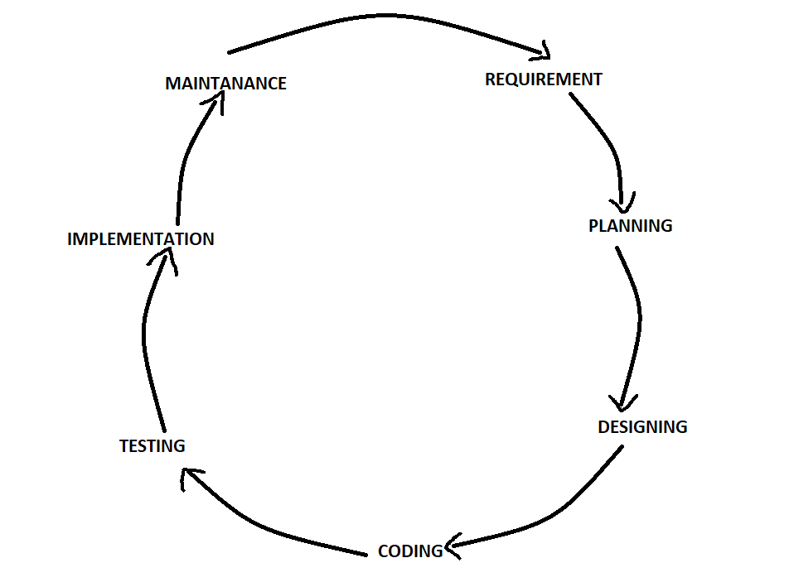

Requirement:

Understand the problem.

Planning:

Gathering the requirements and plan the process.

Designing:

Make the blueprint of the proposed system.

Coding:

Develop the source code.

Testing:

Find out the errors and correct them.

Implementation:

After completing the development of the system, handover it to the customer.

Maintenance:

Modifying and updating the software system.

CMMI (Capability Maturity Model Integration)

