StochFit QuickStart Tutorial

# Model Independent Fitting

## Before the Fit

### Data Format

StochFit expects 3 or 4 column data files in the following format:

Q R dR dQ

Where the errors (dR and dQ) can be either in variance or standard deviation. Standard deviation is the default setting. Data points with negative reflectivity intensities, or negative errors are discarded in the fitting procedure. If the error is in variance, select

Options 🡪 Miscellaneous Options 🡪 Errors are in Variance

### Load the Data

Select ➀ (Figure 1) in the StochFit graphical user interface (GUI) and select your data file. If you have previously fit this data, you will be asked if you want to resume. If you do not resume, enter the expected layer thickness into ➁, the expected layer SLD into ➂, the subphase SLD into ➃, and the number of small boxes to use into ➄ (approximately 1.5 boxes per Å of film thickness). The details of each parameter are explained in depth in the accompanying manual.

## Begin the Fit

Press Start ⑥ (Figure 1). The fit will begin, and the graphs will update approximately every 5 seconds. To end the fit, press Cancel. This will generate several files in the same directory as your data file. The parameters referenced below are explained in more detail in the manual. Depending on the search algorithm, some parameters will not be used

1. settings.xml – Contains all of the settings used to fit the date
2. pop.dat – Contains information used to generate the model independent fit. The first row contains (respectively) the smoothing parameter, the absorption parameter, the temperature for annealing, the normalization constant for the reflectivity, and a parameter for stochastic tunneling simulated annealing. The remaining rows contain a parameter for each small box.
3. rf.dat – Contains the current model independent reflectivity in Q, R
4. rho.dat – Contains the current model independent normalized electron density profile in Z, Rho/Rho∞

➀

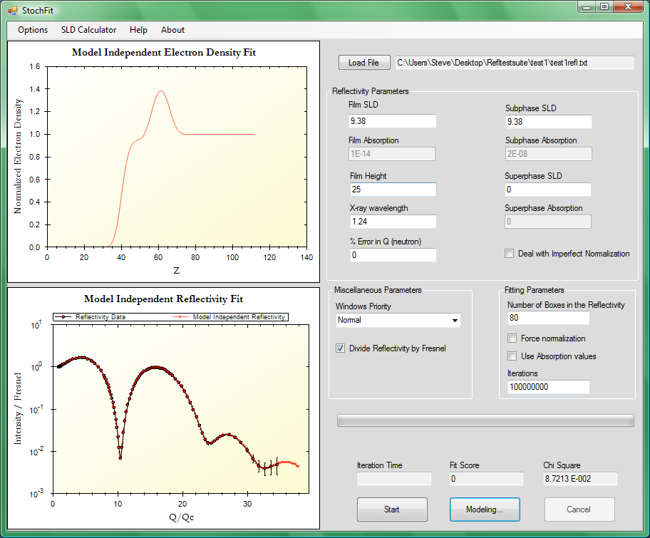

➆

⑥

➄

➃

➂

➁

Figure . Graphical User Interface for StochFit

# Extracting Parameters from a Model Independent Fit

In many cases, it is preferred to generate parameters more closely resembling those of a model dependent box fitting. In this case, press the “Modeling” button on the StochFit window (➆ in Figure 1) to bring up the window to perform this procedure (Figure 2). After providing an approximate solution that somewhat reproduces the model independent fit, press the “Fit” button to perform a non-linear least squares fit to the model independent electron density profile. This procedure will place a file named rhofit.dat in the same directory as the data file that will contain the data fit. To inspect the error in the parameters, press “Fit Details”.

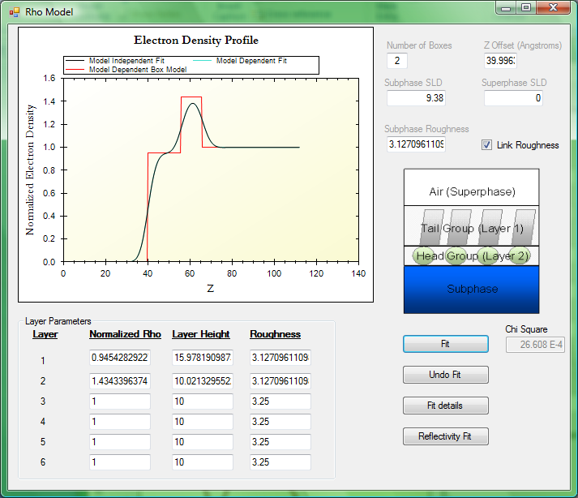

Figure Dialog for generating Model Dependent Fit from a Model Independent Fit