HỆ THỐNG QUẢN TRỊ HẠ TẦNG & NHẬT KÝ KỸ THUẬT
Module 1
mkdir -p docs scripts data backup
echo "DB_HOST=localhost" > .env
echo "DB_PORT=5432" >> .env
echo "DB_PASS=GreenTech2026SecurePass!" >> .env
echo "LOG_PATH=./data/log-he-thong.log" >> .env
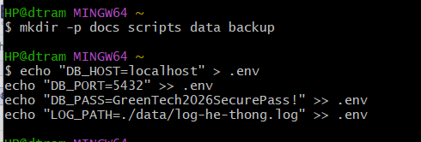
Module 2
@echo off
rem ===================================================================
rem GREENTECH AUTOMATED LOG REPORT SCRIPT
rem System: GreenTech Infrastructure Management System
rem ===================================================================

echo ===================================================
echo [INFO] DANG KHI DONG TIEN TRINH LOC LOG SYSTEM...
echo ===================================================

rem Buoc 1: Kiem tra su ton tai cua tep log goc (Audit Check)
if not exist "..\data\log-he-thong.log" (
echo [ERROR] Tep data\log-he-thong.log khong ton tai!
echo [INFO] Vui long kiem tra lai duong dan file log.
exit /b 1
)

rem Buoc 2: Khoi tao/Ghi tieu de bao cao vao file output
echo =================================================== > ..\backup\bao-cao-su-co.txt
echo BAO CAO SU CO HE THONG GREENTECH >> ..\backup\bao-cao-su-co.txt
echo Thoi gian trích xuat: %DATE% %TIME% >> ..\backup\bao-cao-su-co.txt
echo =================================================== >> ..\backup\bao-cao-su-co.txt
echo. >> ..\backup\bao-cao-su-co.txt

rem Buoc 3: su dung Pipe (|) va findstr de loc cac dong CRITICAL hoac ERROR
echo [INFO] Dang loc cac su co nghiem trong (CRITICAL / ERROR)...
type "..\data\log-he-thong.log" | findstr /C:"CRITICAL" /C:"ERROR" >> ..\backup\bao-cao-su-co.txt

echo [SUCCESS] Da trich xuat bao cao su co vao: backup\bao-cao-su-co.txt
echo ===================================================
pause

Module 3
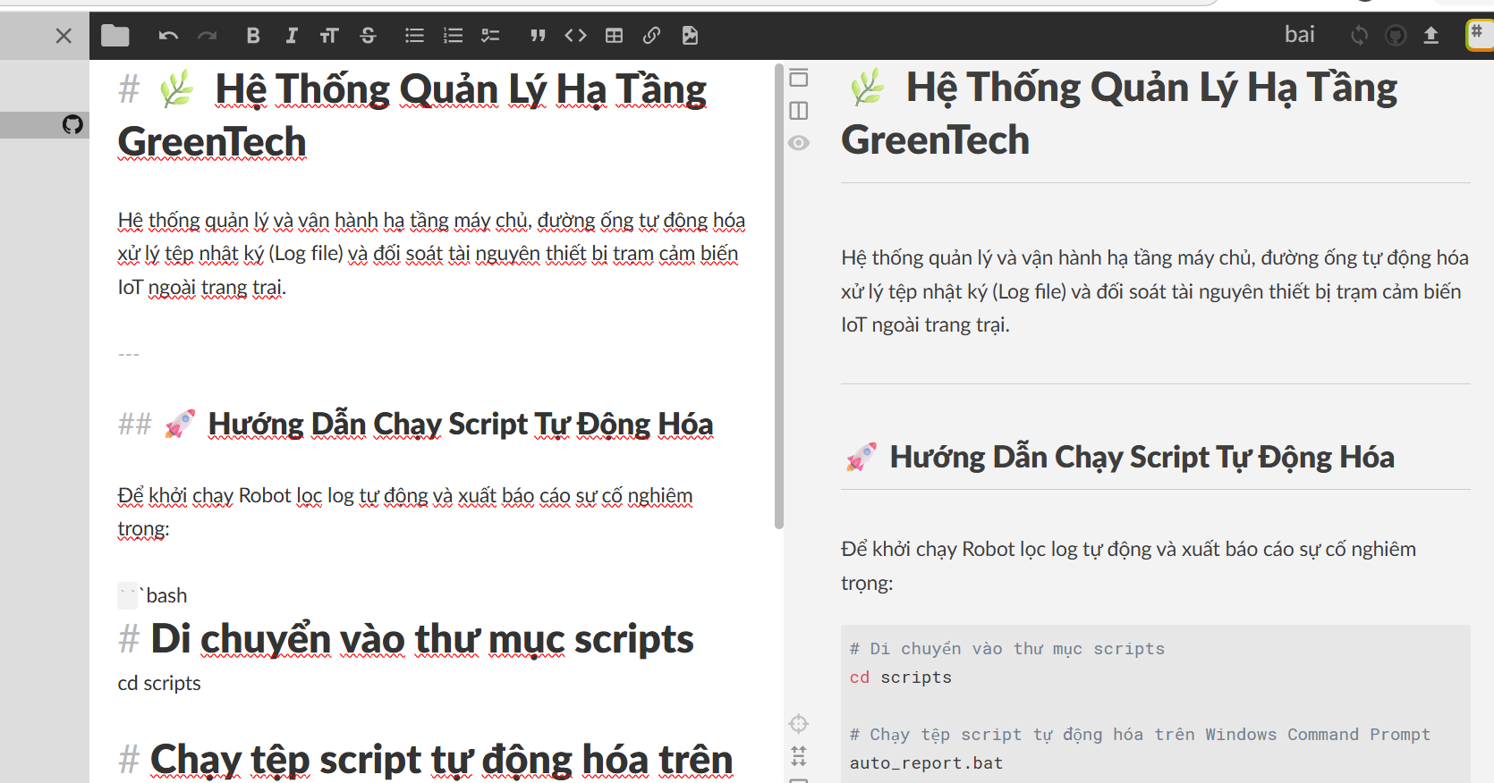
Module 4
