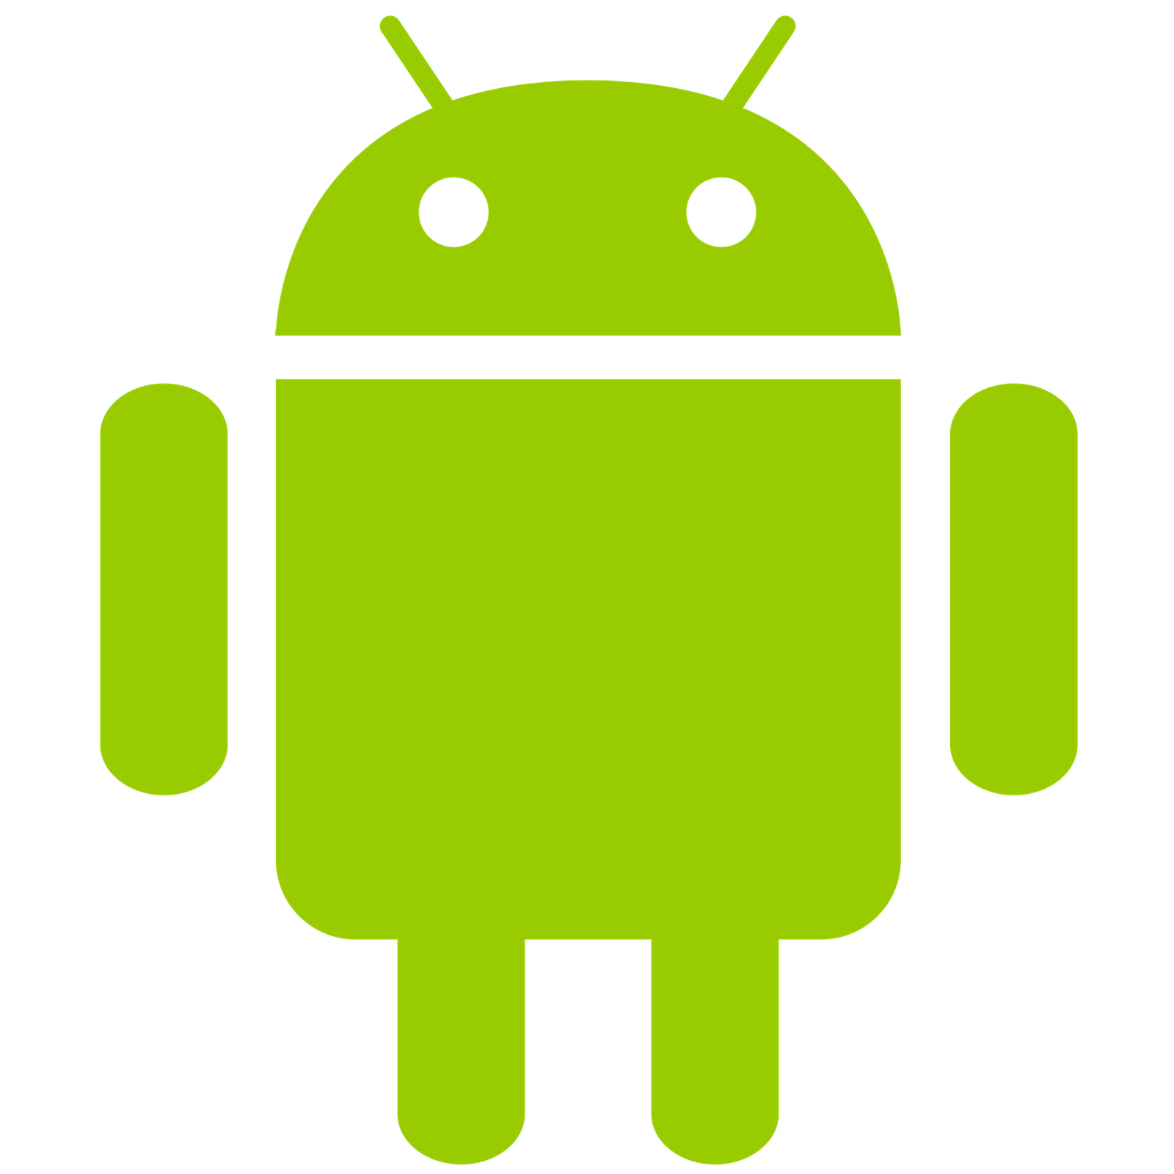

|  |  |  |  |  |
| --- | --- | --- | --- | --- |
| Emil Karamihov |  |  |  | Martin Savov |

Easy Read

Android Project

Table of Contents

1. Consept 1
2. Targeted Audiance 1
3. Project Goal 1
4. Project Setup 1
5. What does the program do 3
6. Hardware Used 4
7. APIs 4
8. Project Setup 4

s

**Concept** of the Android application – delivering to people that love to read, the experience to read their favorite books. We personalize the ability to purchase an e-book from our application and reading it on the spot with one click. We bring to our customers the exclusive option to sign up for free and read their first book free. Searching their chapters and browsing their favorite books.

**Target audience –** our team focuses on clean design, easy to navigate and understandable. Adapting the design to be suitable for an age group that is more centered around young customers. People who follow the newest authors on popular books and want to have a portable reader everywhere with all their favorite books.

**Project Goal –** creating a system reading and recording. We deliver personal freedom to illustrate there opinion, by making comments and rating the books. Making the process of choosing which books to buy easier for our customer. Also we provide the people, the possibility to read at any time and place on their personal android mobile phone application. Along with this project goal we deliver the opportunity to choose the digital and more modern approach over the paper, saving huge amounts of threes in the process.

**Project Steps–**

1. Creating Data branch on Git
2. Brain storming
3. Model on a Firebase database
4. Dependencies scope and getting a research base
5. Wireframes
6. Building an actual design
7. User testing a gathering information on feedback
8. Changing design according to feedback
9. Installing dependencies and components
10. Installing configuration and getting familiar dependencies
11. CRUD data thoughts
12. Data machine setup on REST
13. Connect to Firebase database
14. Accessing and storing data through the REST API
15. Clear logging via different log levels with exporting and serialization
16. Access application configuration through config file
17. Front end application environment configuration
18. Back end development
19. Text to speech and translation and Speech to text
20. Connection to google API
21. Converting data from API and displaying it to the view
22. Firebase management
23. Authentication via Firebase
24. Collection data and displaying each book per account
25. Testing environment
26. Bug fixing

**What does the program do and how to work with it?**

When the program is initiated a log In and Register activity will be prompted. For the application to be used the user first has to make a registration. After that the user is free to use the application.

The innovative part of the application is that the users can make a record of them and translate whatever the they have said. The other way around using text to turn to speech also is possible for use. Our database delivers the possibility to see the users made records.

The application delivers books from our partner google so that a user can buy from google whichever book he likes. Google books deliver us the opportunity to get that information. User can use the to read his chosen book.

The database is used to store our users Speech-to-Text notes/ voice books. For our and their needs, statistics and etc.

**Hardware used**

We have made user convenience by including the build in accelerometer of the phone. When a user wishes to record their session Speech-to-Text. When a user doesn’t want to simply click a button u can shake the phone.

It is required simply to shake the phone and the accelerometer will trigger the google API and a record is initiated.

**APIs**

1.Google Speech-to-Texts API

With the help of Google, a user can use his voice to turn it in to text

2.Google Text-to-Speech API

Again, with the help of Google a user can type some text and it is going to be turn into speech

3.Google Translate API – Dutch, French & German

Google once again made possible to translate text from both speech and text in to both text and speech in another language available: Dutch, French & German.

4.Google Books API

Using Google Books we get the books titles, publishing, link for buying and many more things.

5.FireBase Authentication

Thanks to Firebase we made authentication with automatic log in (once logged in after registration) and a registration function.

6.FireBase Database

Firebase also gave us the opportunity to store the previously made texts from speech. The user can see his records.