DPR – WEEK2

MRUNAL PATIL – 3101851

EMIL KARAMIHOV - 2992884

**Application Description:**

**StockMarket (Subject):** This abstract classdefines the behaviour of a stock market subject. It has two methods *Subscribe()* and *Unsubscribe()* for assigning and unassigning an Investor to a Stock respectively. Method *Notify()* is used for informing about the changes in the stock to the investors. Property “*Price*” is used to get and set the price of Stock.

**IInvestor (Observer):** This is a basic implementation of an Observer. It simply contains the method *Update()* with the parameter of the type *StockMarket,* which means class *StockMarket* call method *Update*(), it pushes data to the interface *IInvestor*.

**Investor (Concrete Observer):** Investor is subscribed or unsubscribed to the Stock. When a price of the stock is modified it is updated to all the investors by calling Update() method.

**IBM (Concrete Subject):** IBM is the stock which is basically the data in the StockMarket.

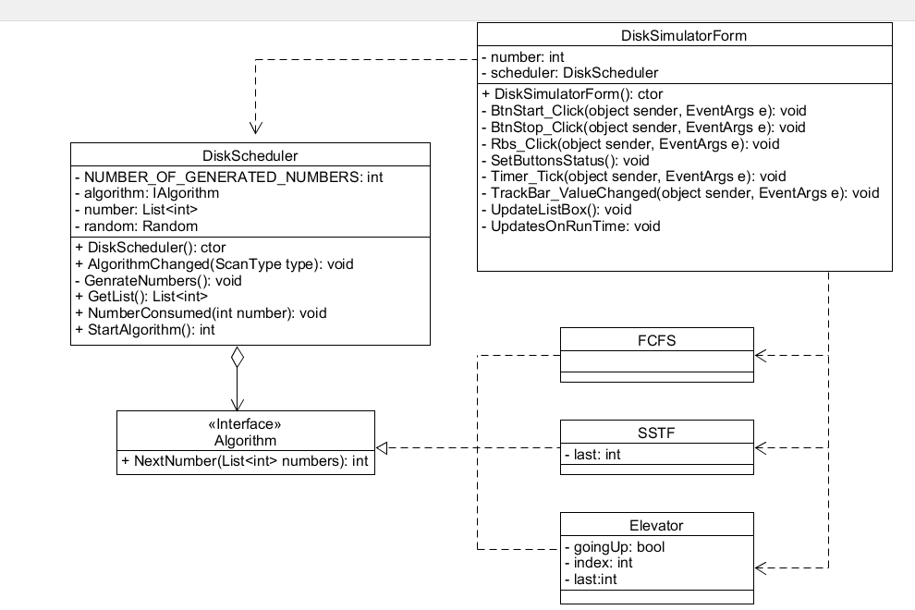

**Advantages of our Design:**

* New Algorithms can be added easily without modifying any other class.
* Behaviour of the application can be changed at runtime. Example: - Changing the algorithm for sorting during runtime.
* The design avoids changing the context of the application(DiskScheduker).

**DISADVANTAGES**

* Too many objects are needed to be created.